Firmware：



Tools: ISP software + serial cable 232



Use ISP software to upgrade

Serial cable connection as shown below：

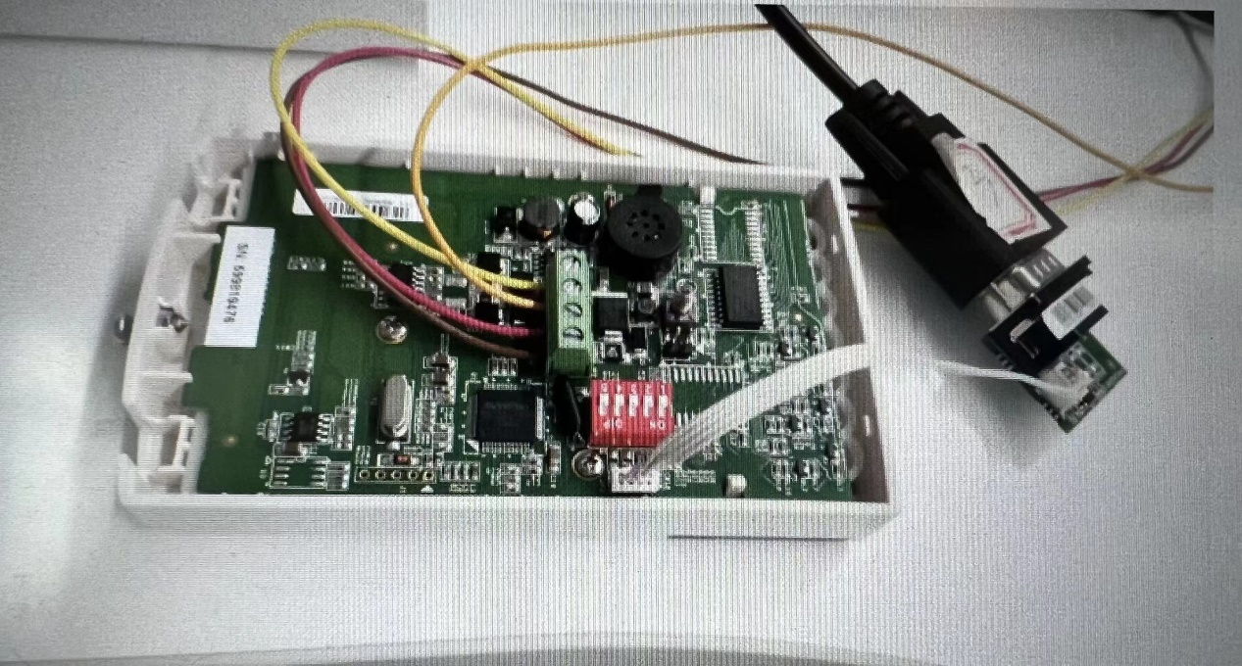

1. Open ISP software：

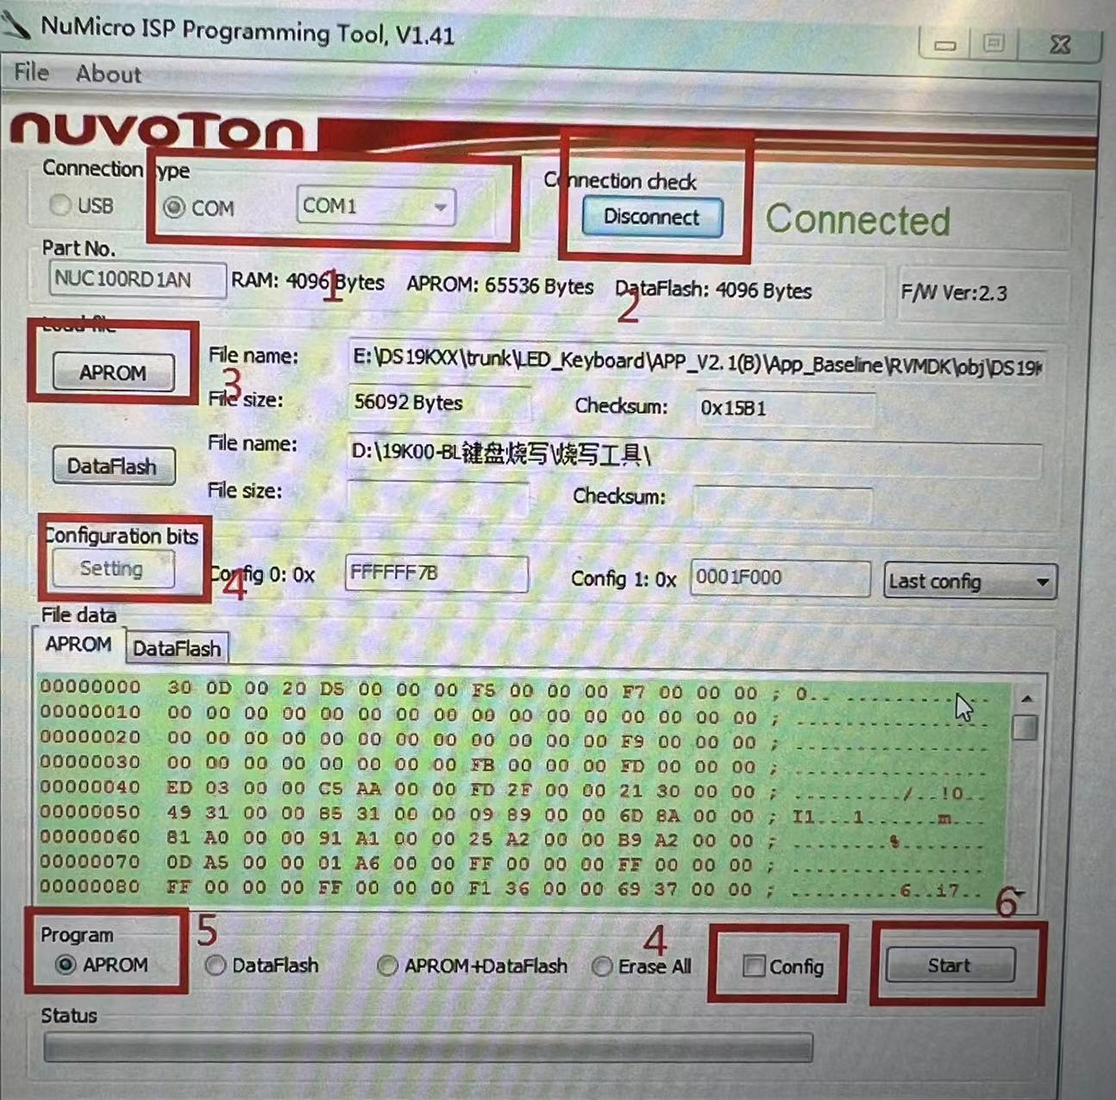

1. Operating procedures
2. Click button 1 to select the serial port number.
3. Click button 2, click connect, then the device is powered off and then powered on, and connected is displayed at this time

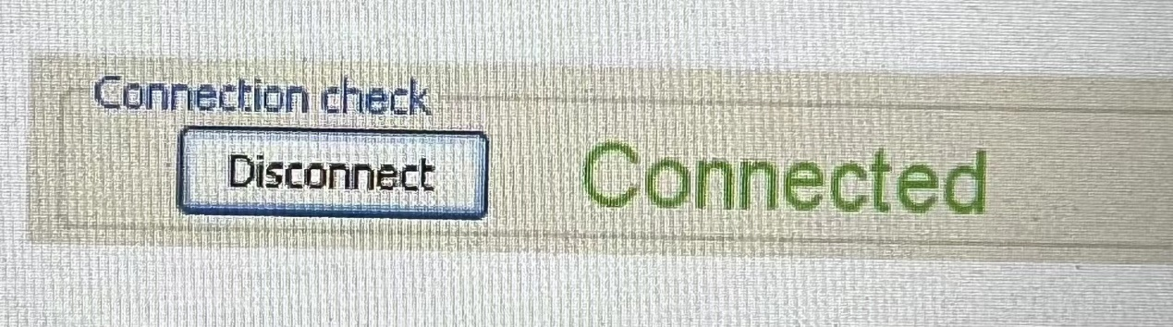

1. Click button 3 to import the application bin file
2. Click config, then setting, the setting dialog box is as follows:

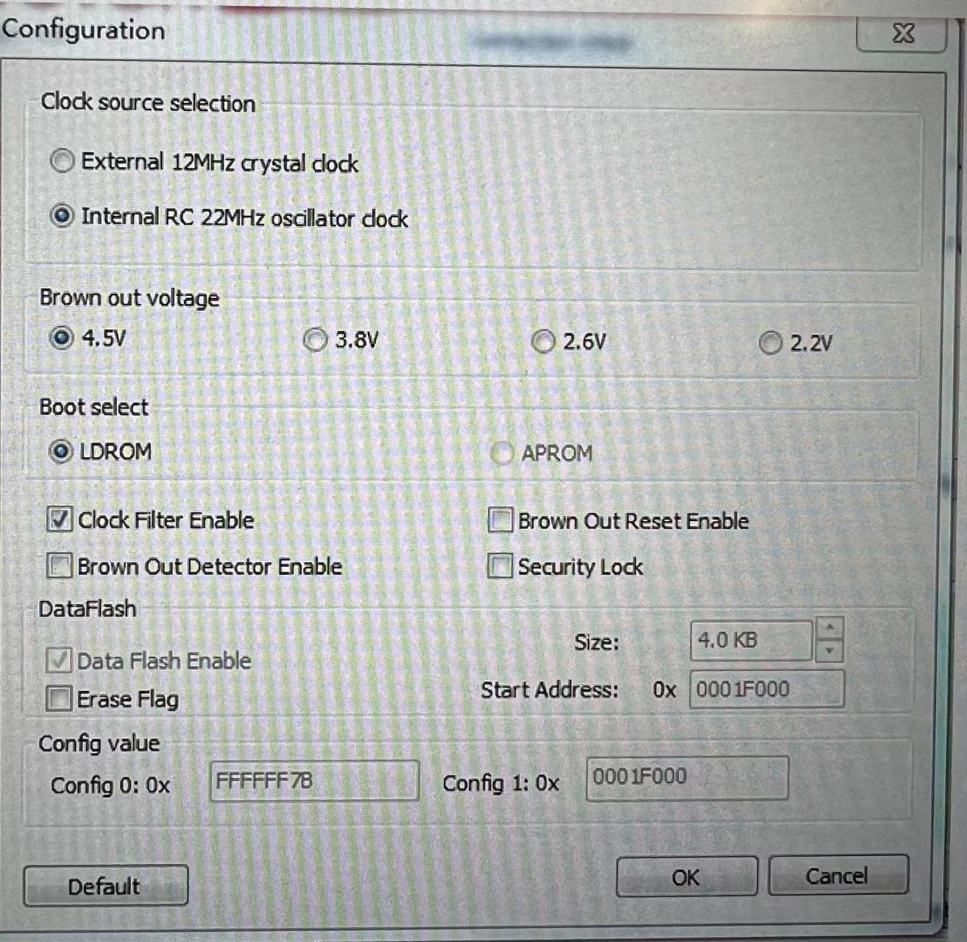

1. Click APROM, other do not select
2. Click start, the display result is PASS

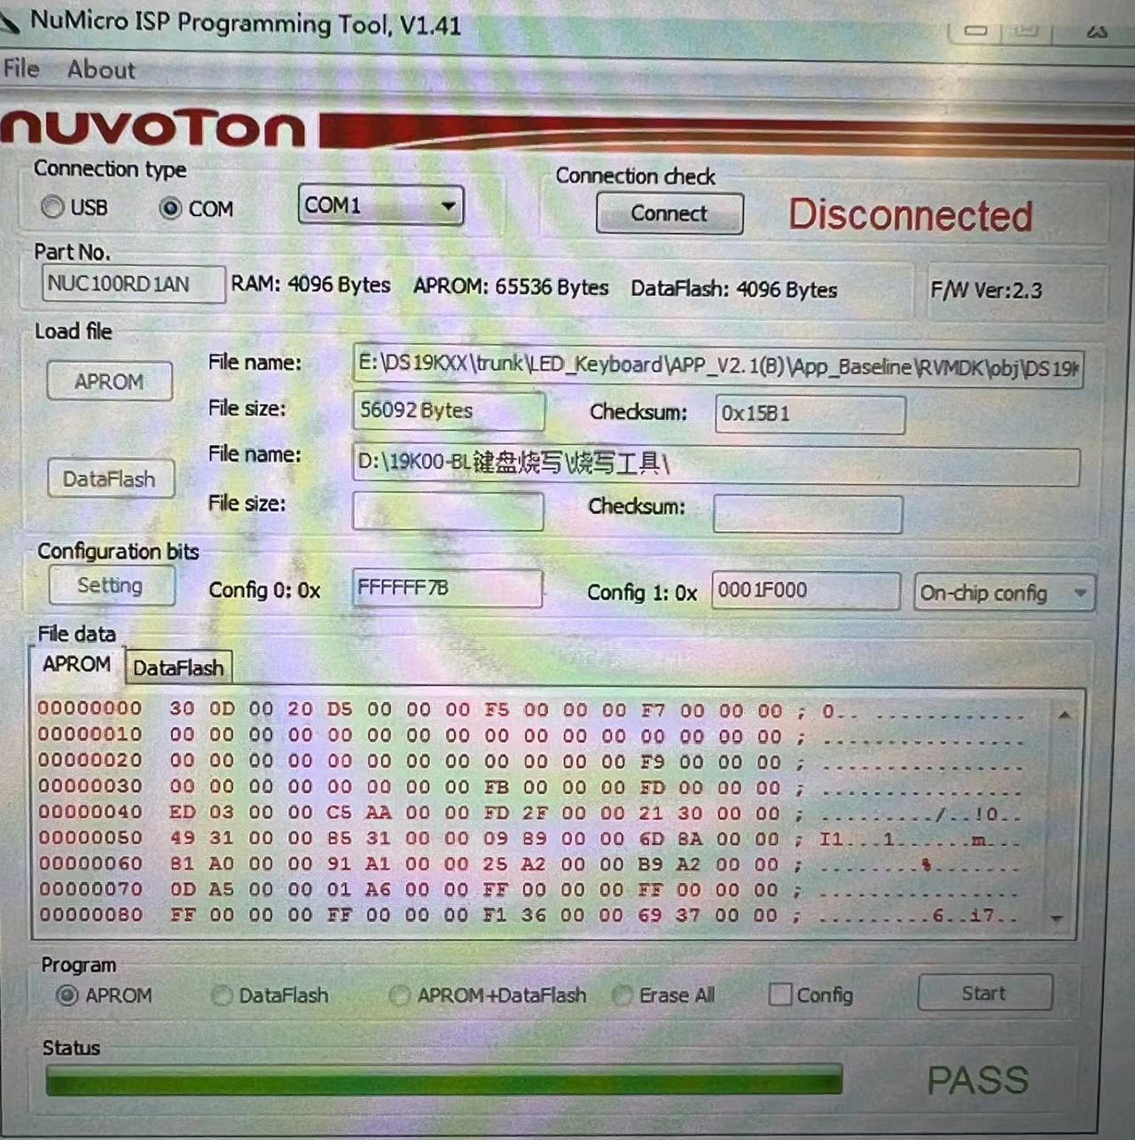

1. Finished