**KB8113 Firmware**

**V2.2.51_210908 Release Note**

**(2021-09-08)**

|  |  |
| --- | --- |
| Device Model | DS-KB8113-IME1 |
| Firmware Version | V2.2.51_210908 |
| iVMS-4200 Version | Latest version |
| Hik-Connect APP | 4.13.1 or above |

**FIX**

1、 Solve the problem of calling Hik-connect failure after enabling Hik-connect for the first time.

**KB8113 Firmware**

**V2.2.51_210816 Release Note**

**(2021-08-16)**

|  |  |
| --- | --- |
| Device Model | DS-KB8113-IME1 |
| Firmware Version | V2.2.51_210816 |
| iVMS-4200 Version | Latest version |
| Hik-Connect APP | 4.13.1 or above |

**Modify**

1、 HiK-Connect is disabled and Verification code is empty by default.

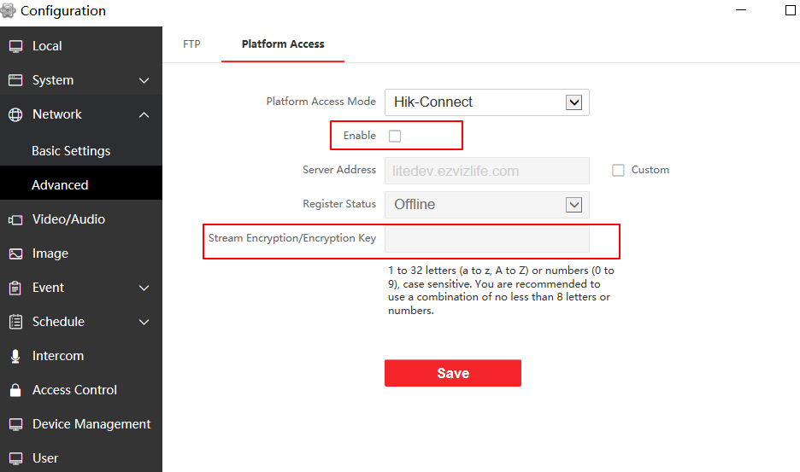

**KB8113 Firmware**

**V2.2.51_210630 Release Note**

**(2021-07-12)**

|  |  |
| --- | --- |
| Device Model | DS-KB8113-IME1 |
| Firmware Version | V2.2.51_210630 |
| iVMS-4200 Version | Latest version |
| Hik-Connect APP | 4.13.1 or above |

**Modify**

1、 **Since V2.2.51_210630, remote degradation of devices is not supported in all subsequent versions.** When degradation occurs, it will prompt Upgrading failed.

**Notice: Although the device can be degraded by serial port, the device will fail to start and cannot change the version by using serial port again, which means that the device will be completely unusable.**

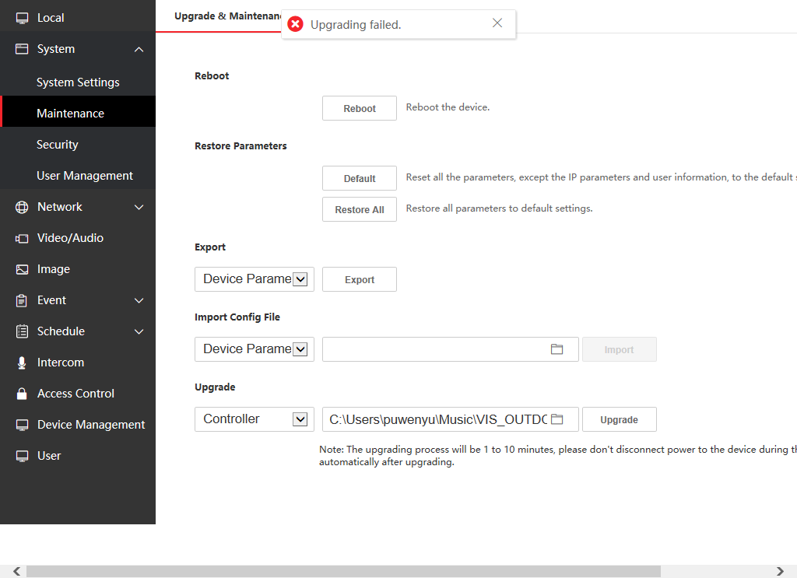

2、Newly support for French voice prompt "calling", "the line is busy" and "the door is open"

3、The method of adding sub door station is changed to the same method as protocol 1.0. (Fill in the Main Door Station IP and Registration Password in the configuration interface of Sub Door Station)

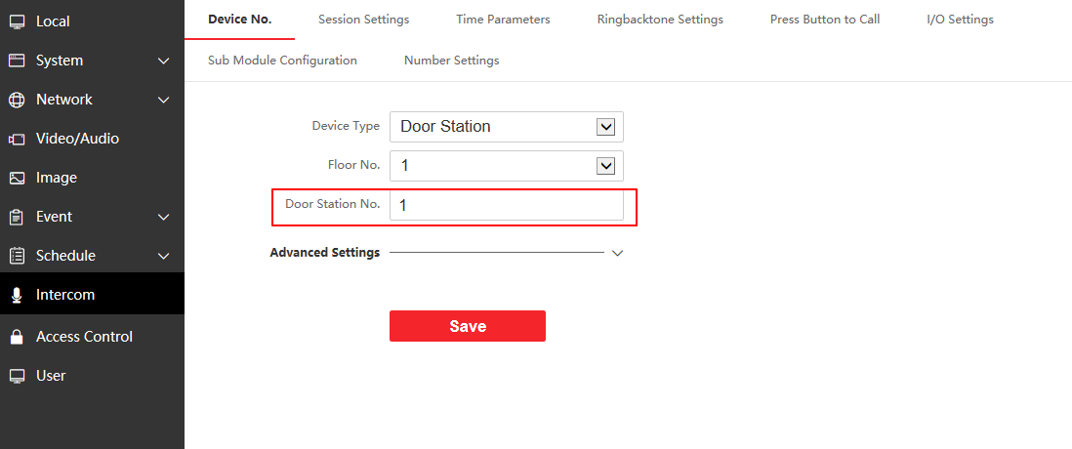

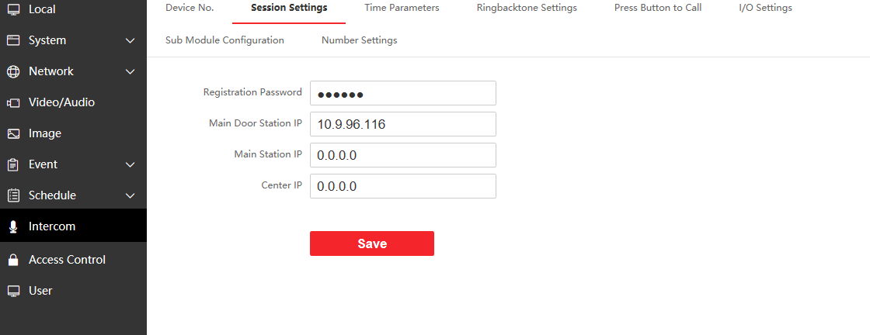

Note: you can refer to the attached file below about how to add a Sub door station.



4、Hik-Connect function is disabled by default.

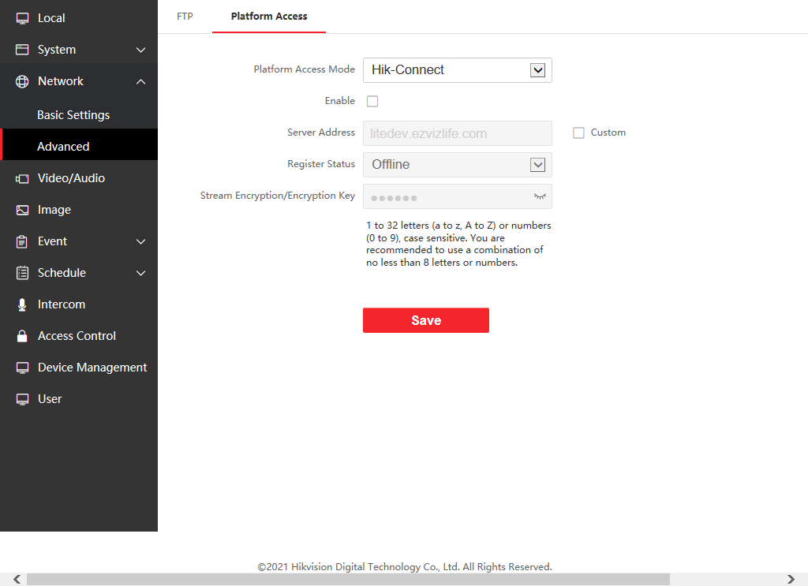

**KB8113 Firmware**

**V2.2.46_210430 Release Note**

**(2021-04-30)**

|  |  |
| --- | --- |
| Device Model | DS-KB8113-IME1 |
| Firmware Version | V2.2.46_210430 |
| iVMS-4200 Version | Latest version |
| Hik-Connect APP | 4.13.1 or above |

**NOTE**

Registration password will correspond to the serial number to prevent other devices from invading the system

**New Function**

1. The changed name of the door station will be displayed on the call interface or preview interface of the indoor station

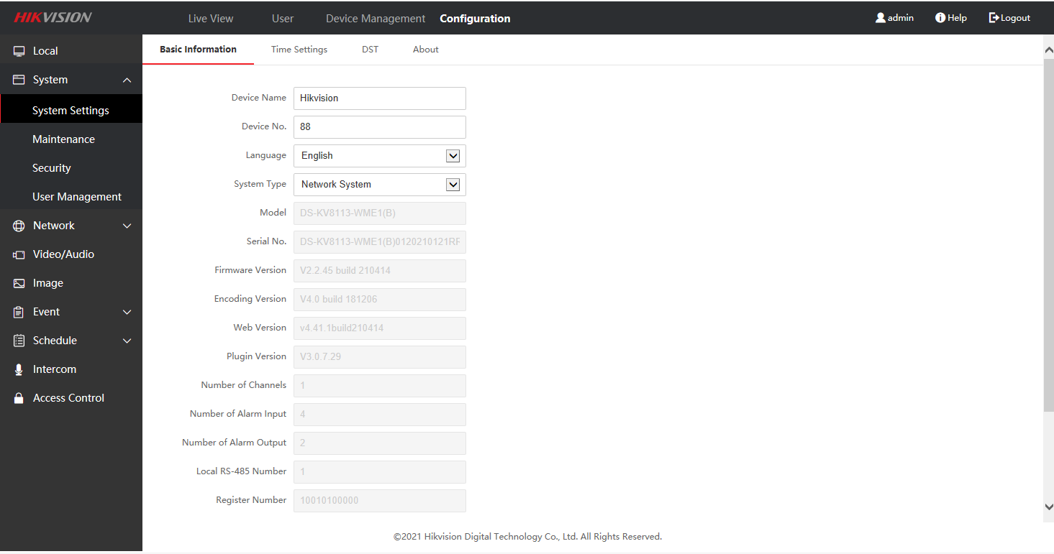

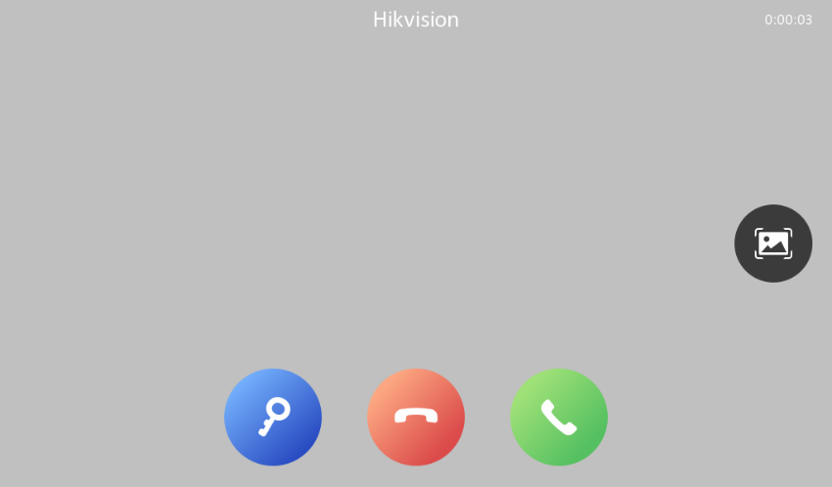

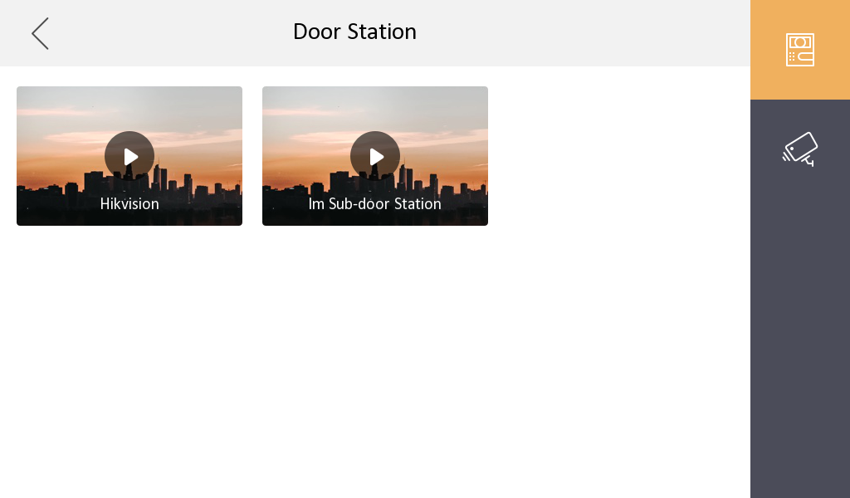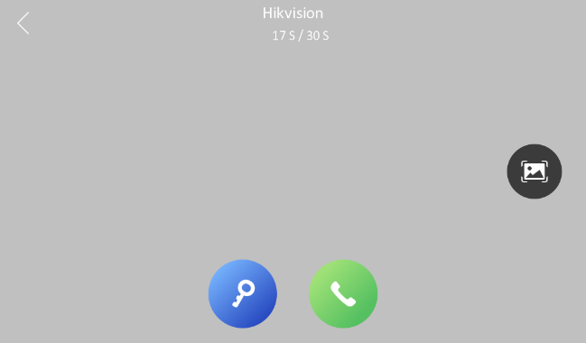

1. Add indoor station or sub-door station to iVMS-4200 or WEB to add default value

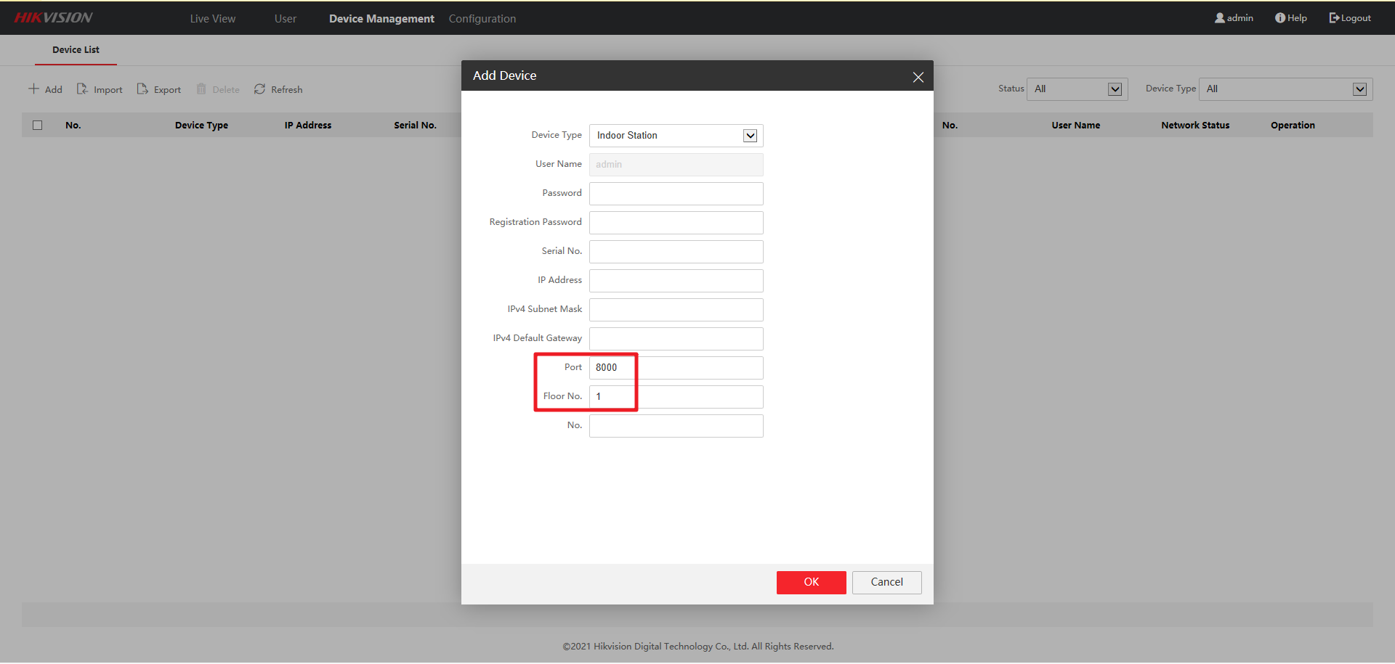

1. If the Registration Password in the door station WEB interface has been configured, it will be displayed in cipher text
2. Video Intercom Server IP (Private SIP server IP) naming changed to Center IP

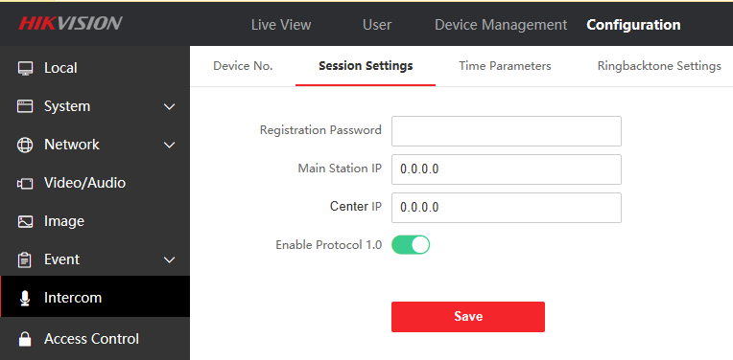

1. The WEB or iVMS-4200 interface community number, building number, and unit number of the door station will be stored in the advanced settings column instead of being displayed directly

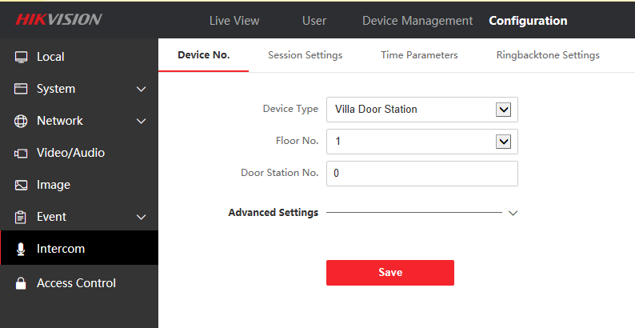

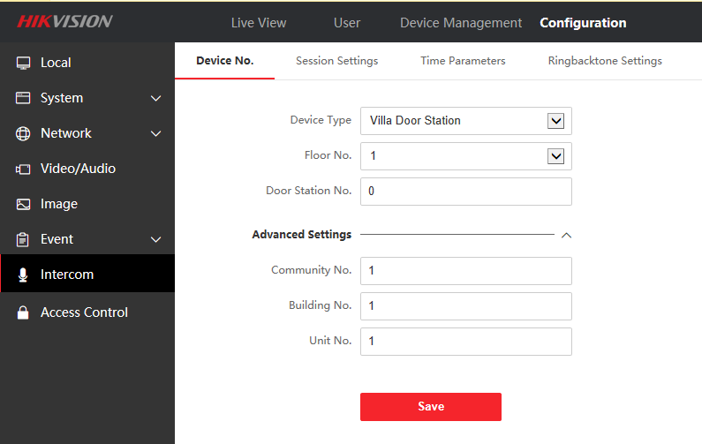

1. Support doorphone mode, when this function is enabled, the door station will no longer actively synchronize the information of the indoor station

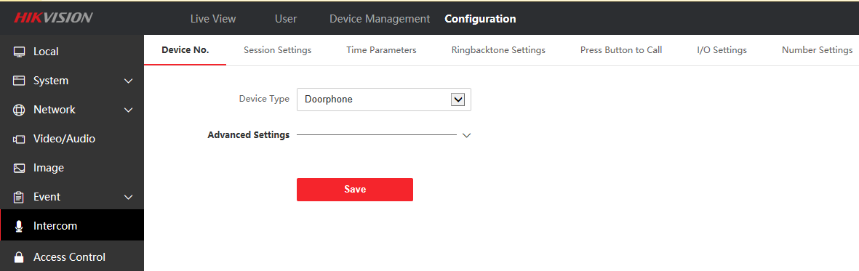

**Modify**

1. Now the doorbell KB8113 has an intercom button on the WEB interface, which can actively send intercom

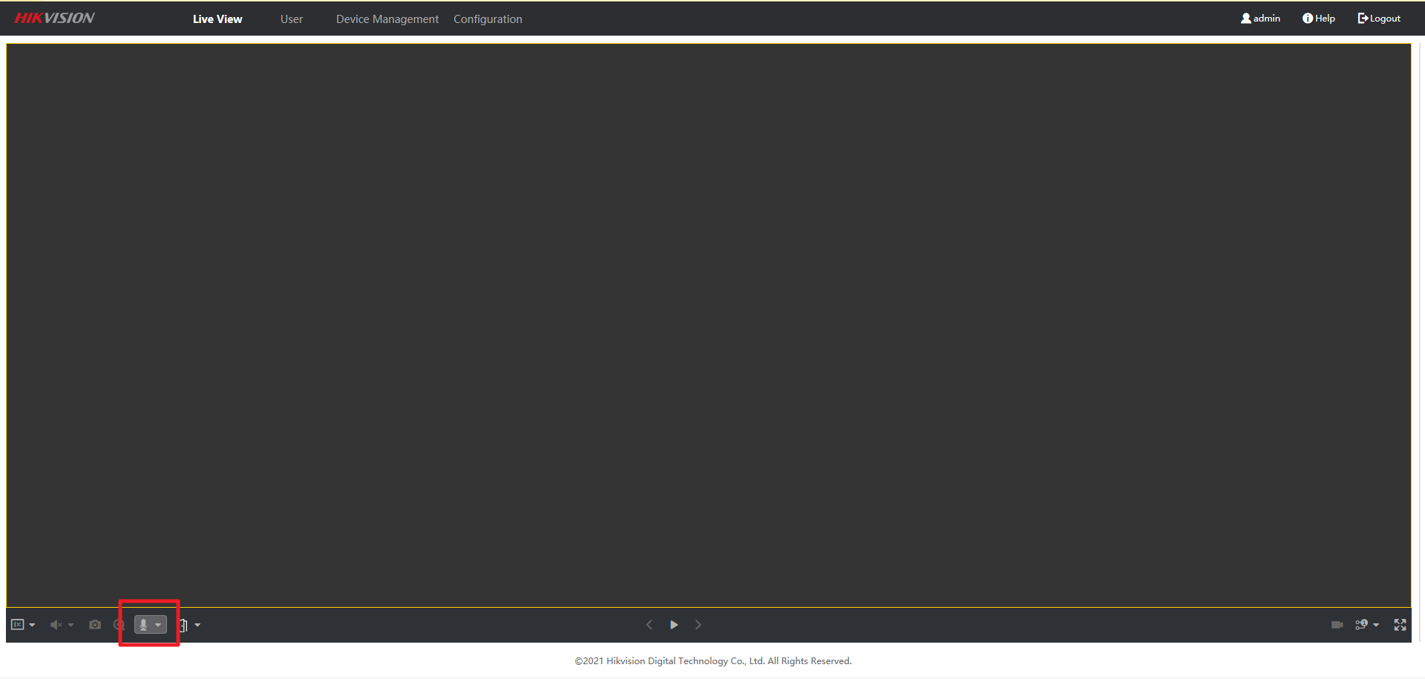

1. Change the Regist Password to the Registration Password in the export excel

