**How to set parameters for display screening**

Applicable to

**Device:** E&E Screening (Multi-language control panel)

**Configuration Tool:** LED Test Tool V2.01C

**Configuration for display screening**

1. Click Search, search control panel

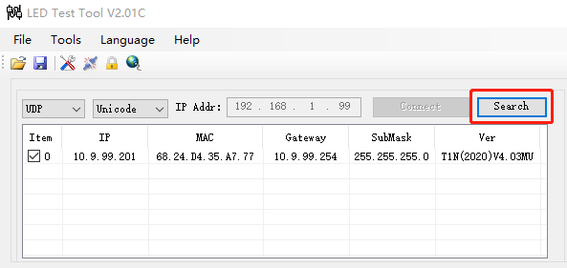

1. After search control panel success, go to Config, set parameters as follows:

**Parameters for screen of two rows:**

Width: 64

Height: 32

Color: Two Colors

OE Polerity: Low

Data Polerity: Low

Save Control: 1: not store

Line: 1.General

Color Channel: R+G+B

Driver IC: General

Scan mode: 8.8

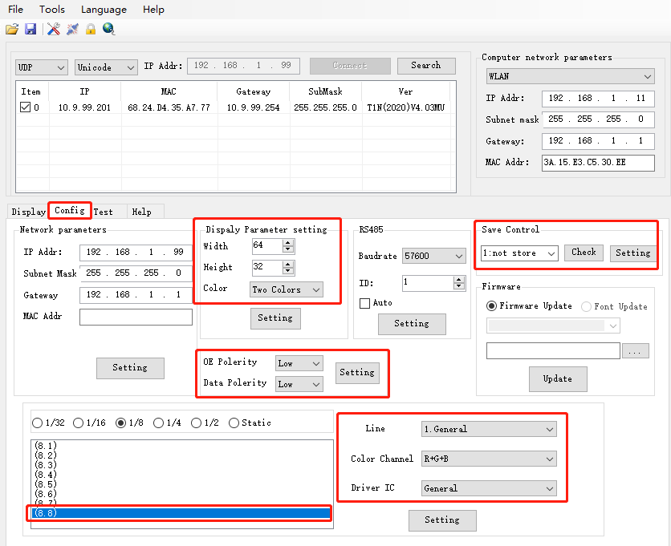

**Parameters for screen of four rows:**

Width: 64

Height: 64

Color: Two Colors

OE Polerity: Low

Data Polerity: Low

Save Control: 1: not store

Line: 1.General

Color Channel: R+G+B

Driver IC: General

Scan mode: 8.4

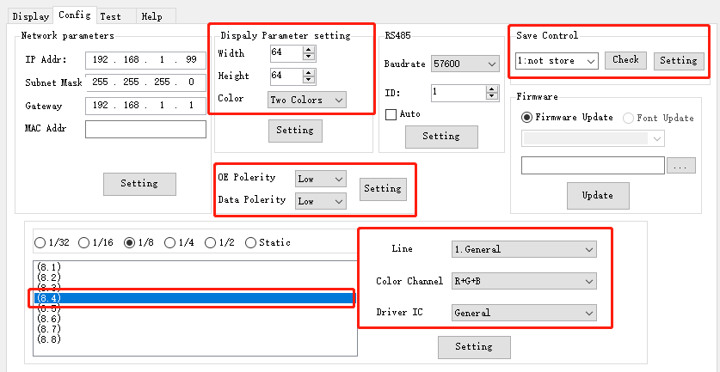

Click  to set parameters into screen

1. Go to Display, you can input content what you want, then click  to send message to screen, to check if the screen can display normal or not.

