1. **Import the alg file, no need restart.**

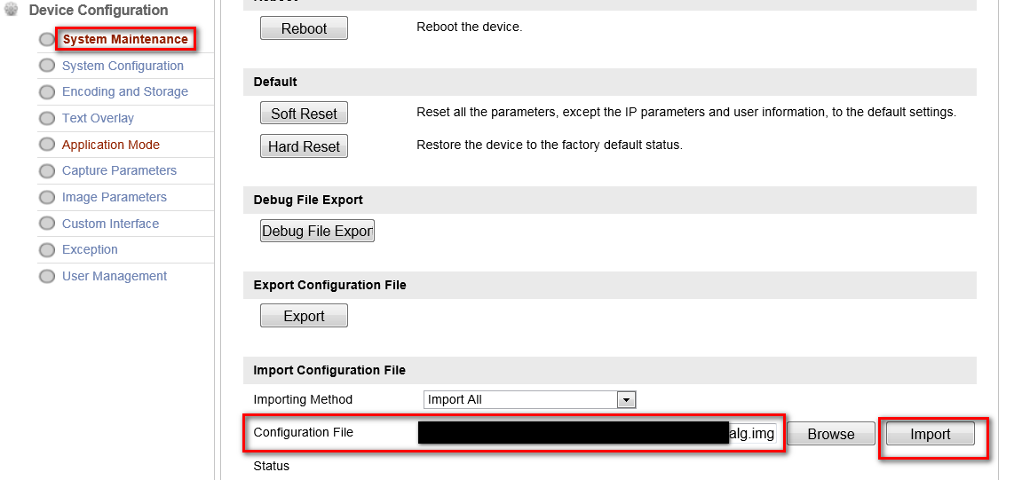

1. **Restart after upgrading the firmware.**

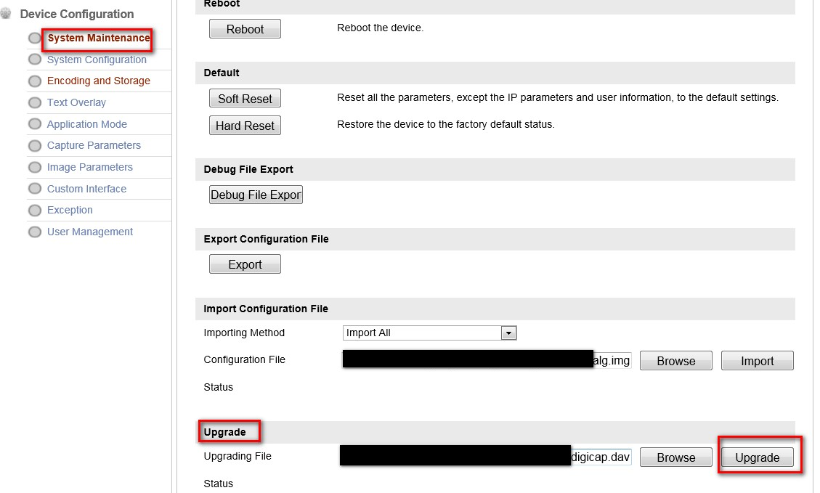

1. Check the software version, smart module status, and whether the ALG version is consistent.

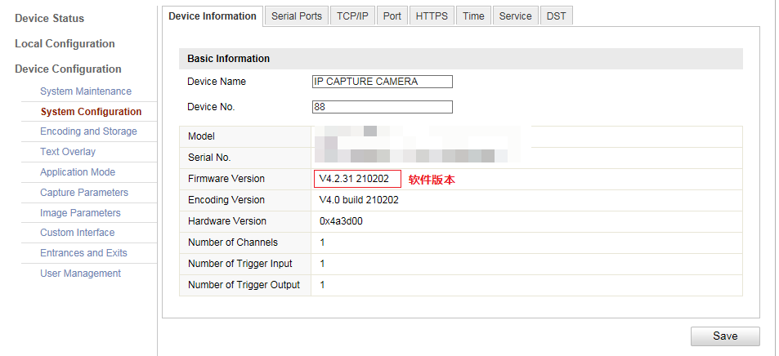

1. Restore

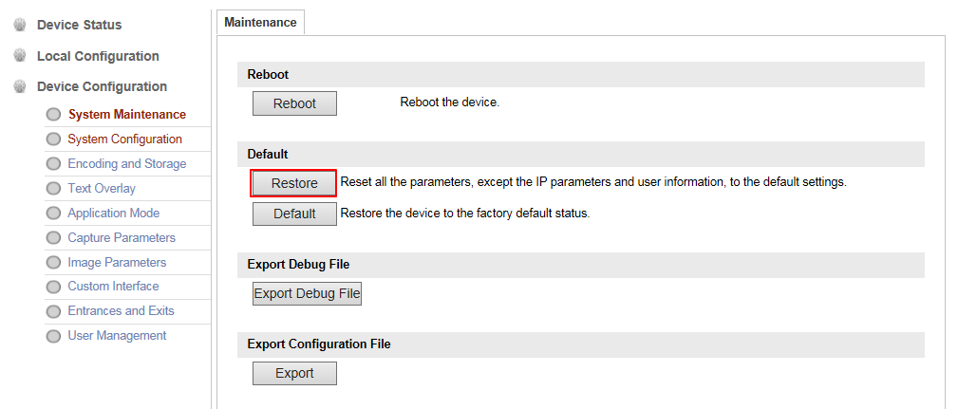

1. OSD ‘Region’

