1. Upgrade firmware

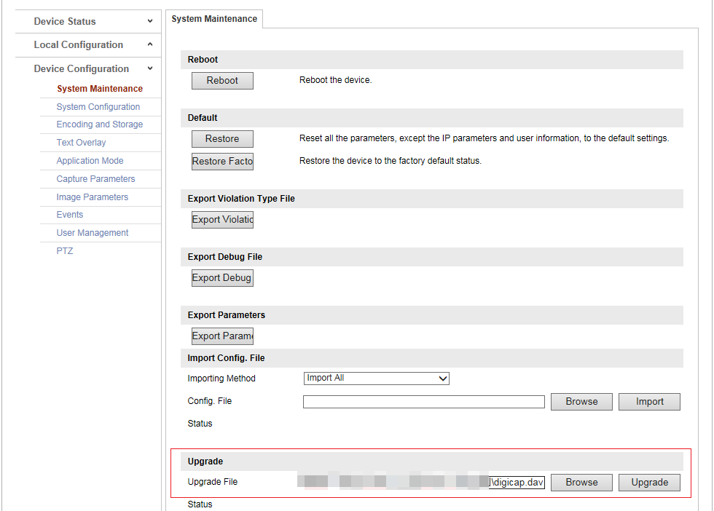

1. After the upgrade, confirm whether the ALG version number and the firmware version number are the same.

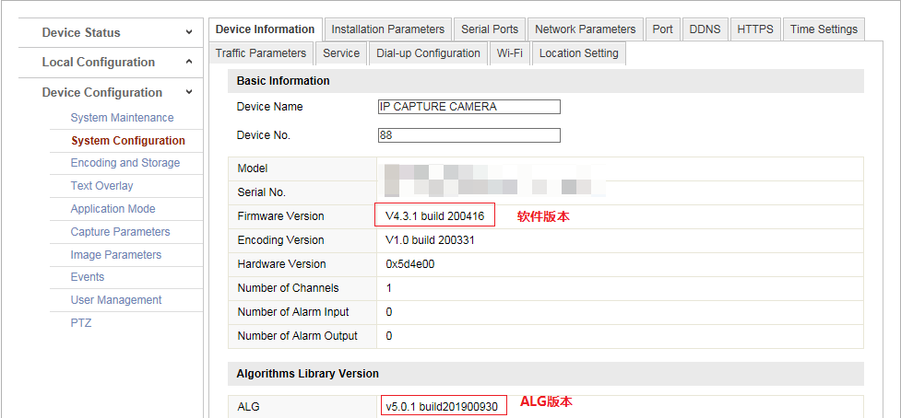

1. **Restore**

**After the camera is upgraded, it must be restore! ! !**

