1、Import the alg file (the model file is alg_xx.zip, need to unzip it as alg.img), after import do not restart!!!!!

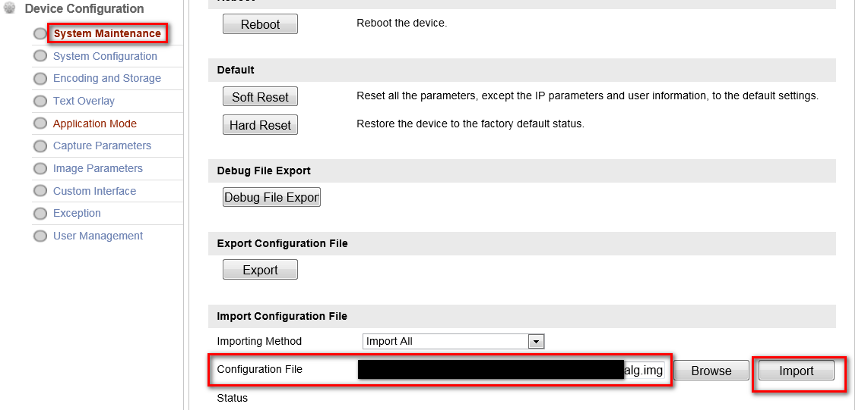

2、Restart after upgrading the firmware.

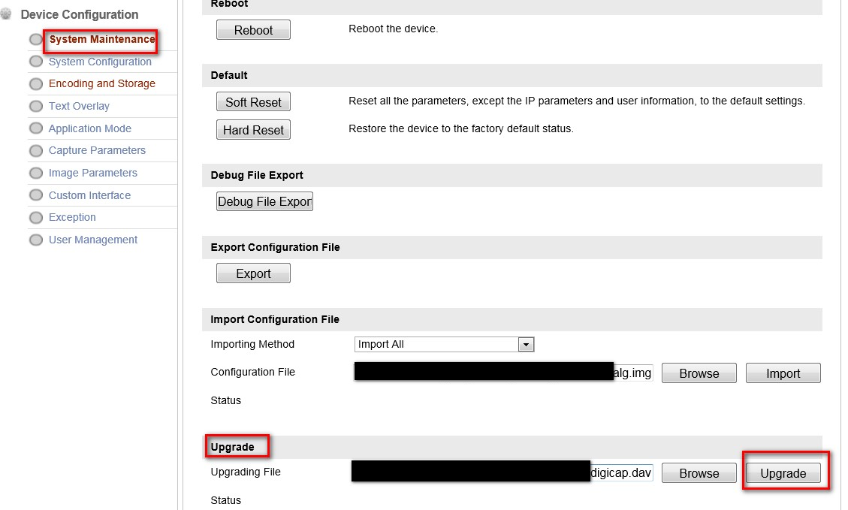

3、After the upgrade, check whether the status of the intelligent module is normal and confirm whether the version number of ALG is consistent with that of the firmware!

**4、Soft Reset**

