1. **Do Not reboot the device after importing the model file. Reboot the device after upgrading the upgrade firmware file.**

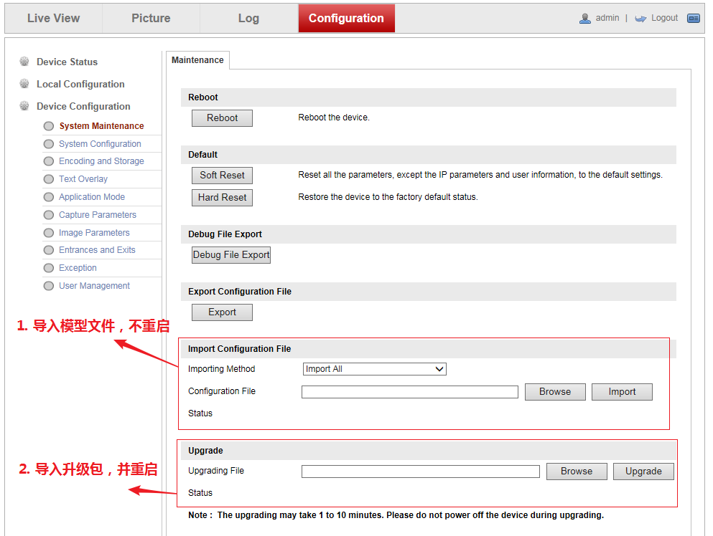

1. **Import and upgrade the firmware, then reboot the device**
2. **Import model file, do not reboot the device**
3. **Configure DYNDNS**

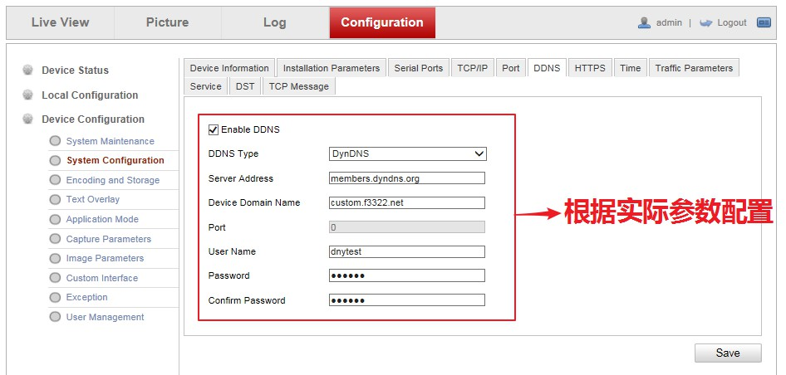

**Configure according to actual parameters**

**Note: Turning on and off DDNS requires Rebooting the device**

**Model file: ALG_V2.2.0_200604**

**Firmware file: DZP20210203131_tcm403_a_EN_STD_4.2.5_210204**