**How to get camera log**

1. Open SSH in camera(login camera and enable SSH port)
2. Open secureCRT to start log
3. Open SecureCRT

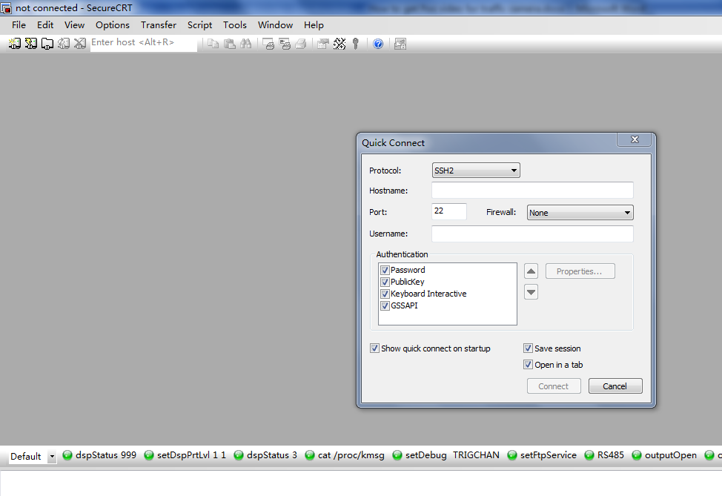

1. SSH2 connect camera(User name:admin , password: camera login password)

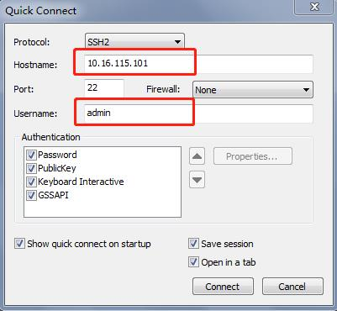

c. And click “Accept Once”

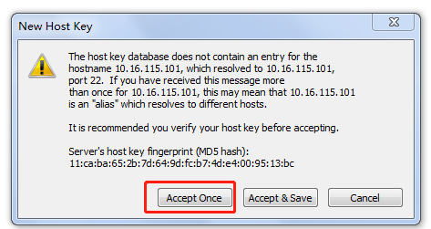

d. Input password and click OK

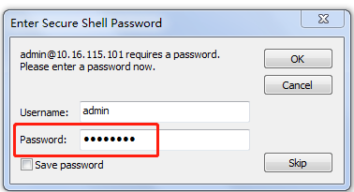

e. Then input “outputOpen” on the page

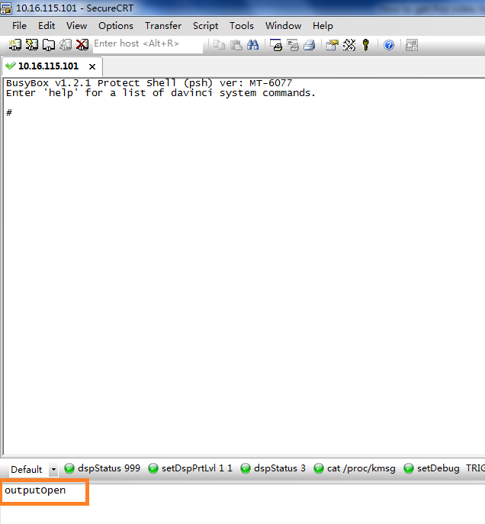

f. If response like below then input “outputClose” then input “outputOpen”

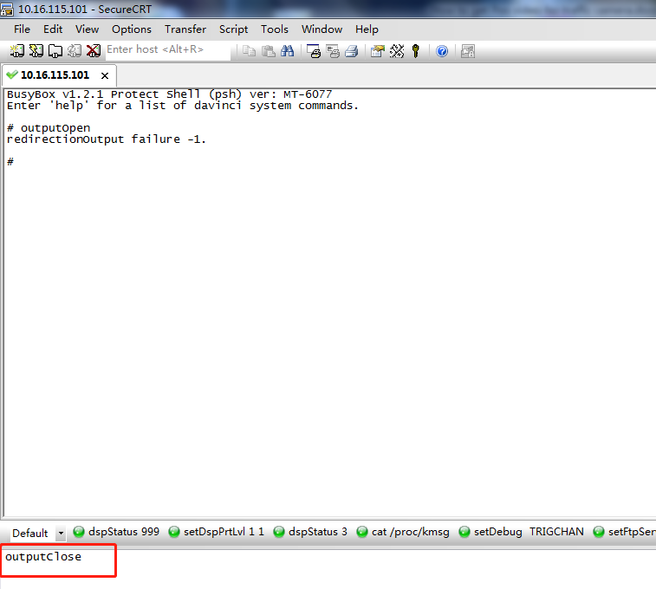

g. Then you will see the camera log

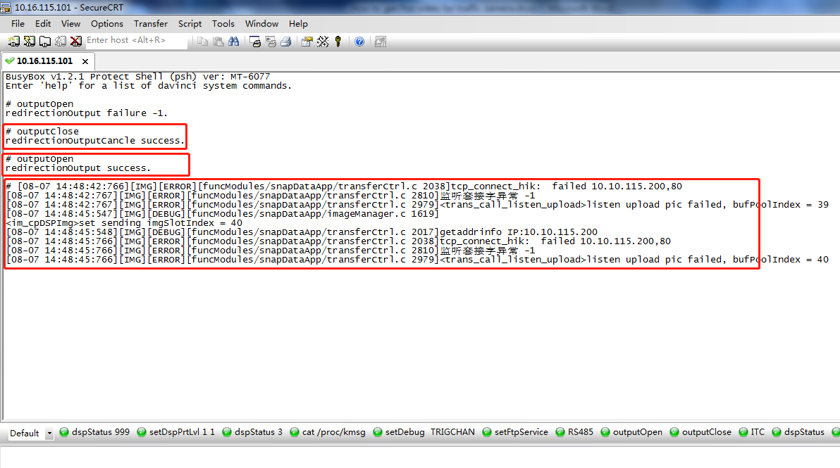

h. Save camera log.

