**How to get POS video for traffic camera**

1. Open SSH in camera(login camera and enable SSH port)
2. 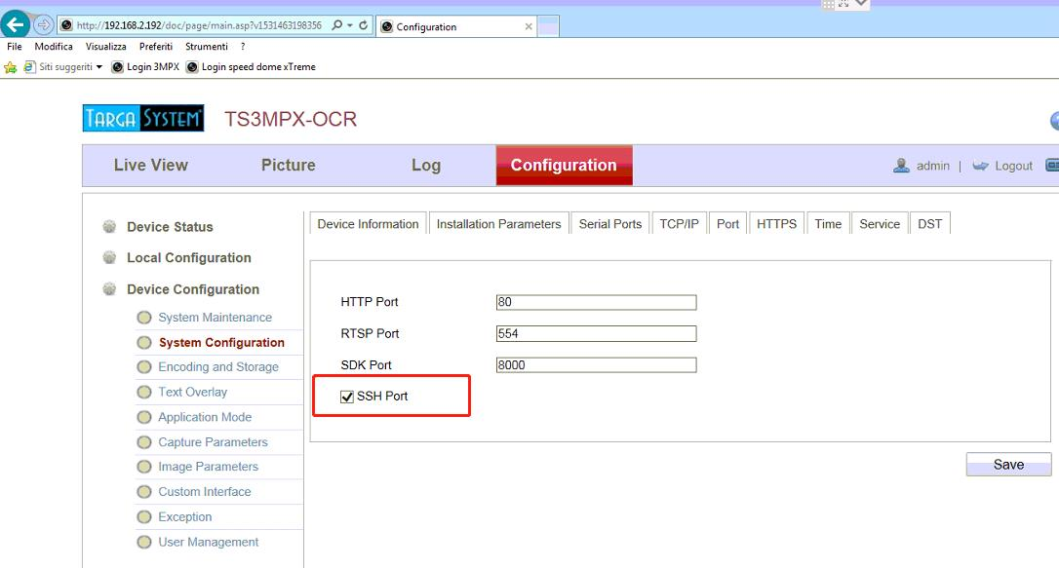Open secureCRT to start POS
3. Open SecureCRT

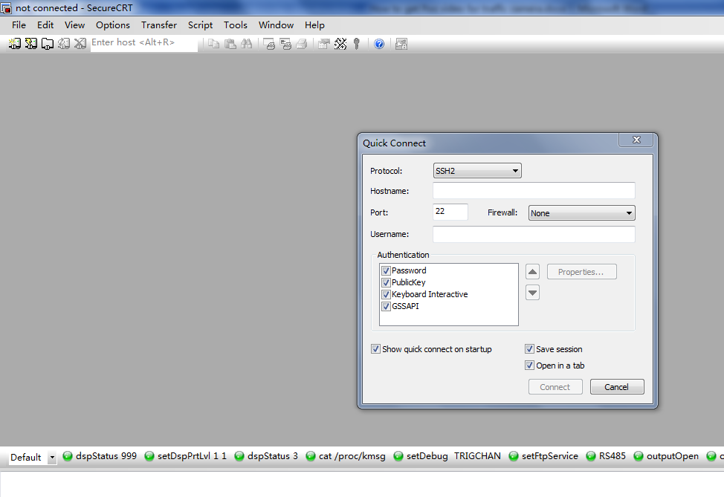

b.SSH2 connect camera(User name:admin , password: camera login password)

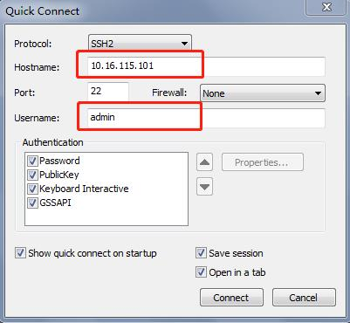

c.And click “Accept Once”

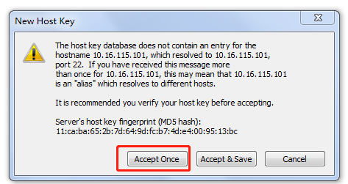

d.Input password and click OK

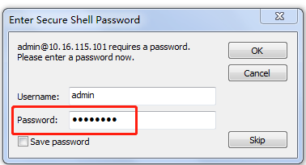

e.Then input “outputOpen” on the page

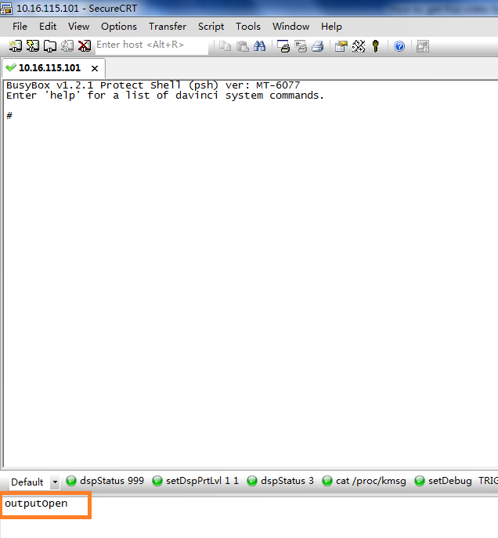

f.If response like below then input “outputClose” then input “outputOpen”

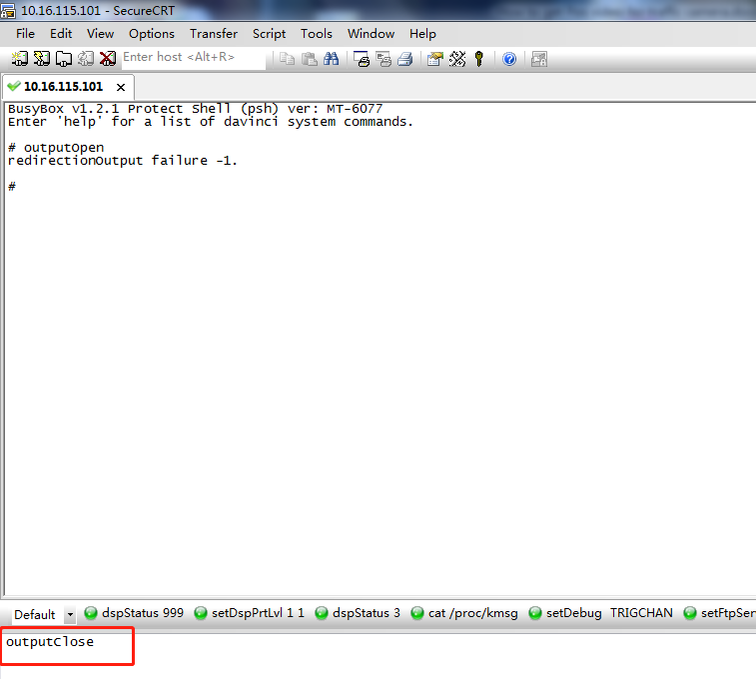

g.Then you will see the camera log

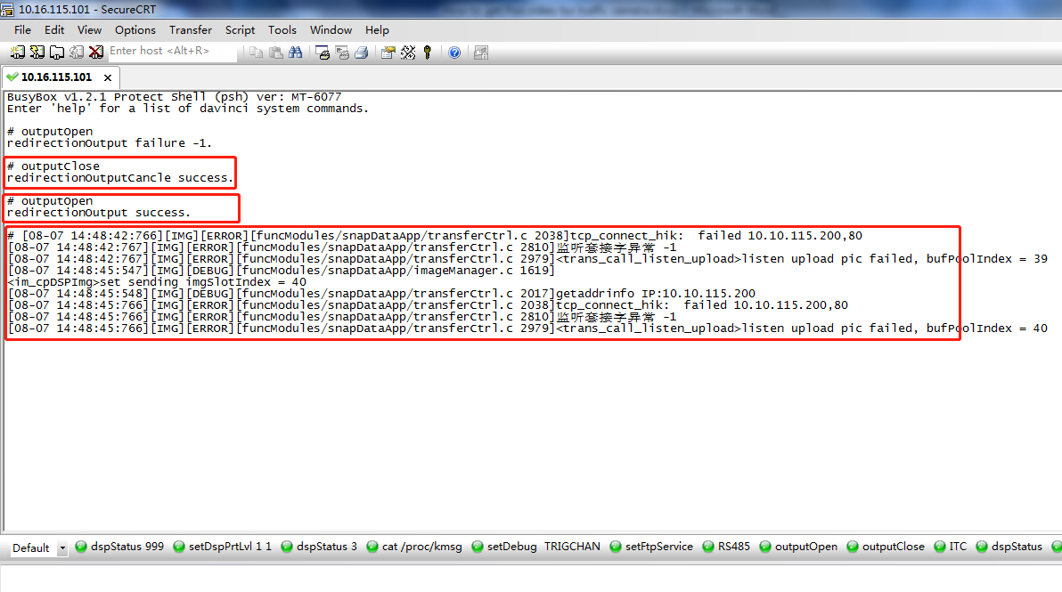

h.input “superOpt 25 1” to Open POS(“superOpt 25 0”)

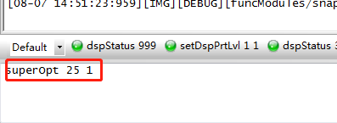

1. if response is this then it’s done

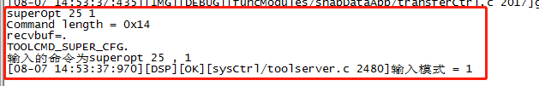

1. Open Demo to record video
2. Open Demo and click below

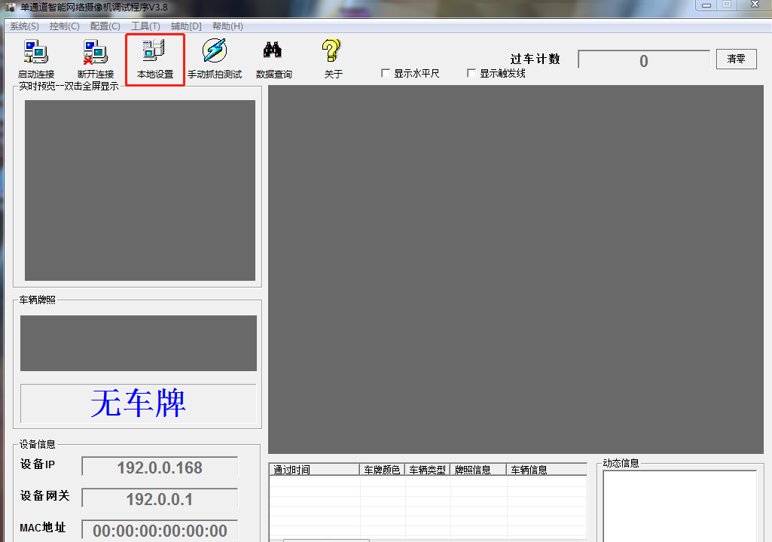

1. Input correct camera IP, user name and password then change the video and pictures saving path then click save

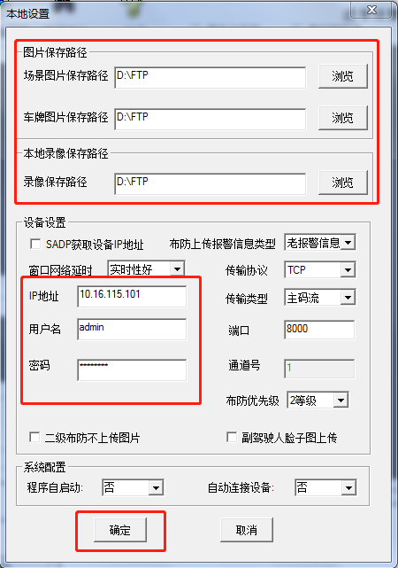

1. Click connect then it will response connection success

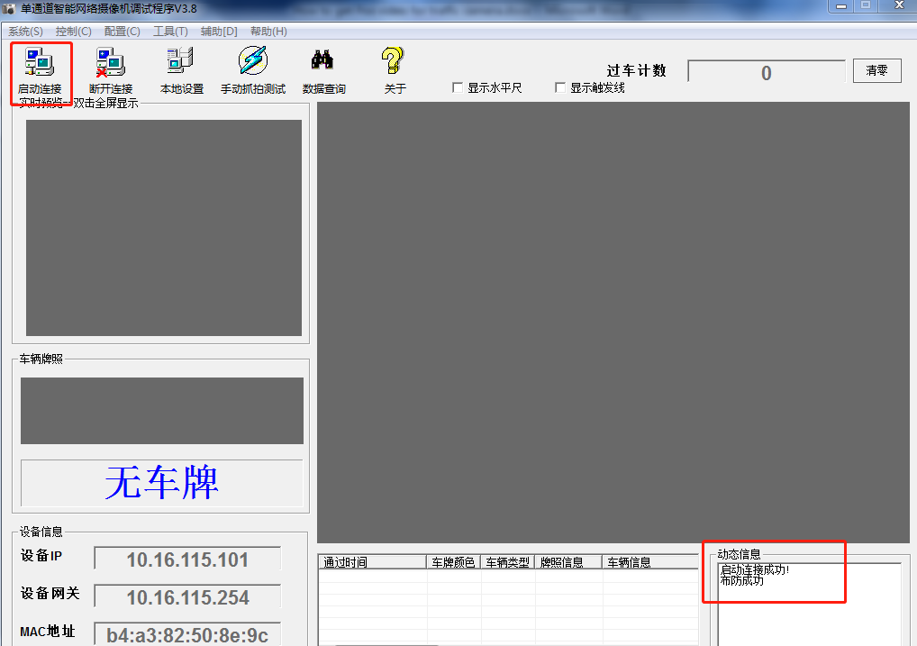

1. Start live view

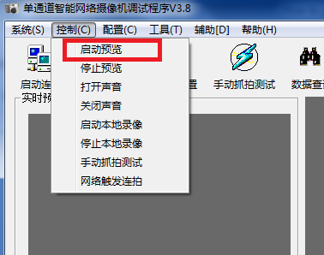

1. Camera live view is available

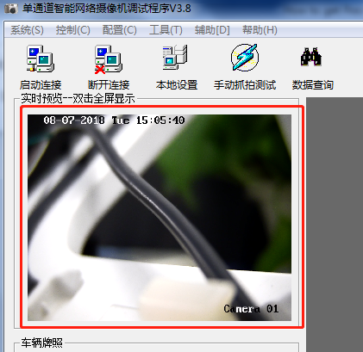

1. Click start video record and response local video record success

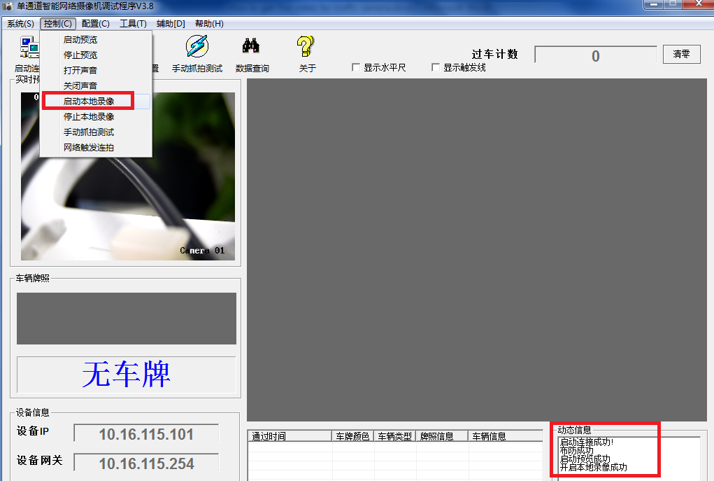

1. Check the video file in the saving path

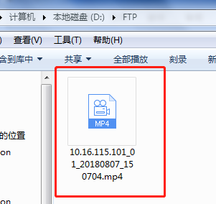

1. check video whether have POS information or not( use VSPlayer V6.1.1 to Open the video)
2. Right click in the VSPlayer and choose show POS information

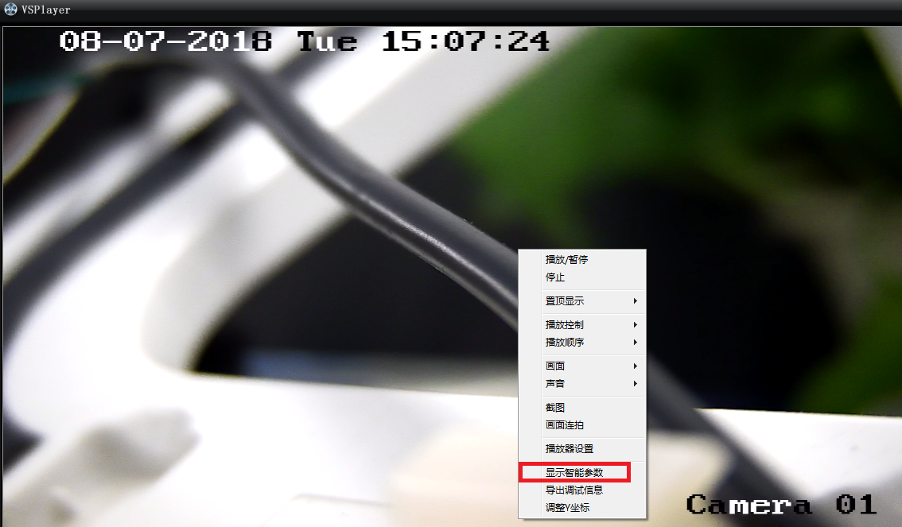

1. Then if POS is ok the video will have some information like below

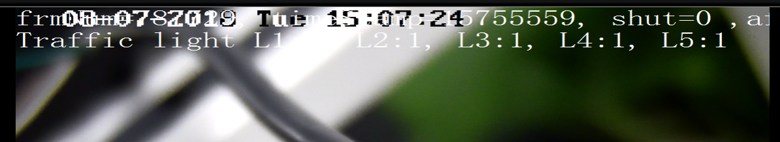

1. Use terminal server to get POS video
2. Check with R&D if both camera and terminal server support POS video
3. Use the above step 1 and 2, and download video from terminal server directly.