**How to Configure Distance Exception Function**

**Camera Installation Requirements**

1. The height of the camera needs to be in the range of 2.5 m to 6 m.

2. The tilt angle of the camera is recommended to be in the range of 25° to 60°.

3. The best detection area is within 6 m of the horizontal distance from the camera.

**Camera Configuration**

1. **Select VCA Resource.**

It is necessary to select the VCA resource as Behavior Analysis.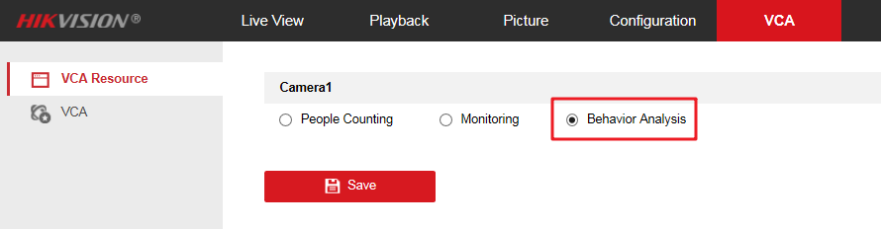

1. **Camera Calibration Configuration.**
   1. Enter 【VCA】-【Camera Calibration】and select the calibration mode. Manual Calibration and Auto Calibration are selectable.

**Auto Calibration Mode:** It will generate the lens height and a green calibration area automatically. The calibration area is used for calibrating the height from the ground to lens. So we strongly recommend to select the totally ground part as calibration area.

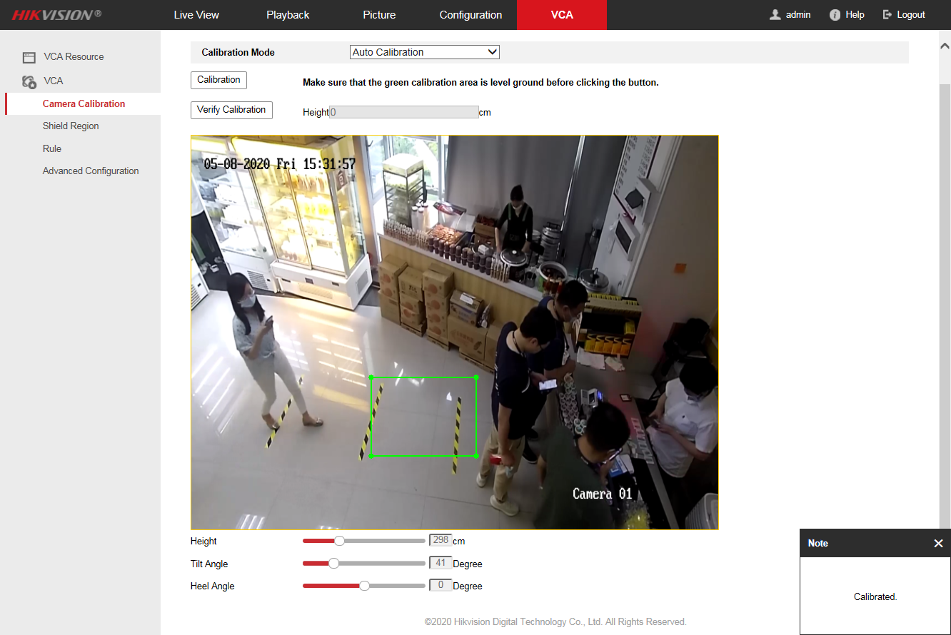

***Note:***

1. The Auto Calibration Mode is recommend.

2. The ground area where the green frame is calibrated should be free of reflections and backlighting. If there is a case of reflective backlighting or less texture, it is recommended to lay a rich texture such as a newspaper for calibration to improve the accuracy of the calibration.

**Manual Calibration Mode**: Input the Lens height (the height from Entry/Exit area to the camera), Tilt Angle and Heel Angle manually. To increase the success rate of the manual calibration, make sure the lens height is the true value in vertical direction between the lens and the ground.

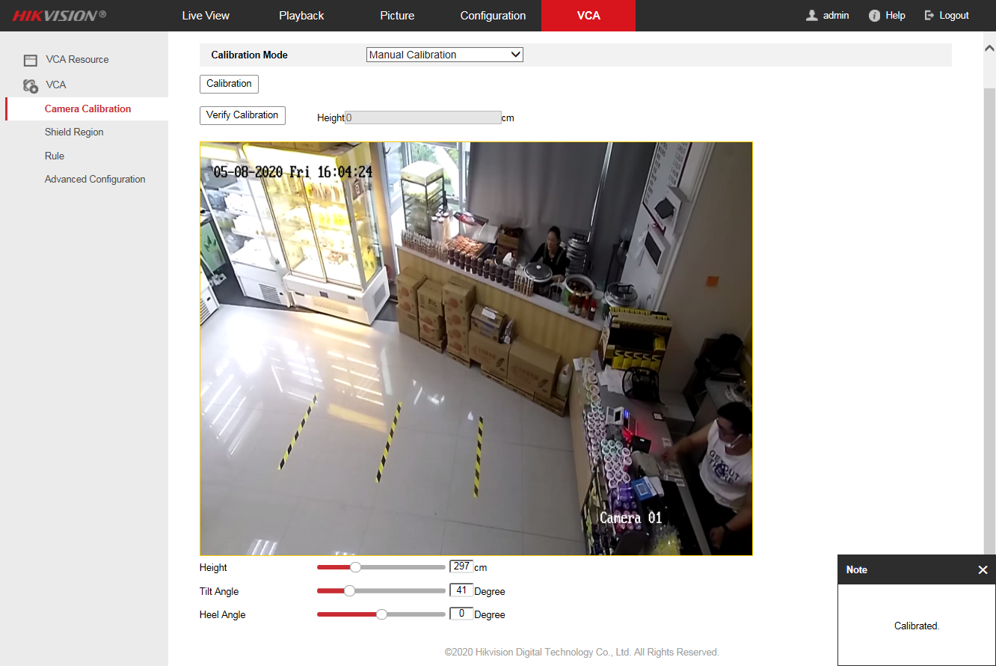

* 1. Click “Calibration”. The blue area is for detection. A prompt “Calibrated” will automatically appear in the lower right corner.

***Note:***

1. If auto calibration fails, please check whether the ground is selected as the calibration area.

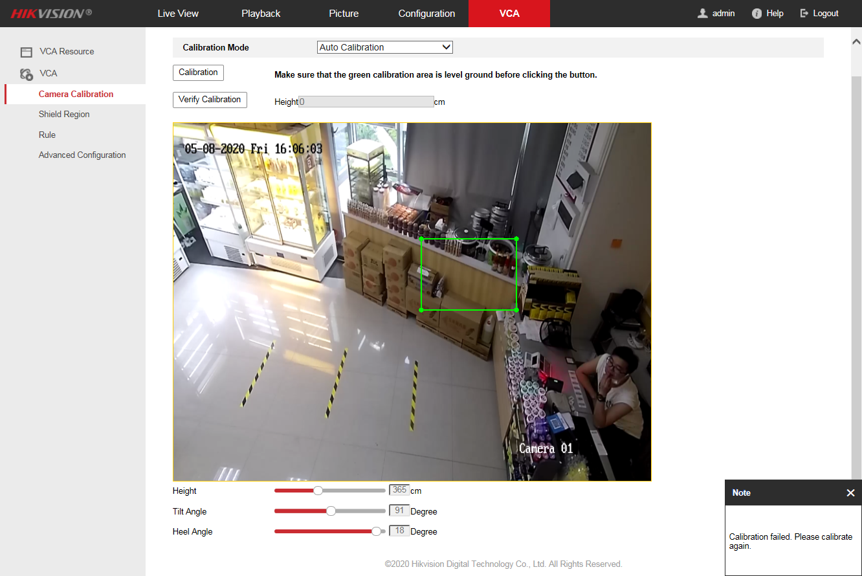

2. It is recommended to keep the Mirror off, otherwise it will cause calibration error.

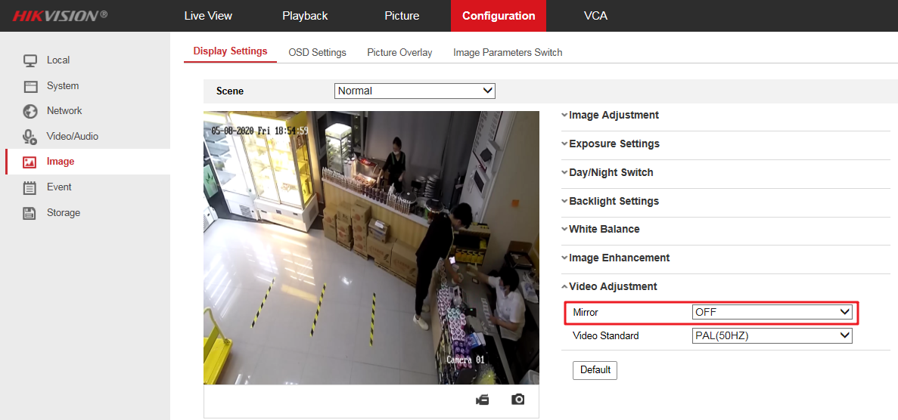

* 1. After the calibration is finished, you can click “Verify Calibration” to obtain the height of the clicked position by clicking the image on the screen, which can verify the accuracy of the calibration.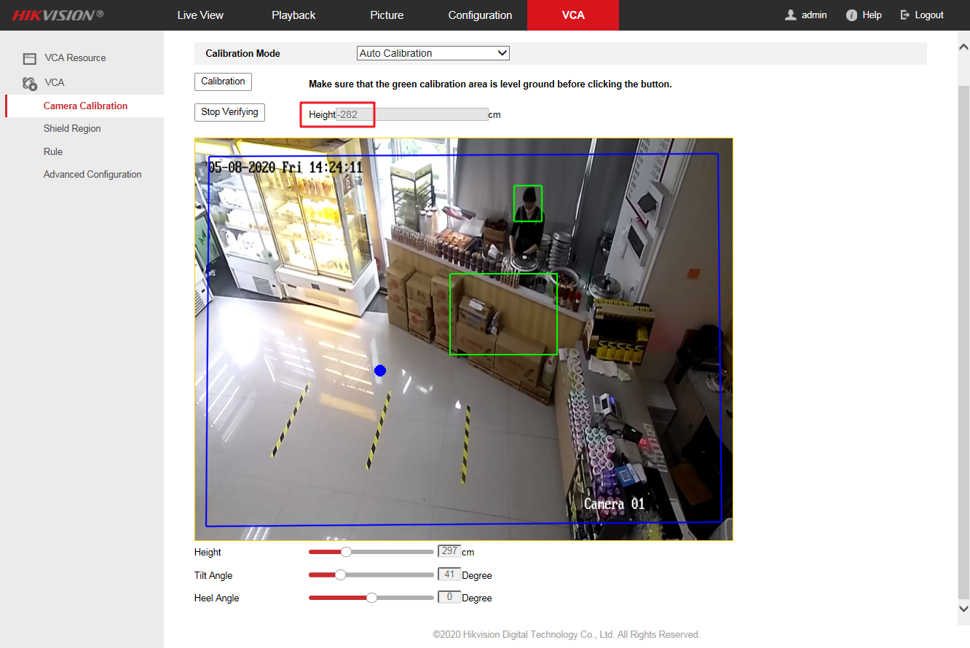

1. **Rule Configuration.**
   1. Enter 【VCA】-【Rule】and click the plus sign in the upper right corner of the interface to add a rule. Enable the rule, set the rule name and choose the rule type as Distance Exception.
   2. Set “Duration”, “Mode” and “Distance Threshold”. The device can trigger the alarm of the corresponding rule by judging the distance between any two people in the rule area.

**Example:** You need to receive the alarm in 2s when the distance between the two is less than 1 m. You can set the “Duration” to 2s, the “Distance Threshold” to 1 m and select “Less than” for the “Mode”.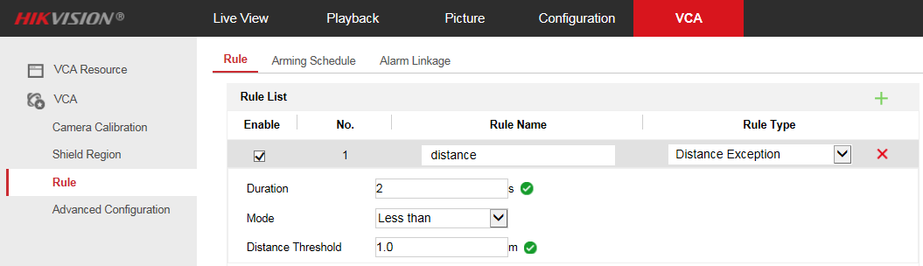

* 1. Click  to draw the rule area, click the left mouse button on the preview image to draw the end points of the rule area, and the click the right mouse button to complete the drawing. If you need to redraw the rule area, click  again.

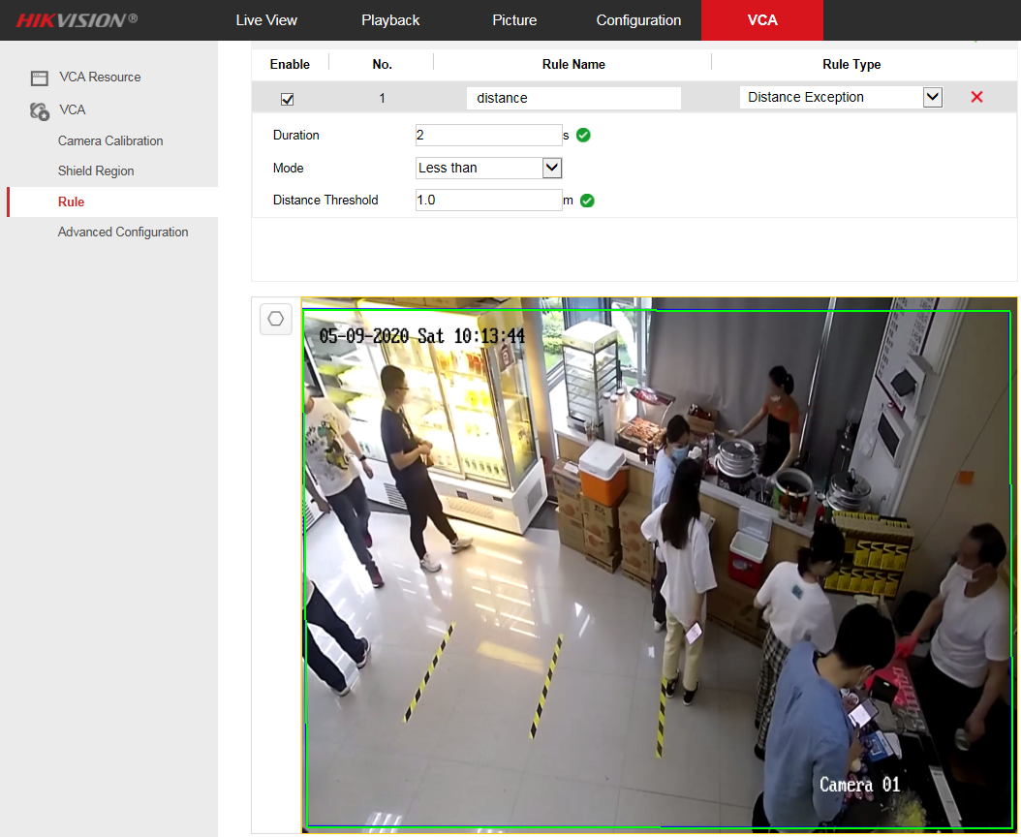

***Note:***

The rule area need not only include the ground area, but also include the area covered by the standing state of the person. If the rule area is drawn like the picture below, the alarm will not be triggered.

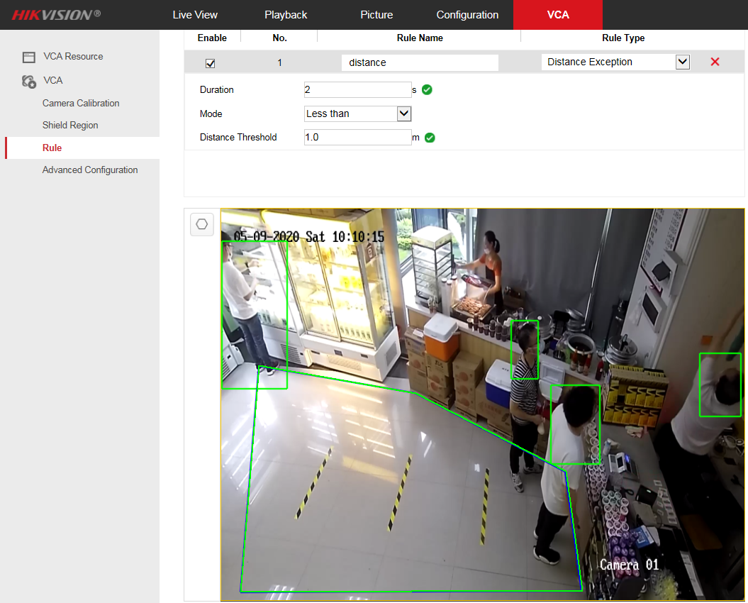

* 1. Click Arming Schedule and select the rule that needs to set arming time, click the arming time period, you can adjust the arming time of the rule. If you need to set the same arming time at other times, click the green copy button on the right side of the timeline. Multiple arming time periods can be set in one day.

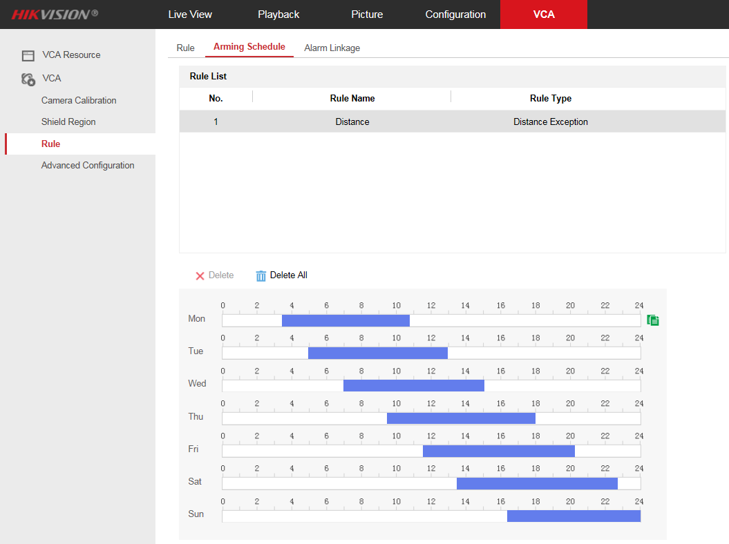

* 1. Click Alarm Linkage and set the linkage mode according to the requirements of smart rules. The linkage mode includes “Normal Linkage”, “Trigger Alarm Output”, “Trigger Recoding”.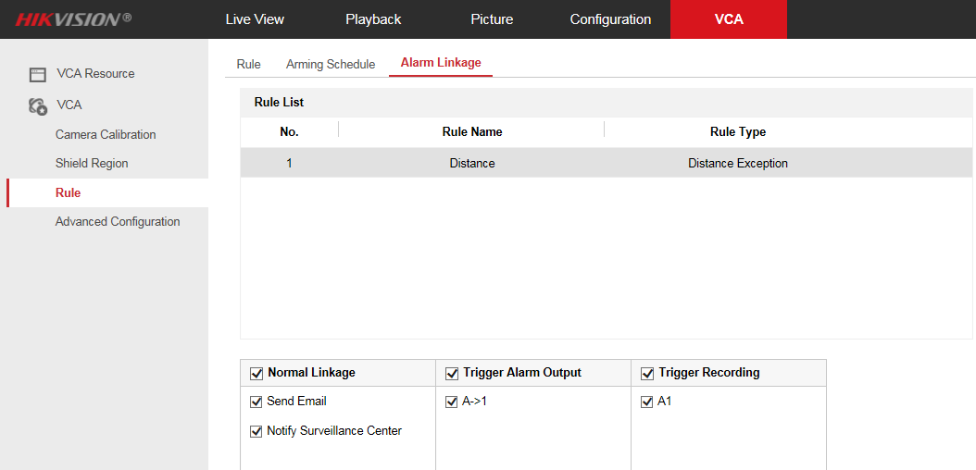

1. **Shield Region Configuration.**
   1. Enter 【VCA】-【Shield Region】and click  to draw the mask area of the polygon frame (3-10 sides), the smart rules set on the device are invalid for the mask area.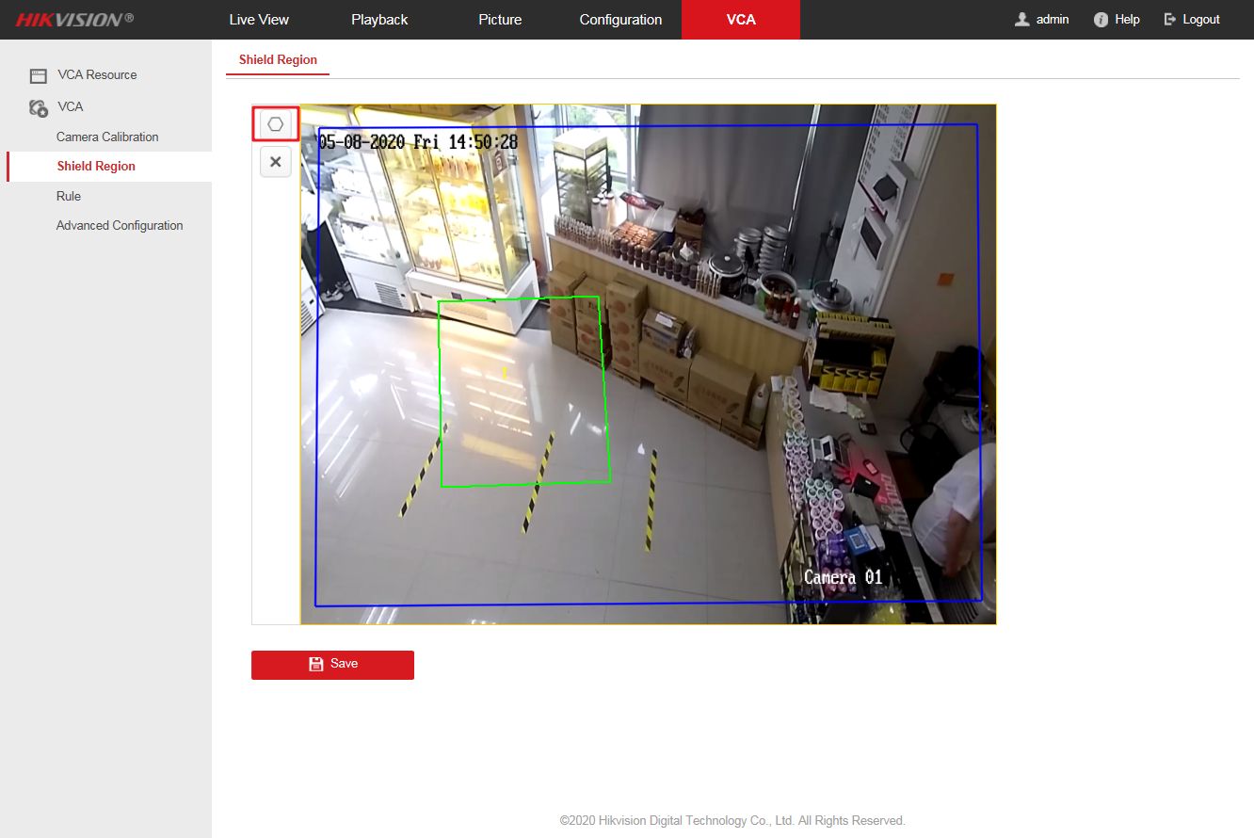
   2. Click  to clear the currently drawn mask area.

**First Choice for Security Professionals**

***HIKVISION* Technical Support**