|  |  |
| --- | --- |
| **DS-MCW405 Series**  **Body Camera** | |
|  | |
|  | |  |  |  | | --- | --- | --- | | D:\01-项目\2019\spec-icon-red\H.265.png | D:\01-项目\2019\spec-icon-red\IR.png | D:\01-项目\2019\spec-icon-red\IP67.png | | **H.265** | **IR** | **IP67** | | D:\01-项目\2019\spec-icon-red\Compact Size.png | D:\01-项目\2019\spec-icon-red\Front Record Button.png | D:\01-项目\2019\spec-icon-red\Long Battery Life.png | | **Compact Size** | **Front Record Button** | **Long Battery Life** | |

|  |
| --- |
| **Introduction** |
| DS-MCW405 series body camera highly integrates with record, local storage, IR night vision, wireless transmission, GPS, central management, etc. It is small and light, convenient to carry, and can be operated with one hand. It is widely applicable to public security protection, city management, industry and commerce, etc. |
| **Key Feature** |
| * 1080p HD record. * Supports GPS, and the position information can be uploaded to the command center in real time. * Supports IR night vision. Even in low illumination condition, the facial characteristics in recorded video are clear. * Waterproof, dustproof, and 2 m fall protection height, adaptable to all weather field operation. * Accessible of Wi-Fi. * Support tag button to mark event record. * Support date & time in video recordings. * The Body camera wearer cannot access view or delete any recordings directly from the device, or Video Manager without appropriate authorization. * Body camera does not appear as a USB storage device, and cannot receive files whilst connected to a Wi-Fi network.   **Note:**  The functions vary with different models. The actual product prevails. |
| **Available Model** |
| DS-MCW405 |

|  |  |
| --- | --- |
| **Specification** | |
|  | |
| ***System*** | |
| Operating System | Linux |
| ***Sensor*** | |
| Type | 1/3″ CMOS |
| Operation Sensitivity | 0.2 lux |
| FOV (field of view) | 140° |
| ***Video Parameter*** | |
| Video Compression | H.264/H.265 |
| Video Resolution | 1920 × 1080, 1280 × 720, 720 × 576 |
| Main Stream | 1080p/25 fps |
| Sub-Stream | 720p/25 fps |
| Video Format | .mp4 |
| Shutter | Digital shutter |
| Day & Night | IR cut filter with auto switch Range 5m |
| White Balance | Auto |
| Flashing Light | Supported |
| Pre-record & Post-record | Pre-record: 60 s Post-record: 60 s |
| ***Audio Parameter*** | |
| MIC | Built-in |
| Pre-record audio | ON/OFF Setup |
| ***Storage*** | |
| Recording Capacity | Max. 256 GB |
| ***Positioning*** | |
| Satellite Positioning | Built-in GPS module |
| ***Network Transmission*** | |
| Wi-Fi | 802.11b/g/n ((2.4GHz & 5GHz)) |
| ***General*** | |
| Working Temperature | -20 °C to +55 °C (-4 °F to +131 °F) |
| Working Humidity | ≤ 90% |
| Ingress Protection Level | IP67 |
| Dimension  (L × W × H) | 82.6 × 58 × 29 mm (3.3 × 2.3 × 1.1 inch) |
| Weight | 154 g (0.4 lb.) |
| ***Others*** | |
| Buttons | Power switch, record button, tag button,  LED record button |
| Vibration Motor | Supported |
| Indicator | 2 indicators |
| USB Interface | Mini USB 2.0 |
| Charging | Charging via USB interface |
| Battery | Integral battery  Lithium-Polymer battery  Typically Battery Recharging Times less than 8h  Up to 12 hours in 720p resolution and 10 hours in 1080p resolution. |
| **Note:**   * Battery life is affected by environment and device configuration. * 12-hours working time depends on 720p video resolution, disabled functions including Wi-Fi, GPS, IR, and 25 °C environment temperature. * 10-hours working time depends on 1080p video resolution, disabled functions including Wi-Fi, GPS, IR, and 25 °C environment temperature. | |

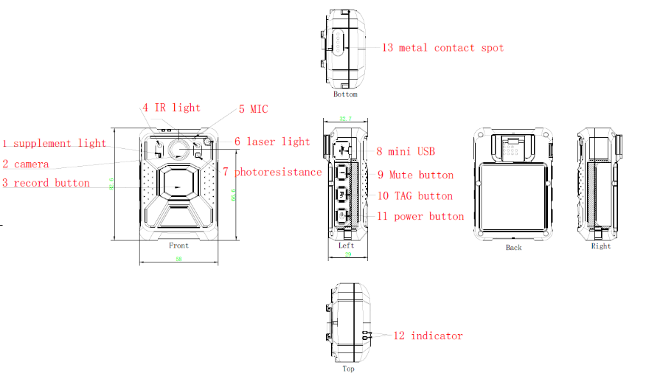 **Dimension**

|  |  |  |  |  |  |  |
| --- | --- | --- | --- | --- | --- | --- |
| |  |  | | --- | --- | | **Accessories** | | |  | | | **Chest fixed-shoulder harness accessories**  Other mounting accessories are available. | **Uniform racket accessories** | |

Unit: mm

Unit: mm