**BatchConfigTool V3.0.2.5** **Build20190307**

**Release Notes**

**(2019-03-18 )**

**V3.0.2.5 Key Updates**

1. Fixed the issue that accessing a device web client through batch configuration tool failed when the HTTP port was not 80;

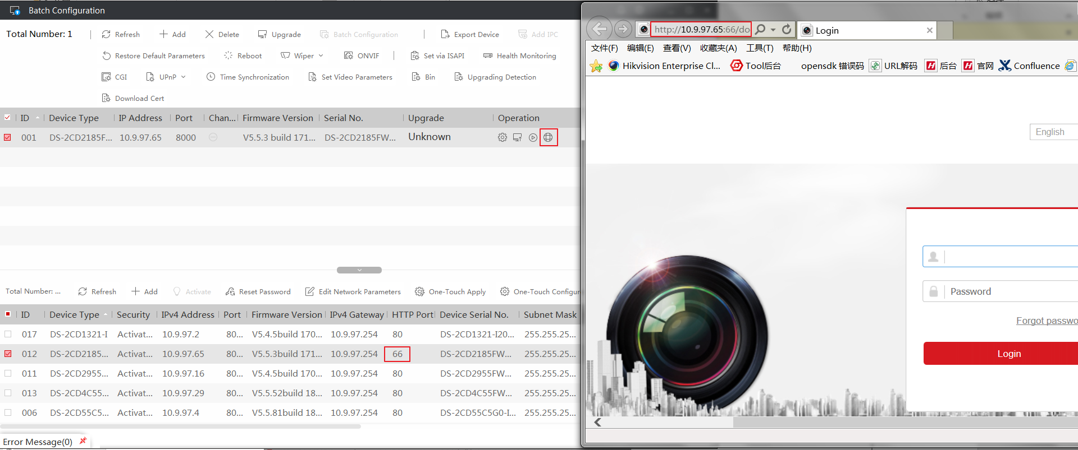

1. Fixed the issue that missing MSVCP.dll file caused the tool to fail to start.

