**BatchConfigTool for Mac V3.0.2.3** **Build20190110**

**Release Notes**

**(2019-01-11 )**

**V3.0.2.3 Key Updates**

1. Fixed the issue that the character “::” is unavailable for IPV6 address.

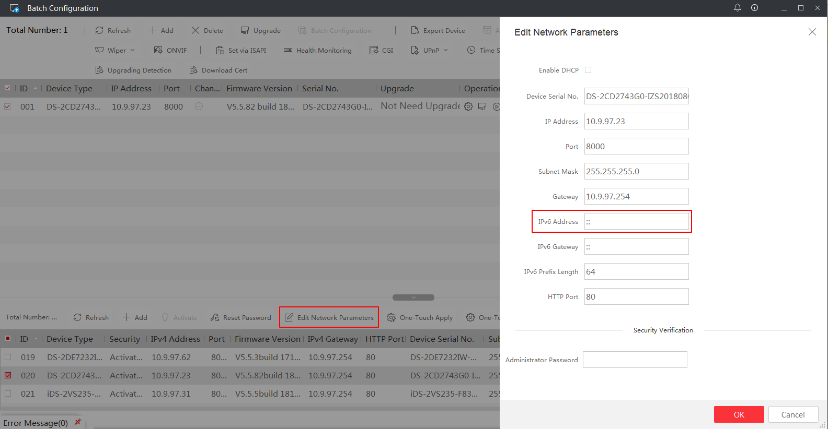

1. The Complete Restoration and Part Restoration function have been removed from the upgrade interface.

