Thermal design tool

Release Notes

(2022-07-13)

General Information:

Compatible with Chrome, Edge, Firefox.

Website linkage: <https://tools.hikvision.com/#/lensSelection-thermal>

Operation Guide: https://youtu.be/1x-r-L5bWlU

**New Features:**

1. Newly add the new released cameras as below:

|  |  |  |
| --- | --- | --- |
| DS-2TD1217-2/QA | DS-2TD1217-3/QA | DS-2TD1217-6/QA |
| DS-2TD2617-3/QA | DS-2TD2617-6/QA | DS-2TD2617-10/QA |
| DS-2TD2637-7/QY | DS-2TD2637-10/QY | DS-2TD2637-15/QY |
| DS-2TD2637-25/QY | DS-2TD2637-35/QY | DS-2TD2137T-4/QY |
| DS-2TD2528T-3/Q | DS-2TD2528T-7/Q | DS-2TD2528T-10/Q |
| DS-2TD2537T-10/Q | DS-2TD2537T-15/Q | DS-2TD4228T-10/W |
| DS-2TXS2628-3P/QA/GLT/CH30S80 | DS-2TXS2628-7P/QA/GLT/CH30S80 | DS-2TXS2628-10P/QA/GLT/CH30S80 |
| DS-2TD4137-25/W(B) | DS-2TD4137-50/W(B) | DS-2TD4167-25/W(B) |
| DS-2TD4167-50/W(B) | DS-2TD4137T-9/W(B) | DS-2TD4137T-25/W(B) |
| DS-2TD4167T-9/W(B) | DS-2TD4167T-25/W(B) | DS-2TD5537T-7/W |
| DS-2TD5537T-15/W | DS-2TD2637T-7/QY | DS-2TD2637T-10/QY |
| DS-2TD2637T-15/QY |  |  |

1. Newly add ‘Camera-Name’ column inside PDF report, it helps to match the camera inside device list and map.

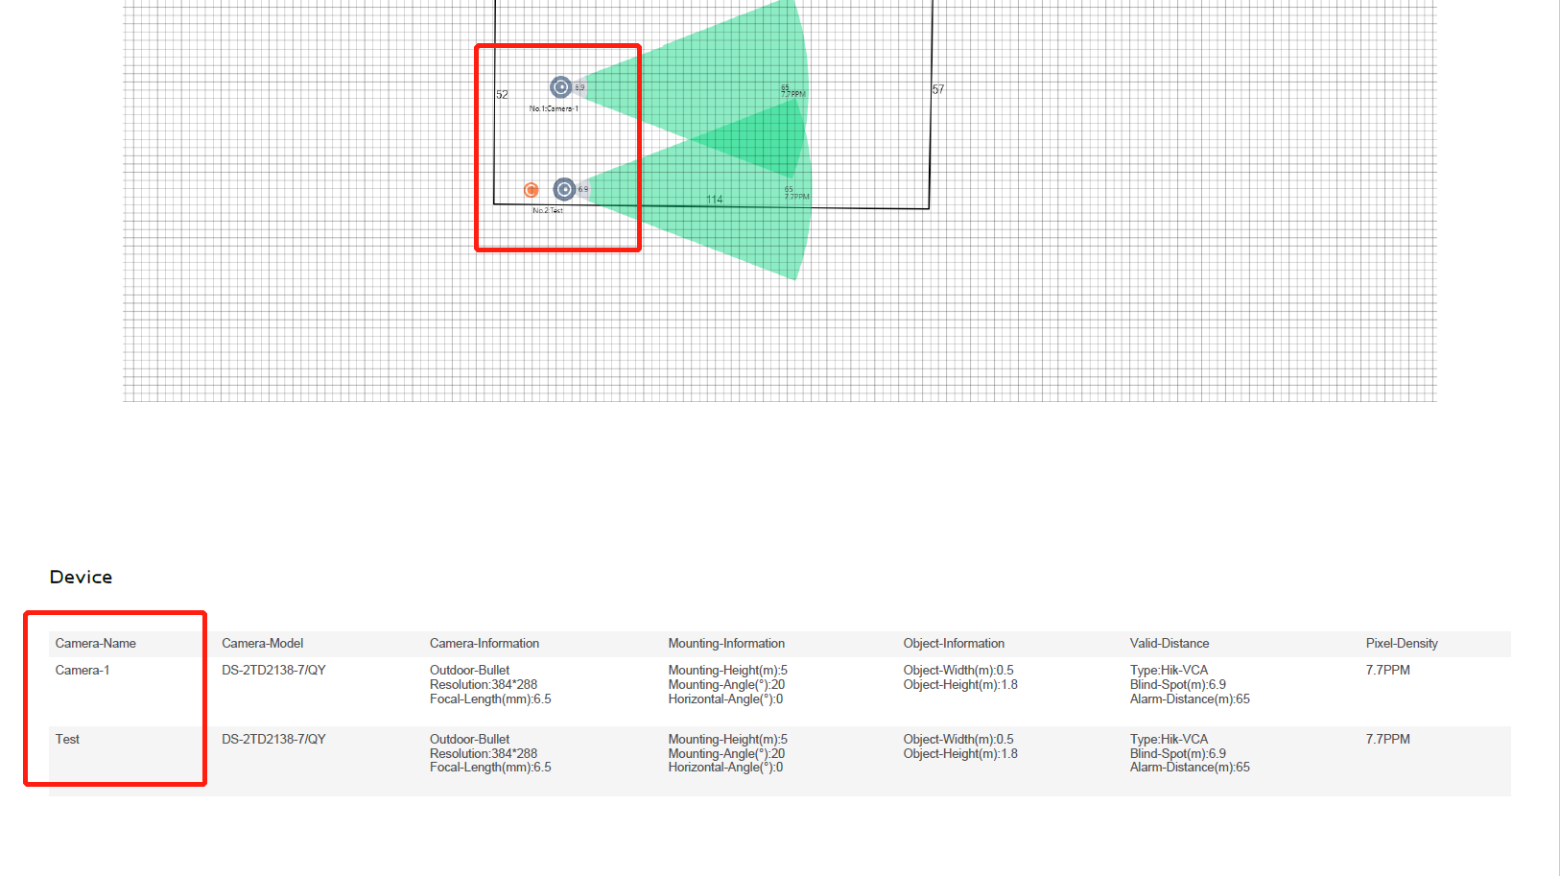

1. Newly add ‘Total’ module to show all the camera and quantities in general.

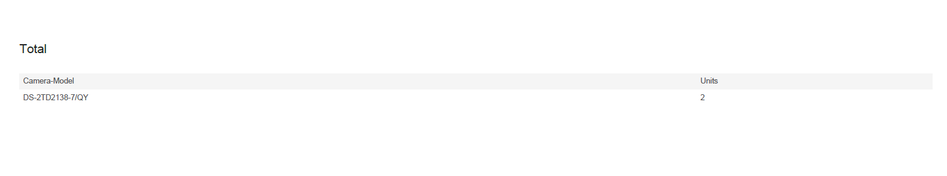

1. Newly support ‘Boat Detection’ inside custom mode. Input the height of the boat to get the detection range.

Note: If Alarm Distance is smaller than Max Distance, it can adjust the mounting angle to get further distance.

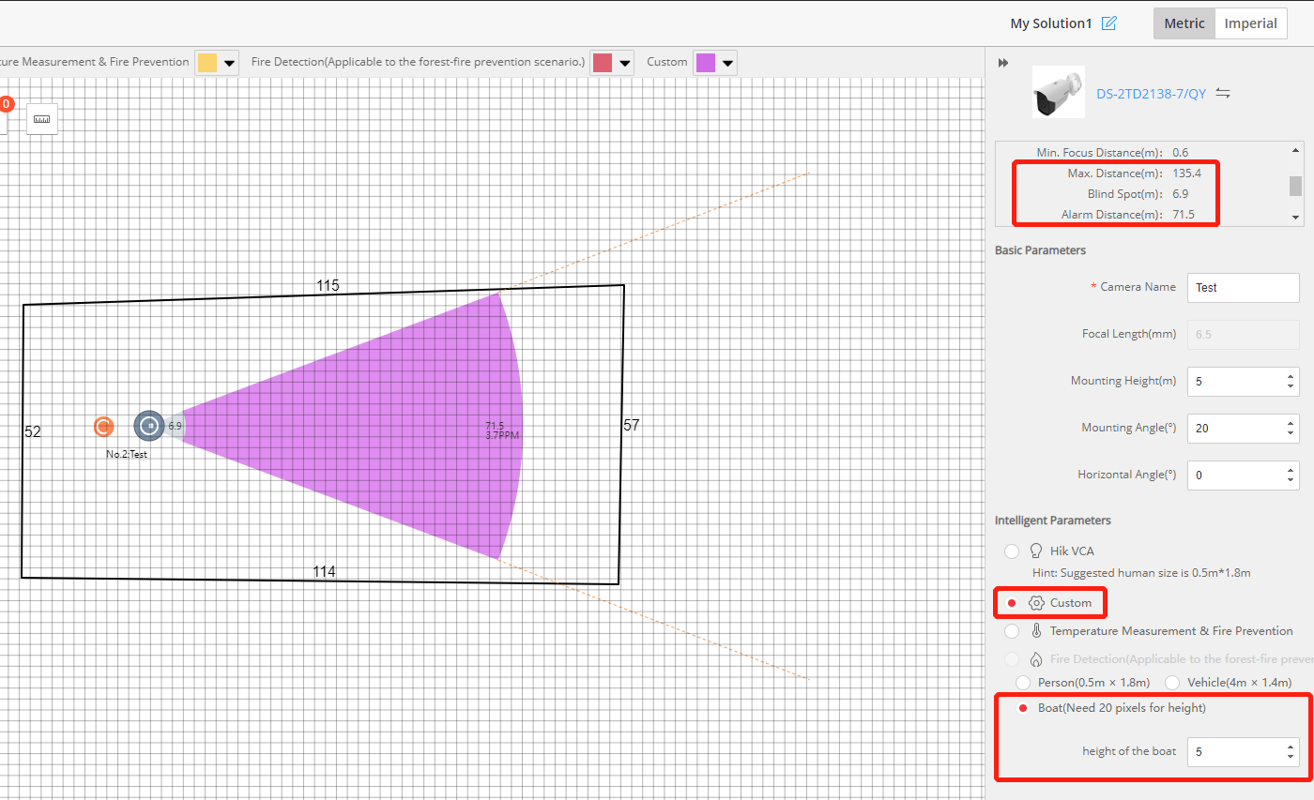

1. Newly add language ‘Portuguese’.

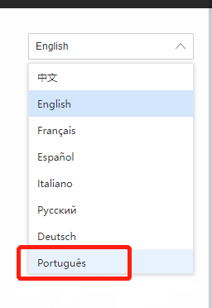

1. Newly support to copy text from PDF report directly.
2. General update for thermal cameras.

Remove very old cameras from the database as in below:

|  |  |  |
| --- | --- | --- |
| DS-2TD2136T-xx | DS-2TD2166T-xx | DS-2TD2336-xx |
| DS-2TD2366-xx | DS-2TD2466-xx | DS-2TD2466T-xx |
| DS-2TD2636-xx | DS-2TD4136T-xx | DS-2TD4166T-xx |
| DS-2TD6236T-xx | DS-2TD2136-xx | DS-2TD2166-xx |
| DS-2TD2137-7/V1 | DS-2TD1217-xx/V1 | DS-2TD2117-xx/V1 |
| DS-2TD2617-xx/V1 | DS-2TD2137-xx/V1 | DS-2TD2166-xx/V1 |
| DS-2TD4136-xx | DS-2TD4166-xx | DS-2TD6236-xx |
| DS-2TD6266-xx | DS-2TX3636-xx | DS-2TD2836-xx |
| DS-2TD2866-xx |  |  |

Add ‘EOL’ inside model name for recently discontinued models as in below:

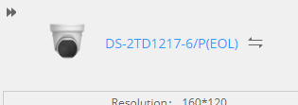

|  |  |  |
| --- | --- | --- |
| DS-2TD6266T-xx | DS-2TD2137-xx/PY | DS-2TD2137-xx/P |
| DS-2TD2137-xx/PI | DS-2TD2167-xx/P | DS-2TD8166-xx |
| DS-2TD1117-xx/PA | DS-2TD1217-xx/PA | DS-2TD2117-xx/PA |
| DS-2TD2617-xx/PA | DS-2TD1117-xx/P | DS-2TD1217-xx/P |
| DS-2TD2117-xx/P | DS-2TD2617-xx/P | DS-2TD2617-xx/PI |
| DS-2TD2617-xx/PAI | DS-2TD2117-xx/PI | DS-2TD2117-xx/PAI |
| DS-2TA21-xx | DS-2TD1217T-xx/PA | DS-2TD2617T-xx/PA |

Note: DS-2TD2137-4/PY is still available.

**Optimizations:**

1. Optimize the transparency of smart function area in map, default at 50% transparency in order to have continuity and visibility of the map.

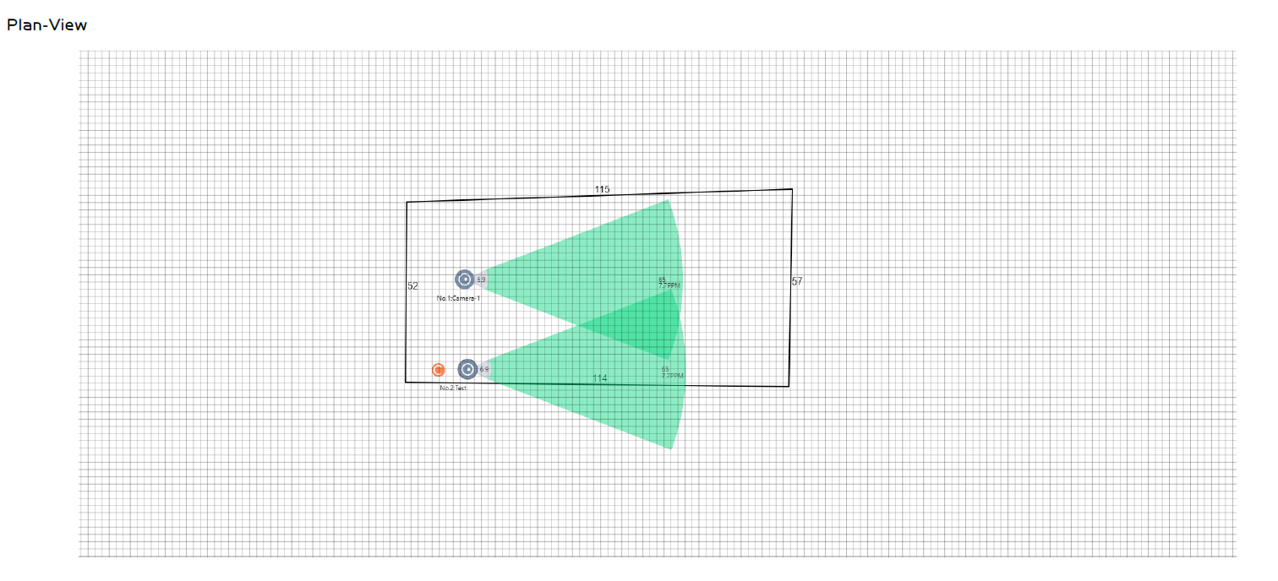

1. Fix the max distance display bug on Custom.
2. PT & dome presets are no longer automatically copied from one model to another.

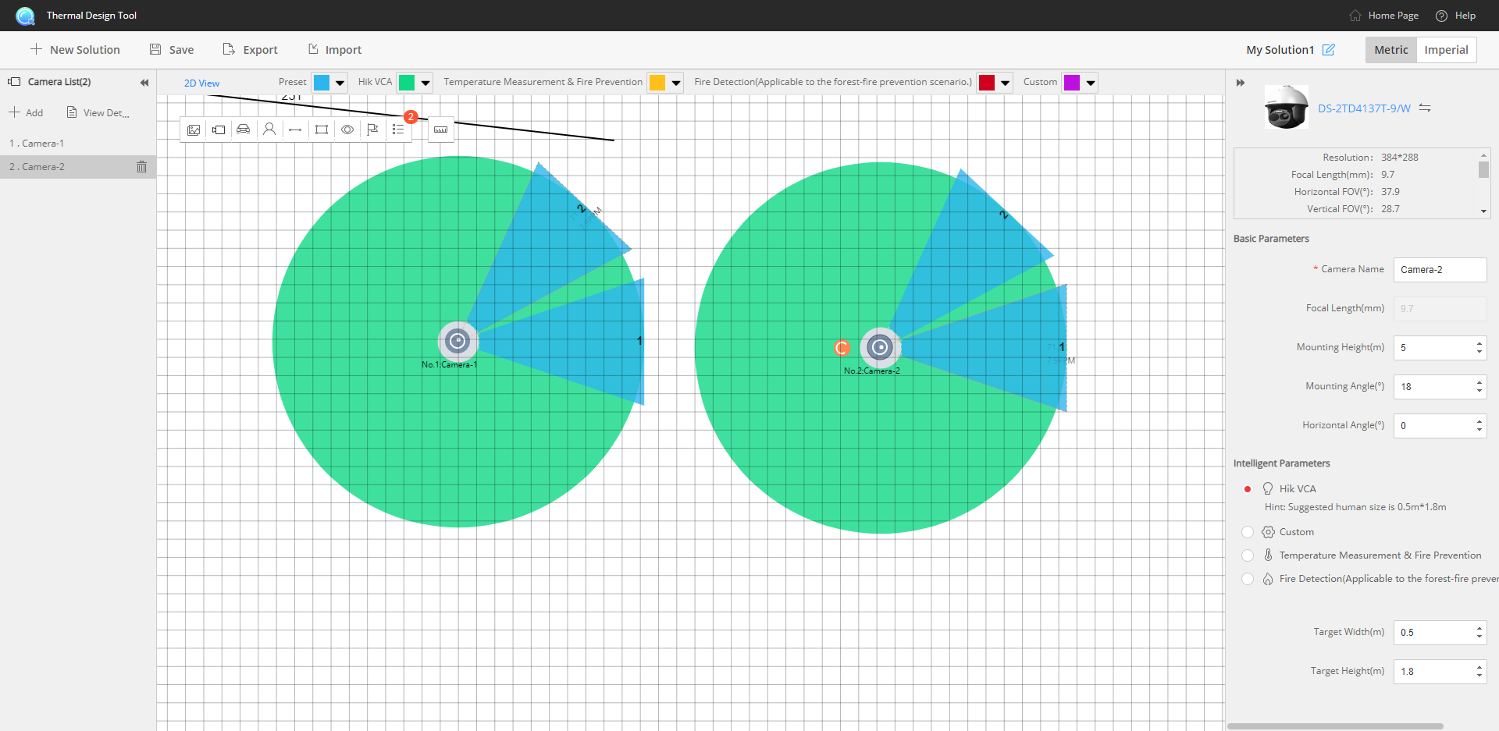

**Remarks:**

* Please use this Document with the guidance and assistance of professionals trained in supporting the Product.
* Pictures, charts, images and all other information hereinafter are for description and explanation only.
* HIKMICRO reserves the right to change, alter or withdraw the above notification without prior notice.
* Product design and specifications are subject to change without prior notice.
* The HIKMICRO firmware may contain errors known as errata, which may cause the product to deviate from published specifications. Current characterized errata are available on request.
* HIKMICRO is not liable for any typing or printing errors.

**Hangzhou Microimage Software Co., Ltd**

Room 313, Unit B, Building 2, NO.399 Danfeng Road,

Xixing Subdistrict,Binjiang District, Hangzhou, Zhejiang **http://www.hikmicrotech.com/en/**

<Tel:+86+571-8807-5998>