**Vandal-Resistant Doorbell Firmware V2.2.10_201126 Release Note**

**(2020-12-08)**

|  |  |
| --- | --- |
| Device Model | DS-KB8113-IME1 |
| Firmware Version | Vandal-Resistant Doorbell : V2.2.10_201126 |
| iVMS-4200 Version | 3.4.0.9 Build20201119 |
| Hik-Connect APP | V4.11.0.1204 |

**New Function**

1. The alarm input interface is changed from the default door status to the default exit button, with optional door status

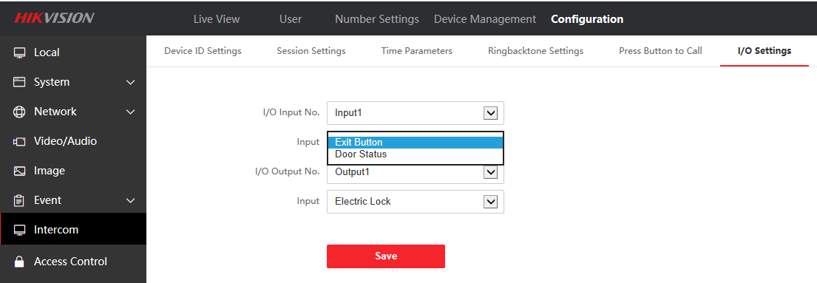

2. Modify the default unlocking time to 2 s, and supporting unlocking time can be configured with 1-255 s

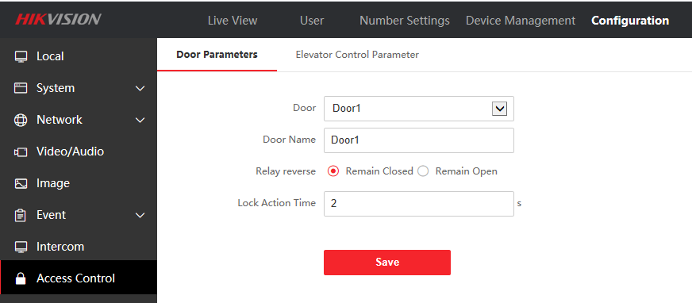

**Fix**

1. Solve the problem that doorbell cannot talk to Hik-Connect

2. Solve the problem of Hik-Connect receiving switch automatically turning off after doorbell power off