**K1T8105 Series Face Recognition Terminal**

**Release Notes (2018-08-17)**

|  |  |  |
| --- | --- | --- |
| **Device Model:**  DS-K1T8105E DS-K1T8105M | Firmware Version | ARM: ACS_8105_EN_GM_V1.0.0_build180817  MCU: ACS_MCU-TRIANGLE_GML_GM_V1.0.0_build180525 |
| SDK | HCNetSDKV5.3.5.40_build20180417_win32  EhomeSDK_V1.2.1.5_build20171101 |
| iVMS-4200 Client Version | V2.6.8.10 build20180522 |

**Reason of Upgrade**

New model DS-K1T8105E and DS-K1T8105M released.

**Modified Features**

1. Card capacity: 1,000; Face capacity: 1,000; Event Capacity: 50,000;

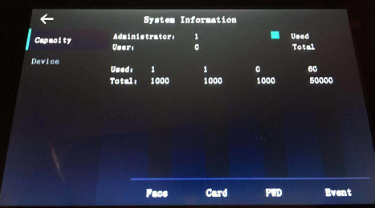

1. Support wiegand 26/34 input and output;

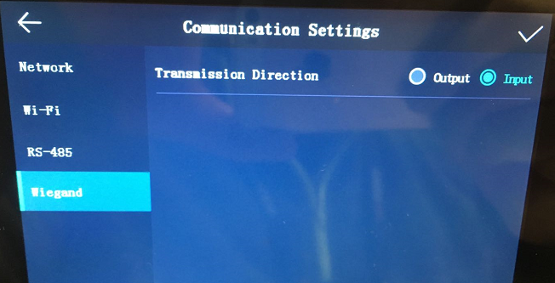

1. RS485 interface supports security module only, not support connecting RS485 reader or output card number;

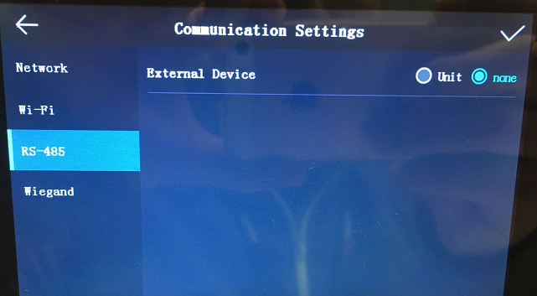

In 4200 client software, we can select security module or disable.

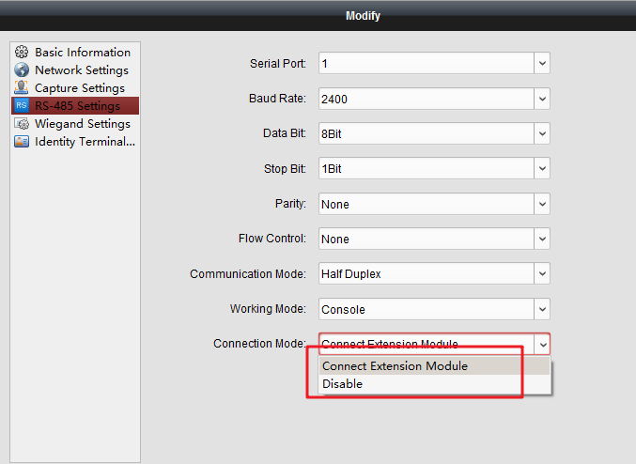

1. Support live face detection algorithm, improve the ability to prevent fake photo authentication.;
2. Upload offline device events automatically to client software.
3. Abundant event linkage setting on client software.
4. Activation interface to select device working environment, users can choose Indoor or others mode;

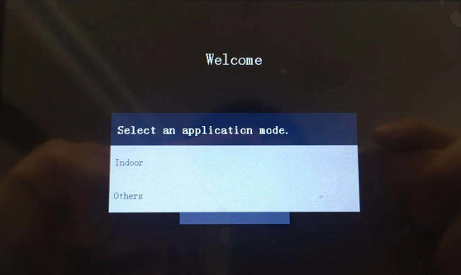

1. Face pictures and fingerprint data can be applied to the device via TCP/IP or uploaded to the device via USB flash drive.

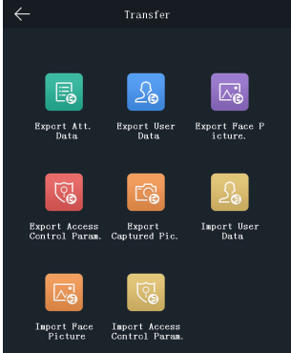

**Customer Impact and Recommended Action**

This new firmware upgrade is to improve product performance, and will take effect automatically after upgrading from previous versions. We’d like to inform you the above changes. Also, we are sorry for any possible inconvenience of use-habit changes caused by this action.

For questions or concerns, please contact our local technical support team.

Note:

* Hikvision has all rights to alter, modify and cancel this notice.
* Hikvision doesn’t give any guarantee for old models’ stock.
* Hikvision is not liable for any typing or printing errors.
* For special model’s change details, please contact our local technical support team.

Hikvision Digital Technology CO., Ltd.

No. 555 Qianmo Road, Binjiang District, Hangzhou 310052, China

Tel: +86-571-8807-5998

FAX: +86-571-8993-5635

Email: support@hikvision.com