**DS-K5032 Series Visitor Terminal Release Notes (2020-10-19)**

|  |  |  |
| --- | --- | --- |
| **Device Model:**  DS-K5032-3XFD  DS-K5032-D  **Naming Rule:**  **D** for dual screen  **3XF** for thermal module | Firmware Version | **System:**  ACS_5032_HCP_AUTO_P_R2_EN_STD_V1.0.0_200905  **Hikcentral Professional App：**  app-HikCentralVisitor-release-20200711 |
| Hikcentral Professional Version | Hikcentral Professional V1.7 |

**Reason of Upgrade**

New model DS-K5032 series dual-screen android visitor terminal visitor terminals first time released.

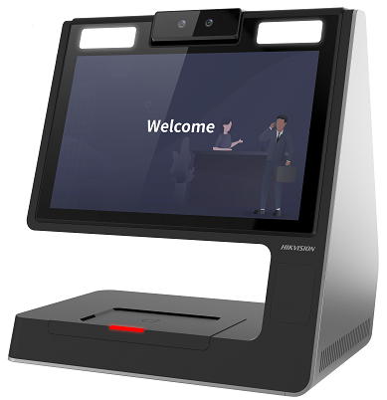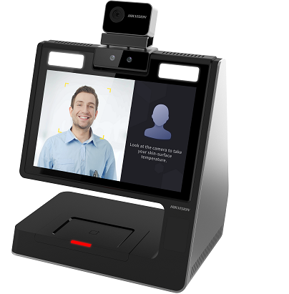

**New Features**

1. Android operation system with 10.1-inch dual-screen design

2. Paperless visitor enrollment

3. Supports both stand-alone and networking application. TCP/IP and Wi-Fi are available for networking application.

4. Real-time visitors counting for the current day

5. Up to 130,000 visitor records can be stored on the device

6. Fast temperature measurement for visitor. Temperature measuring range: 30 °C to 45 °C, accuracy: 0.1 °C deviation: ± 0.5°C （**DS-K5032-3XFD only**）

**Customer Impact and Recommended Action**

This update refers to function/compatibility improvement and will take effect automatically after the Date of Change. We are very sorry for any inconvenience of use-habit changes caused by this action.

For any questions and request for this firmware, please contact our local technical support team.

Note:

* Hikvision reserves the right to change, alter or withdraw the above notification without prior notice.
* Product design and specifications are subject to change without prior notice.
* The Hikvision firmware may contain errors known as errata, which may cause the product to deviate from published specifications. Current characterized errata are available on request.
* Hikvision is not liable for any typing or printing errors.

Hikvision Digital Technology CO., Ltd.

No. 555 Qianmo Road, Binjiang District, Hangzhou 310051, China

Tel: +86-571-8807-5998

FAX: +86-571-8993-5635

Email: overseabusiness@hikvision.com