**DS-K1T680 Series MinMoe Terminal Release Note (2020-11-23)**

|  |  |  |
| --- | --- | --- |
| **Device Model:**  DS-K1T680D(F)-E1  DS-K1T680D(F)W  DS-K1T680D(F)G  DS-K1T680D(F)G1  **Naming Rule:**  D for M1 card, Desfire card, Felica card  E1 for POE  W for Wi-Fi  F for fingerprint  G1 for 3/4G, supported in Australia, Taiwan (China) and Latin America;  G for 3/4G, supported in Europe, the Middle East, Africa, India, and Most Areas of Asia-Pacific (excluding Japan and Taiwan (China)) | Firmware Version | **ARM：** ACS_680_AI3_EN_STD_V3.1.2_build200925  ACS_680_AI3_EN_NEU_V3.1.2_build200925 |
| SDK | HCNetSDKV6.1.5.15_build20200713_win32_EN |
| iVMS-4200 Version | iVMS-4200 AC(V1.0.3.17_E).exe |

**Reason of Upgrade**

New model DS-K1T680 series face recognition terminals first time released.

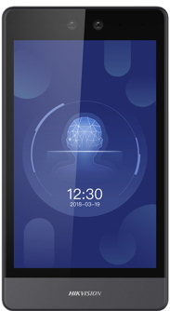 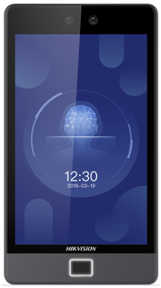

**New Features**

1. 8-inch touch screen with bezel-less design, 2 MP wide-angle dual-lens camera with WDR feature;
2. Connect external card reader or access controller via RS485 or Wiegand26/34 protocol
3. Face recognition duration ＜ 0.2 s/User; face recognition accuracy rate ≥ 99%
4. Support reading Desfire card number/content, Felica card number, Mifare 1 card number
5. Support password only authentication mode (password can be configured from iVMS or HCP only)
6. Support POE (device model with -E1)
7. Support hard-hat detection function
8. Presents card on the screen to authenticate card permission

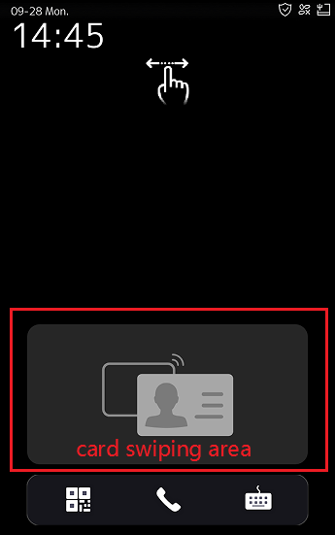

1. Multiple languages: English, Japanese, Thai, Indonesia, Ukrainian, Russian, Spanish, Arabic and Brazilian Portuguese

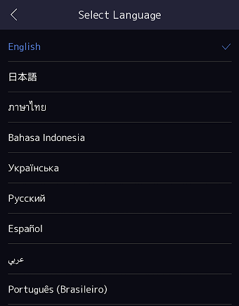

1. **Face, card and event capacity**

|  |  |  |  |  |  |  |  |
| --- | --- | --- | --- | --- | --- | --- | --- |
|  | **Face** | **Card** | **Event** | **Fingerprint** | **POE** | **Wi-Fi** | **3G/4G** |
| DS-K1T680D-E1 | Normal mode:  100,000 | 100,000 | 150,000 | N/A | Support | N/A | N/A |
| DS-K1T680DF-E1 | 10,000 | Support | N/A | N/A |
| DS-K1T680DW | N/A | N/A | Support | N/A |
| DS-K1T680DFW | 10,000 | N/A | Support | N/A |
| DS-K1T680DG | N/A | N/A | N/A | Support |
| DS-K1T680DFG | 10,000 | N/A | N/A | Support |
| DS-K1T680DG1 | N/A | N/A | N/A | Support |
| DS-K1T680DFG1 | 10,000 | N/A | N/A | Support |

**DS-K1T680D(F)G:**

Supported in Europe, the Middle East, Africa, India, and Most Areas of Asia-Pacific (excluding Japan and Taiwan (China))

LTE FDD: B1/B3/B7/B8/B20/B28A

WCDMA: B1/B8

GSM: B3/B8

**DS-K1T680D(F)G1:**

Supported in Australia, Taiwan (China) and Latin America

LTE FDD: B1/B2/B3/B4/B5/B7/B8/B28

LTE TDD: B40

WCDMA: B1/B2/B5/B8

GSM: B2/B3/B5/B8

1. ISAPI protocol makes it easier to integrate with third-party software;
2. Remote video intercom and unlock door from Hik-Connect App on your mobile/Pad
3. Support ISUP 5.0(EHome 5.0) protocol to manage devices located in different location;
4. Self-defined shortcut key (QR Code, Call and Password) on main interface, call Hik-Connect App.

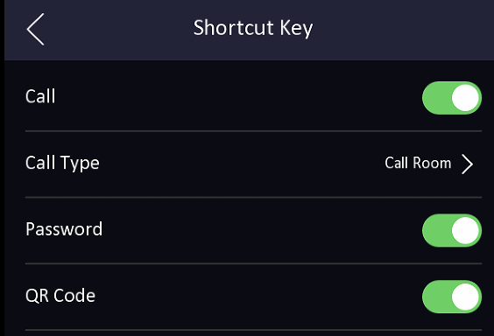 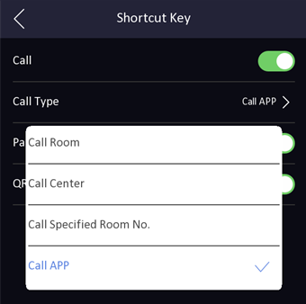

1. New UI design in device menu interface;

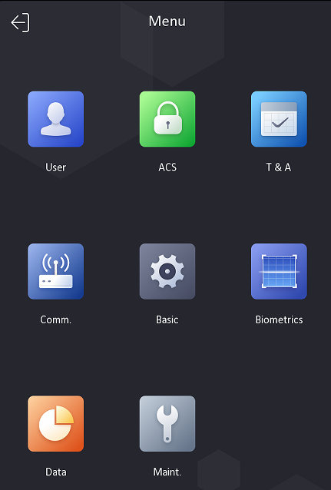

1. Login and configure device in web client via browser to realize person management, parameter configuration, log search and system maintenance;

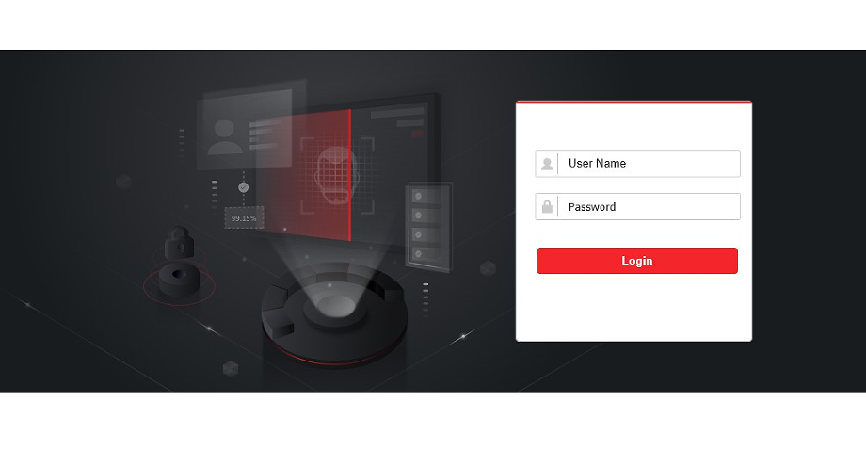

1. Self-defined voice prompt (TTS function, English only) and screen display info (user ID, name and face picture) for authentication result, set different voice prompts maximum for 4 time periods.

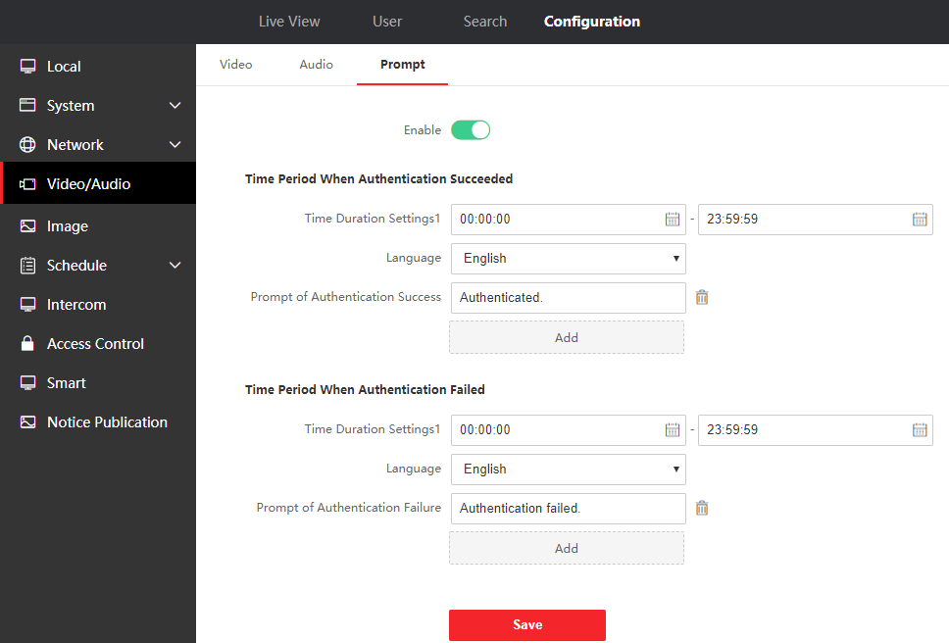

1. **Network**

Support TCP/IP，Wi-Fi and 3/4G, adapt to LAN (network) or WAN (ISUP 5.0) network environment

1. **Function**
2. Video intercom with indoor station, master station, hik-connect mobile app and platform;

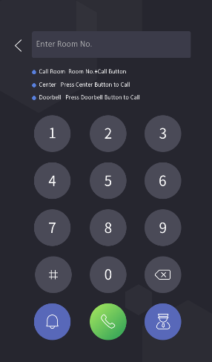

1. Status bar shows device status in real time, include network status, deployment/arm status, Hik-Connect server connection status

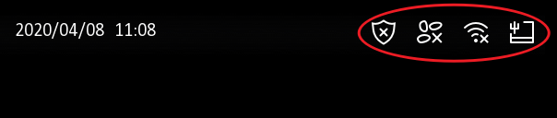

1. Multiple verification modes: Face, card, password and QR code;
2. Face recognition distance ranges from 0.3 to 3 meters;
3. Support check in/check out/break out/break in/overtime in/overtime out status, and attendance status name supports custom modification

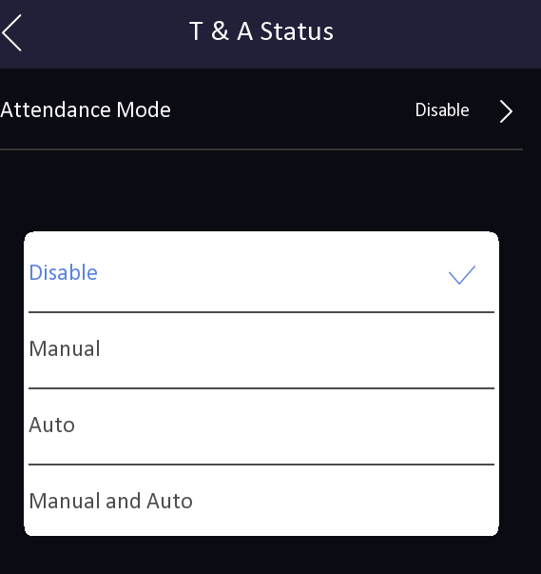 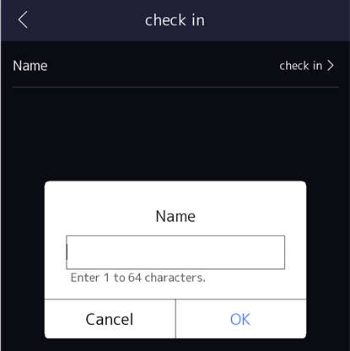

1. Custom standby background image

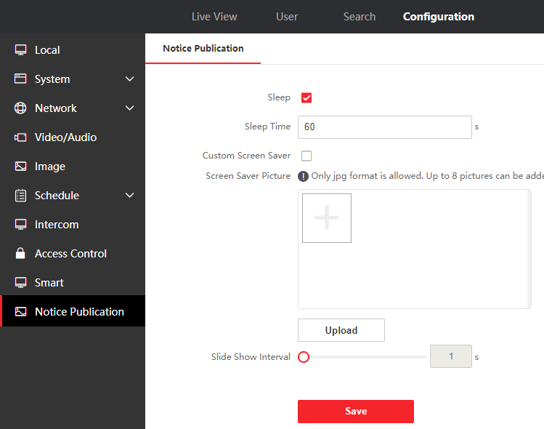

1. Supports face recognition in low illumination
2. Live view on the platform, H.264

**Customer Impact and Recommended Action**

This update refers to function/compatibility improvement and will take effect automatically after the Date of Change. We are very sorry for any inconvenience of use-habit changes caused by this action.

For any questions and request for this firmware, please contact our local technical support team.

Note:

* Hikvision reserves the right to change, alter or withdraw the above notification without prior notice.
* Product design and specifications are subject to change without prior notice.
* The Hikvision firmware may contain errors known as errata, which may cause the product to deviate from published specifications. Current characterized errata are available on request.
* Hikvision is not liable for any typing or printing errors.

Hikvision Digital Technology CO., Ltd.

No. 555 Qianmo Road, Binjiang District, Hangzhou 310051, China

Tel: +86-571-8807-5998

FAX: +86-571-8993-5635

Email: overseabusiness@hikvision.com