**DS-K1T331 Series MinMoe Terminal**

**Release Notes (2020-04-09)**

|  |  |  |
| --- | --- | --- |
| **Device Model:**  DS-K1T331  DS-K1T331W  **Naming Rule:**  W for WIFI | Firmware Version | ACS_331_AI2_EN_GM_V3.1.0_build200331.zip |
| SDK | HCNetSDKV6.1.0.25_build20190718_Win32_EN  HCEhomeSDKV2.2.1.1_build20190410_win32 |
| iVMS-4200 Client Version | iVMS-4200 AC(V1.0.3.11_E).exe |

**Reason of Upgrade**

Add new features, fix bugs, enhance products quality and meet customers’ requirements.

**New Features**

1. Multiple languages: English, Thai, Indonesian, Spanish, Russian and Arabic

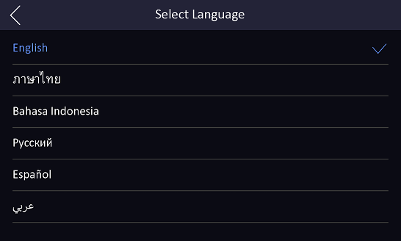

1. Login and configure device in web client via browser to realize person management, parameter configuration, log search and system maintenance;

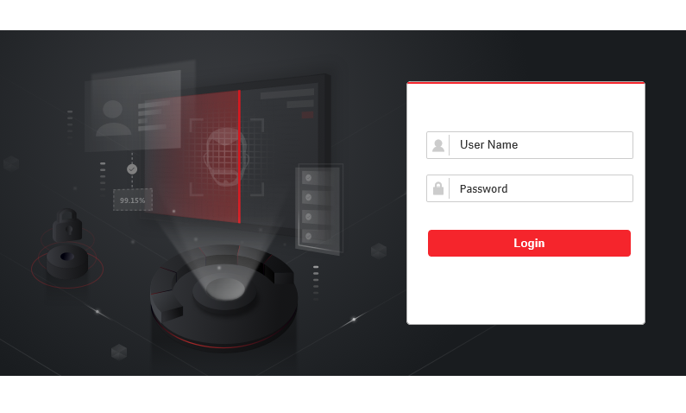

1. Support encryption (4 to 6 characters, optional) for USB import and export data.

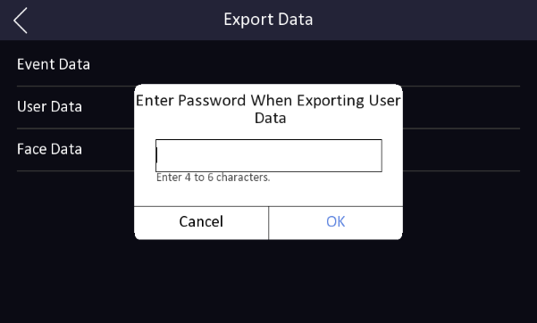 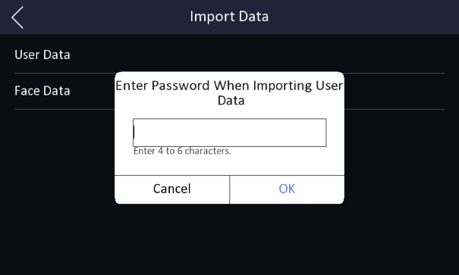

1. Support ISUP 5.0(EHome 5.0) protocol to manage devices located in different locations;

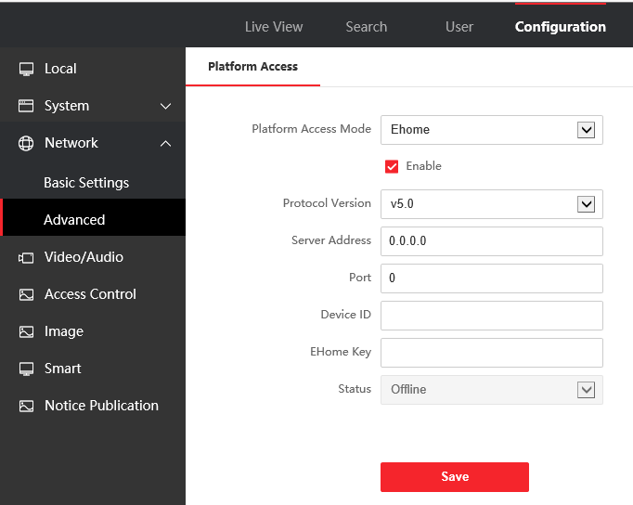

1. Import background pictures, the device will play pictures during standby status

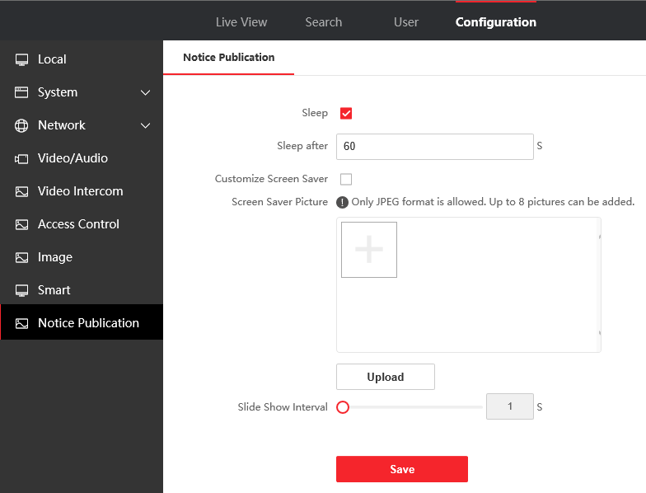

1. Self-defined screen display info (user ID, name and face picture) for authentication result.

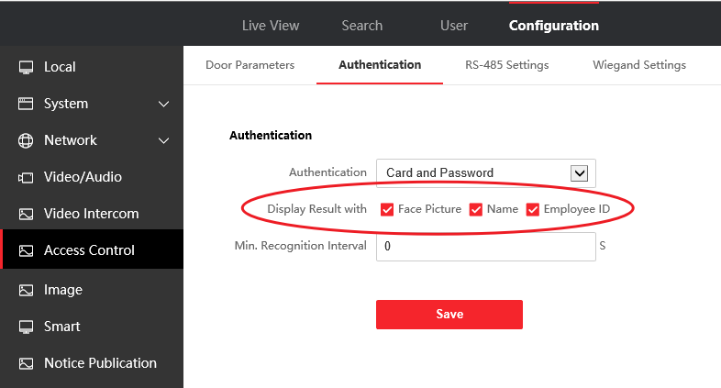

1. Status bar shows device status in real time, including network status, deployment/arm status, Hik-Connect server connection status.

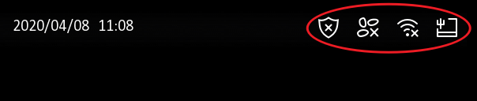

**Modified Features**

1. Optimize new UI style

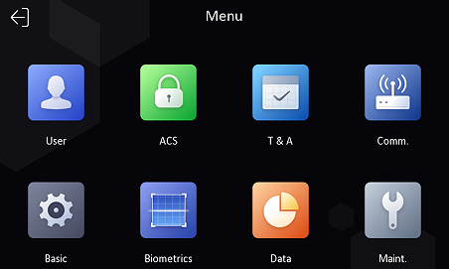

**Customer Impact and Recommended Action**

This update refers to function/compatibility improvement and will take effect automatically after the Date of Change. We are very sorry for any inconvenience of use-habit changes caused by this action.

For any questions and request for this firmware, please contact our local technical support team.

Note:

* Hikvision reserves the right to change, alter or withdraw the above notification without prior notice.
* Product design and specifications are subject to change without prior notice.
* The Hikvision firmware may contain errors known as errata, which may cause the product to deviate from published specifications. Current characterized errata are available on request.
* Hikvision is not liable for any typing or printing errors.

Hikvision Digital Technology CO., Ltd.

No. 555 Qianmo Road, Binjiang District, Hangzhou 310051, China

Tel: +86-571-8807-5998

FAX: +86-571-8993-5635

Email: overseabusiness@hikvision.com