**K1T331 Series Face Recognition Terminal**

**Release Notes (2019-09-29)**

|  |  |  |
| --- | --- | --- |
| **Device Model:**  DS-K1T331  DS-K1T331W  **Naming Rule:**  W for WIFI | Firmware Version | ACS_01_AI2_EN_STD_V2.1.0_190923 |
| SDK | HCNetSDKV6.1.0.25_build20190718_Win32_EN  HCEhomeSDKV2.2.1.1_build20190410_win32 |
| iVMS-4200 Client Version | V1.0.2.13build190923 |

**Reason of Upgrade**

New model DS-K1T331 and DS-K1T331W first time released.

**Modified Features**

1. 3.97 inch LCD touch screen with 800*480 resolution, 2 MP wide-angle dual-lens
2. Connect external card reader, secure door control unit or access controller via RS485 protocol
3. Face recognition duration ＜ 0.2 s/User; face recognition accuracy rate ≥ 99%
4. **Face, card, fingerprint, event capacity**

|  |  |  |  |  |
| --- | --- | --- | --- | --- |
|  | **Face** | **Card (M1)** | **Fingerprint** | **Event** |
| **DS-K1T331/331W** | 300 | 1,500(only work on external card reader) | Not support | 150,000 |

1. **Network**

Support TCP/IP, adapt to LAN network environment, optional WIFI function(model with W only)

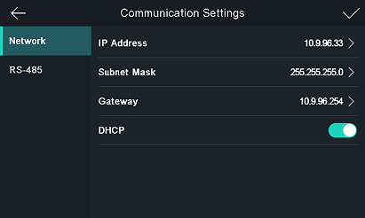

1. **Function**
2. Multiple verification modes:

**For terminal:** face, face&password.

**For RS485 external terminal:** card, face, fingerprint, card&fingerprint, card or fingerprint, card&password (external terminal should support related verification mode)

1. Face pictures can be applied to the device via client software or USB drive.
2. Support live face detection(anti-spoofing) function.
3. Support check in/check out/break out/break in/overtime in/overtime out attendance status selection after successfully verified.

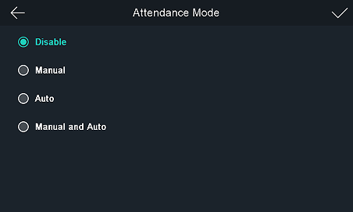 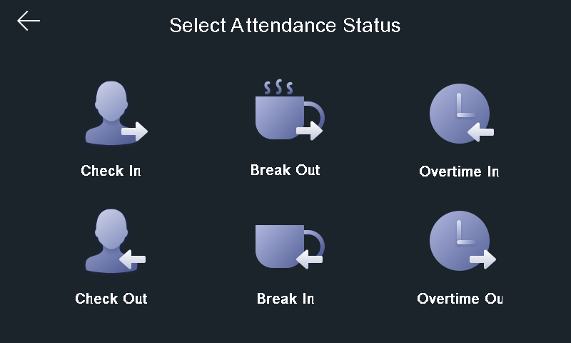

1. Support English, Arabic and Spanish language.

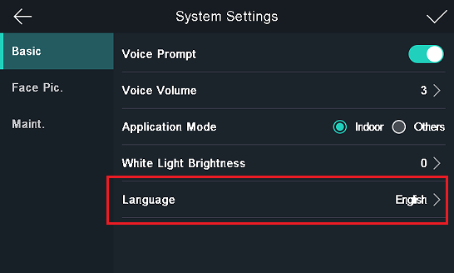

1. Support device admin role configuration, after long press main screen, enter device menu after input activation password or administrator’s(if created) face/card/fingerprint successfully verified.

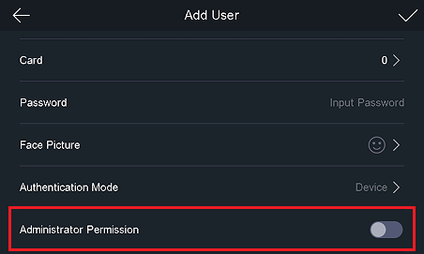

1. Support hik-connect mobile app (Waiting for APP to be compatible with device model)

**Customer Impact and Recommended Action**

This new firmware upgrade is to improve product performance, and will take effect automatically after upgrading from previous versions. We’d like to inform you the above changes. Also, we are sorry for any possible inconvenience of use-habit changes caused by this action.

For questions or concerns, please contact our local technical support team.

Note:

* Hikvision has all rights to alter, modify and cancel this notice.
* Hikvision doesn’t give any guarantee for old models’ stock.
* Hikvision is not liable for any typing or printing errors.
* For special model’s change details, please contact our local technical support team.

Hikvision Digital Technology CO., Ltd.

No. 555 Qianmo Road, Binjiang District, Hangzhou 310052, China

Tel: +86-571-8807-5998

FAX: +86-571-8993-5635

Email: support@hikvision.com