**Fingerprint Terminal V1.4.0_build220523 Release Note (2022-05-25)**

|  |  |
| --- | --- |
| **Device Model** | **Firmware** |
| DS-K1T804AF/AMF/AEF | ACS_1T804A_J1_EN_STD_V1.4.0_build220523 |
| DS-K1T804BF/BMF/BEF | ACS_1T804B_J1_EN_STD_V1.4.0_build220523 |
| DS-K1A802AF/AMF/AEF | ACS_1A802A_J1_EN_STD_V1.4.0_build220523 |
| DS-K1T8003 Series | ACS_1T8000_J1_EN_STD_V1.4.0_build220523 |
| DS-K1A8503 Series | ACS_1A8500_J1_EN_STD_V1.4.0_build220523 |

**Reason of Upgrade**

Add or modify functions, fix bugs, enhance products quality and meet customers’ requirements.

**Modified Features**

1. ID support letter, ID length less than 32 digit

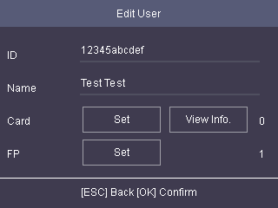

1. Support ID, name desensitization function

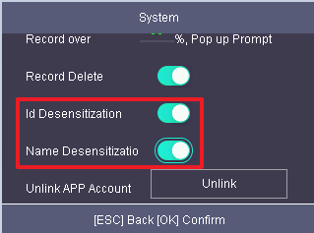

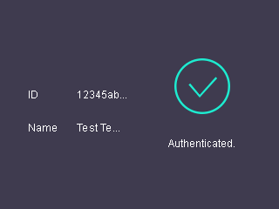

1. Support Hik-connect account unlinking function

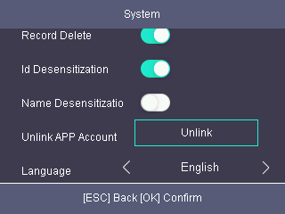

**Fingerprint Terminal V1.3.37_build210802 Release Note (2021-09-09)**

|  |  |
| --- | --- |
| **Device Model** | **Firmware** |
| DS-K1T804AF/AMF/AEF | ACS_1T804A_MCU_J1_EN_STD_V1.3.37_build210802 |
| DS-K1T804BF/BMF/BEF | ACS_1T804B_J1_EN_STD_V1.3.38_build210802 |
| DS-K1A802AF/AMF/AEF | ACS_1A802A_J1_EN_STD_V1.3.37_build210802 |
| DS-K1T8003 Series | ACS_1T8000_J1_EN_GM_V1.2.3_build191120 |
| DS-K1A8503 Series | ACS_1A8500_J1_EN_STD_V1.3.37_build210802 |

**Reason of Upgrade**

Add or modify functions, fix bugs, enhance products quality and meet customers’ requirements.

**Modified Features**

1. Add Hik-Connect menu in device UI Menu🡪Comm🡪Mobile App. The function is disabled in default. （For DS-K1T804A, DS-K1T804B, DS-K1T8003 only）

**Fingerprint Terminal V1.2.3_build191120 Release Note (2019-11-16)**

|  |  |
| --- | --- |
| **Device Model** | **Firmware** |
| DS-K1T804F/MF/EF | ACS_1T804_M0_EN_GM_V1.2.3_build191120 |
| DS-K1A802 F/MF/EF | ACS_1A802_J1_EN_GM_V1.2.3_build191120 |
| DS-K1T8003 Series | ACS_1T8000_J1_EN_GM_V1.2.3_build191120 |
| DS-K1A8503 Series | ACS_1A8500_J1_EN_GM_V1.2.3_build191120 |

**NOTE:**

**If you upgrade ARM firmware from v1.1.x .**

**Don’t reboot device directly!**

**Choose restore all after upgrade.**

This is because new firmware’s data structure is not compatible with old firmware. Rebooting directly will lead to devise crash. It is recommend to upload all the old data to client software (iVMS4200) before upgrade, and apply all data to devise again when upgrade finish.

If you upgrade from firmware 1.2.x, you can directly reboot the device.

**Reason of Upgrade**

Add or modify functions, fix bugs, enhance products quality and meet customers’ requirements.

**Improved Features**

1. Improve the compatibility with Hik-Central Professional platform software.

**Customer Impact and Recommended Action**

This new firmware upgrade is to improve product performance, and will take effect automatically after upgrading from previous versions. We’d like to inform you the above changes. Also, we are sorry for any possible inconvenience of use-habit changes caused by this action.

For questions or concerns, please contact our local technical support team.

Note:

* Hikvision has all rights to alter, modify and cancel this notice.
* Hikvision doesn’t give any guarantee for old models’ stock.
* Hikvision is not liable for any typing or printing errors.
* For special model’s change details, please contact our local technical support team.

Hikvision Digital Technology CO., Ltd.

No. 555 Qianmo Road, Binjiang District, Hangzhou 310052, China

Tel: +86-571-8807-5998

FAX: +86-571-8993-5635

Email: support@hikvision.com