**Access Controller V2.1 Project Release Note**

**(2019-12-25)**

|  |  |  |
| --- | --- | --- |
| Device Model:  Controller:  DS-K2600T Series  DS-K2600-G Series  Card Reader:  DS-K1107/08 Series  DS-K1201 Series | Firmware  Version | DS-K2600T/DS-K2600-G Series:  ACS_DS-K260X_ST9_GML_GM_V1.0.0_build191202  DS-K1107/08 Series:  ACS_DS-K1107-1108_ST4_GML_GM_V2.1.0_build191125  DS-K1201 Series:  ACS_DS-K1201F_ST4_GML_GM_V2.0.0_build191114 |
| SDK  Version | HCNetSDKV6.1.0.20_build201900706_Win32 |
| iVMS4200 Version | V2.7.3.6 build191119 |

**NOTE:**

**Controller’s firmware is only for 2600T and 2600-G series controller, not compatible with DS-K2600 series controller.**

**Reason of Upgrade**

New controller hardware with new data structure controller firmware.

**New Features**

**K2600T/K2600-G Series:**

1. Person information data structure changes from “based on card” to “based on person ID”, now controller can support store ID(32 bytes), name(32 bytes) and card No. together;
2. Support OSDP protocol;

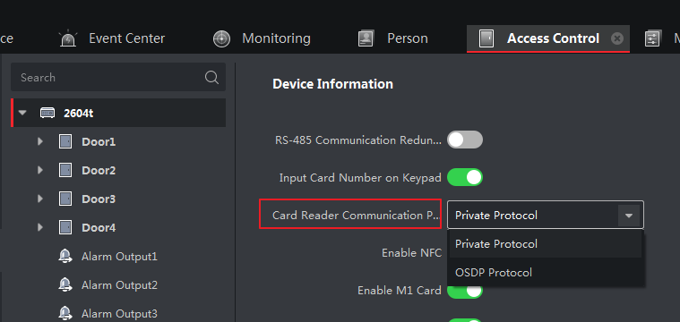

1. Support Ehome 5.0 protocal;

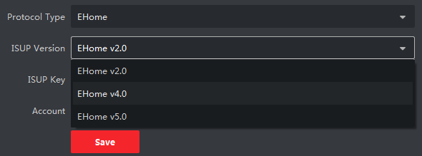

1. Support ISAPI protocal;
2. When enable DST function, the uploading events will contain time zone and DST information;
3. Improve fingerprint downloading speed.

**K1201 Series:**

1. Compatible with new 2600T/2600-G firmware;
2. Improve fingerprint downloading speed.

**K1107/08 Series:**

1. Support OSDP protocol. When connect to controller, card reader will automatically choose using private RS485 or standard OSDP according to controller’s protocol.

***Remarks:***

* Hikvision reserves the right to change, alter or withdraw the above notification without prior notice.
* Product design and specifications are subject to change without prior notice.
* The Hikvision firmware may contain errors known as errata which may cause the product to deviate from published specifications. Current characterized errata are available on request.
* Hikvision is not liable for any typing or printing errors.

Hikvision Digital Technology CO., Ltd.

No. 555 Qianmo Road, Binjiang District, Hangzhou 310051, China

Tel: +86-571-8807-5998

FAX: +86-571-8993-5635

Email: overseabusiness@hikvision.com