DS-K1107/08 card reader with firmware version: V2.1build191125(products from 2019.12 to 2020.9 ), M1 encryption is enabled by default, this function can be enable or disable by 5th dip switch on card reader

5th dip switch is in “0” position:

Enable M1 encryption, disable NFC virtual card reading.

5th dip switch in “1” position:

Disable M1 encryption, enable NFC virtual card reading.

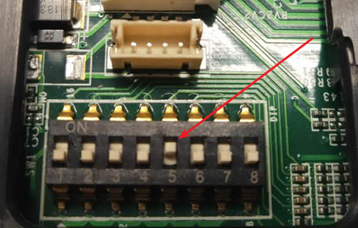

5th dip switch in “1” position

According to existing market feedback, more application scenarios do not need M1 encryption in Wiegand protocol. In order to better fit the market application, the headquarters will update the card reader 1107 / 1108: M1 encryption is not required by default. If encryption is required, customers can configure it by setting the 5th dip switch to “1” position. The firmware is expected to be released at the end of September.

|  |  |  |
| --- | --- | --- |
| 5th dip switch | 0 | 1 |
| Current FW  V2.1build20191125 | Enable M1 encryption, disable NFC virtual card reading | Disable M1 encryption, enable NFC virtual card reading |
| Next FW  Release before 2020.10 | Disable M1 encryption, enable NFC virtual card reading | Enable M1 encryption, disable NFC virtual card reading |

固件版本为V2.1.0_build191125的DS-K1107/08读卡器（时间范围主要在从2019年12月到2020年9月之间），出厂默认M1加密，该功能可通过读卡器第5位拨码进行调整。

默认不拨，拨码在位置0：

启用M1加密，禁止NFC类型虚拟卡；

拨码拨到1位置：

不启用M1加密，使能 NFC类型虚拟卡。



第五位拨码拨1

从现有市场反馈来看，在wiegand使用中，更多应用场景无需M卡加密。为了更加贴合市场应用，总部对读卡器1107/1108会进行更新升级：默认不做M卡加密，如需加密，客户可通过拨码5进行配置。此固件预计在9月底发布，最终发布时间，会同步更新推送。

|  |  |  |
| --- | --- | --- |
| 第五位拨码 | 0 | 1 |
| 当前固件V2.1build20191125 | 启用M1加密，禁止NFC类型虚拟卡 | 不启用M1加密，使能 NFC类型虚拟卡 |
| 下个固件  2020年9月底发布 | 不启用M1加密，使能 NFC类型虚拟卡 | 启用M1加密，禁止NFC类型虚拟卡 |