**DS-K1F600-D6E(-F) Enrollment Station**

**Release Notes (2020-11-30)**

|  |  |  |
| --- | --- | --- |
| **Device Model:**  DS-K1F600U-D6E  DS-K1F600U-D6E-F  **Naming Rule:**  -F for fingerprint module | Firmware Version | ARM：ACS_FRACS_AI2_EN_STD_V1.0.1_build201127  MCU：ACS_DS-K1F600U_ST0_GML_GM_V1.0.0_build200929 |
| SDK | HCUsbSDKV1.0.3.1_build20200925_win32.rar  HCISUPSDKV6.1.0.151_build20200831_Win64_ZH  HCNetSDKV6.1.5.151_build20200826_win32_ZH |
| iVMS-4200 Client Version | Latest version |

**Reason of Upgrade**

New model DS-K1F600U-D6E and DS-K1F600U-D6E-F enrollment station first time released.

**Modified Features**

1. 3.97 inch LCD touch screen with 800*480 resolution, 2 MP wide-angle dual-lens
2. Built-in card issuing module, in line with ISO14443A/B standard, card reading frequency 13.56MHZ and 125KHZ, support EM card, Mifare 1 card, CPU card enrollment
3. Support enroll card, face & fingerprint (DS-K1F600U-D6E-F only) remotely via platform
4. Multiple languages: English, Japanese, Thai
5. Offline user, face, card, fingerprint and event capacity

|  |  |  |  |  |  |
| --- | --- | --- | --- | --- | --- |
|  | **User** | **Card** | **Fingerprint** | **Face** | **Offline enrollment records** |
| **DS-K1F600U-D6E** | 2,000 | 20,000 | Not support | 2,000 | 2,000 |
| **DS-K1F600U-D6E-F** | 2,000 | 20,000 | 20,000 | 2,000 | 2,000 |

1. **Communication**

Support USB2.0，wired network and Wi-Fi communication to connect platform for card/fingerprint/face enrollment

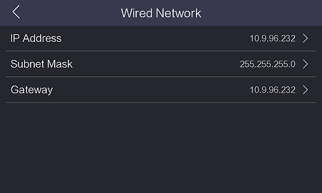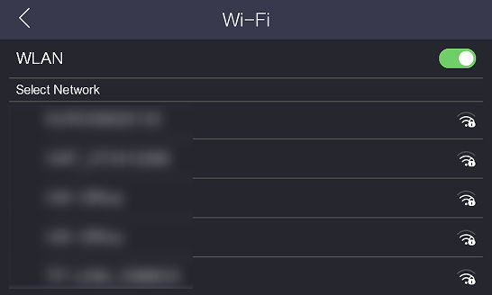

1. **Function**
2. Support 5 administrators for device local and remote platform configuration;
3. Login device menu via admin’s face or password;
4. Support live face detection (anti-spoofing) and WDR function;
5. User data import(export) from (to) another device via USB;
6. User-defined flexible enrollment rules:

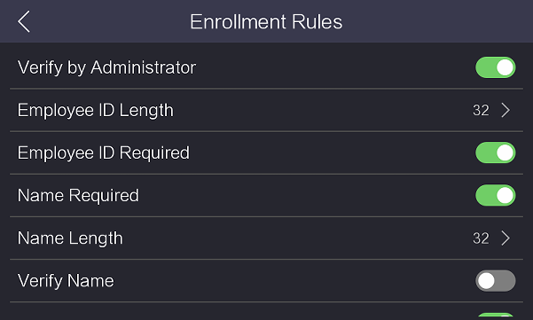 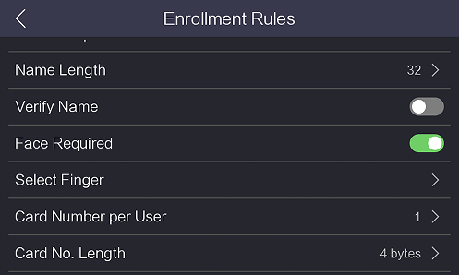

**Customer Impact and Recommended Action**

This new firmware upgrade is to improve product performance, and will take effect automatically after upgrading from previous versions. We’d like to inform you the above changes. Also, we are sorry for any possible inconvenience of use-habit changes caused by this action.

For questions or concerns, please contact our local technical support team.

Note:

* Hikvision has all rights to alter, modify and cancel this notice.
* Hikvision doesn’t give any guarantee for old models’ stock.
* Hikvision is not liable for any typing or printing errors.
* For special model’s change details, please contact our local technical support team.

Hikvision Digital Technology CO., Ltd.

No. 555 Qianmo Road, Binjiang District, Hangzhou 310052, China

Tel: +86-571-8807-5998

FAX: +86-571-8993-5635

Email: support@hikvision.com