**Turbo HD DVR V4.26.010 build 200923 Release Notes**

**(2020-10-18)**

|  |  |  |
| --- | --- | --- |
| **Firmware**  **Basic Information** | Firmware Version: | V4.26.010 build 200923 |
| SDK Version:: | V6.1.4.20 build 20200320 |
| Onvif： | V2.2 |
| Player： | 4.810mini |
| Player library： | 7.3.8.49 |
| Web version： | V4.0.1 build 20200822 |
| Client version： | V2.6.13.0 build 20181115 |

**Reason of Upgrade**

* Add some new functions, modify some functions, and enhance product quality to meet customers’ requirements.

**Main update**

1. Supports sending customized voice to front-end analog camera through Hik-connect, and supports linkage of front-end customized voice playback in case of alarm.
2. Integrated audio noise reduction algorithm with native player library.
3. The analog channels of 4-ch HUH-M device support accessing 8MP camera, the analog channel 1 remains the same as the original (live view and coding configuration, etc.), the analog channels 2-4 access 8MP camera, local live view will be 8MP@15 and adopt 8MPlite code (1920*2160) , and smart code is not supported after access to 8MP.
4. For advanced motion detection, a tip is added below the drawing button in the interface of “System - Event – Normal Event - Motion Detection”: “Tip: Right click to finish drawing”.

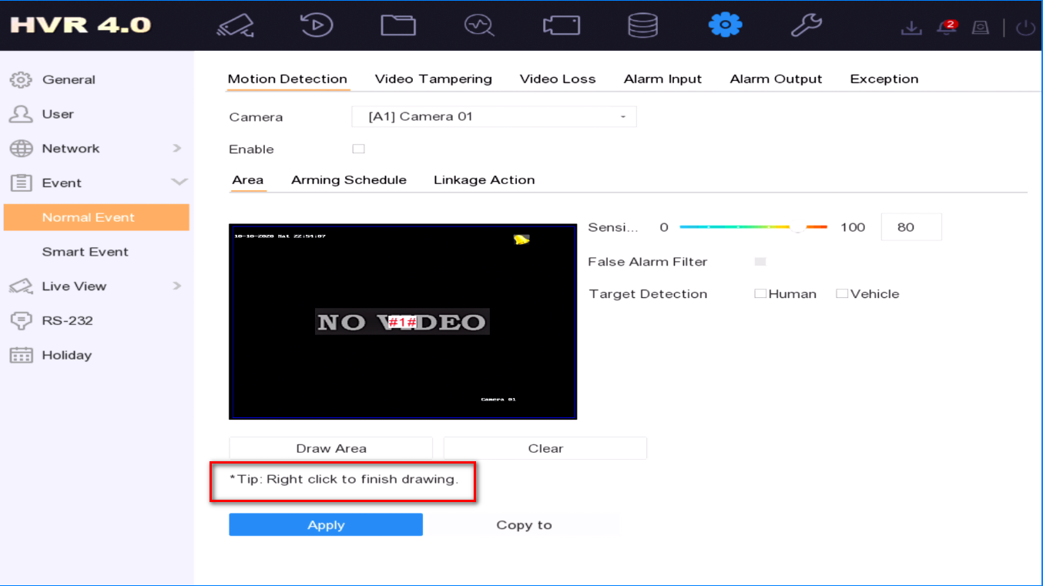

**Modified functions**

1. The content of black and white list in local GUI and web is changed to Block list and Allow list.
2. The main stream of the analog channel defaults variable bit rate, and other parameters remain unchanged; The sub stream of the analog channel defaults variable bit rate of H.265, and other parameters remain unchanged; There is no configuration compatibility: the encoding parameters won’t be adjusted, if the released version is upgraded to this version.
3. Cloud storage does not support Google drive. The configuration will automatically change to One drive after upgrading, if it is Google drive before.
4. Web vehicle retrieval picture display Chinese (country / Province).
5. Modification of prompt characters for unbound EZVIZ cloud in the prompt box.
6. Modification of customer’s problem: when the device access the 1005K keyboard, operating rocker in the front and rear, the PTZ camera should rotate up and down rather than left and right.
7. Modification of the device running cold and hot restart. When it starts to 36s, the network card will be abnormal and the device cannot be started normally.
8. Solve the problem of U disk may not be identified.
9. Solve the problem of no Russian keyboard.
10. Solve numerical scrambling problem of searching image similarity in face IE.
11. Solve the problem: when the device is connected to the IPC, and then the analog signal is repeatedly plugged in and out, resulting in the black screen of the analog channel live view.
12. Optimization of advanced motion detection algorithm.
13. Solve the problem of device stuck, including production line automation stuck.
14. Solve the problem: some HDMI monitors have no audio output.
15. T1 front panel connecting function defect merging.
16. Modification of EZVIZ multiple speed playback problem.
17. Modified the logic of false alarm filter in motion detection function.
18. Web supports Ukrainian.
19. Solve the problem: the IPC of G711U audio coding type is connected to DVR through ONVIF protocol, there is no sound when remote view main stream of the IPC on IE.
20. Modification of EZVIZ key authentication exception.

**Available Modes:**

|  |  |
| --- | --- |
| K8A3 | iDS-7216HQHI-M1/S  iDS-7216HQHI-M2/S  iDS-7208HUHI-M1/S  iDS-7208HUHI-M2/S |
| K8A3FA | iDS-7208HQHI-M2/FA  iDS-7216HQHI-M1/FA  iDS-7216HQHI-M2/FA  iDS-7208HUHI-M1/FA  iDS-7208HUHI-M2/FA |
| K8A4 | iDS-7208HQHI-M1/S  iDS-7208HQHI-M2/S  iDS-7204HUHI-M1/S  iDS-7204HUHI-M2/S |
| K8A4FA | iDS-7208HQHI-M1/FA  iDS-7204HUHI-M1/FA  iDS-7204HUHI-M2/FA |
| K8A5 | iDS-7204HQHI-M1/S |
| K8A5FA | iDS-7204HQHI-M1/FA |

**Customer Impact and Recommended Action**

This new firmware upgrade is to improve product performance, and will take effect automatically after upgrading from previous versions. We’d like to inform you the above changes. Also, we are sorry for any possible inconvenience of use-habit changes caused by this action.

For questions or concerns, please contact our local technical support team.

Note:

* Hikvision has all rights to alter, modify and cancel this notice.
* Hikvision doesn’t give any guarantee for old models’ stock.
* Hikvision is not liable for any typing or printing errors.
* For special model’s change details, please contact our local technical support team.

Hikvision Digital Technology CO., Ltd.

No. 555 Qianmo Road, Binjiang District, Hangzhou 310052, China

Tel: +86-571-8807-5998

FAX: +86-571-8993-5635

Email: support@hikvision.com