

**How to add solar camera to NVR via OTAP**

**How to add solar camera to NVR via OTAP**

### Description

Since version 4.63, NVR supports access to solar cameras by OTAP protocol, and realizes the functions of preview, video uploading, video retrieval and power display of solar cameras.

### Preparation

One M series device, whose version must be higher than 4.63. This article uses DS-9664NI-M16 / R V4.63.000 build 230412 as an example.

One solar camera that supports OTAP protocol. This article uses DS-2XS6A87G1-L/C36S80 V5.7.40 build 230424 as an example.

### Configuration on Camera

1. Log in to the web side of camera, and click **Configuration-Network-Advanced Settings-Platform Access** to enter the platform configuration page. Set Platform Access Mode as OTAP, enable the function, input related parameters, and then save the configuration.

Note:

1. Server Address is the IP of NVR.
2. Port is OTAP port, set 7800 by default.
3. Device ID is defined by user, and will be used for adding solar camera to NVR.
4. Key specifies the authentication password required for registration. The value is user-defined.
5. Register Status shows the OTAP connection status of the current device. After the connection is successful, Online will be shown here.

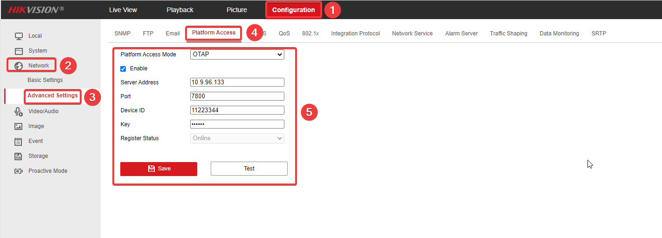

1. Configure a recording schedule on the camera to ensure that the camera has videos required by the customer for video uploading.

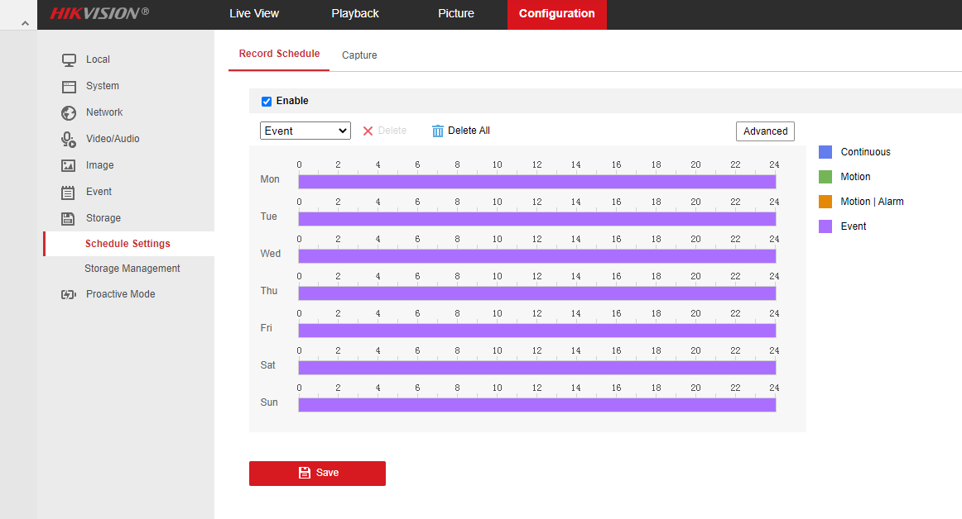

### Configure on NVR

1. Log in to the NVR web side, and click Configuration-Network-Advanced Configuration-OTAP Service to enter the OTAP Service configuration interface. Enable the OTAP Network Camera Service, enter the server port (default: 7800), and enter the verification password to save the configuration.

Note:

If Auto Add Network Camera is enabled, NVR will automatically add the solar camera whose OTAP server address is NVR’s IP address and password verification passes.

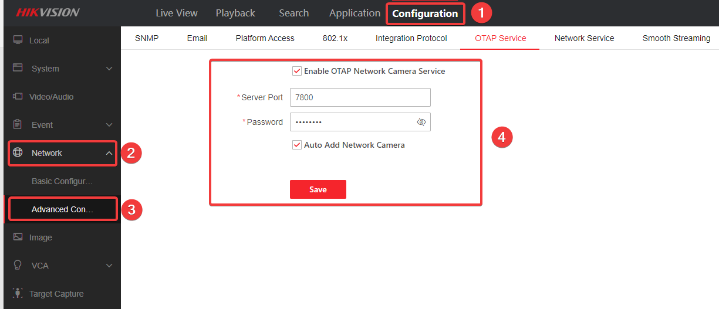

1. If the solar camera is not automatically added, user can go to the channel management page and add the solar camera manually.

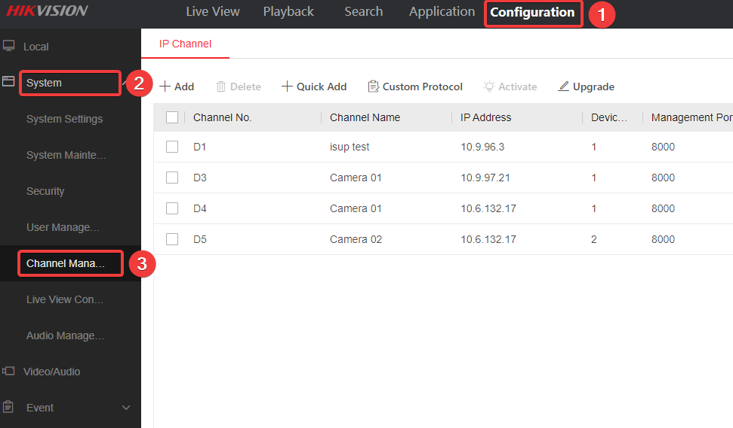

**Quick Add:** Click Quick Add and the device will search the camera that can be added. You can quickly add a solar camera in this way.

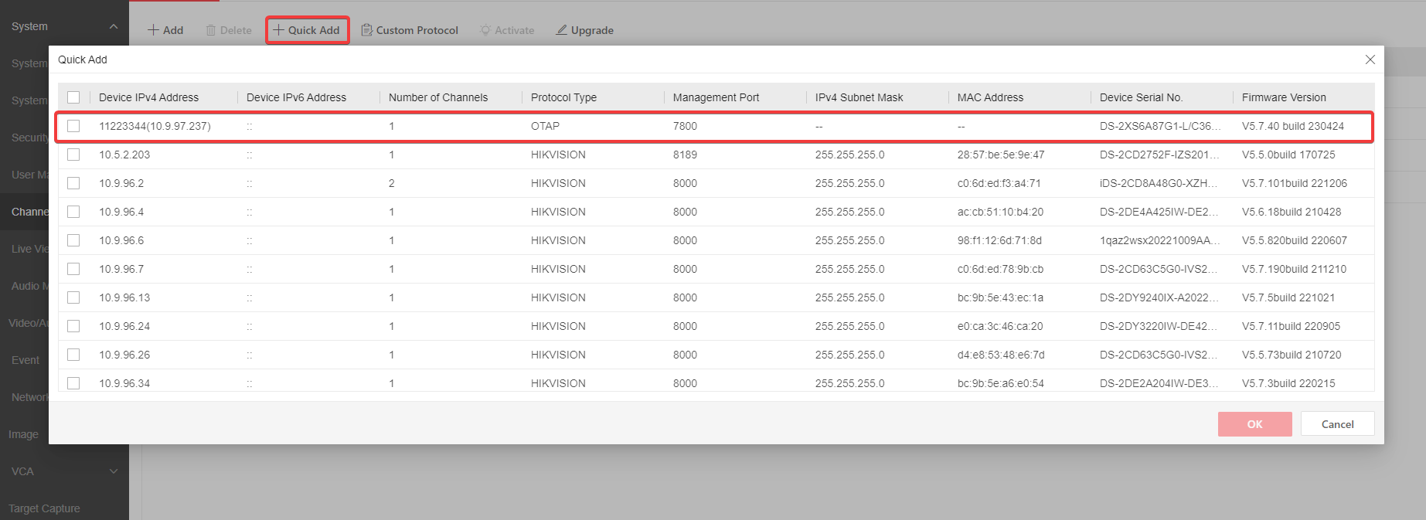

**Manually Add:** Click Add, select protocol as OTAP, and enter the camera Device ID to add the solar camera.

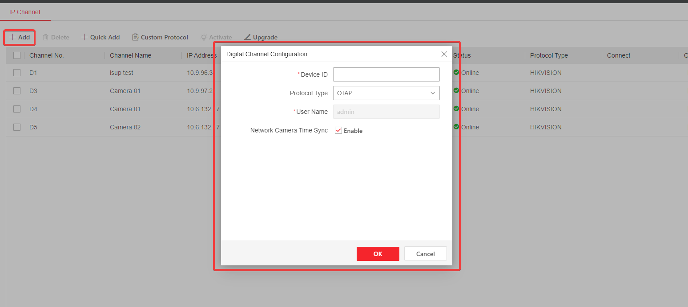

After the camera is successfully added, you can view the information about it. In addition, this version supports the power display of the solar camera.



1. Click Live View on the top bar, then user can enter the Live View page to check the live view and power display of solar camera.

Note: In order to prevent excessive traffic consumption, only 5 minutes is supported for single live view. NVR will stop streaming from camera after 5 minutes. If necessary, you can click the channel again to get stream.

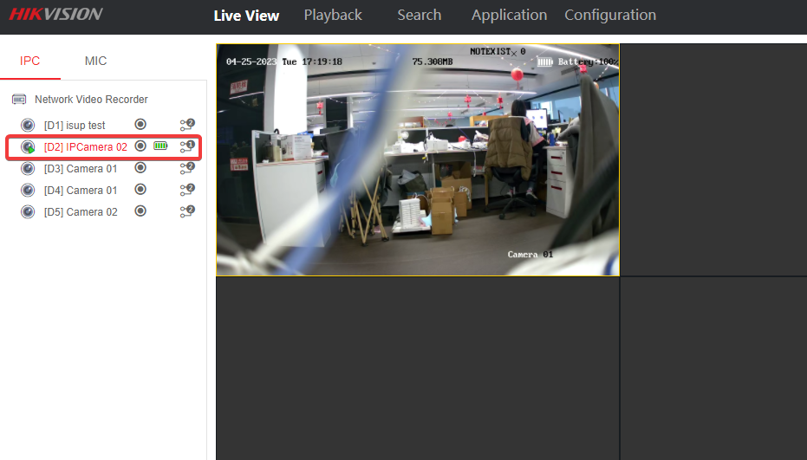

1. In order to check playback of solar camera on NVR, users need enter recording schedule setting page to do related configuration first.

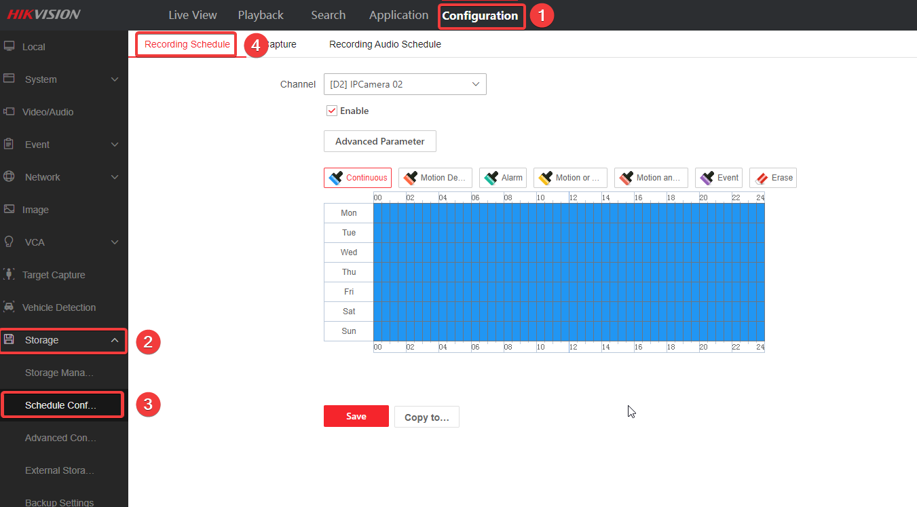

NVR recording schedule is only valid for video clips that the NVR streams. To configure video uploading from solar camera, users need click Advanced Parameter to enable ANR and set the ANR uploading cycle.

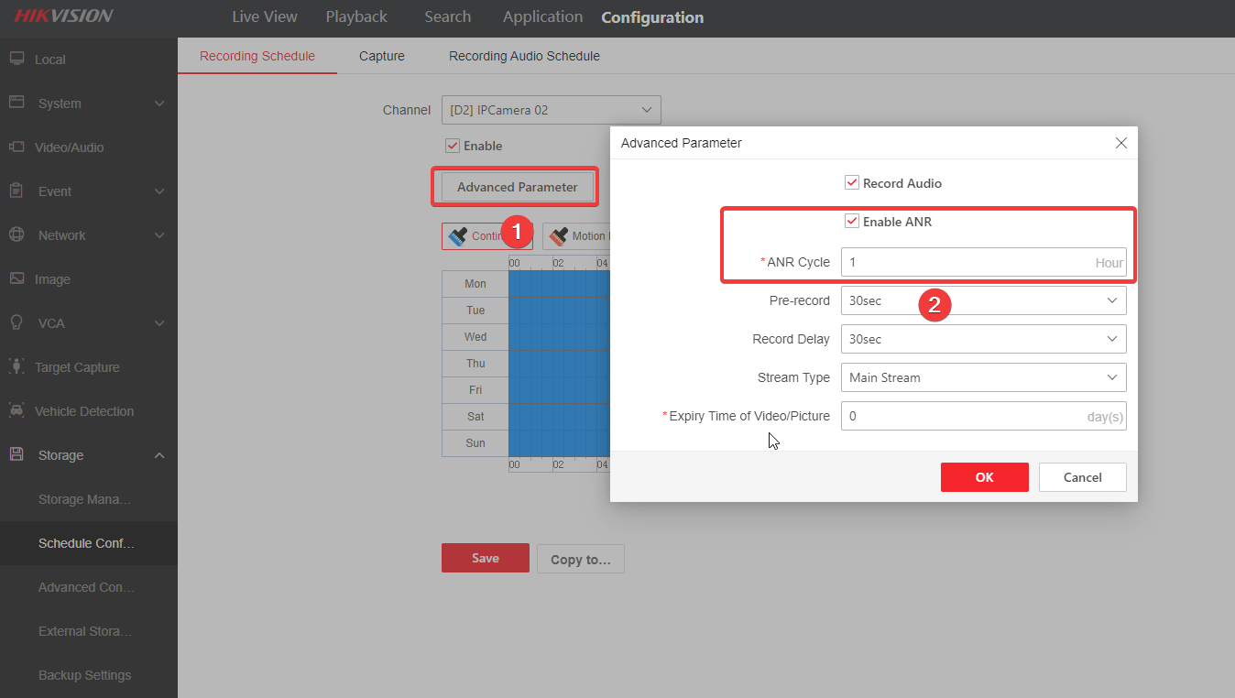

After configuration, user can check playback on NVR later.

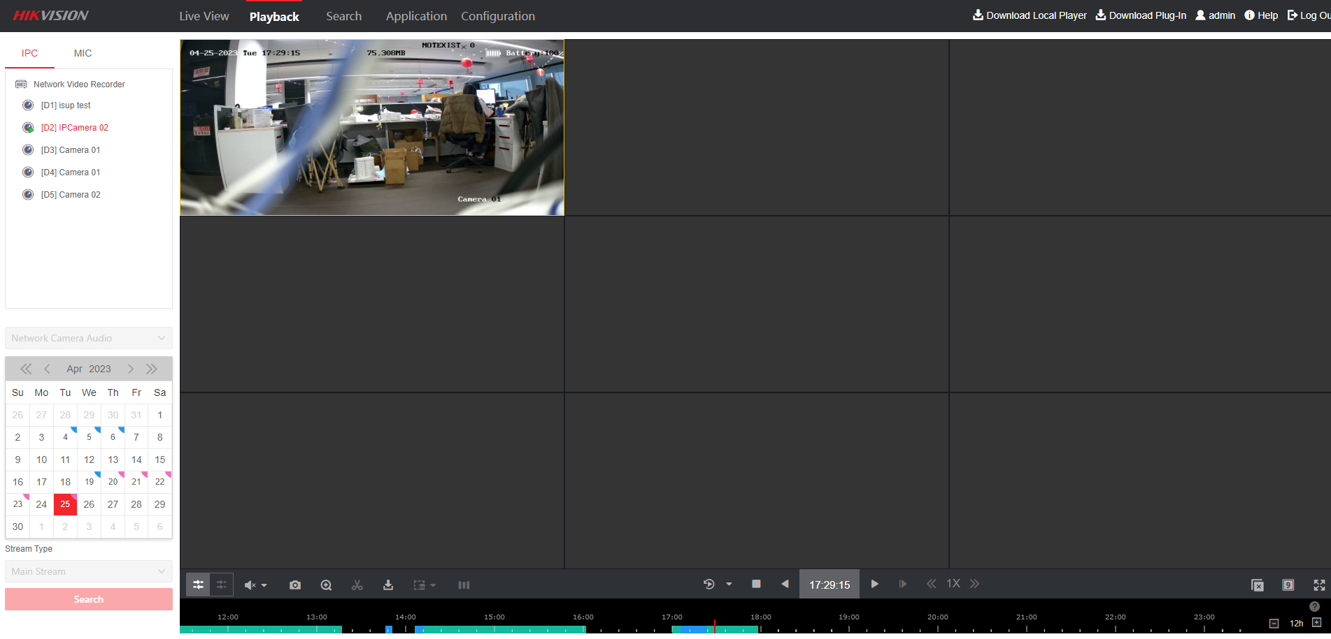

1. This version of NVR also supports the configuration of the Power Consumption mode of the solar camera. Click **Configuration-Low Power Consumption** and user can switch between the three power consumption modes shown as below.

