**3rd generation of DeepinMind NVR V4.60.110_220303 Release Notes**

**(2022-3-20)**

|  |  |  |
| --- | --- | --- |
| **Firmware**  **Basic Information** | Firmware Version: | V4.60.110_220303 |
| SDK Version: | V6.1.7.20_build20210513 |
| Play Library (PlayCtrl.dll) | V7.3.8.45 |
| Web version | V4.5.0build220124 |
| Client version | V3.7.3.3 build20220223 |

**Reason of Upgrade**

Add new features and optimize product performance.

**New features**

1. **Support “Throwing Objects from Building” event of cameras**
2. Support add “Throwing Objects from Building” camera;
3. Support receive “Throwing Objects from Building” event and retrieval on NVR;
4. Support track overlay in playback video.
5. **Increase“Throwing Objects from Building” mode on DeepinMind NVR**
6. Increase new mode “Throwing Objects from Building”, integrated Throwing Objects from Building algorithm in NVR;

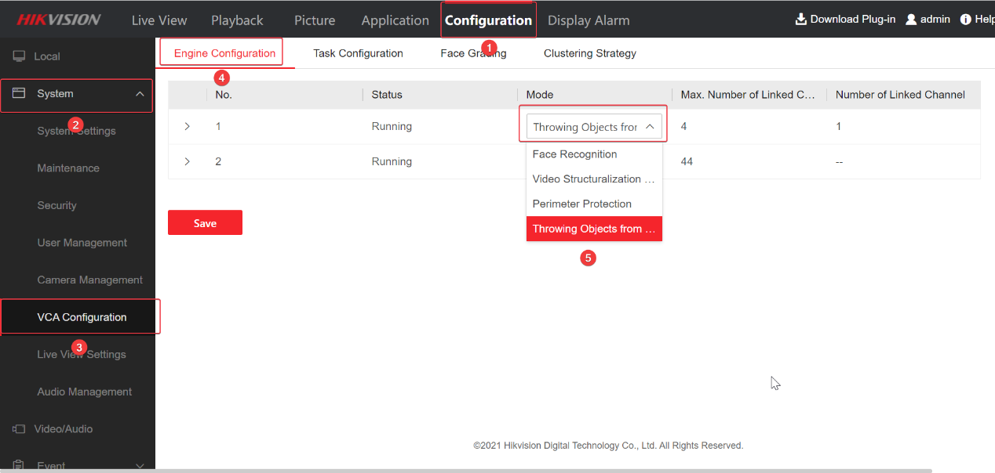

1. Support detect throwing objects from building and generate track;

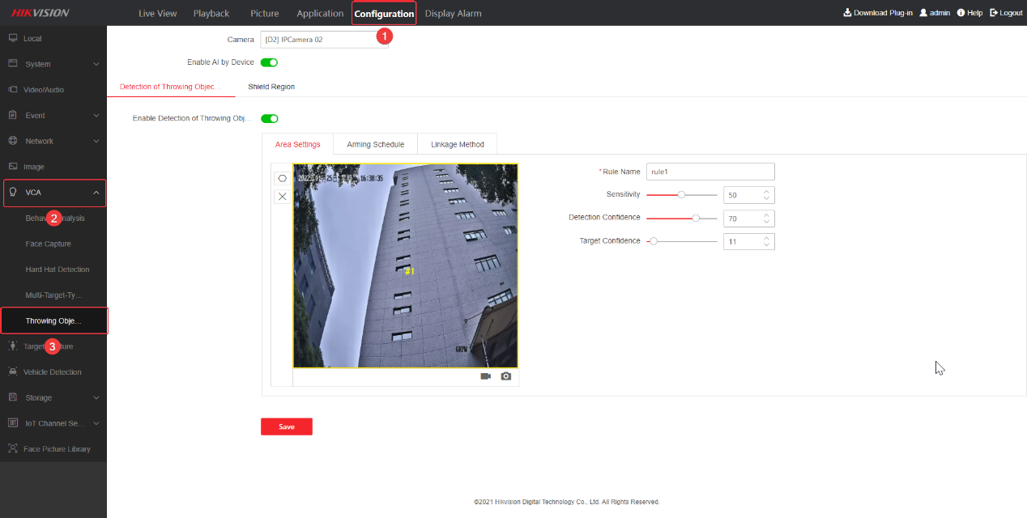

1. Support view the track in live view/playback/alarm.

**Related product list:**

|  |  |
| --- | --- |
| 3rd generation of DeepinMind NVR | Overseas (8/16/32/64 channels)  iDS-6708NXI-I/FA  iDS-6708NXI-I/FA  iDS-7608NXI-I2/X  iDS-7608NXI-I2/X  iDS-7616NXI-I2/X  iDS-7616NXI-I2/X  iDS-7608NXI-I2/8P/X  iDS-7616NXI-I2/16P/X  iDS-7608NXI-I2/8P/X  iDS-7616NXI-I2/16P/X  iDS-9616NXI-I16/X  iDS-9616NXI-I16/X  iDS-9632NXI-I16/X  iDS-9632NXI-I16/X  iDS-9664NXI-I16/X  iDS-9664NXI-I16/X  iDS-9616NXI-I8/X  iDS-9616NXI-I8/X  iDS-9632NXI-I8/X  iDS-9632NXI-I8/X  iDS-9664NXI-I8/X  iDS-9664NXI-I8/X  iDS-7716NXI-I4/X  iDS-7716NXI-I4/X  iDS-7732NXI-I4/X  iDS-7732NXI-I4/X  iDS-7716NXI-I4/16P/X  iDS-7716NXI-I4/16P/X  iDS-7732NXI-I4/16P/X  iDS-7732NXI-I4/16P/X  iDS-7732NXI-I4/16P/S  iDS-9616NXI-I8/S  iDS-9632NXI-I8/S  iDS-9664NXI-I8/S  iDS-6716NXI-I/S  iDS-7732NXI-I4/S  iDS-7716NXI-I4/S  iDS-7716NXI-I4/16P/S  iDS-7732NXI-I4/16P/S  iDS-7732NXI-I4/S  iDS-7716NXI-I4/16P/S  iDS-7716NXI-I4/S  iDS-6716NXI-I/S  iDS-9664NXI-I8/S  iDS-9616NXI-I8/S  iDS-9632NXI-I8/S |

**Customer Impact and Recommended Action**

This new firmware upgrade is to improve product performance, and will take effect automatically after upgrading from previous versions. We’d like to inform you the above changes. Also, we are sorry for any possible inconvenience of use-habit changes caused by this action.

For questions or concerns, please contact our local technical support team.

Note:

* Hikvision has all rights to alter, modify and cancel this notice.
* Hikvision doesn’t give any guarantee for old models’ stock.
* Hikvision is not liable for any typing or printing errors.
* For special model’s change details, please contact our local technical support team.

Hikvision Digital Technology CO., Ltd.

No. 555 Qianmo Road, Binjiang District, Hangzhou 310052, China

Tel: +86-571-8807-5998

FAX: +86-571-8993-5635

Email: support@hikvision.com