**3rd generation of DeepinMind NVR V4.60.000_211129 Release Notes**

**(2021-11-29)**

|  |  |  |
| --- | --- | --- |
| **Firmware**  **Basic Information** | Firmware Version: | V4.60.000_211129 |
| SDK Version: | V6.1.7.20_build20210513 |
| Play Library (PlayCtrl.dll) | V7.3.8.45 |
| Web version | V4.5.0build211101 |
| Client version | V3.6.5.4 build20210929 |

**Reason of Upgrade**

Add new features and optimize product performance.

**New features**

1. **Support displaying VCA information on GUI live view**
2. Support displaying VCA rules on GUI live view.
3. VCA rules display of 16 channels can be enabled at the same time.
4. Support enable/disable VCA rules for single channel.
5. The events of VCA rules can be displayed contain:

Perimeter Protection.

Human Body Detection.

Fire Source Detection.

Temperature Measurement of thermal camera.

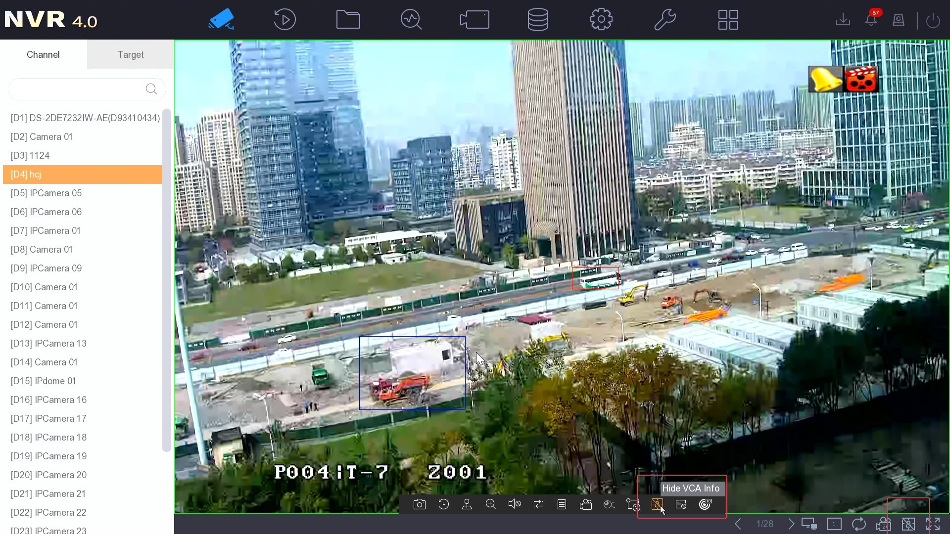

1. **Support Min Moe device access**
2. Support Min Moe device access.
3. Min Moe devices can be detected and shown in online device list of local GUI, web and 4200.
4. Support UI display of Min Moe’s events (Face picture and Authentication result).
5. Capture Pictures of Min Moe devices can be searched through Card Swiping Record interface.

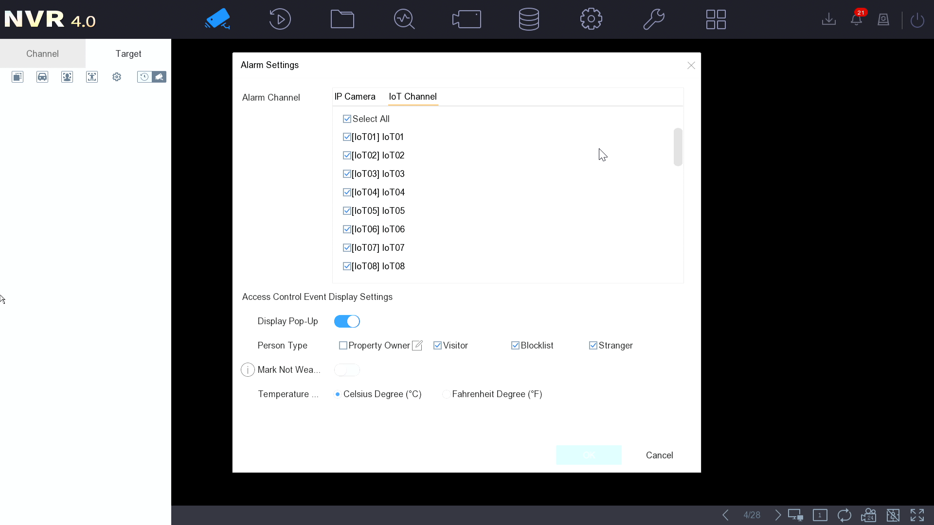

1. **Support sound and light functions of sound and light alarm products (Hik-connect)**
2. Support triggering sound and light alert of IPC through Hik-connect APP.
3. Support adjusting brightness of supply light through Hik-connect APP.
4. Support importing custom audio through Hik-connect APP.

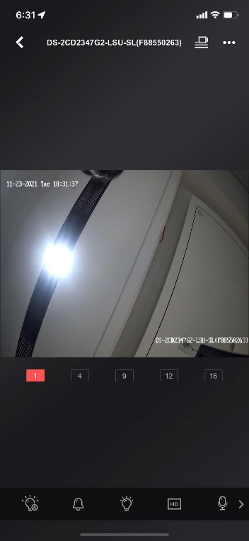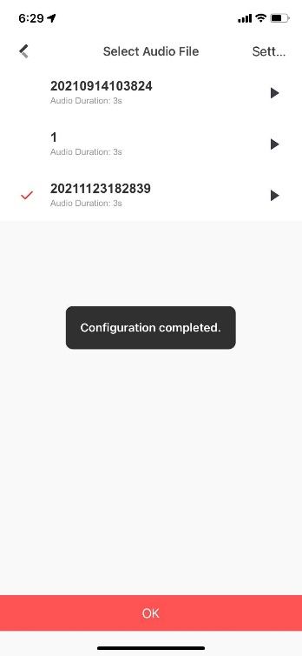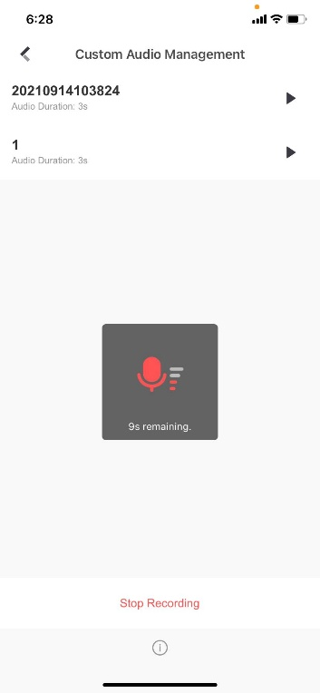

1. **Support Panovue camera access**
2. Support Panovue camera access and display as its original image scale. The models support: DS-2CD2T87FP-L、DS-2CD3T87FP-L、DS-2CD2T87FAP-L、DS-2CD3T87FAP-L.
3. The main stream resolution supported is 5120*1440, the sub-stream resolution supported is 1920*540.
4. Support capture picture of IPC display at local GUI as its original image scale.
5. **Support video quick backup**
6. Support video quick backup on local GUI.
7. Support asynchronous backup, and backup process can be viewed.

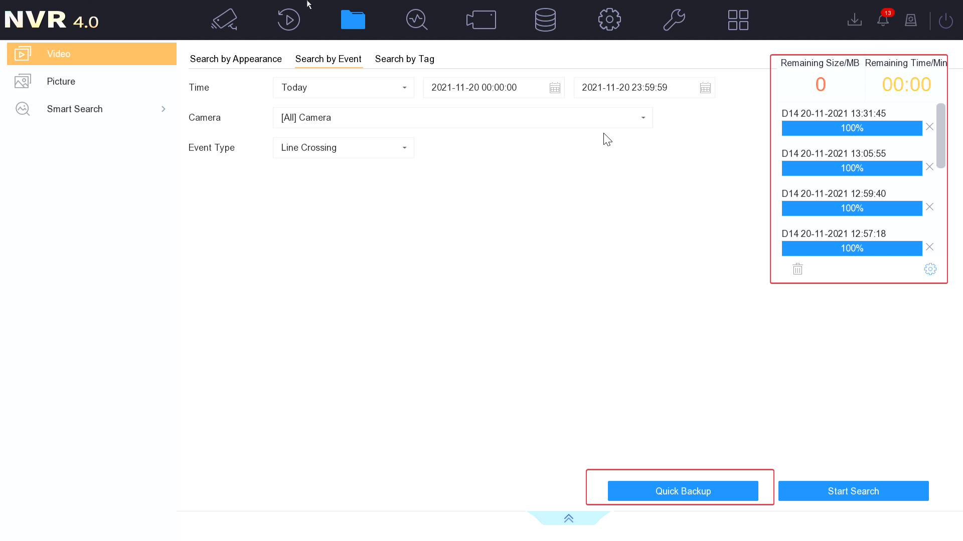

**Modified functions**

1. **Password recovery mode modification**
2. When NVR is activated, one or multiple methods must be selected to restore password.
3. If resetting password by email is selected, correct email address must be input.
4. If resetting password by HC is selected, NVR should be added to a HC account first.
5. If resetting password by security questions is selected, three questions and answers must be set.
6. For simple restore, you do not need to reset security questions.
7. **Extend maximum storage period of device log**

After set Log Storage Mode as Custom, log storage period can be extended to 180 days maximum.

1. **Buzzer linkage optimization**
2. For HDD Error and Record/capture Exception alarm, if no HDD has been connected to the device, or the connected HDD has not been identified, these two types of alarm will not be triggered
3. Only after record schedule is enabled, IPC are connected and HDD is identified, Record/capture Exception alarm can be triggered.
4. By default, alarm of all events will not link buzzer.
5. Support one-key enable/disable buzzer.

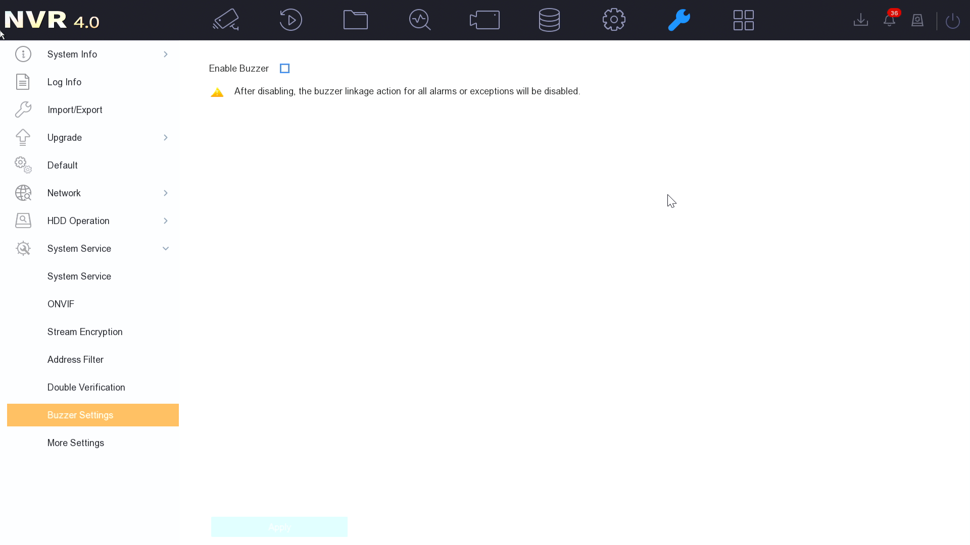

1. **Custom protocol URL prompt optimization**

Add URL prompt of third party IPC when configure custom protocol.

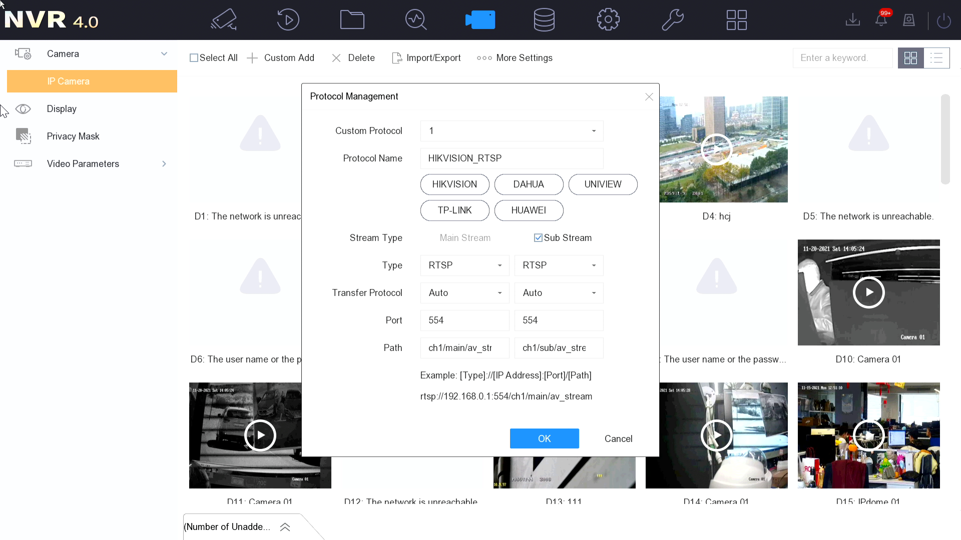

1. **New IPC parameter is included in import/export file**

Channel name is included in import/export file of IP camera parameters now.

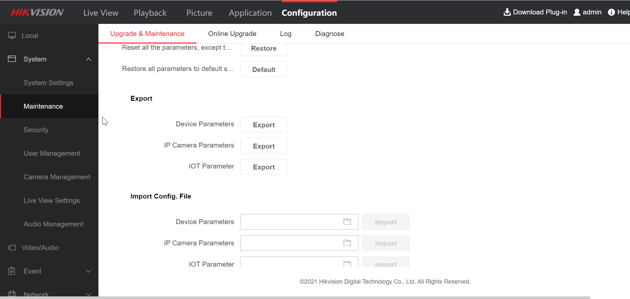

1. **Support switch between the main and auxiliary interface by middle mouse button**

Double click middle mouse button on local GUI can switch between the main and auxiliary interface.

1. **Add product usage tips**

Add product usage tips when users activate or log in to NVR.

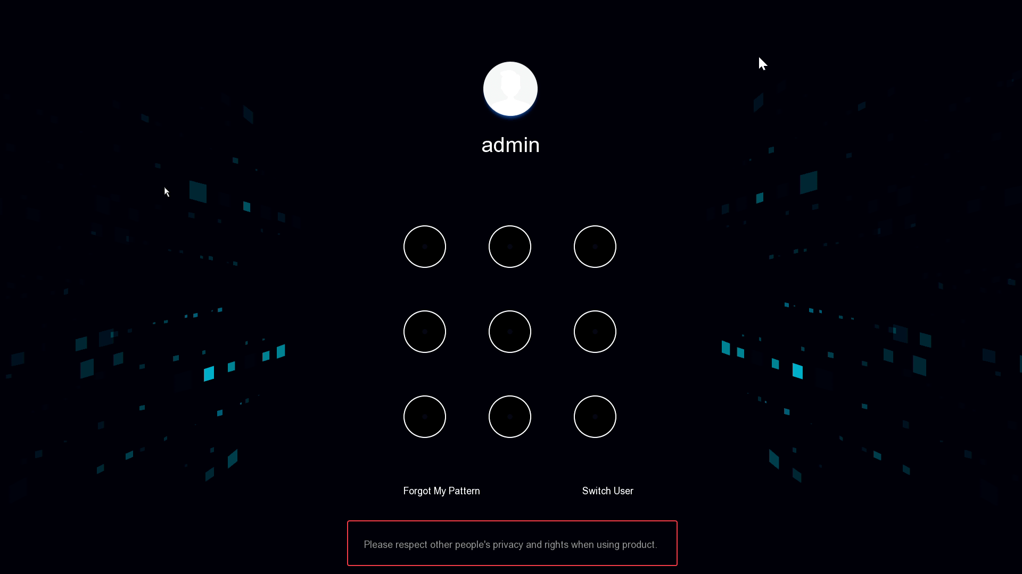

1. **Support one-key time sync configuration**
2. Time sync for all connected devices can be one-key enabled/disabled.
3. Both local GUI and WEB support this function.

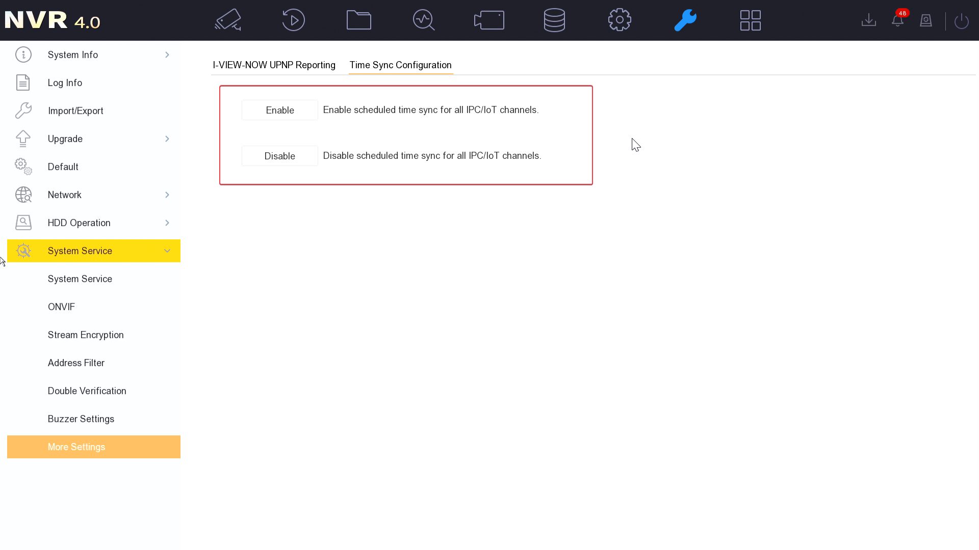

1. **Error code optimization**

Error codes for users to view are more readable so it could help users avoid some operational problems.

**Related product list:**

|  |  |
| --- | --- |
| 3rd generation of DeepinMind NVR | Overseas (8/16/32/64 channels)  iDS-6708NXI-I/FA  iDS-6708NXI-I/FA  iDS-7608NXI-I2/X  iDS-7608NXI-I2/X  iDS-7616NXI-I2/X  iDS-7616NXI-I2/X  iDS-7608NXI-I2/8P/X  iDS-7616NXI-I2/16P/X  iDS-7608NXI-I2/8P/X  iDS-7616NXI-I2/16P/X  iDS-9616NXI-I16/X  iDS-9616NXI-I16/X  iDS-9632NXI-I16/X  iDS-9632NXI-I16/X  iDS-9664NXI-I16/X  iDS-9664NXI-I16/X  iDS-9616NXI-I8/X  iDS-9616NXI-I8/X  iDS-9632NXI-I8/X  iDS-9632NXI-I8/X  iDS-9664NXI-I8/X  iDS-9664NXI-I8/X  iDS-7716NXI-I4/X  iDS-7716NXI-I4/X  iDS-7732NXI-I4/X  iDS-7732NXI-I4/X  iDS-7716NXI-I4/16P/X  iDS-7716NXI-I4/16P/X  iDS-7732NXI-I4/16P/X  iDS-7732NXI-I4/16P/X  iDS-7732NXI-I4/16P/S  iDS-9616NXI-I8/S  iDS-9632NXI-I8/S  iDS-9664NXI-I8/S  iDS-6716NXI-I/S  iDS-7732NXI-I4/S  iDS-7716NXI-I4/S  iDS-7716NXI-I4/16P/S  iDS-7732NXI-I4/16P/S  iDS-7732NXI-I4/S  iDS-7716NXI-I4/16P/S  iDS-7716NXI-I4/S  iDS-6716NXI-I/S  iDS-9664NXI-I8/S  iDS-9616NXI-I8/S  iDS-9632NXI-I8/S |

**Customer Impact and Recommended Action**

This new firmware upgrade is to improve product performance, and will take effect automatically after upgrading from previous versions. We’d like to inform you the above changes. Also, we are sorry for any possible inconvenience of use-habit changes caused by this action.

For questions or concerns, please contact our local technical support team.

Note:

* Hikvision has all rights to alter, modify and cancel this notice.
* Hikvision doesn’t give any guarantee for old models’ stock.
* Hikvision is not liable for any typing or printing errors.
* For special model’s change details, please contact our local technical support team.

Hikvision Digital Technology CO., Ltd.

No. 555 Qianmo Road, Binjiang District, Hangzhou 310052, China

Tel: +86-571-8807-5998

FAX: +86-571-8993-5635

Email: support@hikvision.com