**2nd generation of DeepinMind NVR V4.50.000 Build210125 Release Notes**

**(2021-2-25)**

|  |  |  |
| --- | --- | --- |
| **Firmware**  **Basic Information** | Firmware Version: | V4.50.000 Build210125 |
| SDK Version: | V6.1.6.5_build20201028 |
| Play Library (PlayCtrl.dll) | V7.3.8.40 |
| Web version | V4.0.1.1build201209 |
| Client version | V3.3.3.105 build20201130 |

**Reason of Upgrade**

Add new features and optimize product performance.

**New features**

1. **Local GUI menu operation optimization**
2. Local Live View supports shortcut operation of right-click menu. The specific menu options are: Single-screen selection; Multi-screen selection; Previous screen; Next screen; Start/stop Auto-switch; Add IP channel; Playback; PTZ control; Full screen/Main menu.

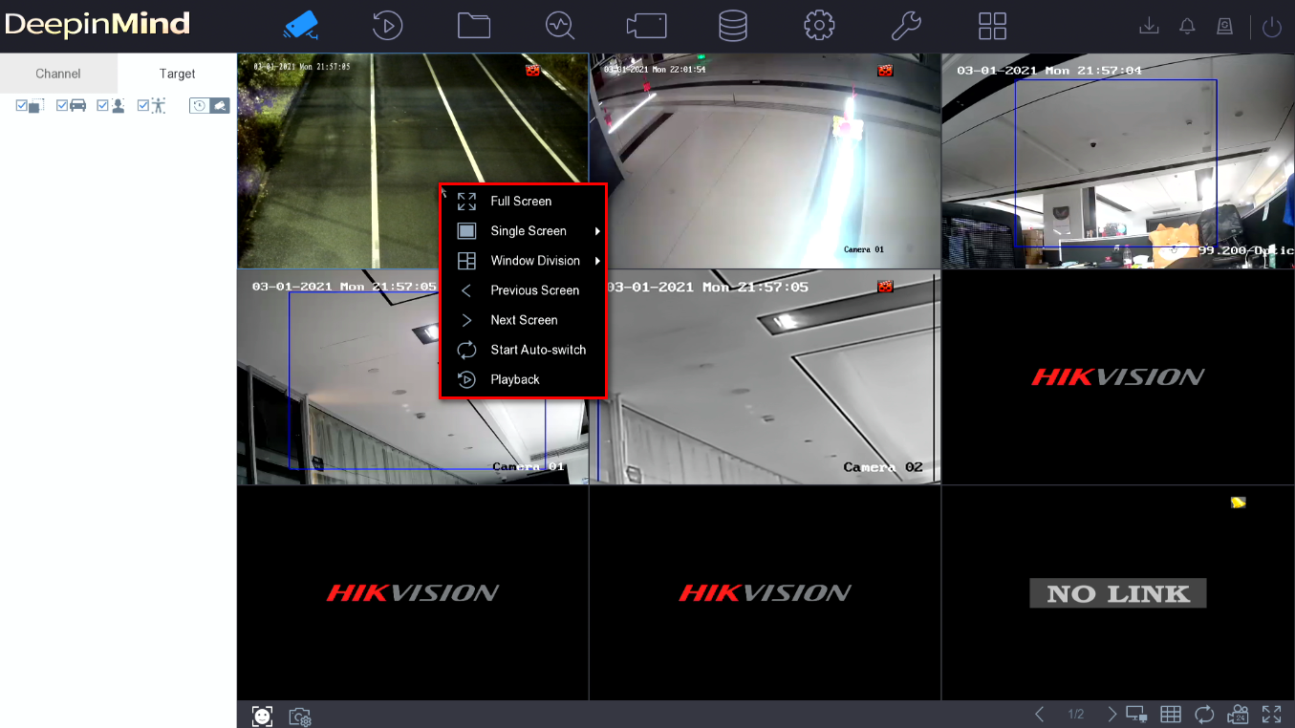

1. Local normal playback and custom playback support channel group selection function.

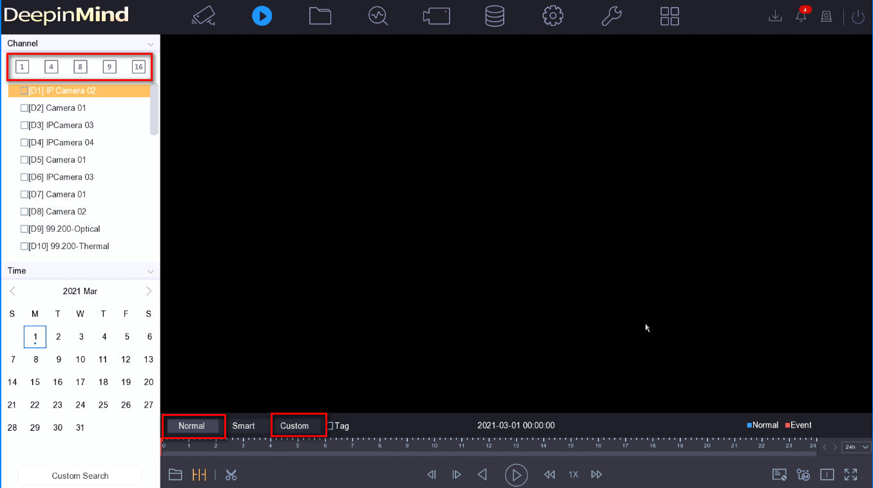

1. The progress bar supports mouse wheel control when playing back video, and the left mouse button is used for positioning.

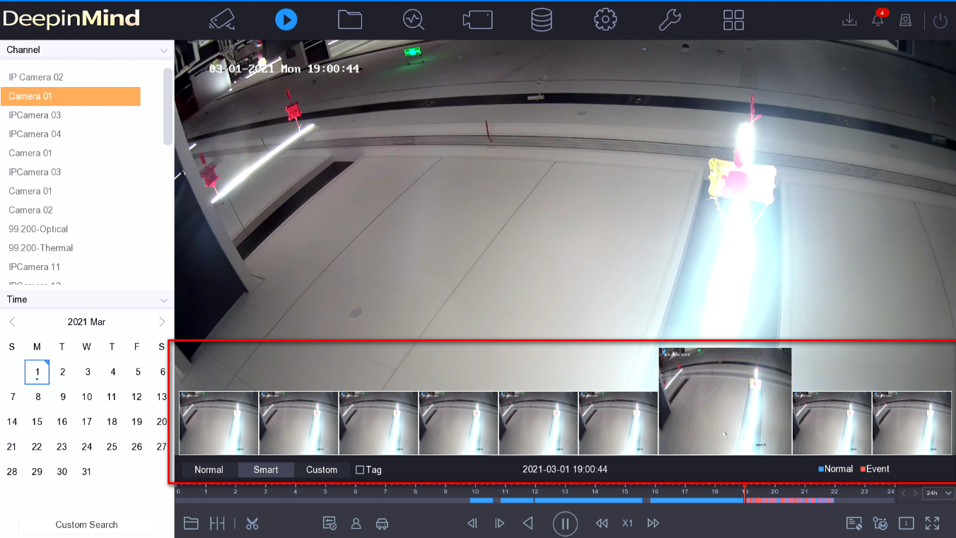

1. Remove the double progress bar, the progress bar only displays the video distribution of the currently selected channel.
2. **N+M function**
3. N+M system hot backup is to solve the scenario where multiple working machines fail at the same time, it supports adding up to 32 working machines and 32 hot backup machines.

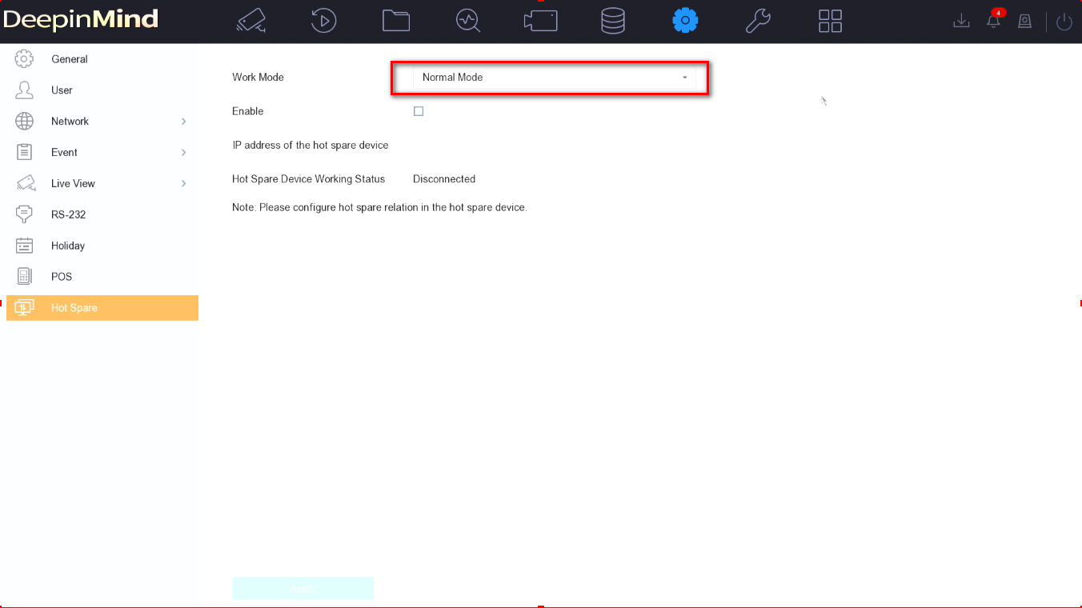

1. The hot standby NVR can automatically take over the offline working machine, and return the video after the working machine is restored.
2. Compatible with the original N+1 function, the original local N+1 configuration menu is modified to the N+M configuration menu, the N+M menu is added on the WEB, and only the N+1 configuration menu is retained on the 4200.

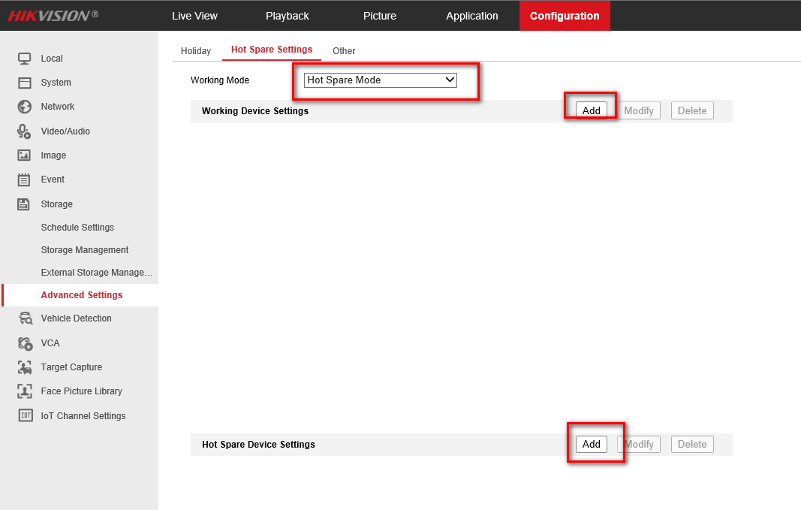

1. Based on the existing N+1 environment, other hot standby machines can be added to the hot standby machine to form an N+M system.
2. **Local GUI multi-channel alarm linkage association**
3. Target detection on the preview interface, showing pictures and videos of the associated channel.
4. The bell interface can play channel recordings associated with multi-channel camera event alarms.

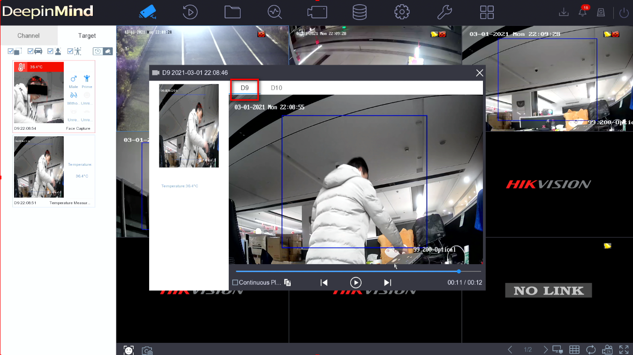

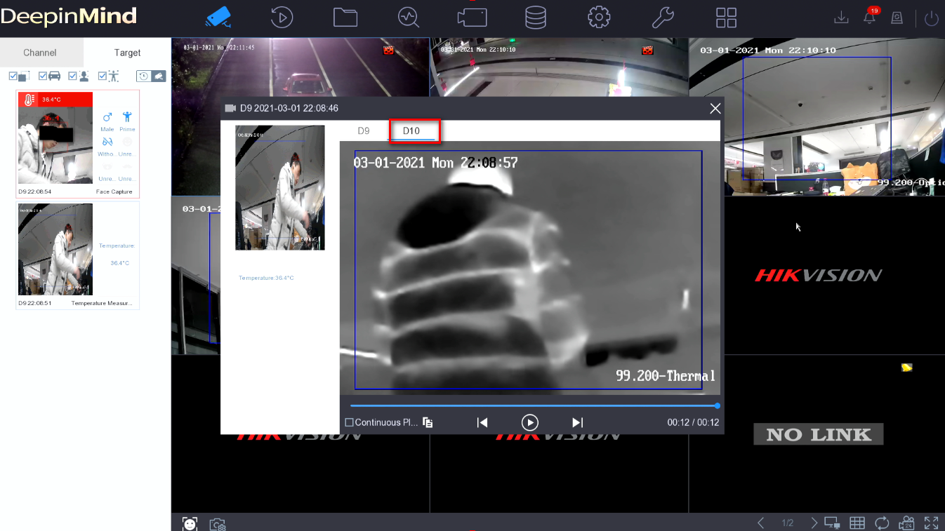

1. **ISUP5.0 protocol supports stream encryption function**

In order to improve the security of data information, ISUP5.0 protocol supports TCP, NPQ stream encryption transmission and voice intercom data encryption.

***Note:*** The platform software has not yet released this feature version.

1. **ISUP5.0 protocol supports NPQ mode low bandwidth transmission**

After the platform software uses the ISUP5.0 protocol to add the NVR, you can select the NPQ mode for preview and playback when the network is not good.

***Note:*** The platform software has not yet released this feature version.

1. **Add the hardware version number on the local GUI**

The local GUI adds the hardware version number to distinguish the devices of the same model with different motherboards.

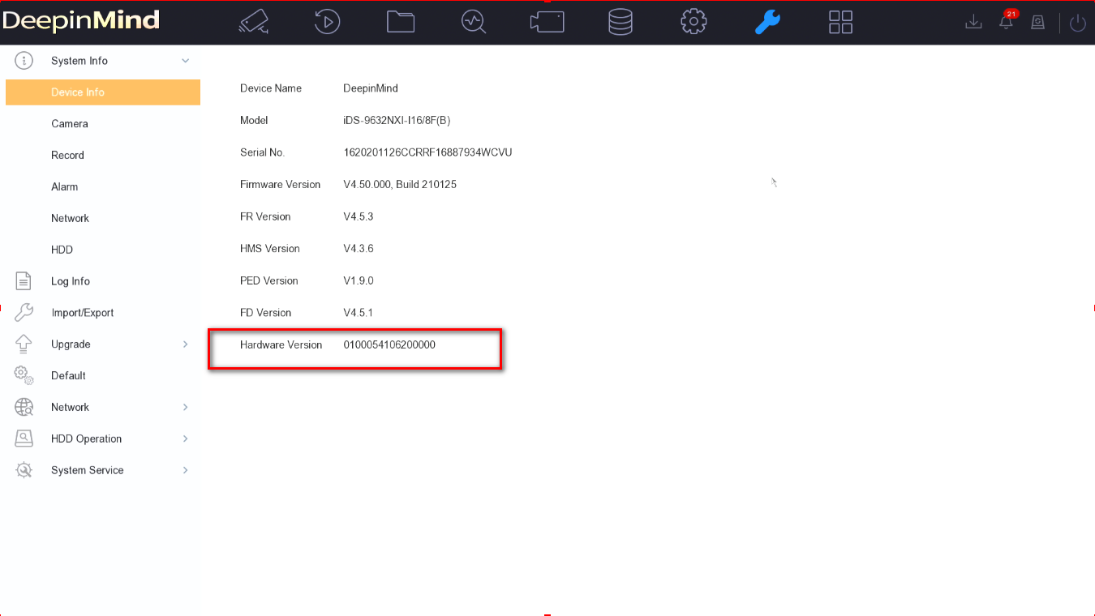

1. **Local voice broadcast control**

Local one-key disarming can control local voice broadcast.

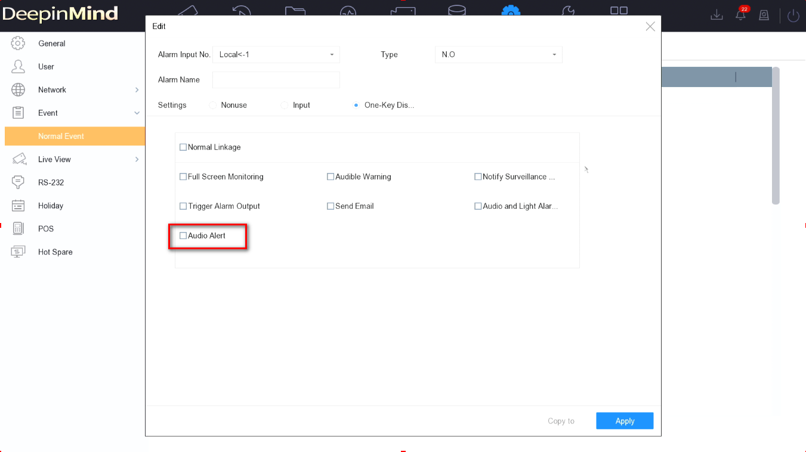

**Modified functions**

1. **Multi-track stream ultra HD resolution camera access optimization**
2. Maximum support for multi-track streaming and ultra HD resolution cameras to connect to any 4 channels of NVR.
3. The maximum resolution of high-resolution cameras that support single-track streaming is 4096*4096.
4. **"Black and white" sensitive character optimization**

In order to improve the read and write capacity of the HDD, NVR does not store the VCA data of the camera by default. If the user needs to use the VCA data for retrieval and playback, both the IPC's Dual-VCA function and the NVR's Save Camera VCA Data function must be activated.

1. **IP camera intelligent analysis data storage optimization**

In order to improve the read and write capacity of the HDD, NVR does not store the VCA data of the camera by default. If the user needs to use the VCA data for retrieval and playback, both the IPC's Dual-VCA function and the NVR's Save Camera VCA Data function must be activated.

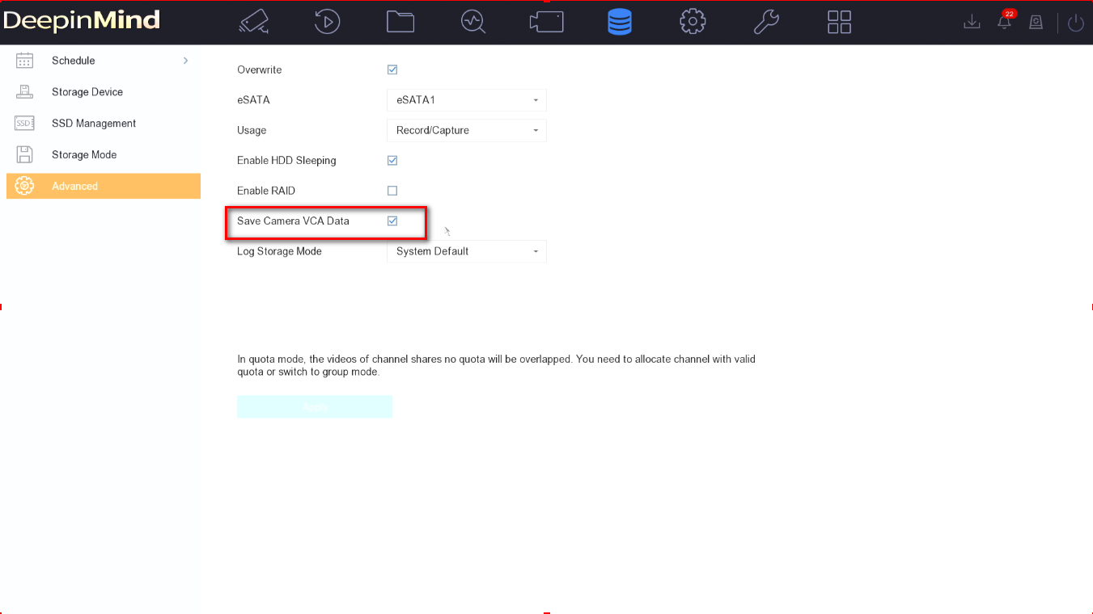

1. **WEB experience optimization**

Optimized WEB, it is smoother to use.

1. **Fisheye expansion effect optimization**

Improved the smoothness of the fisheye expansion during playback.

**Related product list:**

|  |  |
| --- | --- |
| 2nd generation of DeepinMind NVR | Overseas (16/32/64 channels)  iDS-9600NXI-I8/X(B)  iDS-9600NXI-I16/X(B)  iDS-9600NXI-I8/8F(B)  iDS-9600NXI-I16/8F(B)  iDS-9600NXI-I8/16S(B)  iDS-9600NXI-I16/16S(B)  iDS-7700NXI-I4/16S(B)  iDS-7700NXI-I4/16P/16S(B)  iDS-7700NXI-I4/X(B)  iDS-7700NXI-I4/16P/X(B)  iDS-6716NXI-I/16S(B)  iDS-6708NXI-I/8F(B) |

**Customer Impact and Recommended Action**

This new firmware upgrade is to improve product performance, and will take effect automatically after upgrading from previous versions. We’d like to inform you the above changes. Also, we are sorry for any possible inconvenience of use-habit changes caused by this action.

For questions or concerns, please contact our local technical support team.

Note:

* Hikvision has all rights to alter, modify and cancel this notice.
* Hikvision doesn’t give any guarantee for old models’ stock.
* Hikvision is not liable for any typing or printing errors.
* For special model’s change details, please contact our local technical support team.

Hikvision Digital Technology CO., Ltd.

No. 555 Qianmo Road, Binjiang District, Hangzhou 310052, China

Tel: +86-571-8807-5998

FAX: +86-571-8993-5635

Email: support@hikvision.com