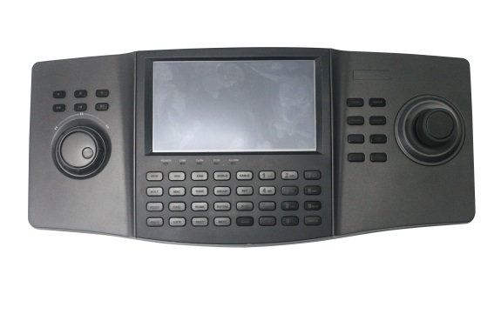**DS-1100KI V3.0.0 Release Notes**

|  |  |
| --- | --- |
| Reference NO: | 20160508_01 |
| Product Classification: | DS-1100KI |
| Date of Publication: | Apr. 29, 2016 |

**Reason of Upgrade**

Due to the firmware upgrade of old decoder (V3.5.0 of DS-6400HDI-T) and new release decoder model (DS-6900UDI), compatibility with decoder is the main reason to upgrade DS-1100KI keyboard.

**Firmware Upgrades**

**New features**

1. **Password security of Web Service**

1). After wrong password input on web service, 7 times for “admin” account and 5 time for “operator” account, the logging account associated with certain IP will be locked for 30 minutes, while other accounts logging with different IP can login in normally;

2). For keyboard under “inactivated” state, when login in web service, web page shall ask operator to activate device , so customer can activate the keyboard and modify a safe password;

3). When login web service with a risky password, the web page will warn operator to modify risky password to a safe one; click “OK” to enter the password revise page and click “cancel” to skip over the warning and login in the keyboard;

1. **Compatible with new decoder version or model**

The V3.0.0 is compatible with the V3.5.0 of DS-6400HDI-T and the newly released DS-6900UDI decoder.

1. **Device Category Management**

As to device management of V3.0.0, devices are divided into three categories, “Encoder”, “Controller” and “Decoder”. (IPC/NVR/DVR categorized as Encoder, DS-6900UDI/B20 MVR/C10S /DS-6400HDI-S categorized as Controller, DS-6400HDI-T categorized as Decoder)

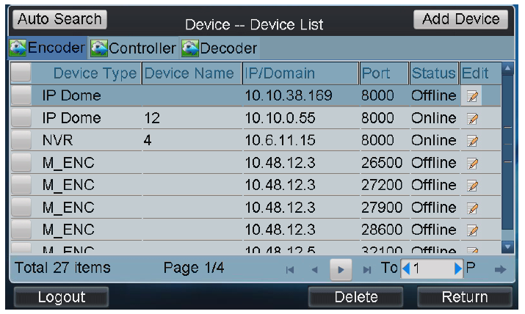

**Customer Impact and Recommended Action**

This new firmware upgrade is to improve product performance, and will take effect automatically after upgrading from previous versions. We’d like to inform you the above changes. Also, we are sorry for any possible inconvenience of use-habit changes caused by this action.

For questions or concerns, please contact our local technical support team.

Note:

* Hikvision has all rights to alter, modify and cancel this notice.
* Hikvision doesn’t give any guarantee for old models’ stock.
* Hikvision is not liable for any typing or printing errors.
* For special model’s change details, please contact our local technical support team.

Hikvision Digital Technology CO., Ltd.

No. 555 Qianmo Road, Binjiang District, Hangzhou 310052, China

Tel: +86-571-8807-5998

FAX: +86-571-8993-5635

Email: support@hikvision.com