**Temperature Screening MinMoe Terminal**

**Release Notes (2021-06-28)**

|  |  |  |
| --- | --- | --- |
| **Device Model:**  DS-K1T671TM-3XF  DS-K1TA70MI-T  DS-K5671-3XF  DS-K5604A-3XF | Firmware Version | **ARM**：  ACS_671_3XF_AI3_EN_**STD**_V3.2.32_build210610  ACS_671_3XF_AI3_EN_**NEU**_V3.2.32_build210610  **MCU**：ACS_DS-K1T671_ST1_GML_GM_V1.0.1_build210320  **Thermal Module**：digicap_thermo-en-gm_V5.5.10_build210406 |
| SDK | Latest baseline |
| iVMS-4200 Version | Latest baseline |

**Reason of Upgrade**

Fix bugs, enhance products quality and meet customers’ requirements.

**Modified Features**

1. Optimize the function of exporting data to U disk.
2. Optimize the working mechanism of supplement light

**Temperature Screening MinMoe Terminal**

**Release Notes (2021-04-02)**

|  |  |  |
| --- | --- | --- |
| **Device Model:**  DS-K1T671TM-3XF  DS-K1TA70MI-T  DS-K5671-3XF  DS-K5604A-3XF | Firmware Version | **ARM**：  DS-K1T671TM-3XF, DS-K1TA70MI-T, DS-K5671-3XF/ZU:  ACS_671_3XF_AI3_EN_**STD**_V3.2.2_build210324  ACS_671_3XF_AI3_EN_**NEU**_V3.2.2_build210324  DS-K5604A-3XF:  ACS_5604A_3XF_AI3_EN_**STD**_V3.2.2_build210323  ACS_5604A_3XF_AI3_EN_**NEU**_V3.2.2_build210323  **MCU**：ACS_DS-K1T671_ST1_GML_GM_V1.0.1_build210320  **Thermal Module**：digicap_thermo-en-gm_V5.5.10_build210316 |
| SDK | Latest baseline |
| iVMS-4200 Version | Latest baseline |

**Reason of Upgrade**

New function for other 2 models: DS-K5671-3XF, DS-K5604A-3XF

**New Feature**

1. Support web interface to login and configure device from browser.
2. Support TTS (English only) self-defined audio prompt for verification (disabled in default).

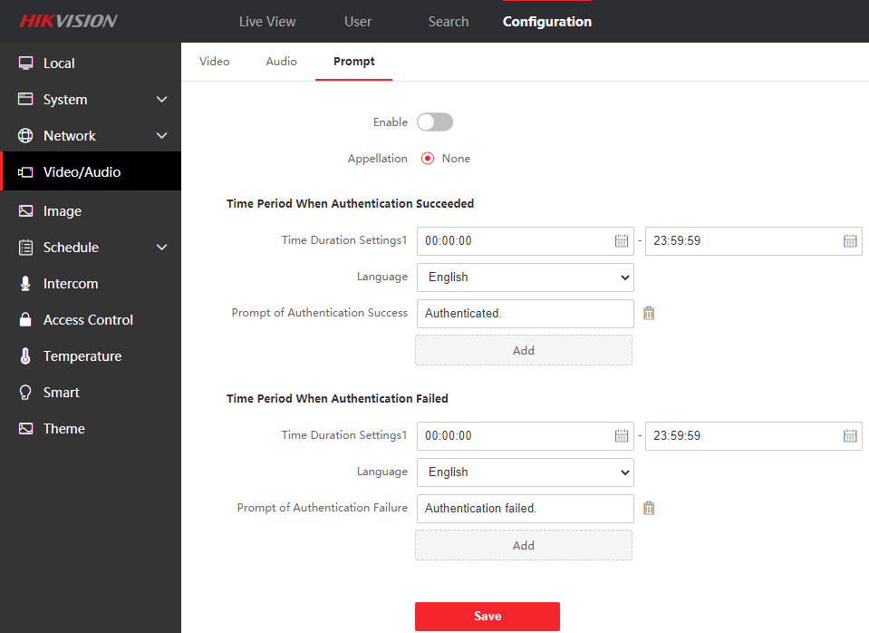

1. Add device operation log query function

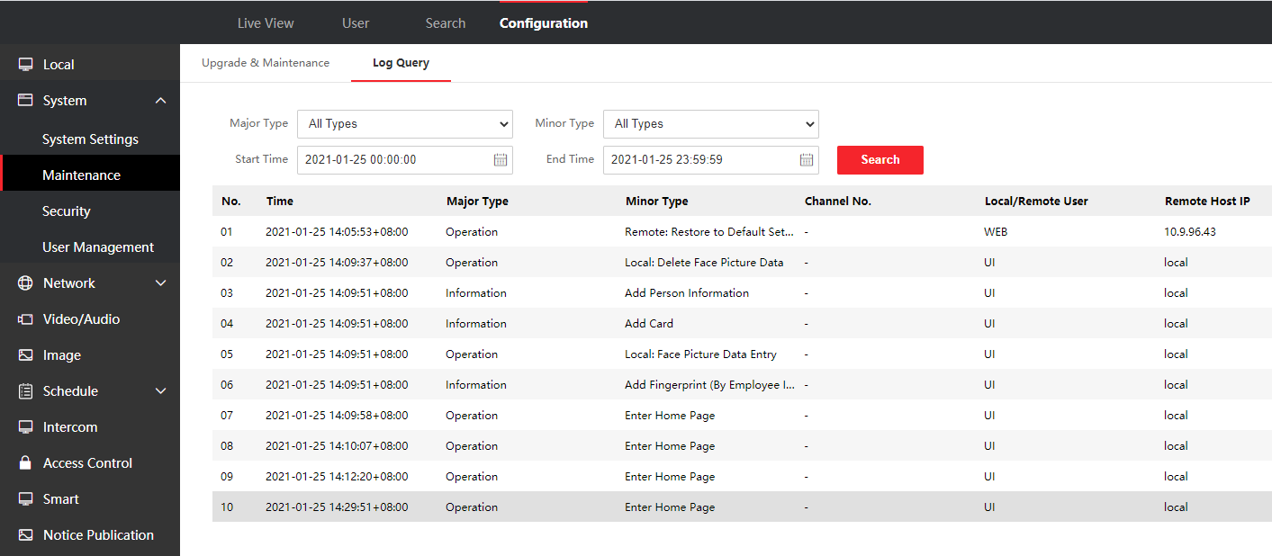

1. Add ISAPI event monitoring upload (HTTP/HTTPS listening) function for integration

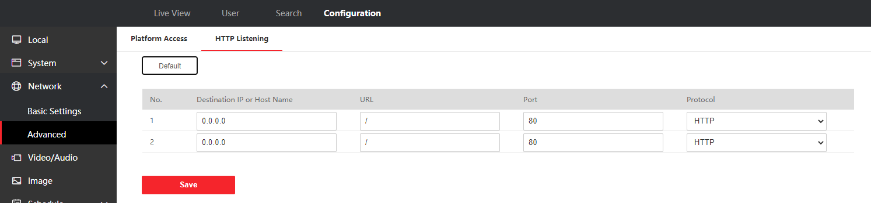

1. Add simple mode (disabled in default), after enable, it will not display live view when verify face

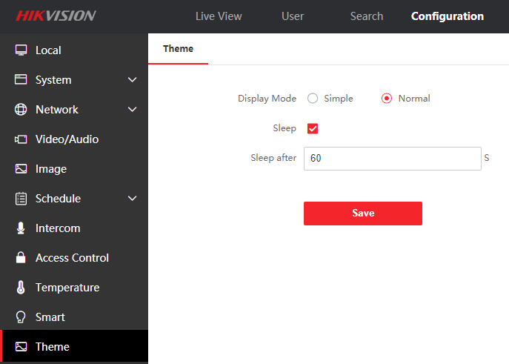

1. Add privacy protection, customer can define the privacy related parameter, such as whether to display photo, name, ID number, temperature after verification, Event Storage Settings, Picture Uploading and Storage, Clear All Pictures in Device

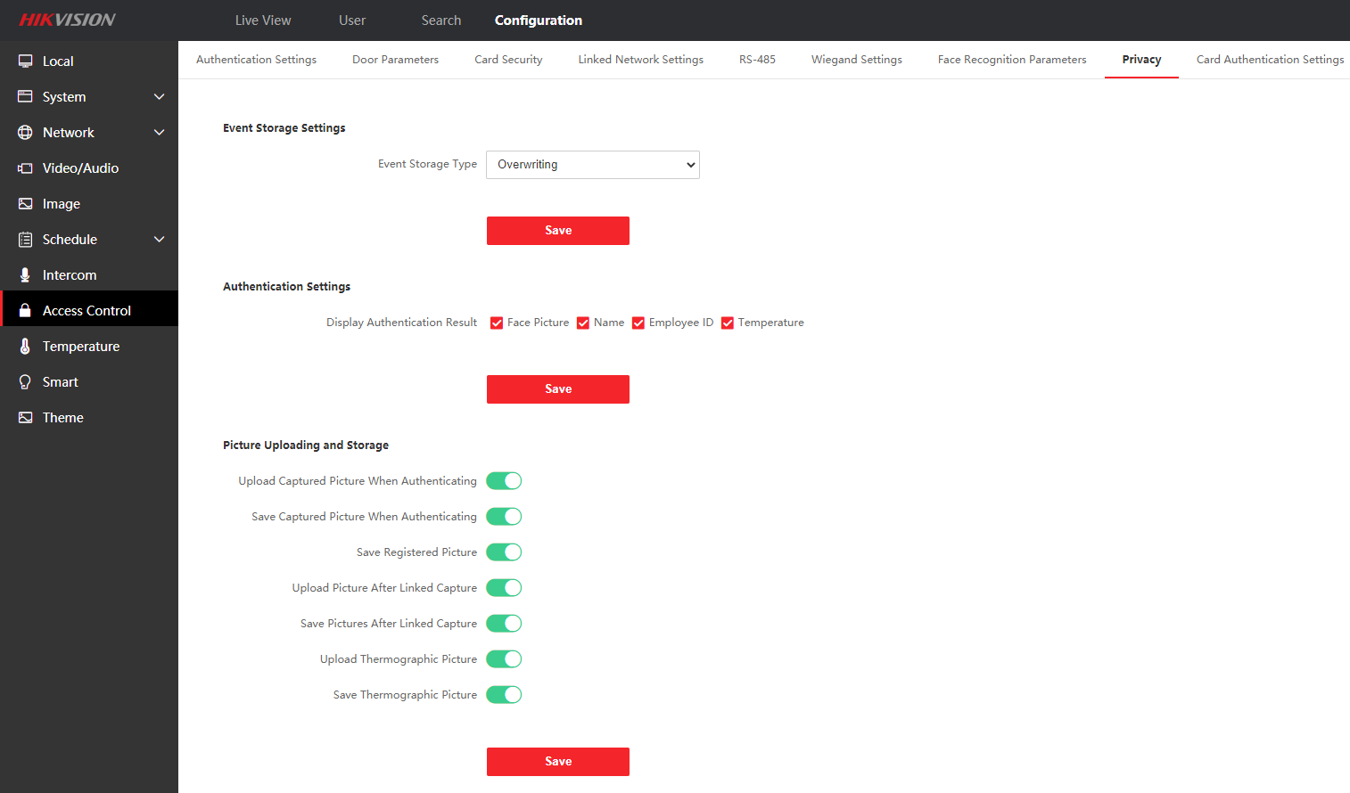

1. Support ISUP 5.0 to manage devices located in different network.

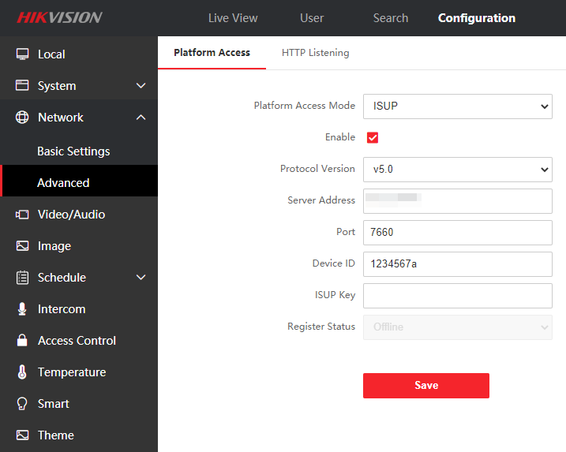

1. Support PIN code only to open the door (disabled in default)

Note：PIN code should be configured from software, iVMS4200 already support, HikCentral Pro will support PIN code configuration in V2.1 expected to be released in June

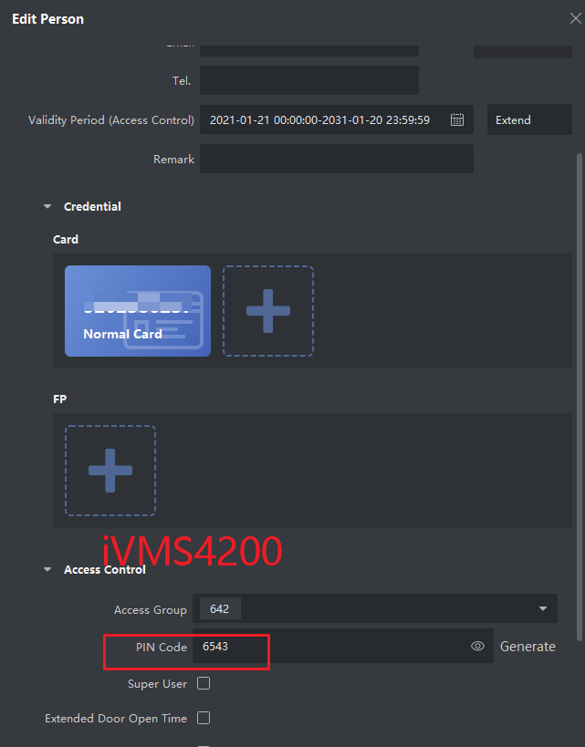 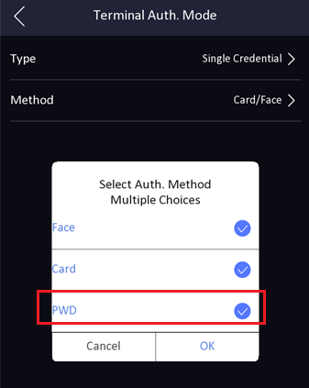

1. Support unbind device with hik-connect account on SADP tool, local UI and web

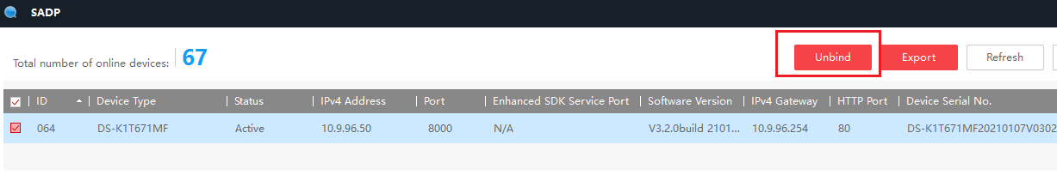

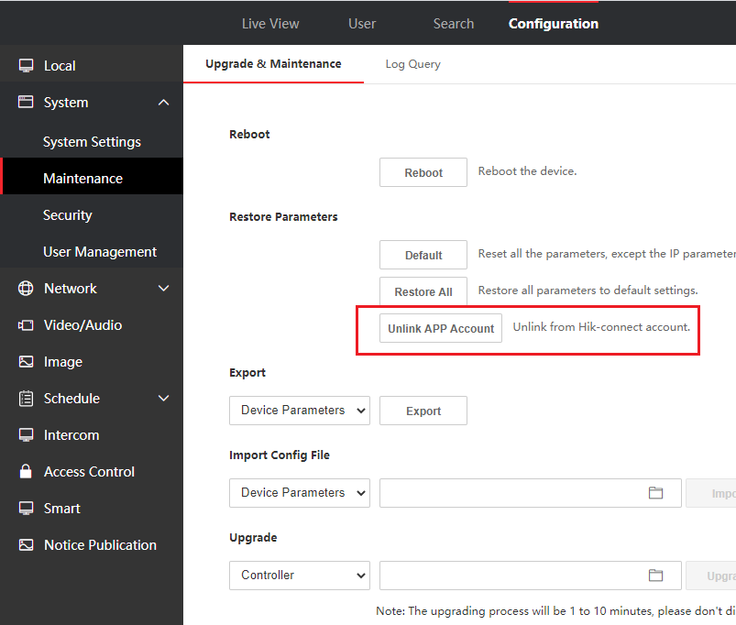 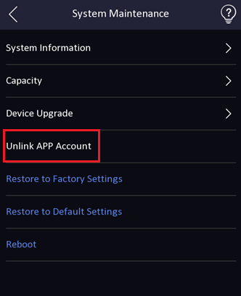

1. Add help interface to check module version for technical support (long press for 3s)

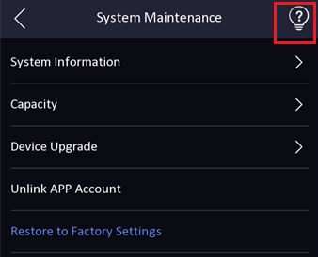 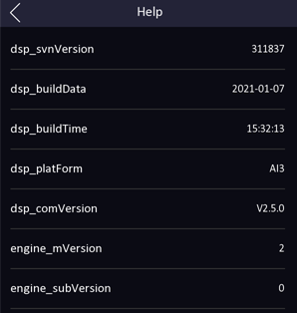

1. Add audio prompt ‘The door is open’ when open door on iVMS4200, HikCentral Pro, Hik-Connect App, and device UI will show prompt

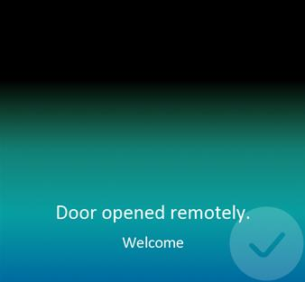

**Modified Features**

1. Upgrade face and mask algorithm. Improve the speed and accuracy of face and dark mask recognition.
2. Hik-Connect function is disabled in default for privacy protection, if customer want to manage device from App, please turn on manually in the web.

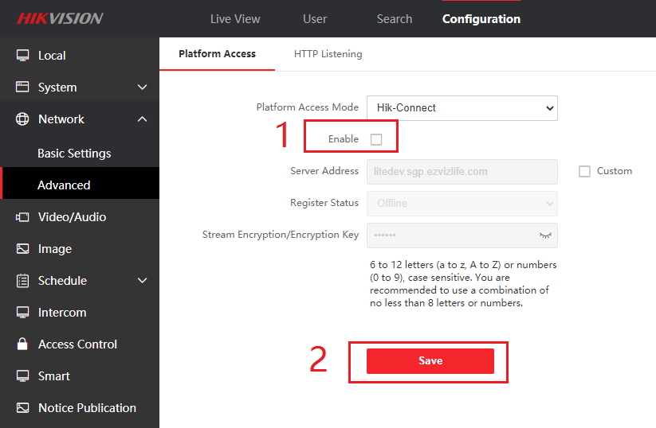

1. Black body parameters are deleted from device UI and move to web interface (DS-K1TA70MI-T doesn’t support black body function)

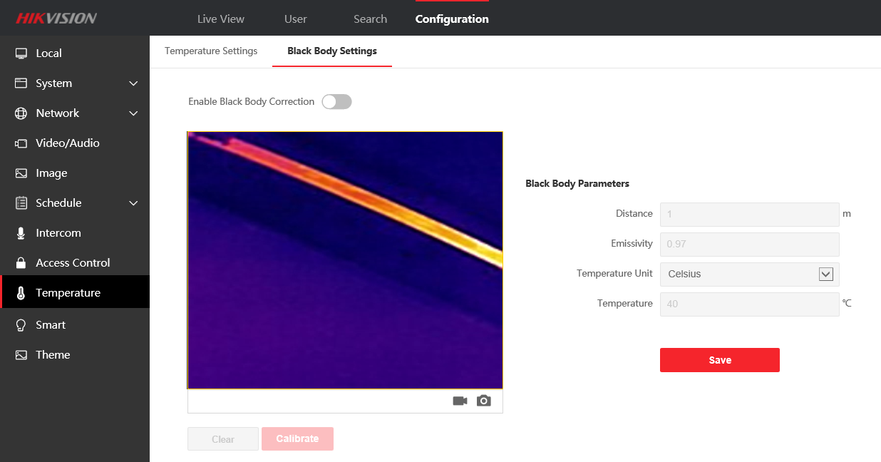

1. Event search function is deleted from device UI and move to web interface.

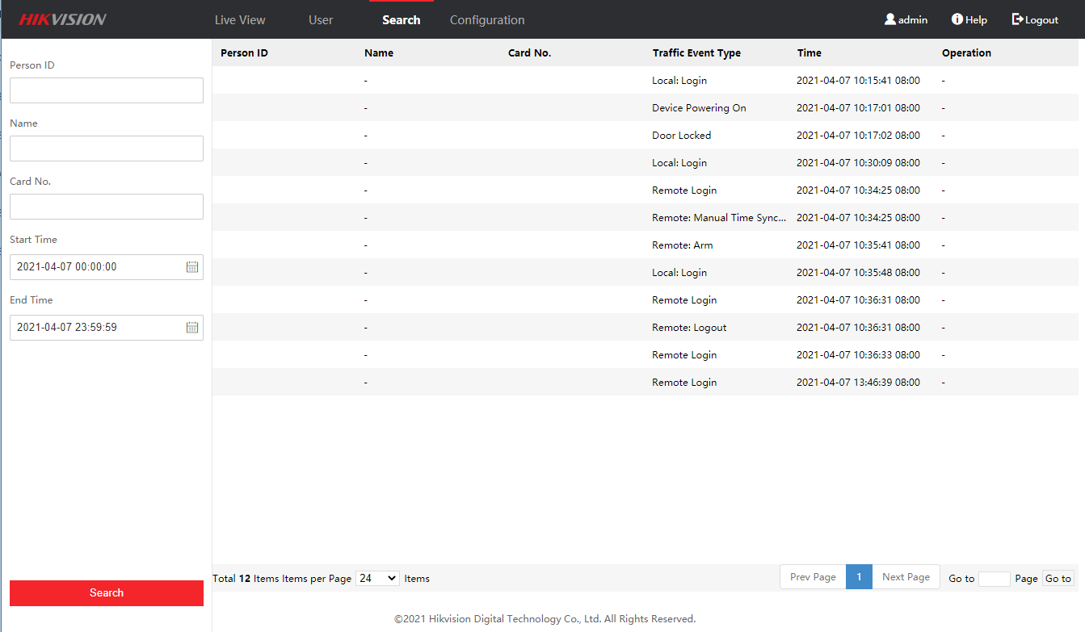

1. DNS can be configured from device UI in menu→Comm.-->Wired Network

**Customer Impact and Recommended Action**

This new firmware upgrade is to improve product performance, and will take effect automatically after upgrading from previous versions. We’d like to inform you the above changes. Also, we are sorry for any possible inconvenience of use-habit changes caused by this action.

For questions or concerns, please contact our local technical support team.

Note:

* Hikvision has all rights to alter, modify and cancel this notice.
* Hikvision doesn’t give any guarantee for old models’ stock.
* Hikvision is not liable for any typing or printing errors.
* For special model’s change details, please contact our local technical support team.

Hikvision Digital Technology CO., Ltd.

No. 555 Qianmo Road, Binjiang District, Hangzhou 310052, China

Tel: +86-571-8807-5998

FAX: +86-571-8993-5635

Email: support@hikvision.com