

How to add multi-channel cameras to NVR through POE

## Document introduction

The NVR can realize the plug and play function when it is connected to the single-eye IPC through POE. However, when a multi-channel camera is added to the NVR, the NVR can normally power the camera but only the first channel of the multi-channel camera can be successfully displayed on the NVR. In fact, all channels of the camera can be displayed on the NVR side through simple configuration. The following is the configuration process.

## Preparation in advance

One NVR with POE function and one multi-channel IPC (take the binocular PTZ camera as an example).

## Specific operations

1. Enable the POE port of NVR and make sure that the number of enabled channels is the same as the number of multi-channel cameras。

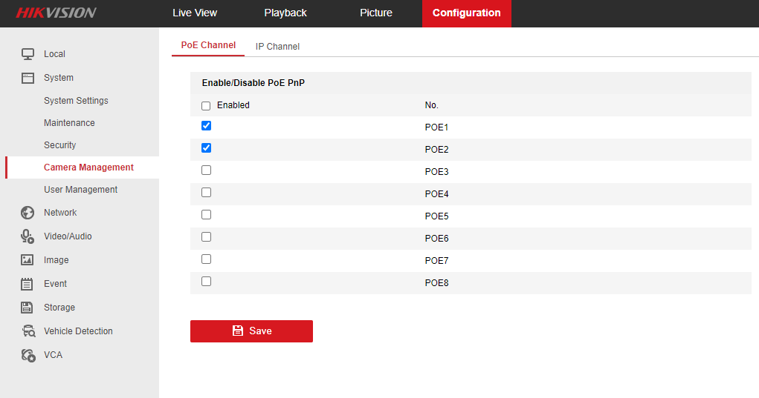

1. The camera accesses the NVR through the POE port and the corresponding POE channel prompts that the camera status is offline (detecting). It is estimated that it will take about 1 minute to detect. After that, the channel will prompt that the camera is online.

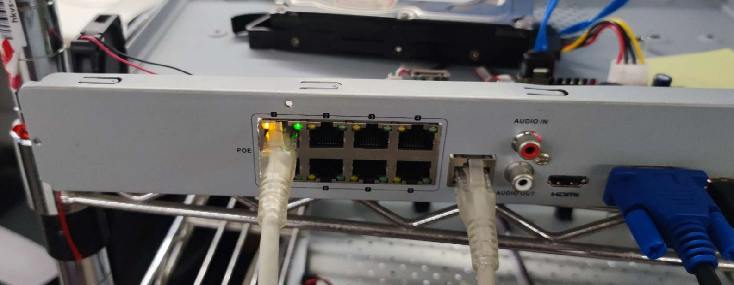

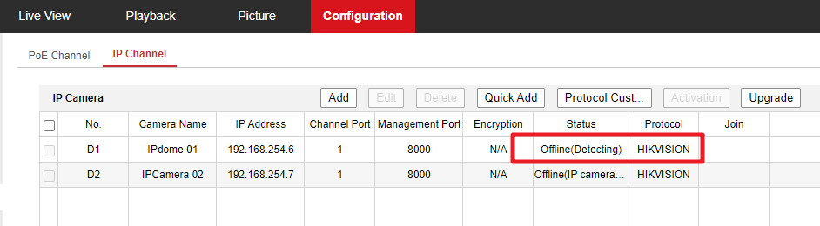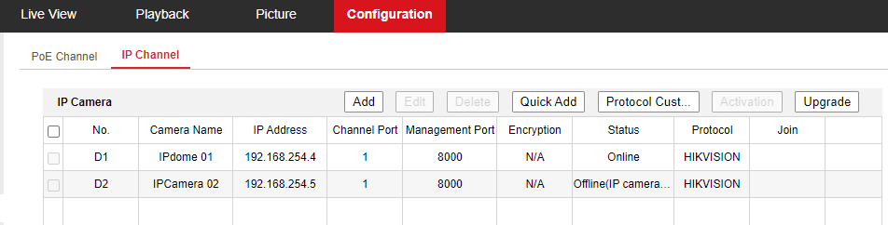

1. After D1 channel is online, select D2 channel and click ‘edit’ to enter the channel parameter modification interface. Select the drop-down box in the adding method parameter and change the adding method from plug and play to manual. Then, all parameters on the camera adding page can be set。

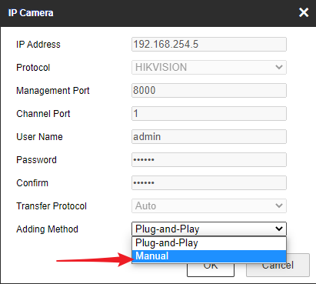

1. Modify the IP address of the channel in the page to the IP address of the D1 channel (here, the D1 channel IP is 192.168.254.4), and modify the channel port to 2 which means the second channel of the camera (192.168.254.4). Then input the password of the camera and save the configuration。

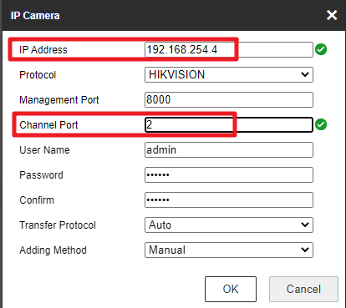

1. Click ‘OK’, the camera has been added normally, channel 1 and channel 2 are online, all channels can be previewed normally, and the configuration is completed。

