**How to switch different function of iDS-7 series**

1. Configuration

Different functions mean different VCA Resource that can be switched by the selections below:

Go to [Configuration] – [System] - [system settings] – [VCA Resource] and check whether you are choosing the right VCA resource.

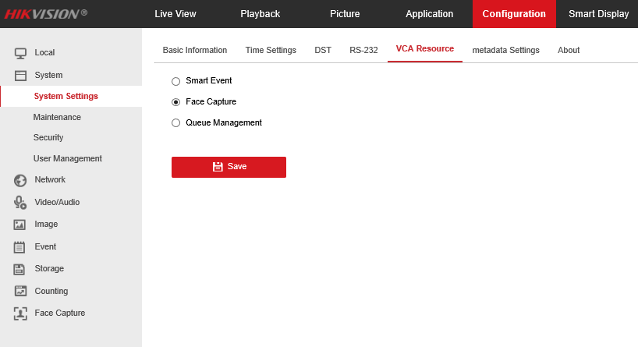

This picture is the DS-7 series normal camera VCA Resource selections.

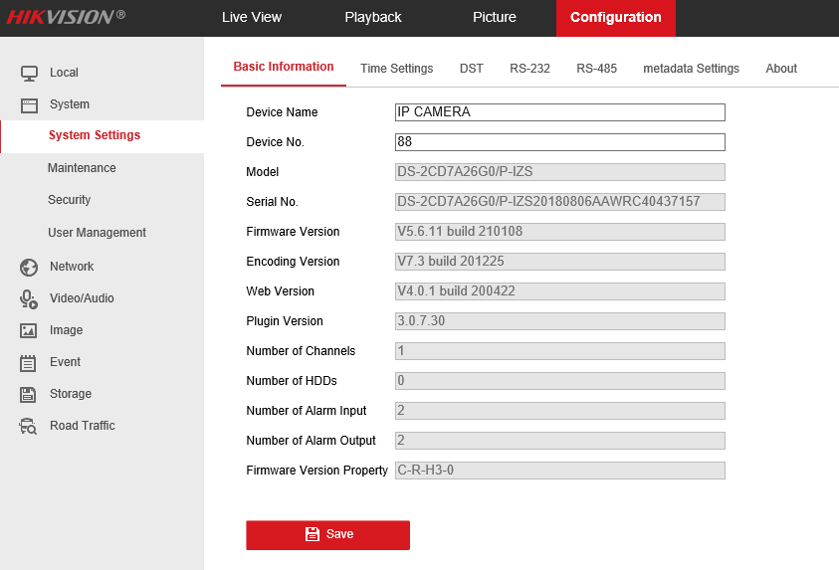

This picture is the DS-7 series ANPR camera and it don’t have other functions.

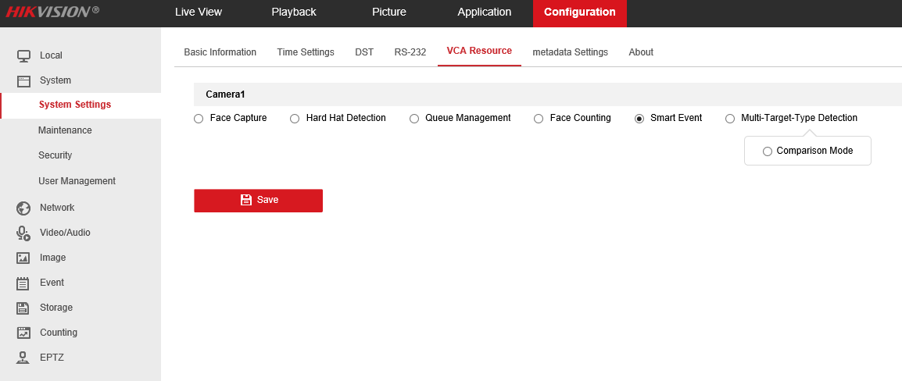

This picture is the iDS-7 series normal camera VCA Resource selections.

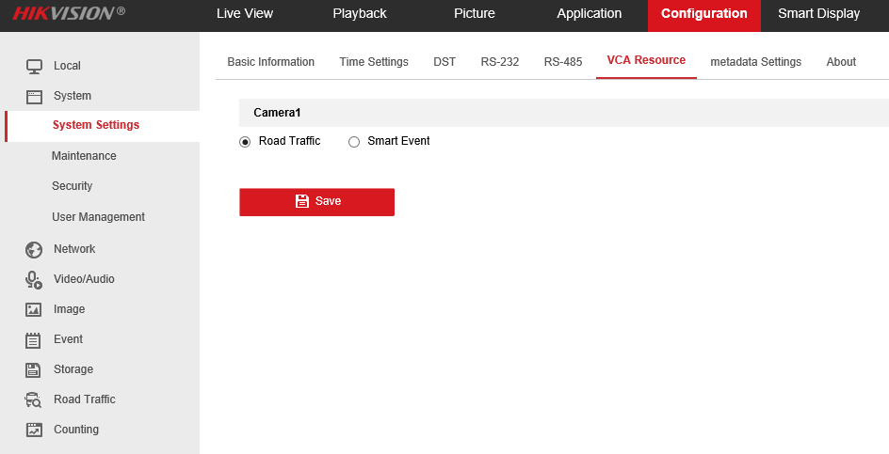

This picture is the iDS-7 series ANPR camera VCA Resource selections.

VCA Resource function varies according to different camera models. Click Save to save the settings. A reboot is needed for the settings to take effect.