**How to count the people in the area using Queue Management**

1. Preparation

Queue Management can be found in DS7, iDS7 series cameras.

1. Configuration

Go to [Configuration] – [System] - [system settings] – [VCA Resource] and check whether you are choosing the right VCA resource (Queue Management).

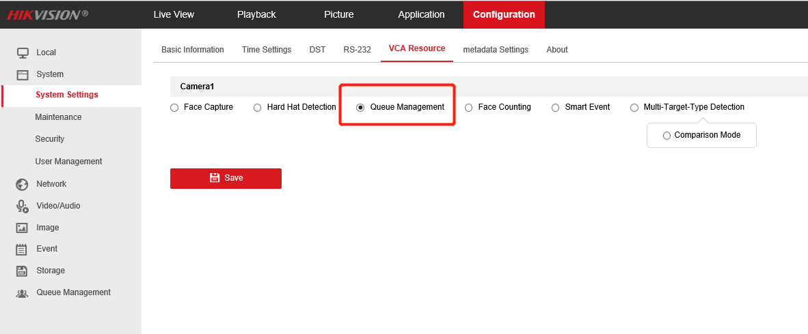

Go to Queue Management and enable all selections below.

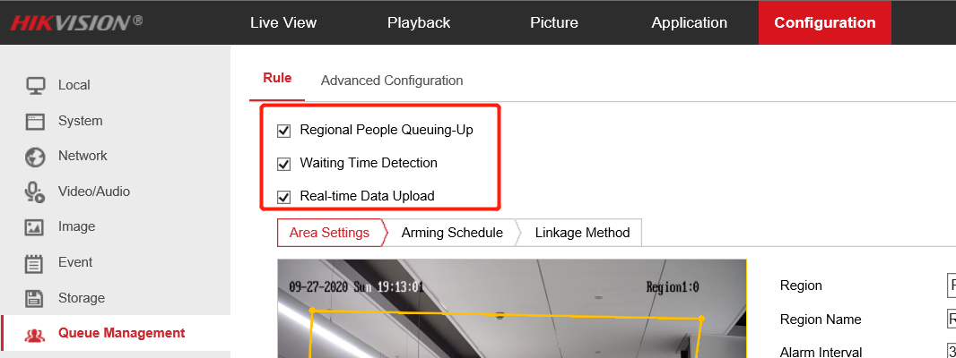

Draw the detection area as your scenario needs. Then Enable the OSD to show how many people inside the area.

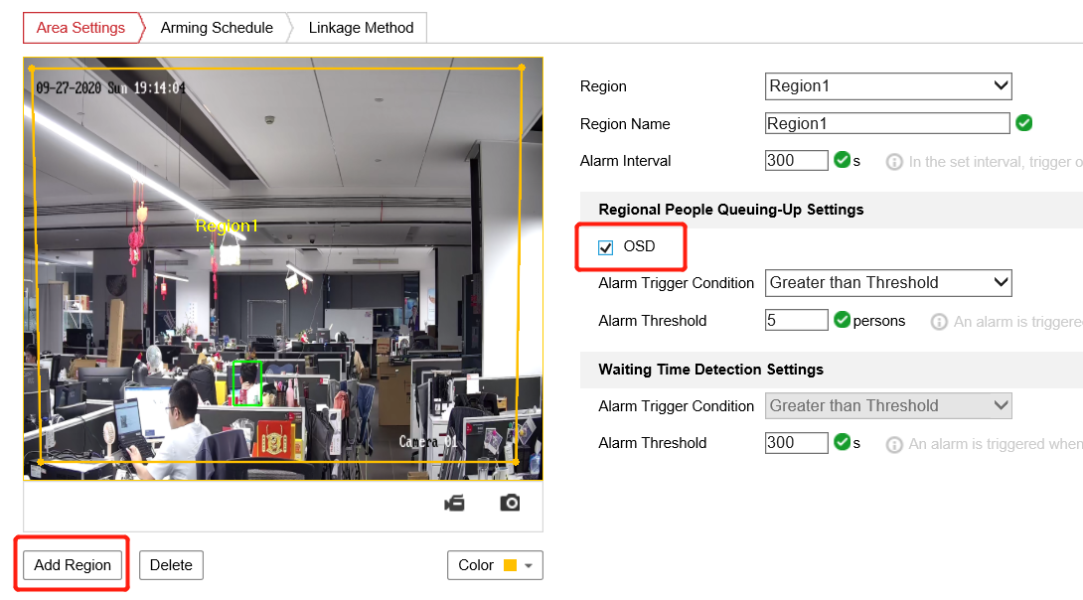



which you will see eventually like above.

Set the Arming schedule and linkage method as the scenario needs.

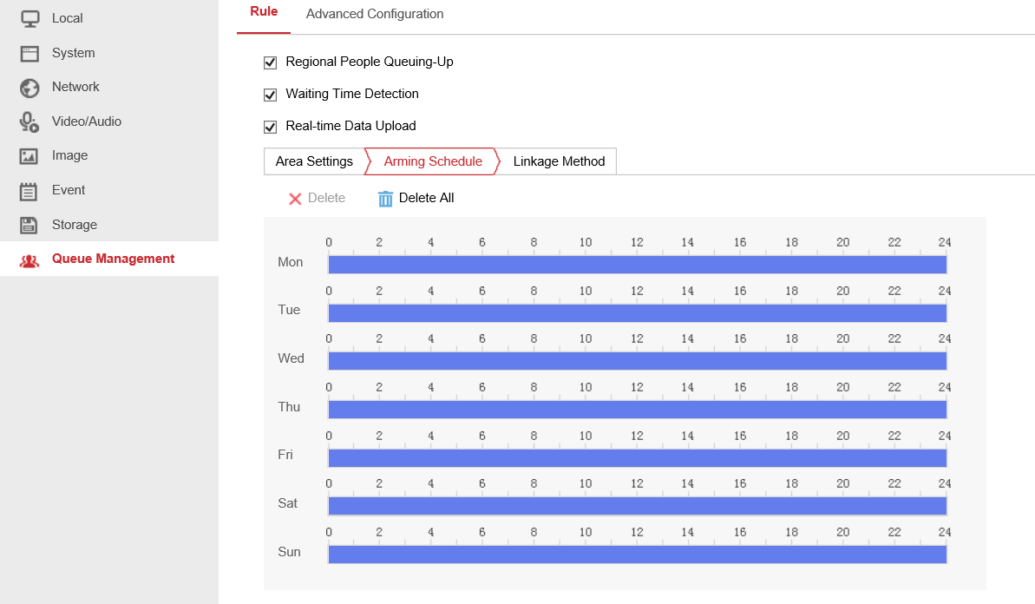

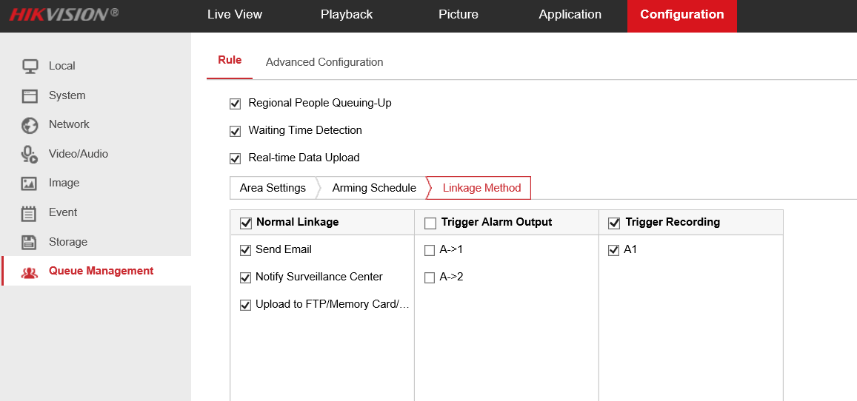

Then set the trigger condition by switching the settings below:

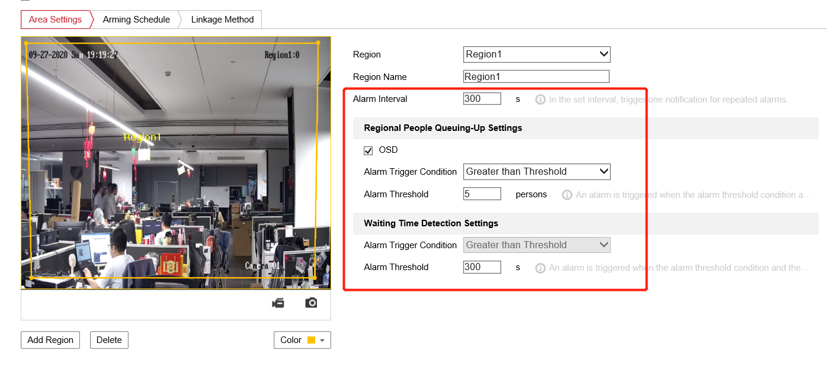

After all, we can set the target filter in the Advanced Configuration. Switch the Target Size to limit the counting target size, which default is 96 pixels target width.

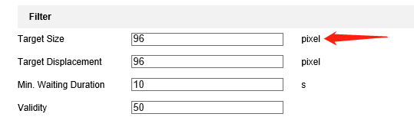

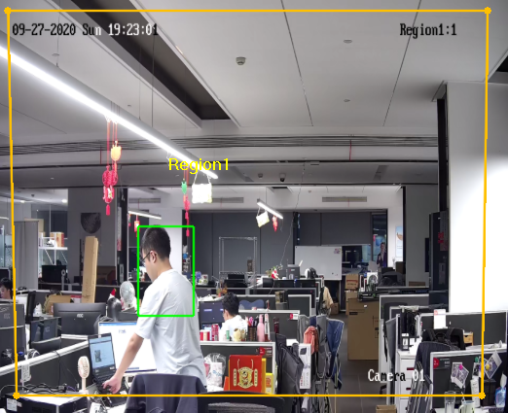

Target size: 96 pixels

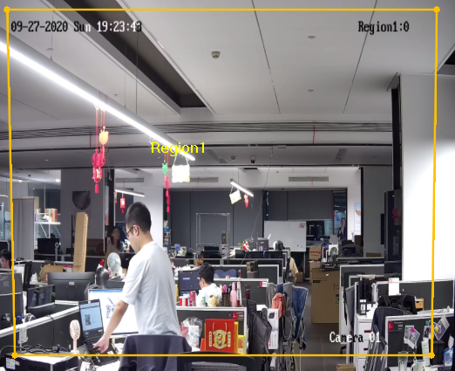

Target size: 300 pixels

【Important】Then set the Min. Waiting Duration to 0s which default is 1s to make the camera count the target immediately when it goes into the area.

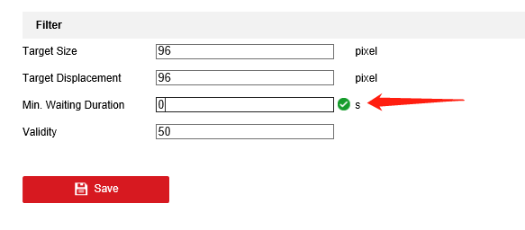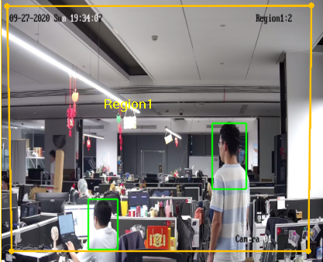

Min. Waiting Duration: 0s

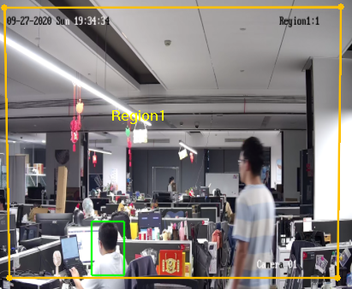coming outside the area

Min. Waiting Duration: 5s

1. Demonstration

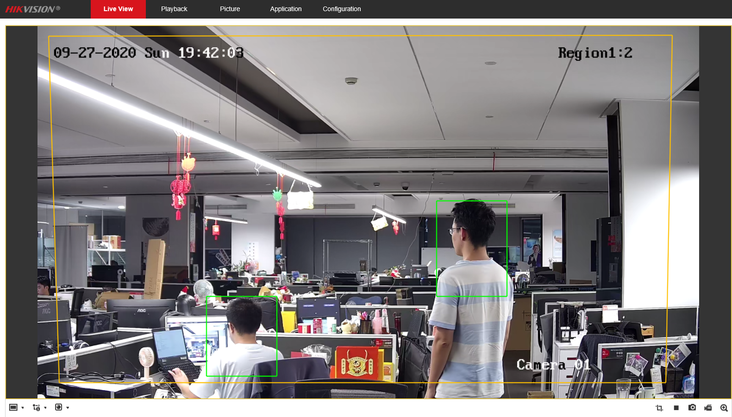

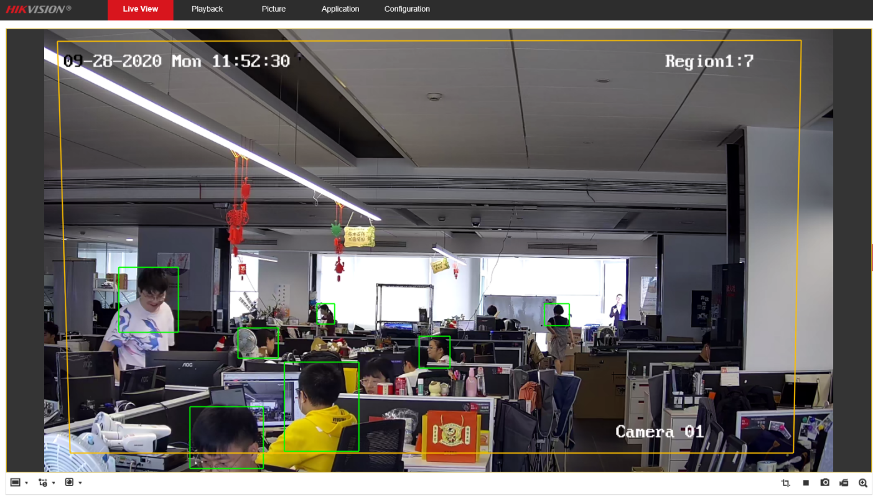

【The demonstration scene in this article is NOT standard installation requesting scene. Please refer to the Queue Management Application Guidance for installation help to have a better effect.】