**How to Configure Smart-linkage PTZ Camera**

**For DS-SE7C124IW-AE(S5)**

**Preparation**

For flashing and audible alarm smart-linkage PTZ camera (DS-2SE7C124IW-AE(S5))

**How to Configure Smart-linkage PTZ Camera**

1. **Calibration for Panorama Tracking**
   1. **Purpose:** When you first time use this device, you have to do the calibration before using panorama tracking functions. The smart events could have a linkage of panorama tracking for detected target. When the target is detected by the panoramic view, the PTZ camera channel will track the target constantly. The PTZ camera channel automatically adjusts its PTZ position to ensure that the target is in the center of PTZ view with certain detailed information. So, the Calibration is required to establish the link between the camera channels.
   2. **Step:** 
      1. Tick the Track checkbox to enable panoramic tracking function.
      2. It suggests using **Auto Calibration**:
         1. Select the **Calibration Mode** to **Auto**, then click the **Start Calibration;**
         2. It will start to auto calibrate, waiting for calibration complete and click **Auto Calibrating succeeded** on the bottom right.

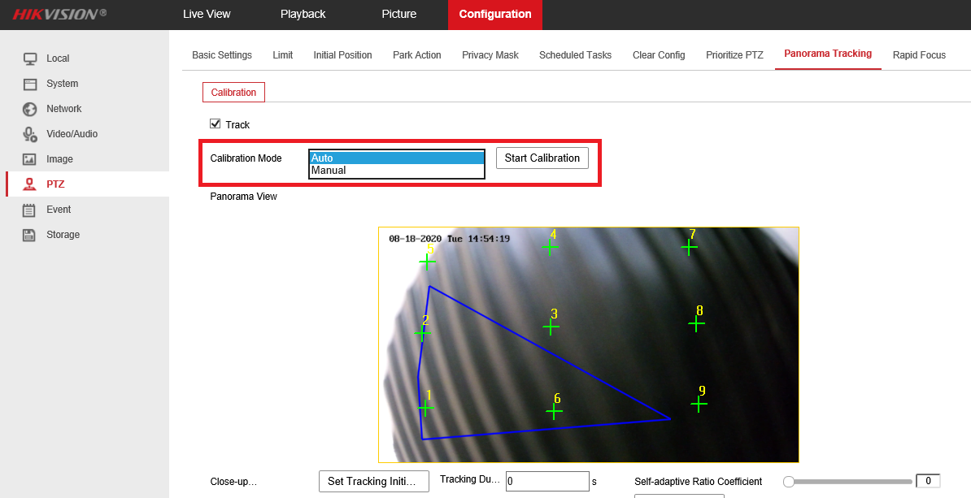

* + 1. Set the tracking duration. Click **Save:**

**Tracking Duration**: It is used to set the duration of tracking. The PTZ channel switches to next target after the set duration time. When tracking duration is set to 0, tracking continues until the target leaves the scene.

1. **Configure Flashing Alarm Light & Audible Alarm Output** 
   1. **Purpose:** These pages offer options to configure flashing light & audible warming when Flashing Alarm & Audible Warming are enabled as linkage methods.
   2. **Configure Flashing Alarm Light Output:**
      1. Set the parameters for flashing light:

**Flashing Duration:** the time period the flashing lasts when one alarm happens

**Flashing Frequency:** the flashing speed of the light. High Frequency, Medium Frequency, Low Frequency, and Normally On are selectable.

**Brightness:** the brightness of the light.

* + 1. Click **Arming Schedule** and edit the arming schedule by dragging and drawing blue time bar
    2. Click Save to save the settings.

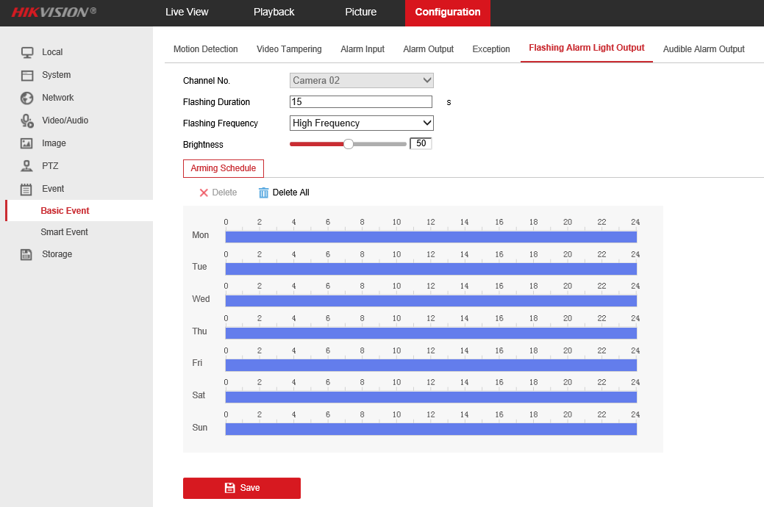

* 1. **Configure Audible Alarm Output:**
     1. Set the parameters for flashing light.

**Sound Type:** the type of audible warning.

*Note: You can select Custom Audio to upload your own alarm audio.* *Upload a .wav mono sound audio file with the size smaller than 512 KB and sampling rate as 8 KHz. It supports up to 3 custom audio documents.*

**Warning:** the content of audible warning.

**Alarm Times:** the repeating times of the warning

* + 1. Click **Arming Schedule** and edit the arming schedule by dragging and drawing blue time bar
    2. Click **Save** to save the settings.

1. **Configure and use Manual Tracking for manual linkage.** 
   1. **Before you start:** You have to enable a smart event then you could track the detected target manually. And then enable the **Rules** in Local configuration.
   2. **Step:**
      1. Left click the panoramic channel in live view screen, the **Start Manual Tracking** button will change to available.

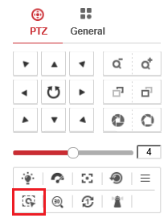

* + 1. Click this button, when there are multiple targets detected by panoramic camera, select one target and left click its rule box, the PTZ camera will start to track that target.

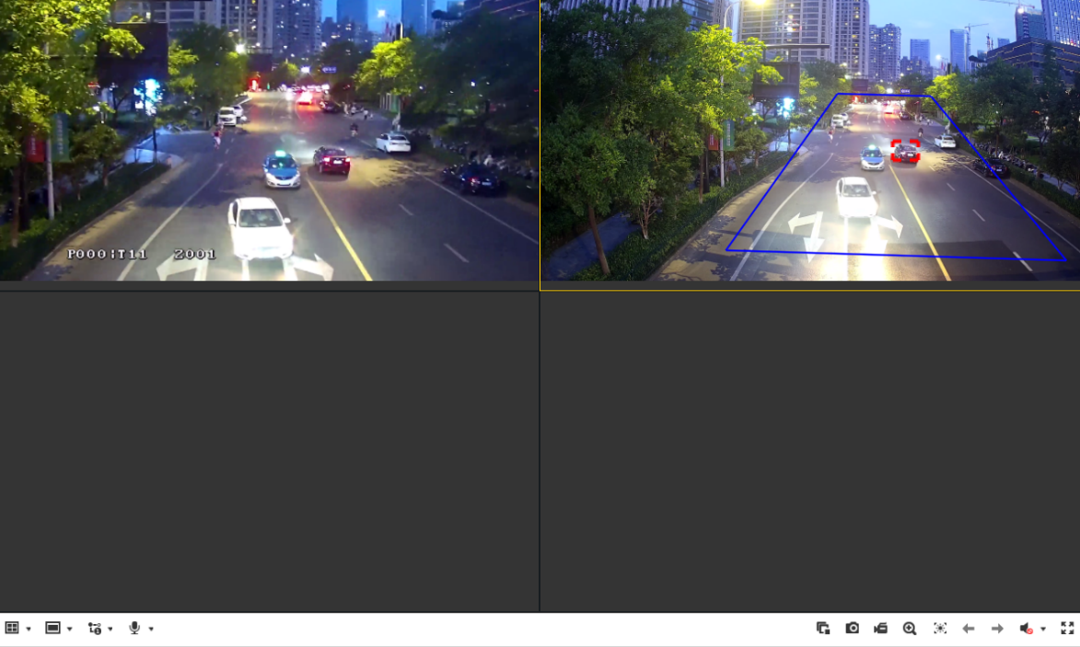

1. **Configure smart event and linkage method.** 
   1. **Setup:**

**Detection distance:** 53m

**Blind area:** 6.8m

**Installation height:** 6m

* 1. **Step:**
     1. Configure smart event like Intrusion Detection. (Only panorama camera channel support)
     2. In **Linkage Method**, tick **Flashing Alarm** and/or **Audible Warning** to link those functions when the event triggers. Also, tick **A1** and/or **A2** in **Trigger Recording** to record the video in respectively channels.

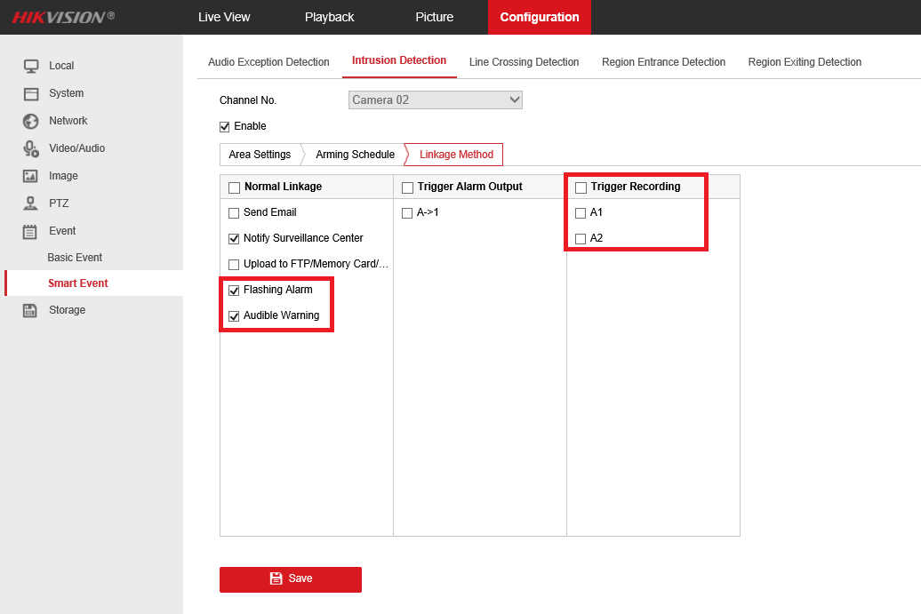

***Note:*** *When multiple targets are detected and enable tracking, the PTZ camera will loop tracking the targets in order. (If the* ***Tracking Duration*** *is set to 0, the PTZ will constantly tracking the first detected target until it left. )*