**How to configure Unattended Baggage Detection and Object Removal Detection of DF series PTZ Camera**

*Notes:* Unattended Baggage Detection and Object Removal Detection are added to DF series PTZ Camera (only H3 and R7 platform support)

***For Unattended Baggage Detection***

**Steps:**

1. Go to Configuration🡪Event🡪Smart Event🡪 Unattended Baggage Detection. Draw Area, set Threshold(s), Sensitivity, Arming Schedule and Linkage Method parameters. Enable the function and click  in the end.

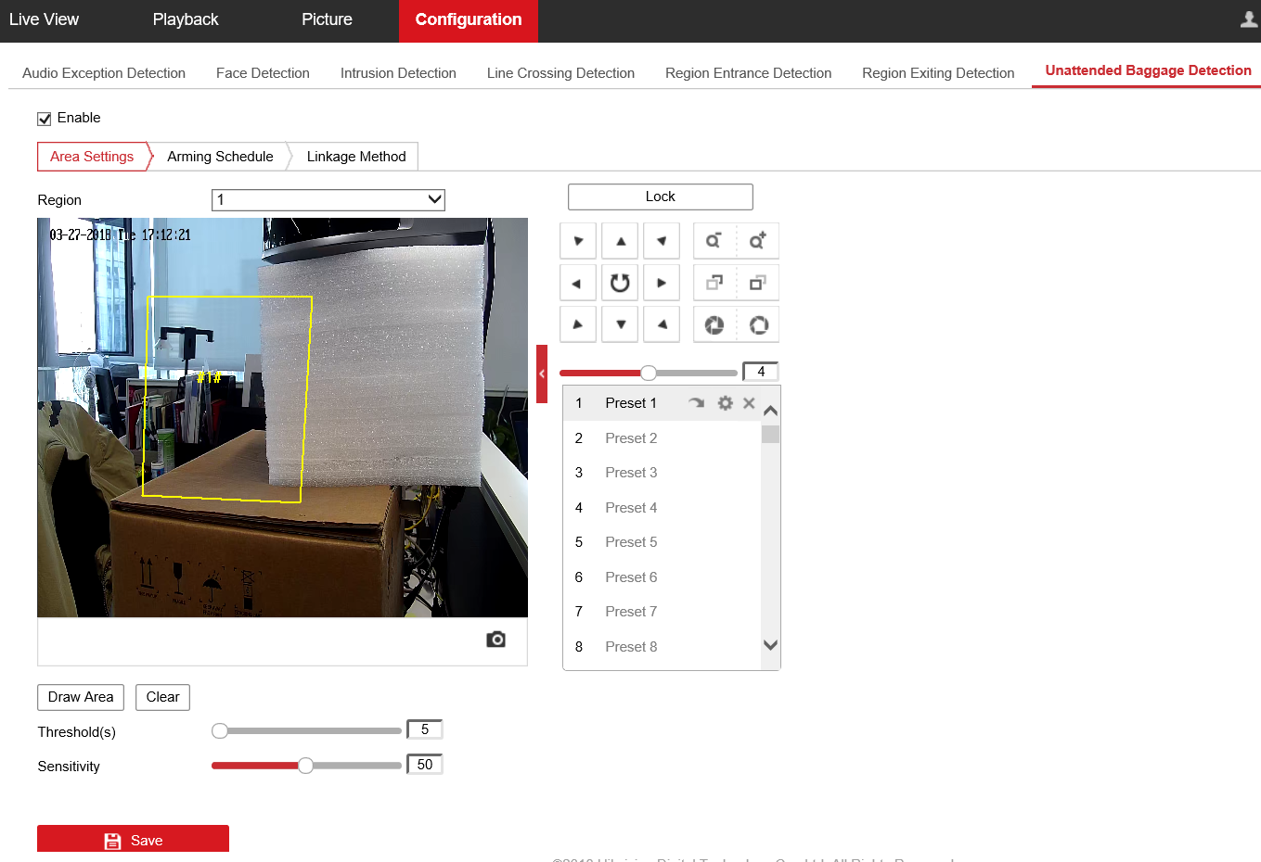

1. If something is left into the drawn area, it will trigger the alarm as the below picture shows:

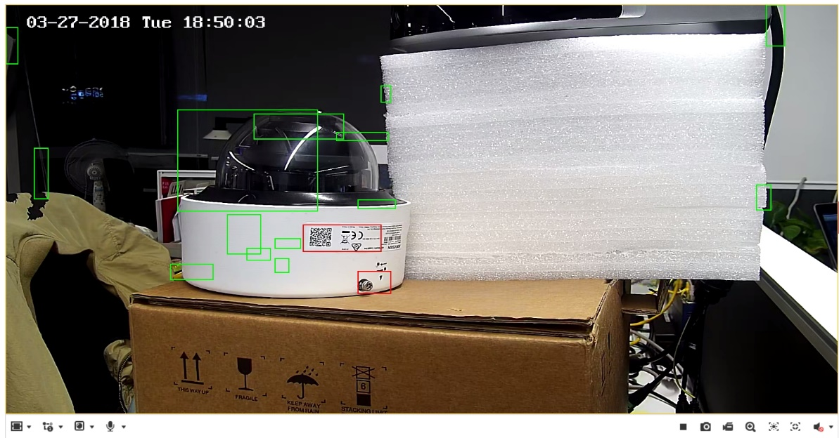

***For Object Removal Detection***

**Steps:**

1. Go to Configuration🡪Event🡪Smart Event🡪 Object Removal Detection. Draw Area, set Threshold(s), Sensitivity, Arming Schedule and Linkage Method parameters. Enable the function and click  in the end.

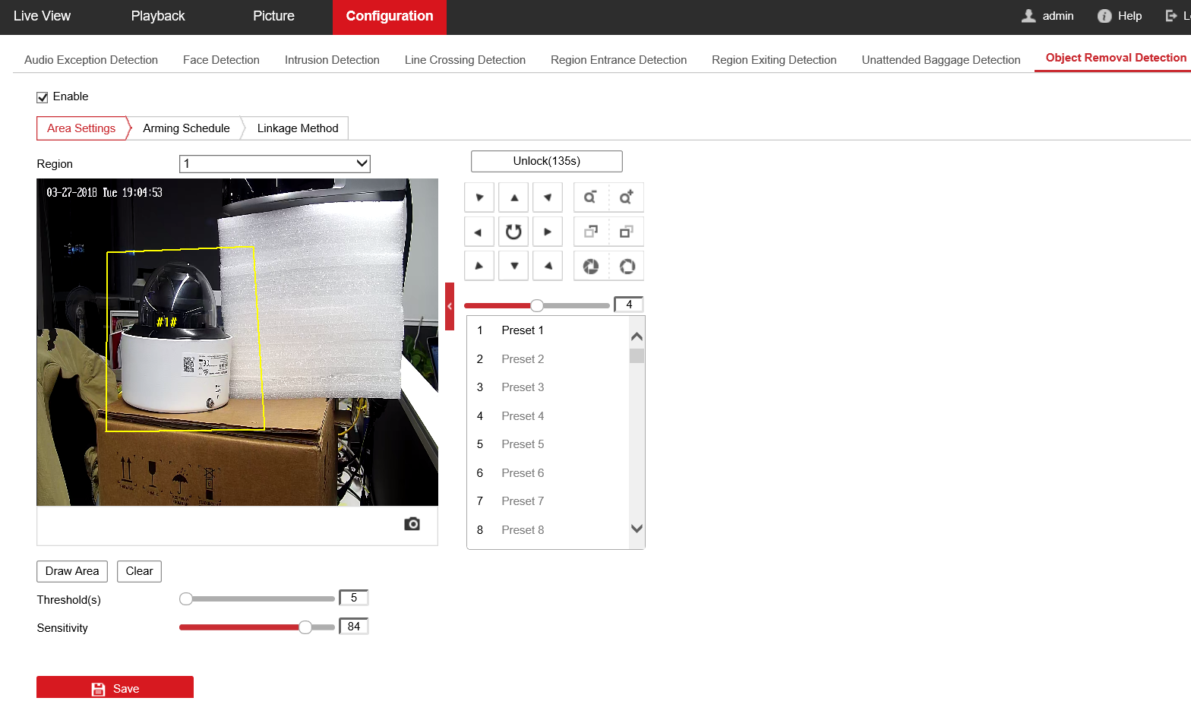

1. If something is removed from the drawn area, it will trigger the alarm as the below picture shows:

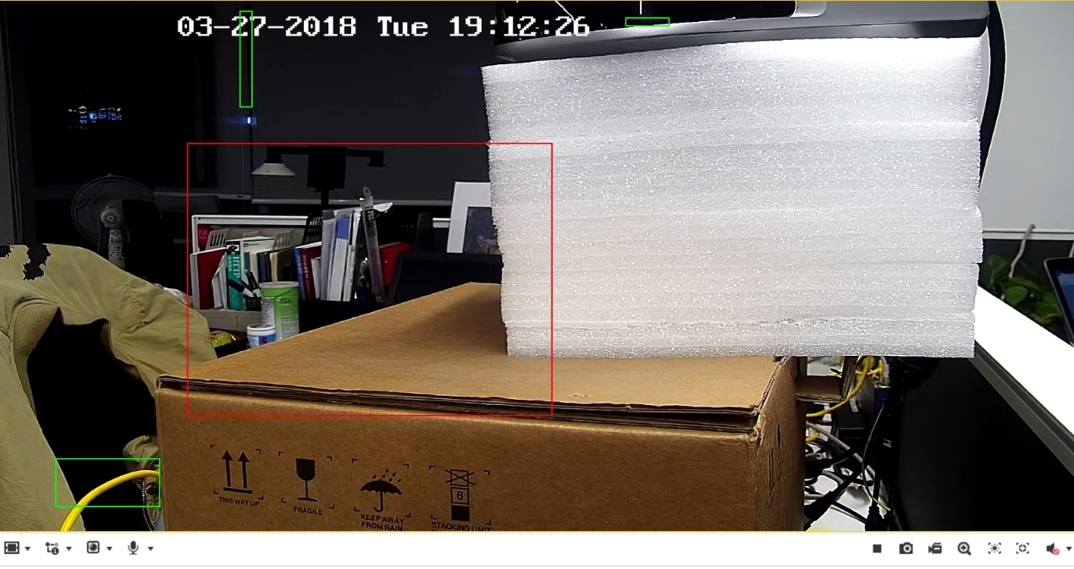

**First Choice for Security Professionals  
*HIKVISION* Technical Support**