**How to configure Smart Tracking of DS-2DFxxxxIX**

*Notes:* **Tracking Zoom Ratio** and **Color Consistency** were added in V5.5.6 build 180511 firmware version for DS-2DFxxxxIX models.

**Steps:**

1. Go to Configuration🡪PTZ🡪Smart Tracking, control PTZ Camera to the monitoring scenario.
2. Check the Enable Smart Tracking checkbox to enable smart tracking function.

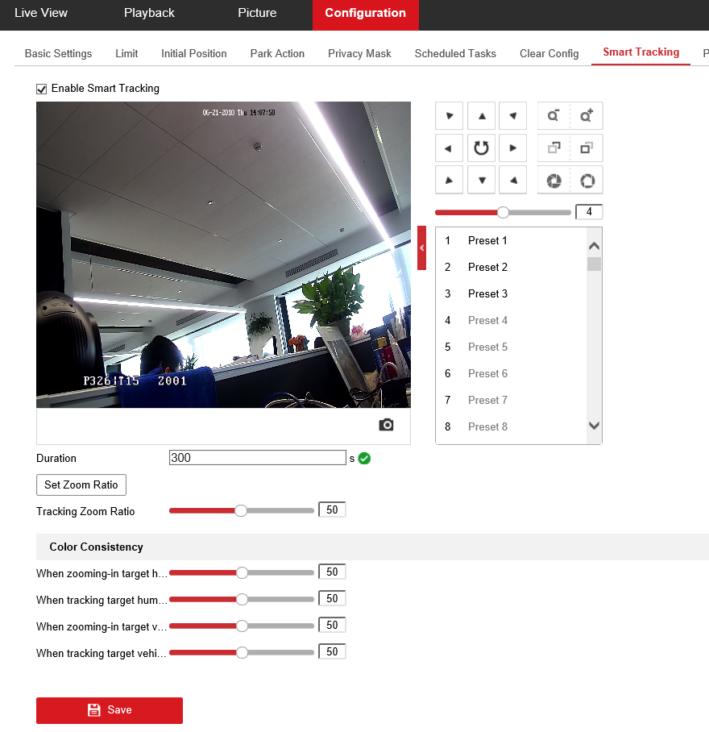

1. Set **Duration:** the duration ranges from 0 to 300 seconds, The speed dome stops tracking when the duration time is up.
2. Set zoom ratio for tracking. You can set a fixed zoom ratio. Or you can let the camera calculates the actual zoom ratio automatically **and this operation is recommended.**

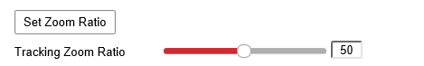

1. **PTZ Camera Calculates Zoom Ratio Automatically**

Adjust the **Tracking Zoom Ratio** to a desired value. Then the camera determines the actual zoom ratio dynamically according to the detected target size and the set value. Larger value means larger zoom ratio.

1. **Set a Fixed Zoom Ratio**

* Move the Tracking Zoom Ratio cursor to 0.
* Select a target in the live image and adjust the PTZ buttons to see the target at desired size.
* Click Set Zoom Ratio to set the current zoom ratio as the zoom ratio.

***Note:*** As long as you set the Tracking Zoom Ratio value as not 0, the zoom ratio you set manually is invalid.

1. Set Color Consistency:

The camera checks the color of the detected target several times during tracking and compares the color resemblance to determine whether it should continue to track the target or not. If the returned resemblance is lower than the set value, the camera stops tracking. Higher value means higher resemblance requirement to continue tracking.

**First Choice for Security Professionals  
*HIKVISION* Technical Support**