**How to add solar camera on NVR through ISUP protocol**

**How to add solar camera on NVR through ISUP protocol**

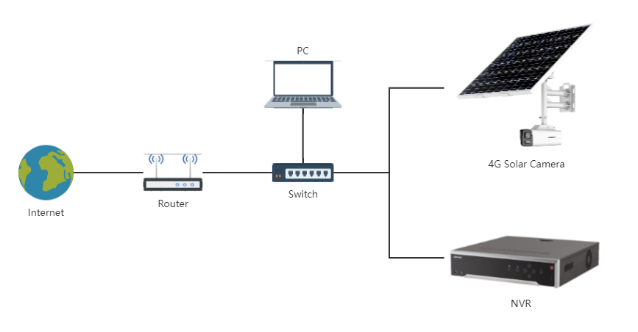

# Connect the camera to the power supply and network cable, turn the camera switch to ON，and insert the 4G SIM card. Upgrade Solar camera and NVR to custom firmware[1]. Ensure that the camera, NVR and router are under the same router network segment, and the router connect to the external network.

[1]:For the way to obtain customized firmware, please contact the technical support in the corresponding area

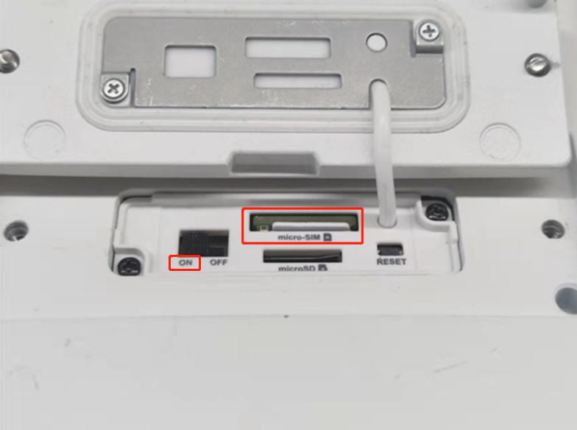

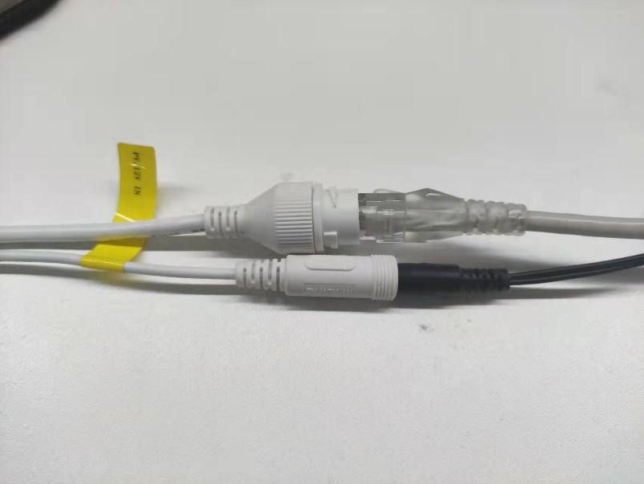

# Open SADP, find NVR and solar camera, and double-click to open it.

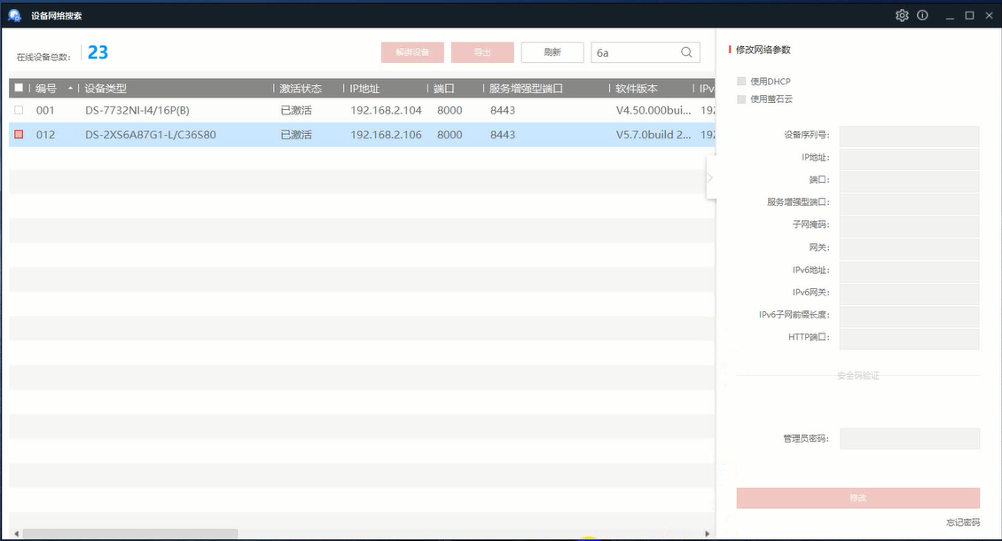

# Open port mapping page of the router

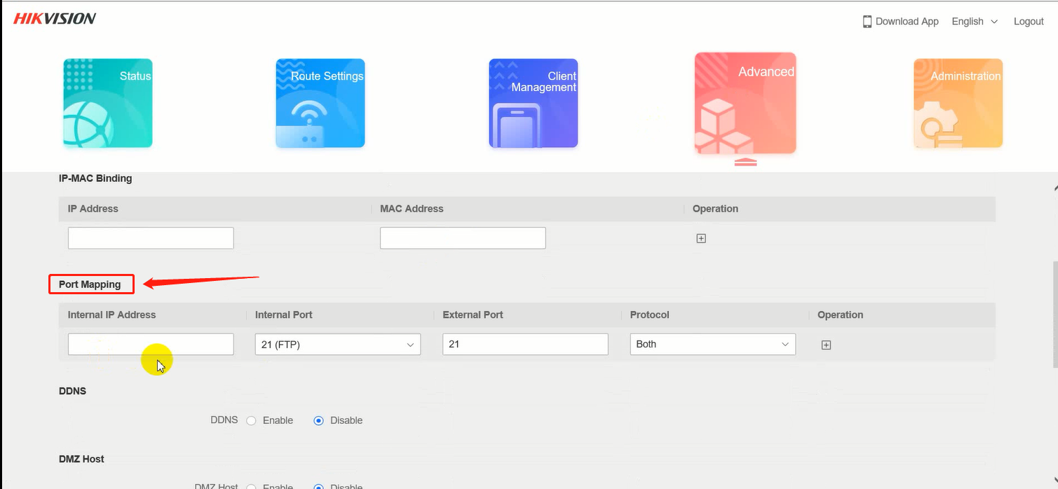

# In the NVR webpage, network setting, record the external port of port 80[1] in NAT and the following 4 ports[2] in ISUP service setting

[1]: Port 80: receive camera HTTP alarm

[2]: The purpose of each port is stated

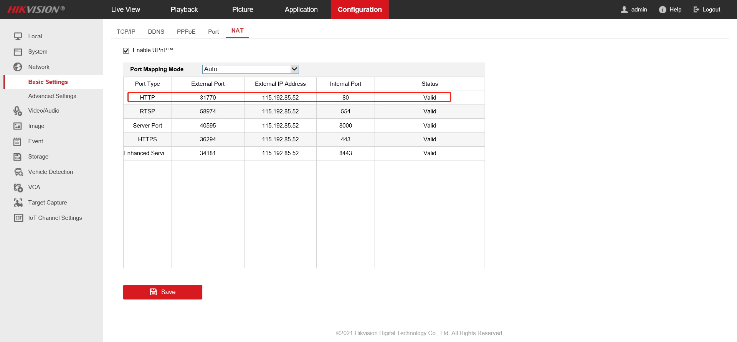

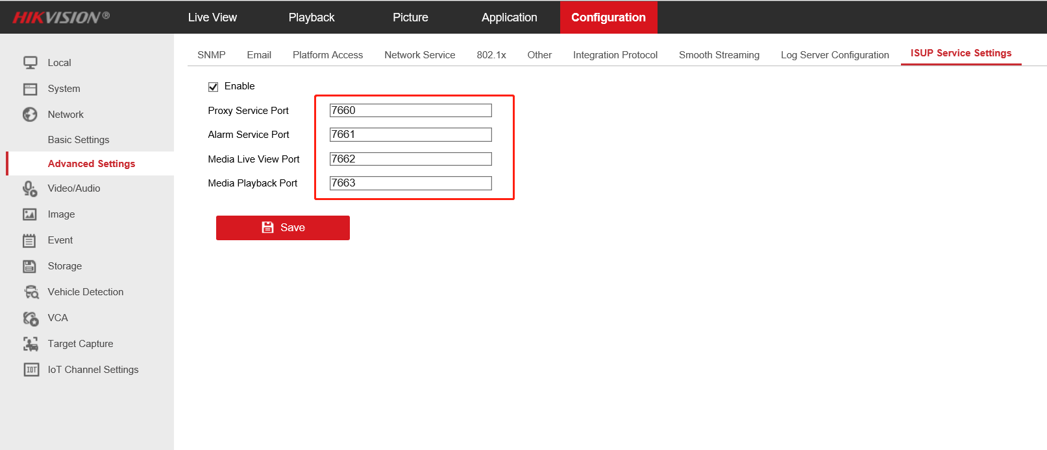

# Port mapping: map the five ports just recorded to the outside. The external port needs to be consistent with the internal port.

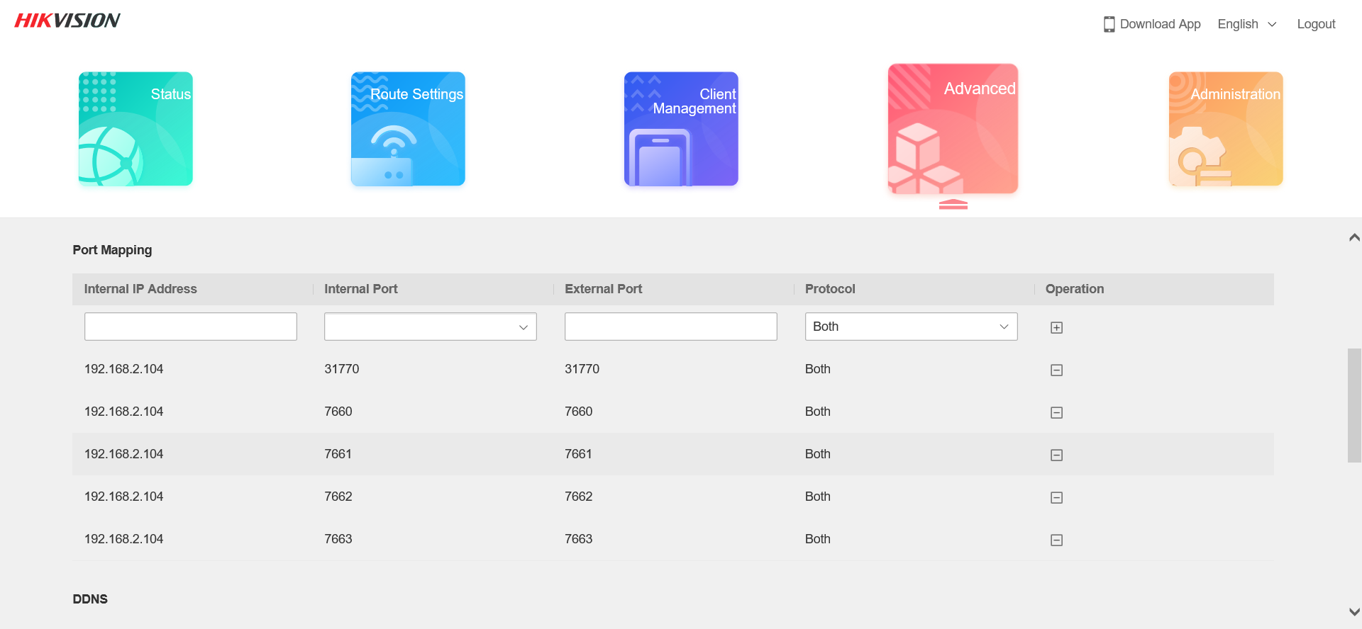

# To the camera web page, first check whether the 4G connection is normal.

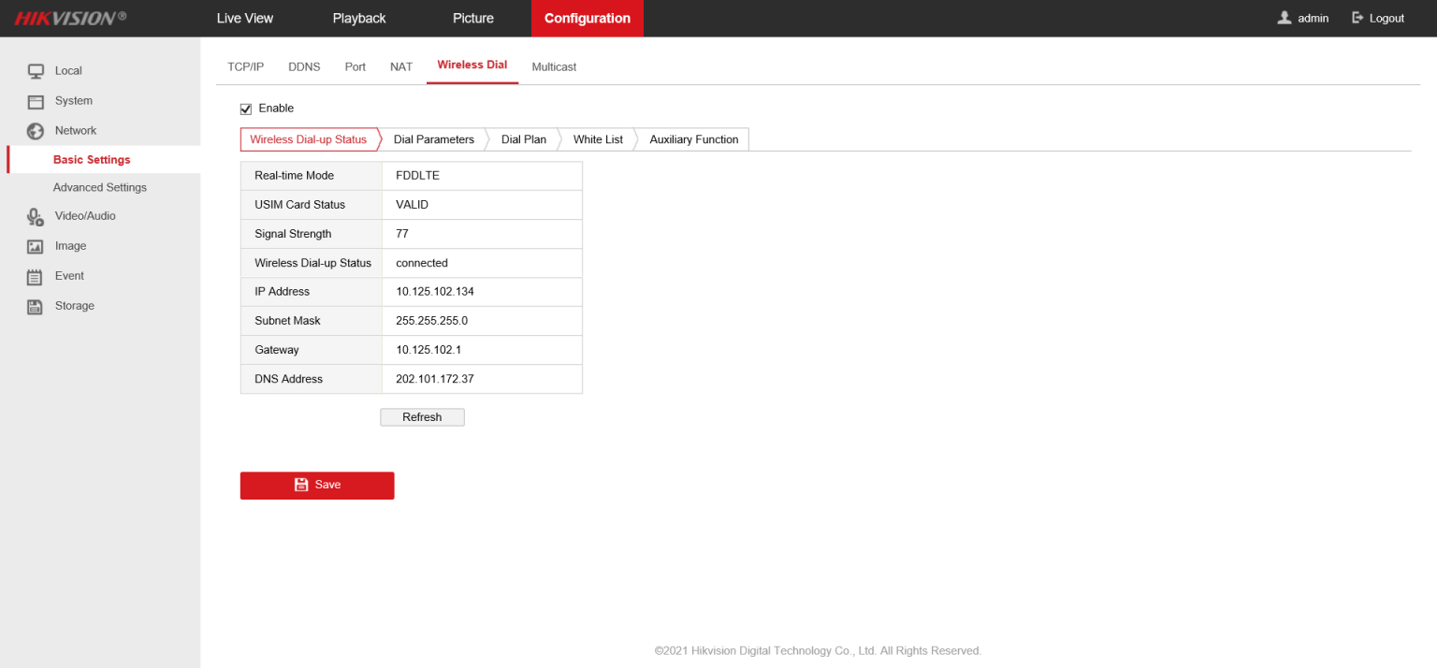

# Configure the ISUP protocol on the web side of the camera. The server address is the external IP address of NVR. The port is the Proxy service port of NVR. The ID and password of the camera can set it at will. If there are multiple cameras, the ID should not be the same. Save after setting.

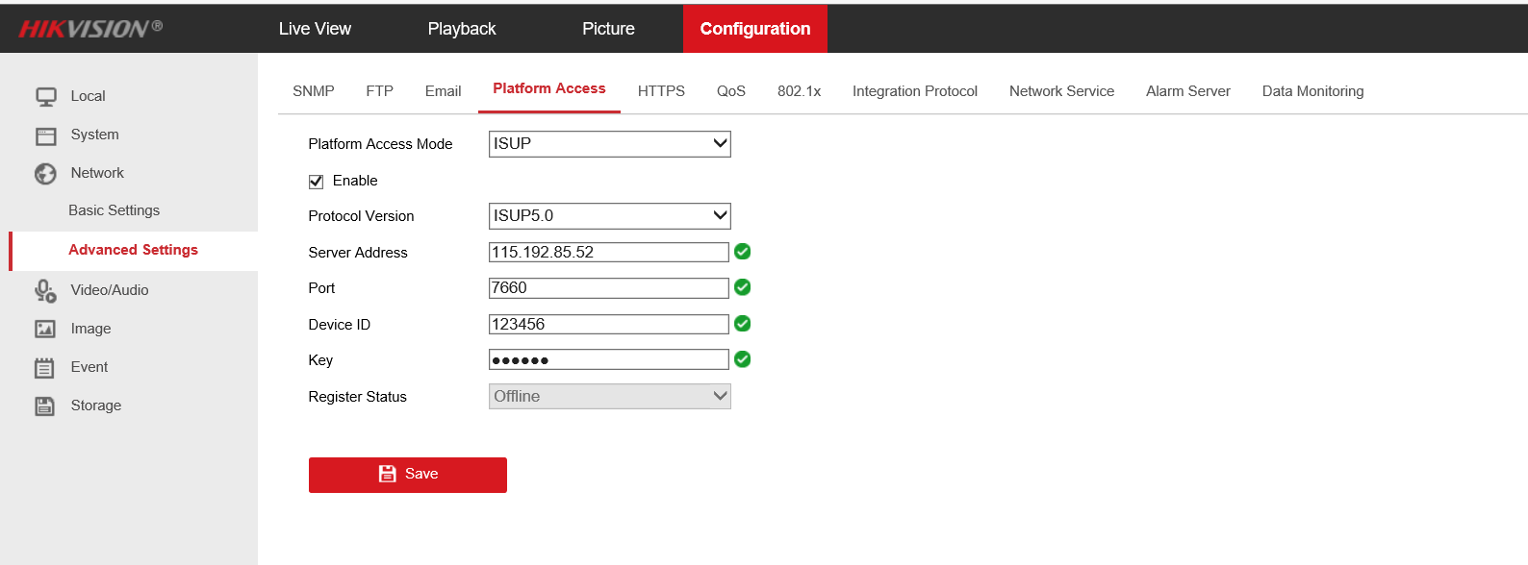

# Go to the web page of NVR, add a camera, and select ISUP as the protocol

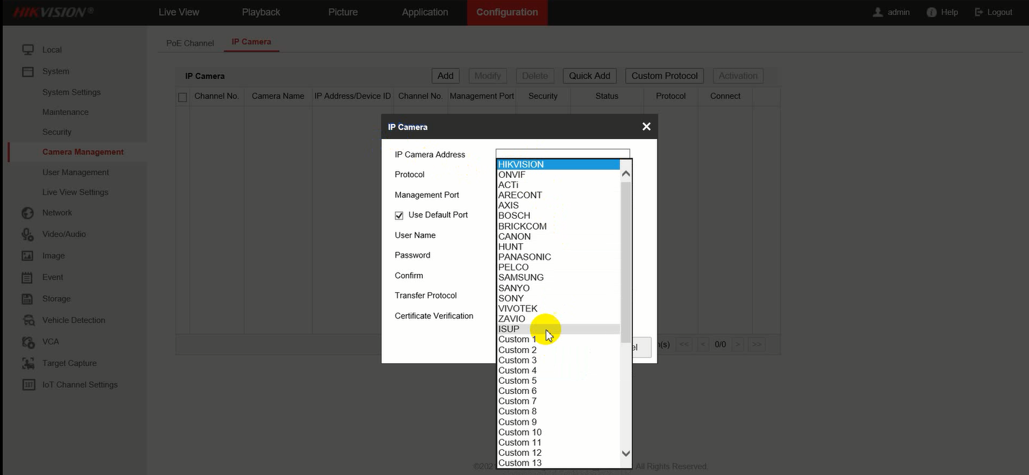

# Fill in the device ID and password just set.

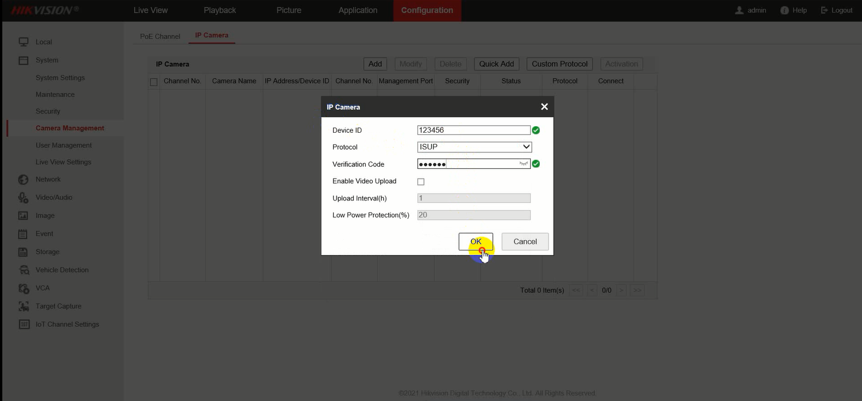

# Refresh the page and the camera status is online.

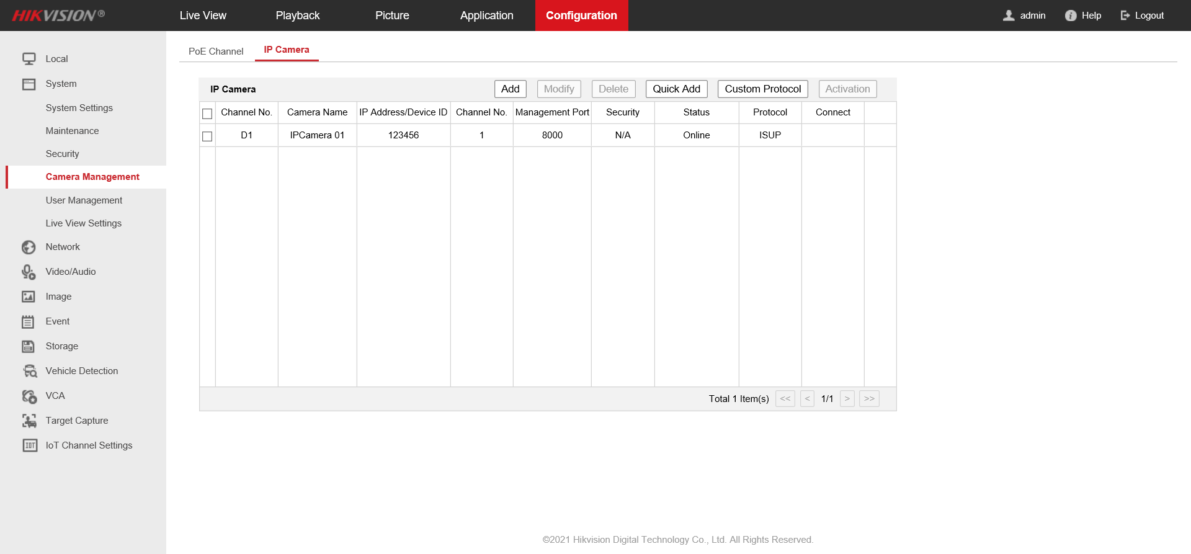

# In the Live View interface, the camera can be previewed

