**How to Use Intelligent Parking Detection**

# Introduction

## Description

Outdoor parking places management system is a kind of parking charge management system which combines high-position video surveillance camera and terminal platform integrated management.

## Function

The single camera monitors the outdoor parking lot, locate the vehicle position, bind with the configured parking place, detect the vehicle stay time, and output the corresponding alarm event.

## Requirements and Installation

In order to detect the vehicles and parking places, the installation of camera needs to meet the following requirements:

1. Height: The recommended installation height is more than 6 meters, and the best height is 10 meters. The angle between the field of view of the camera and the parking direction of the vehicle is less than 15 degrees. Try to ensure that the installation is forward or backward to improve the detection effect.
2. Occlusion: Vehicles cannot be covered more than 50%.

# Configuration

## Web configuration

Configuration > Event > Basic Event > Parking Config.

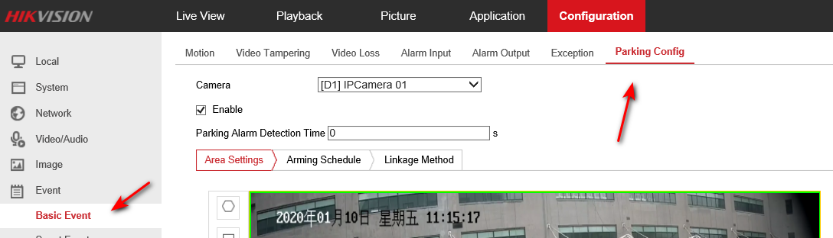

## Set Parking Alarm Detection Time

Enable this function and Set the Parking Alarm Detection Time (1min to 999999mins), when the vehicles stay for more than the value you set, it will trigger the alarm and report the corresponding channel and parking place’s number.

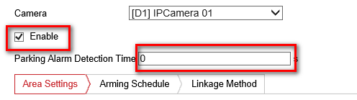

## Arming Schedule and Linkage Method

Set Arming Schedule and Linkage Method.

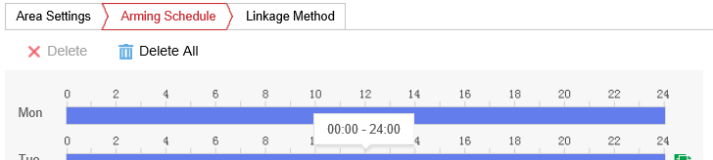

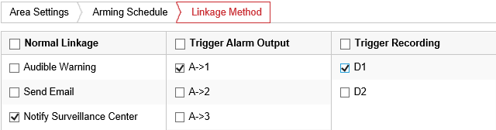

## Configure the rules

1. Draw rule area: one channel can just set one rule area.

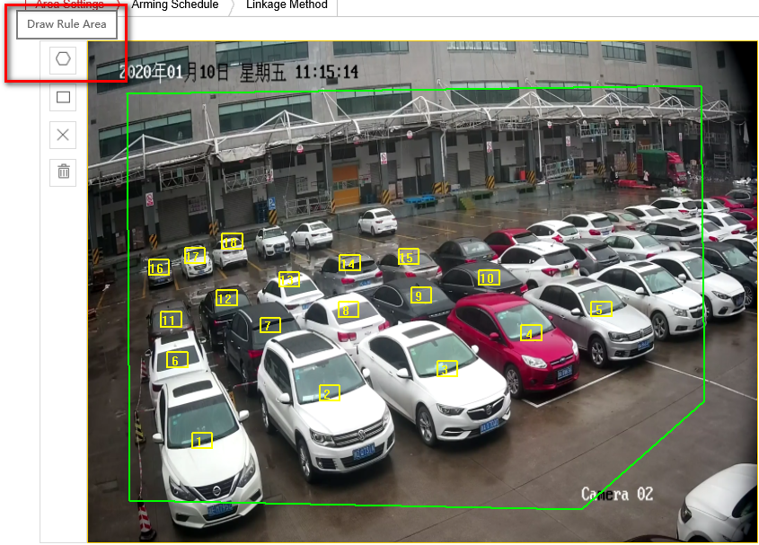

1. Mark parking place: click the Mark Parking Place, there will increase 10 new place icons in screen; select and click one place icon, then drag it to where the parking space is located.

***Note:*** Up to 40 place icons can be added.

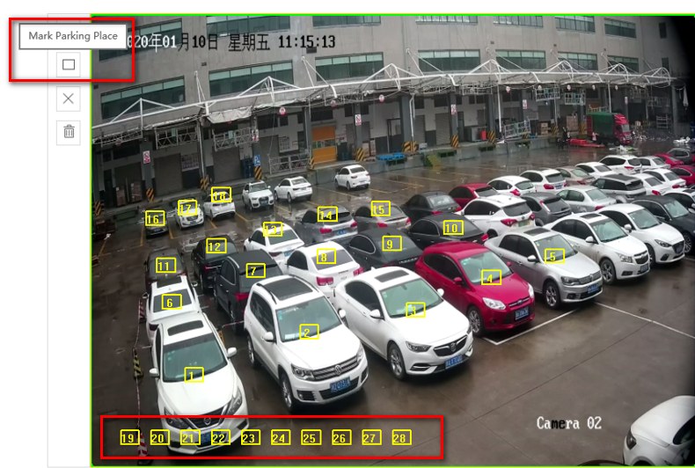

1. Delete single parking place: select one place icon and click Delete One Parking Place.

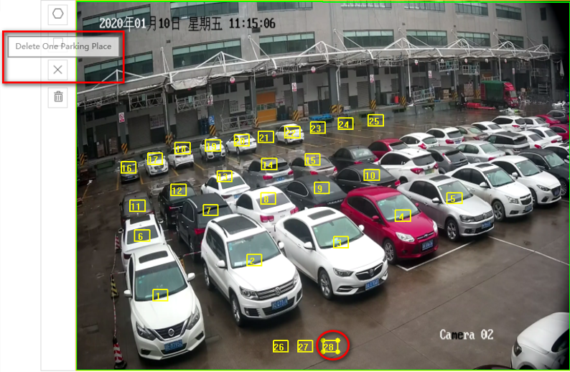

1. Delete all parking place: click Delete All Parking Place to clear all place icons.

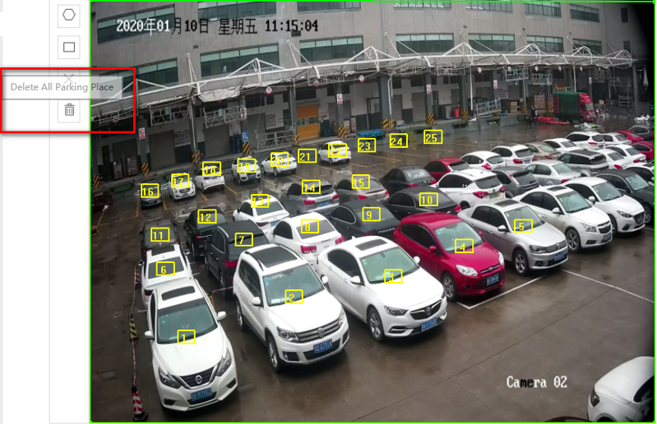

## Select the algorithm mode

Due to different algorithm for day and night, it need to change algorithm every whole day.

1. In Auto Mode, the algorithm will be changed automatically.
2. In Manual Mode, you can set time manually, Start Time for turning to Night Mode, End Time for turning to Day Mode.

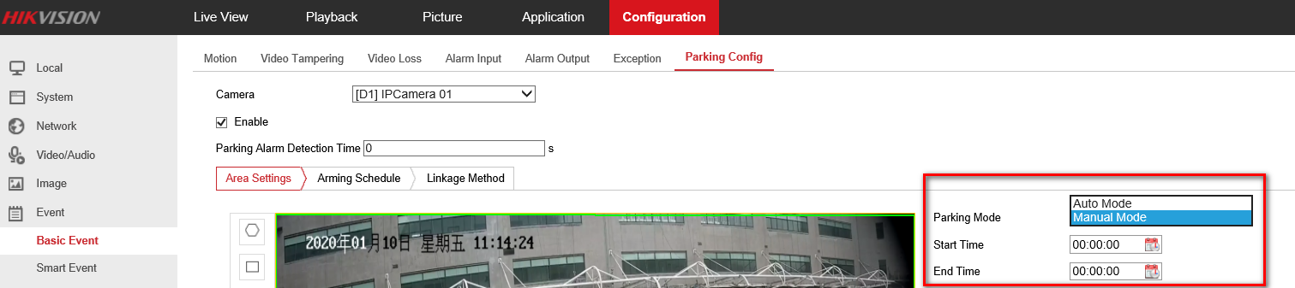

## Name the parking place and check the status

You can modify the name and check the status of every parking place.

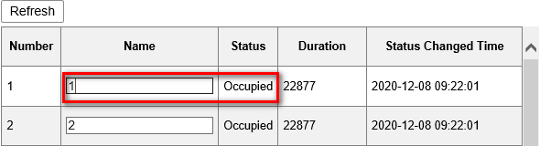

## Save the rules

Save all configuration and check it in live view.

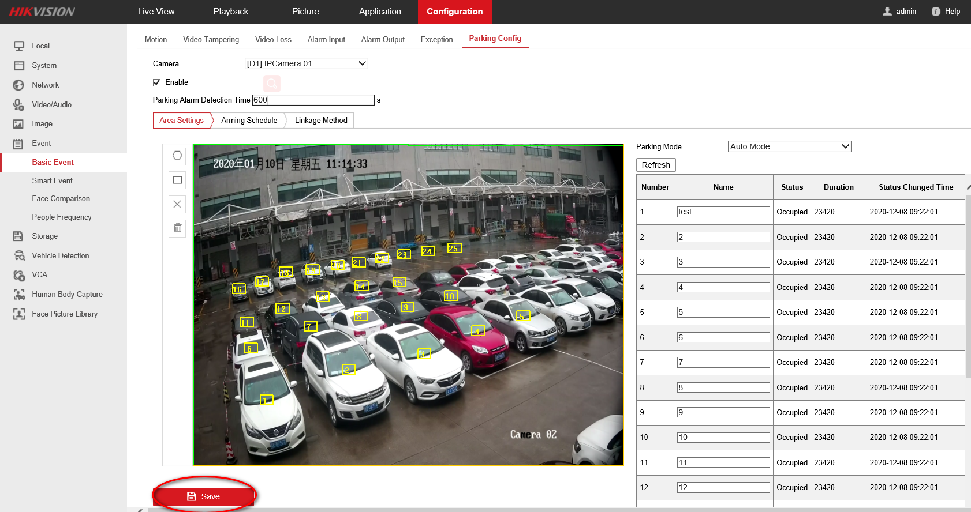

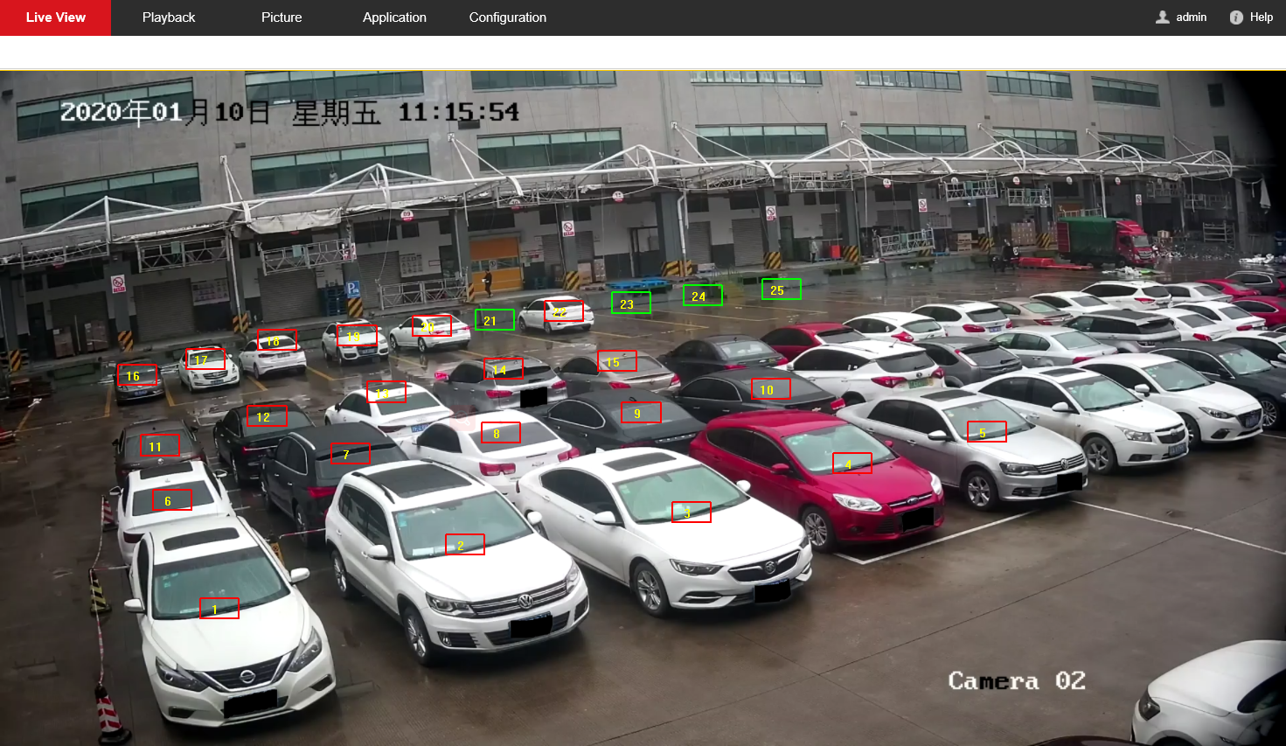

# Display

## Web configuration

Configuration > System > Display Settings.

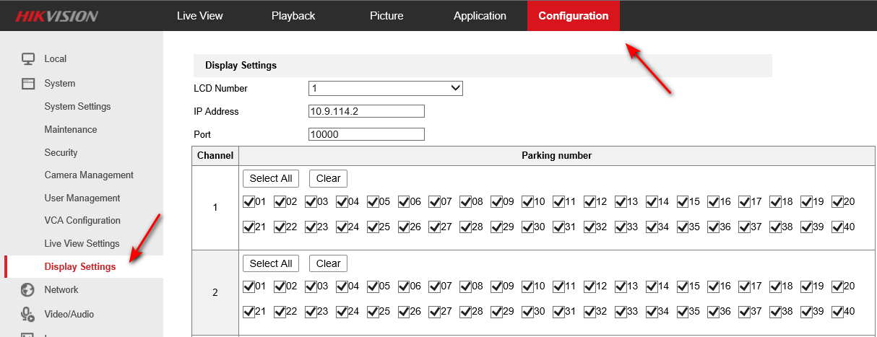

## LCD settings

1. Select LCD device and input IP address.
2. Bind the corresponding channels and parking places.
3. Save the settings.

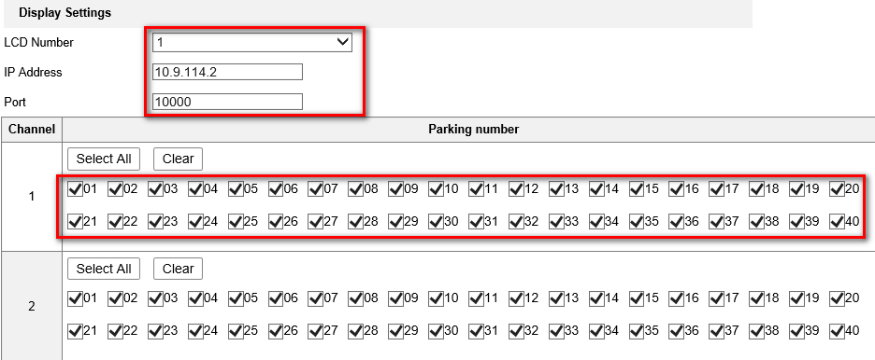



## LCD display

