**Preparation**

1. Second generation AcuSense camera(-SL models).
2. Custom audio with .wav format sampling rate as 8 KHz.

**How to Upload Custom Sound of Audible Alarm**

1. **Website upload** 
   1. **Find uploading page on web**

Configuration---Event---Basic Event---Audible Alarm Output.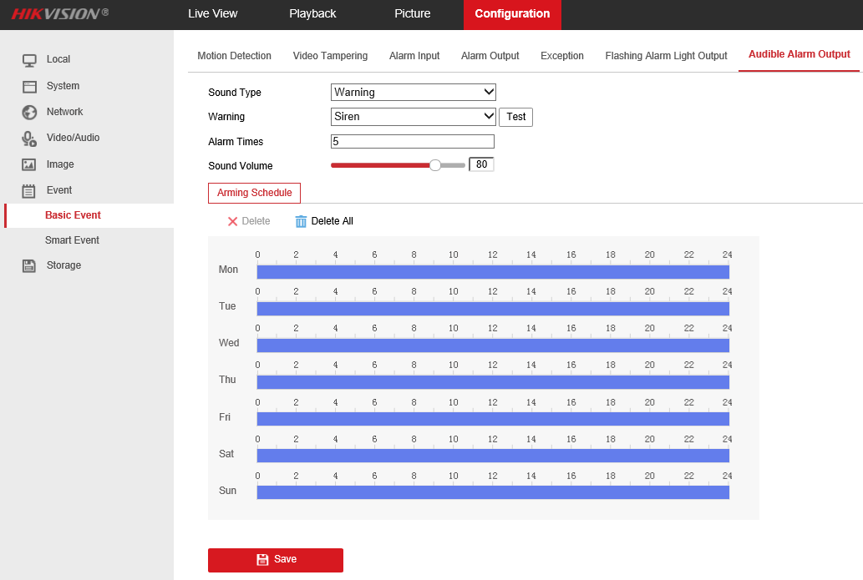

* 1. **Select sound type.**  
     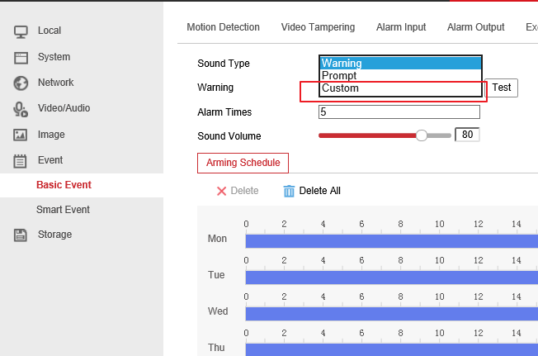
  2. **Import custom audio file.**

Click Add, than upload a .wav mono sound audio file with the size smaller than **512 KB** and sampling rate as 8 KHz.

If audio do not meet above requirements, it will prompt Uploading failed.

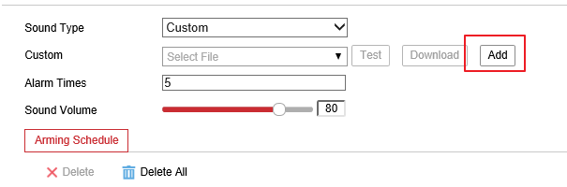

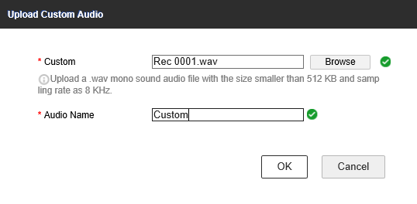

* 1. **Test.**

Save all settings and click Test, if prompt “Audio is playing…Please wait”, that means uploading succeed.

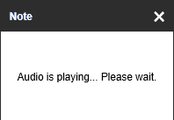

1. **Hik-Connect upload**

Hik-Connect is expected to support uploading custom sound in June.

**First Choice for Security Professionals**

***HIKVISION* Technical Support**