

# How to Realize the Redundancy Video Record Function in Back-end Devices

**Preparation**

A NVR or DVR, at least two HDDs, an NAS server for redundant recording if needed.

# How to Realize the Redundancy Video Record Function in Back-end Devices

## Background

To protect data security, back-end products like NVR and DVR can record videos of key channels locally while keep them in two disk groups simultaneously. A hard disk can be an HDD or Net HDD such as NAS.

**Redundancy:** For some video channels, recordings can be saved and copied as a backup in several disk groups. The function can effectively enhance data security.

**Redundant Recording:** Recordings stored in the redundant disk.

**Redundant disk**: Disks for redundant recordings storage.

## Configuration Steps:

To configure redundant recording, the back-end device needs to add hard disks first. If the disk belongs to the NAS Net HDD type, please add the disk to the devices according to below document:

<https://hiknow.hikvision.com.cn/kms/kms/multidoc/kms_multidoc_knowledge/kmsMultidocKnowledge.do?method=view&fdId=1813c90a76c8282f8309e4f4d4482ca0>

### Configure the Storage Mode as Group Mode

Enter **Storage** interface and select **Group Mode** in the Storage Mode. If the previous Storage Mode is **Quota**, the device will reboot.

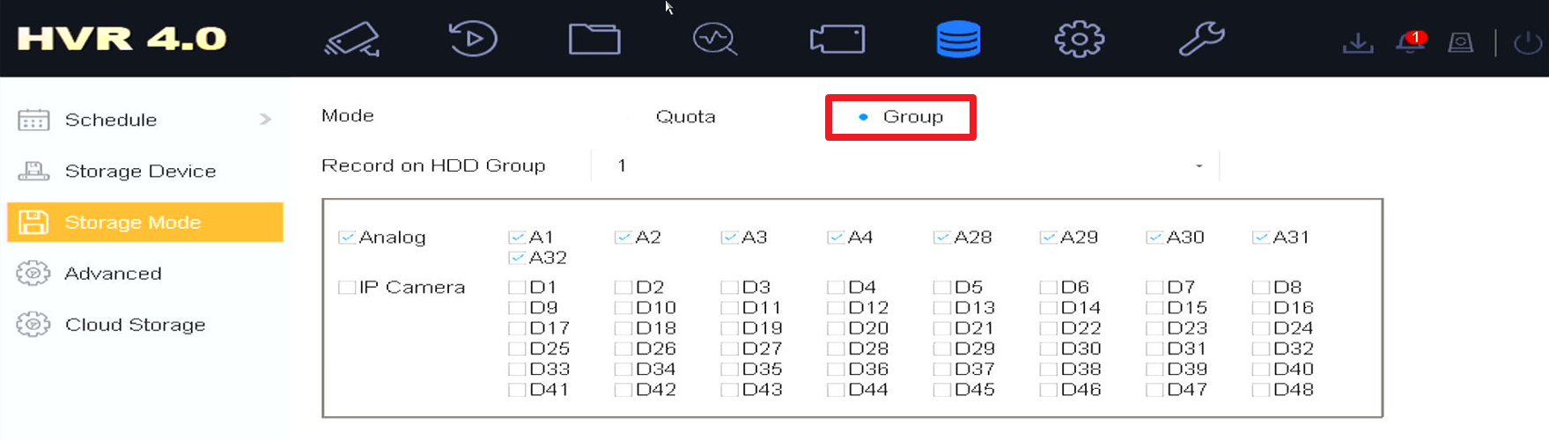

### Configure Group ID for all the disks in Storage Device

Enter S**torage>Storage Device** interface and drag the left-right bar on the selection menu. Select **Edit** button to the disk configuration interface by clicking the **Edit** button of each disk.

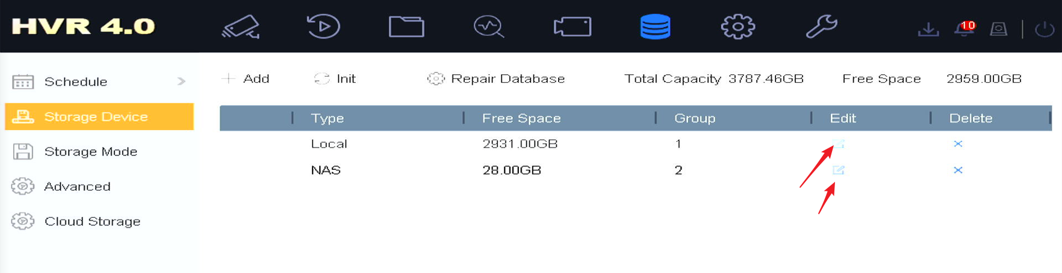

Enter the disk **Edit** interface to configure HDD Property and Group parameters.

* HDD Property: R/W for non-redundant disks and Redundancy for redundant disks.
* Group: The Group parameter is to configure Group ID. The Group configurations of redundant and non-redundant disks need to be different.

**P.S. Several hard disks can be configured under the same Group.**

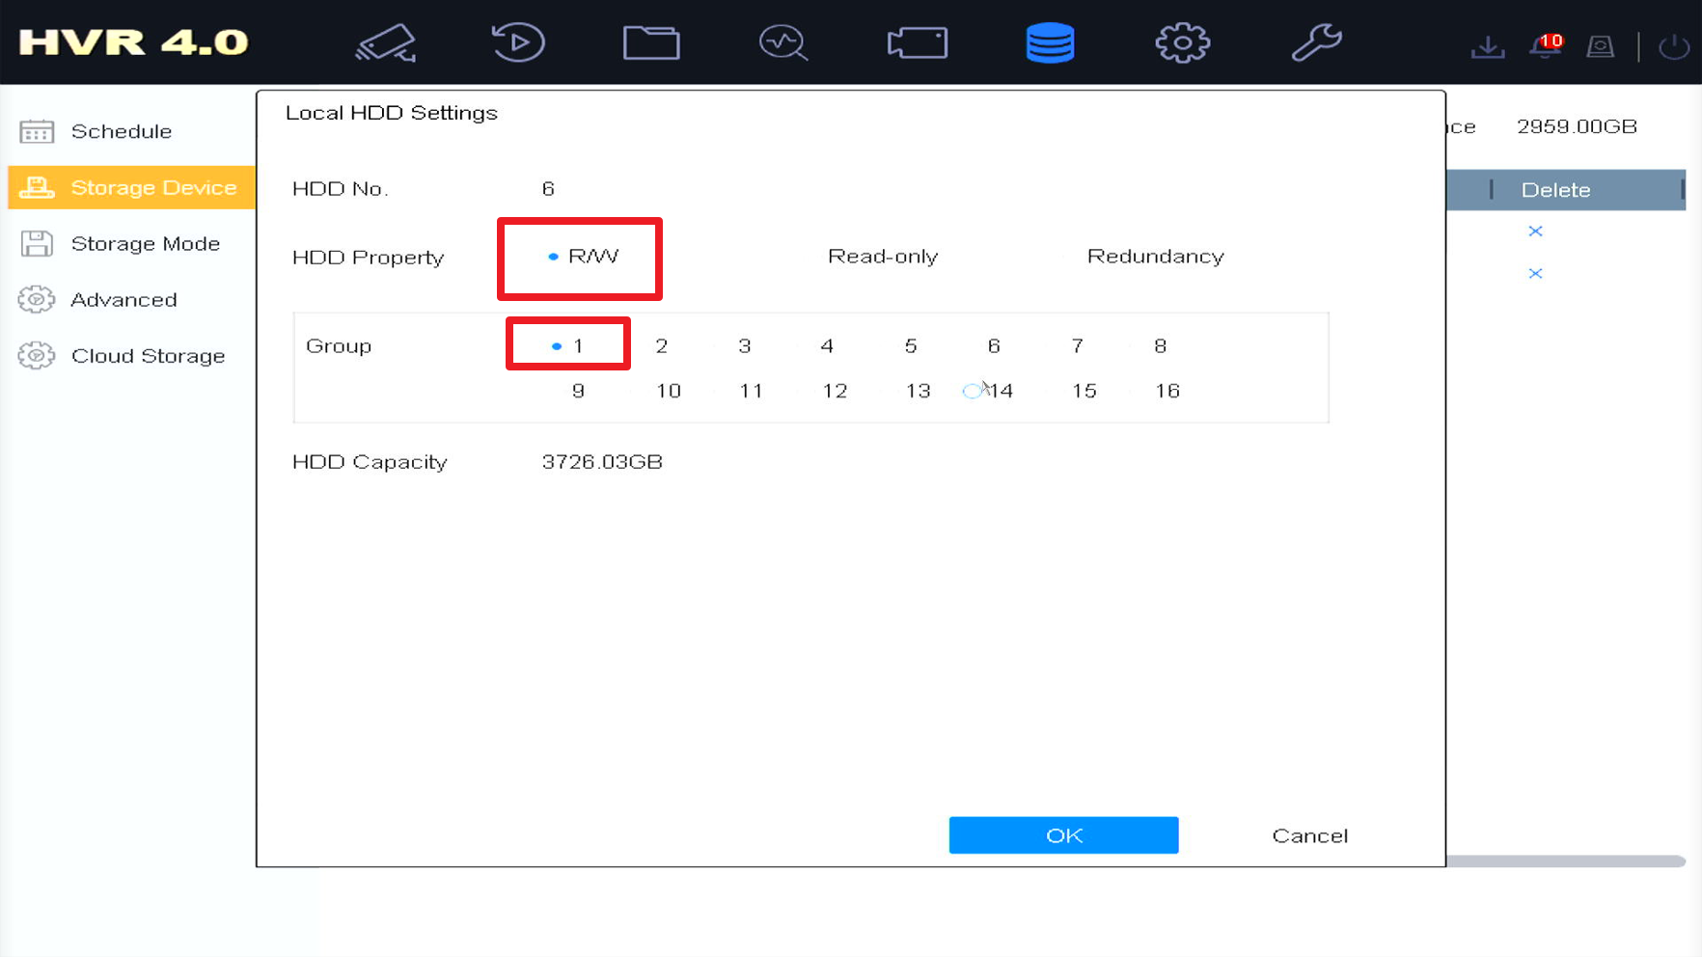

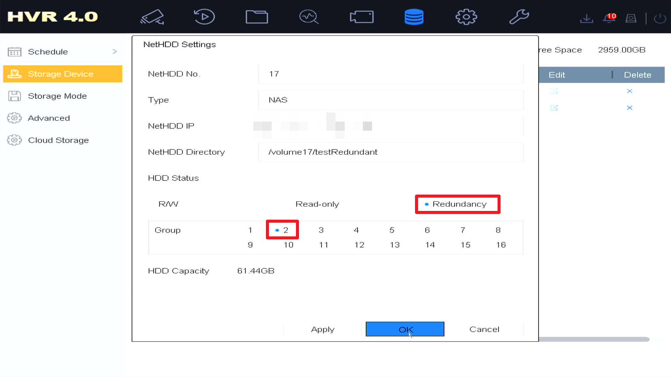

After finishing configuration, all the Property and Group parameters seen in all the disks are the updated ones.

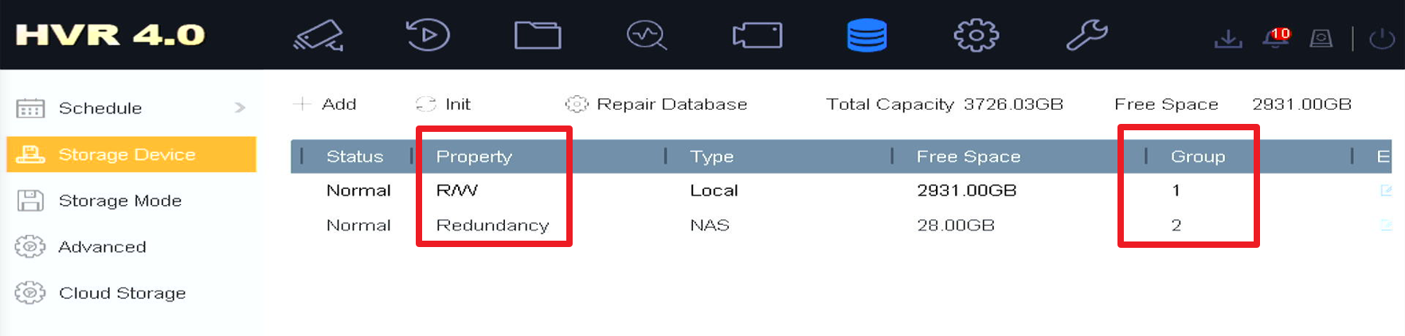

### Configure Redundant Record in Schedule Page

Enter Storage>Schedule, select the target camera channel to configure record schedule. Select Advanced button and choose the Redundant Record in the pop-up window.

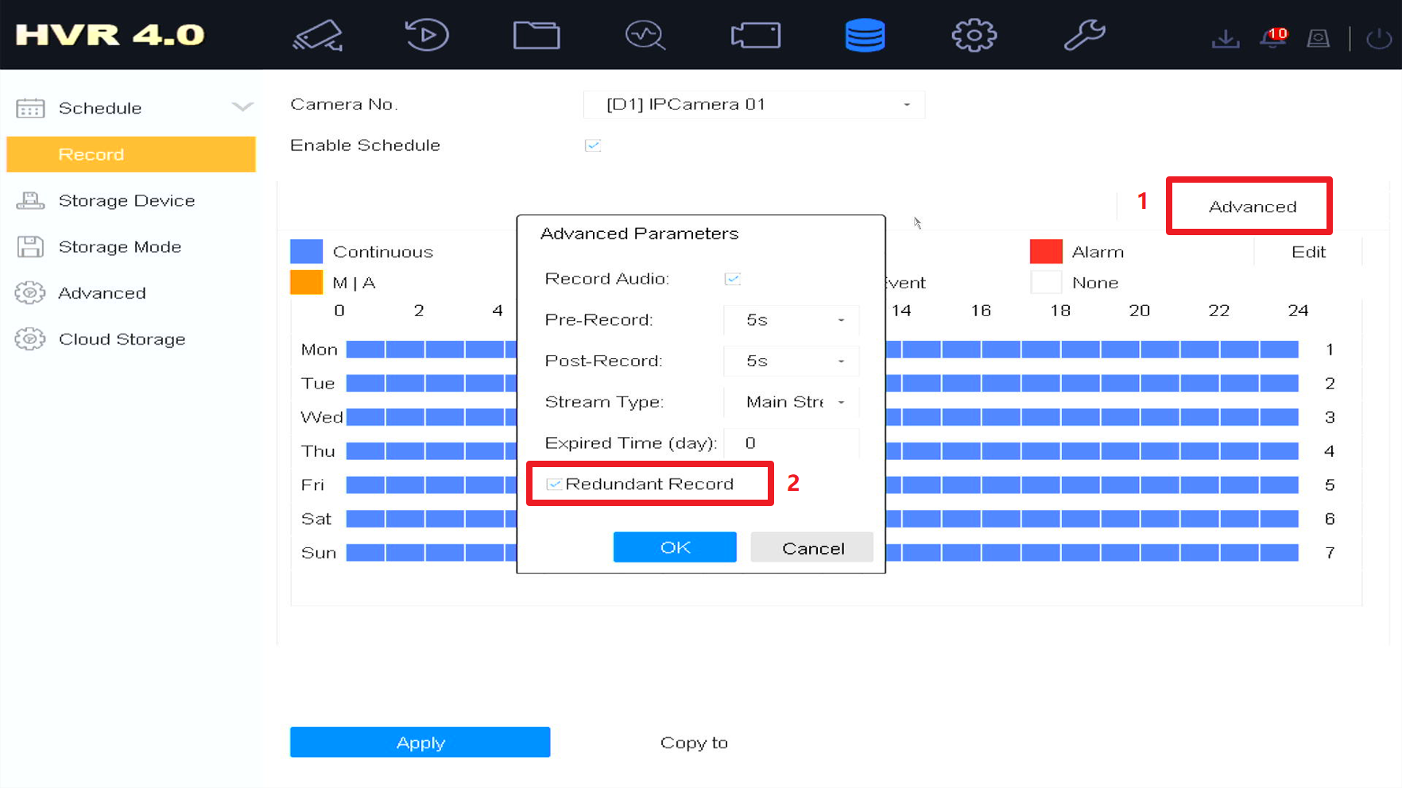

### Allocate Video Channel for Each Group

Go to Storage Mode and select the video channel that needed to be recorded for each Group, which is seen as the following picture.

* Allocate non-redundant disk video channel: select the HDD Group ID, then check the boxes you need in red rectangle shown in below picture. For instance, in below picture all video channels will record to Group 1.

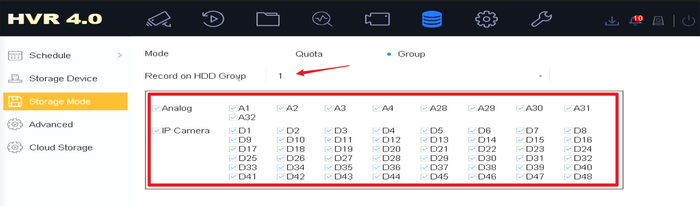

* Allocate redundant disk video channel: choose the redundant disk Group ID and channels for redundant recordings.

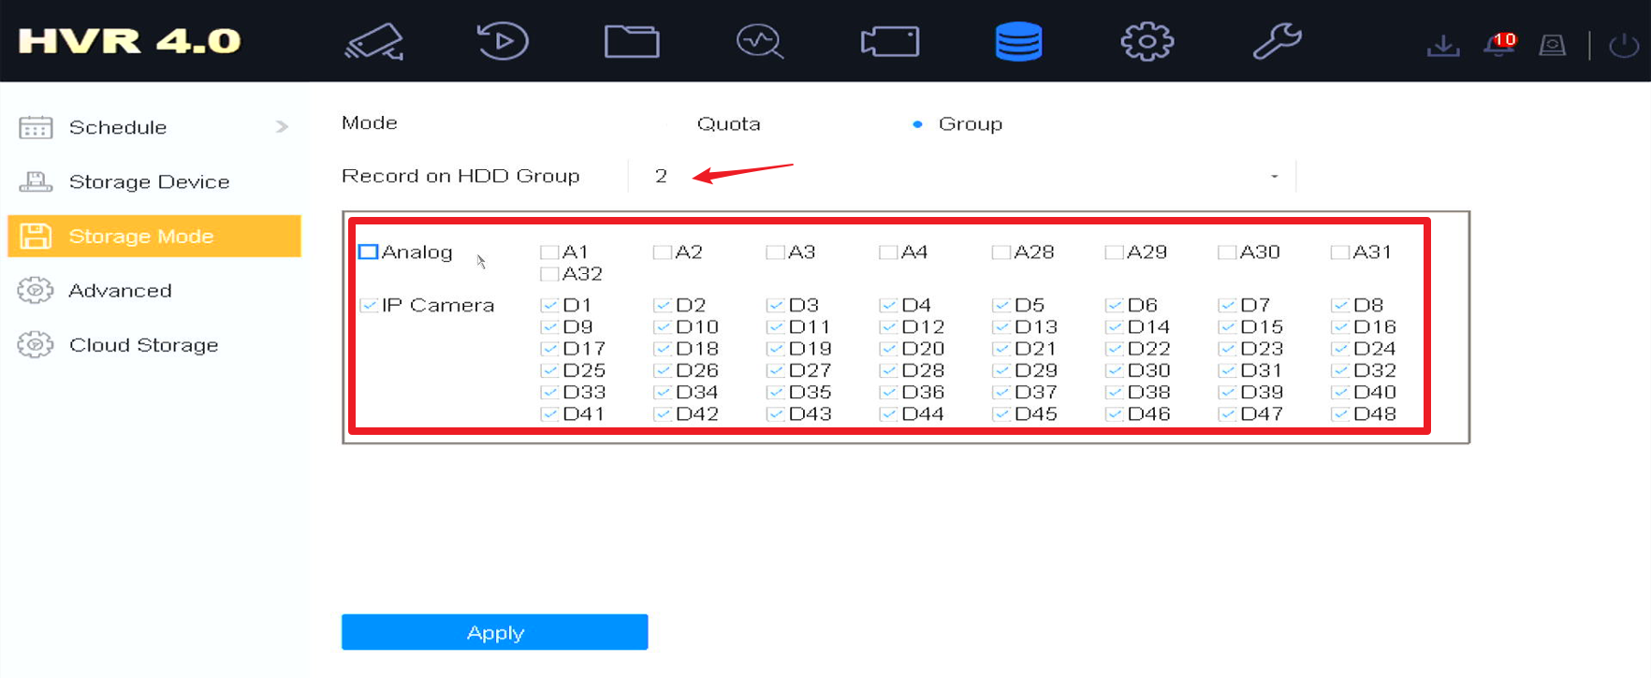

Finishing the steps above, the redundant record function is realized. To verify the configuration, the user can delete the non-redundant recording disk but only keep the disk for redundancy to see whether the recording exists.

