**How to Configure People Frequency Function**

# Introduction

People frequency function is mainly used for detection, frequency recording, alarm upload and retrieval of high-frequency people and low-frequency people. And people frequency function can only be configured on the web page.

# Configuration

## Web configuration

Configuration > Event > People frequency > Frequently Appeared Person / Rarely Appeared Person.

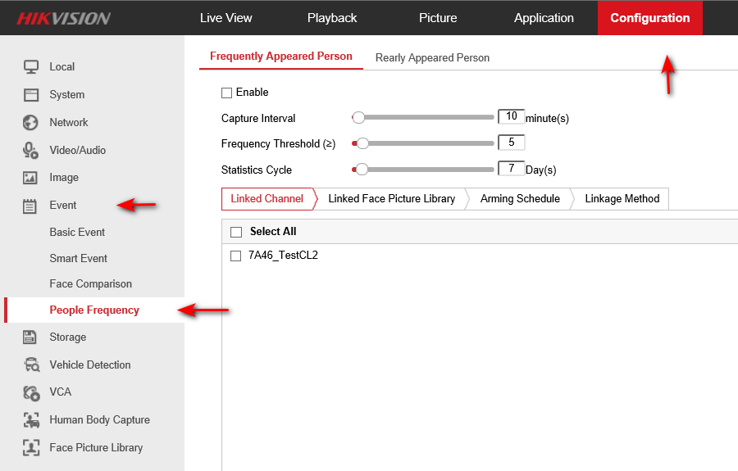

## Enable function and set detection parameters

Enable this function and Set the detection parameters:

1. Set Capture Interval (1-1440mins)
2. Set Frequency Threshold (1-100)
3. Set Statistics Cycle (1-31Days)

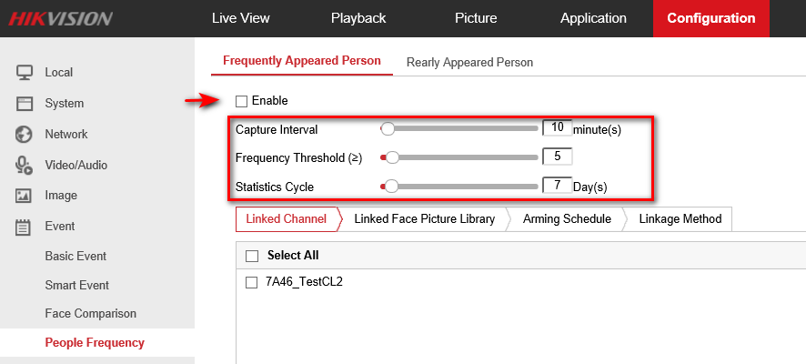

There is a Daily Report Time setting for Rarely Appeared Person:

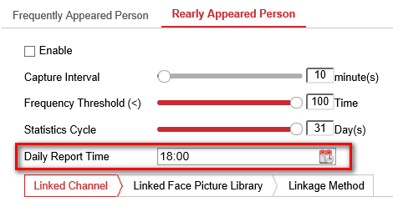

## Linked Channel

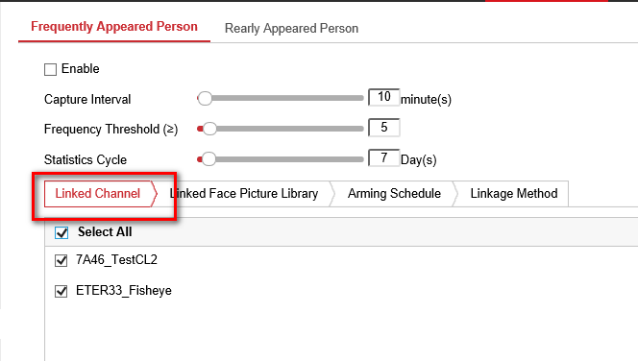

1. **Linked Face Library**

In Frequently Appeared Person, there is a default Stranger library. The captured strangers’ face model will be stored in the library for comparison, so that the high-frequency appeared stranger will trigger the Frequently Appeared Person alarm.

For the other face picture library, you can choose filter or alarm. If the library is set as filter, people in the face library will not trigger Frequently Appeared Person alarm.

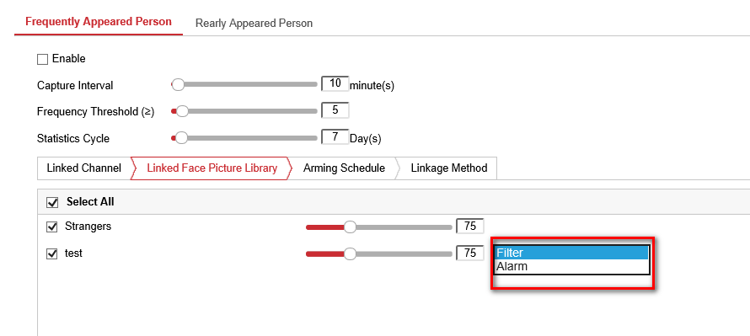

## Set Arming Schedule and Linkage Method

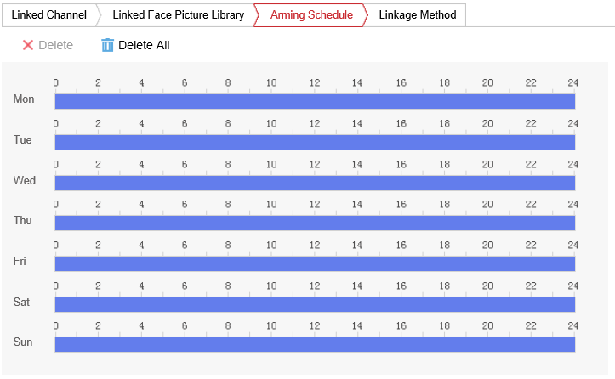

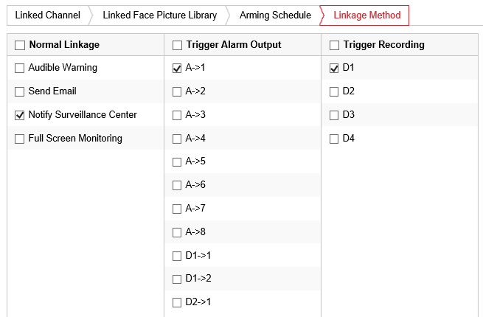

## Save the rules

