**How to Close Heater Of Analog PTZ Camera**

**Steps:**

1. Enter the main meus, go to DOME SETTINGS🡪 SYSTEM INFO SETTINGS, and You can set the HEAT CONTROL as TEMP (controlled by the temperature), ON or OFF.

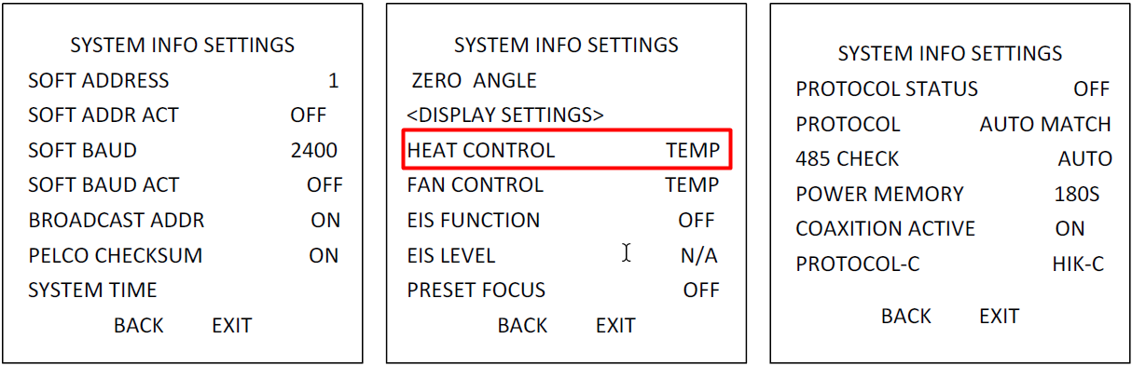

**First Choice for Security Professionals  
*HIKVISION* Technical Support**