**Flashing and Audible Alarm Configuration Guide of Ultral series PTZ camera**

# Flashing Alarm Light Output Configuration.

This page offers options to configure flashing light when the Flashing Alarm is enabled as an linkage method.

* 1. Enter 【Configuration】-【Event】-【Basic Event】-【Flashing Alarm Light Output】 page, set flashing parameters.

**Flashing Duration**: the time period the flashing lasts when one alarm happens.

**Flashing Frequency**: the flashing speed of the light. High, Medium, Low and Normal are selectable.

**Brightness**: the brightness of the light.

* 1. Set arming schedule for flashing alarm.
  2. Save the settings.

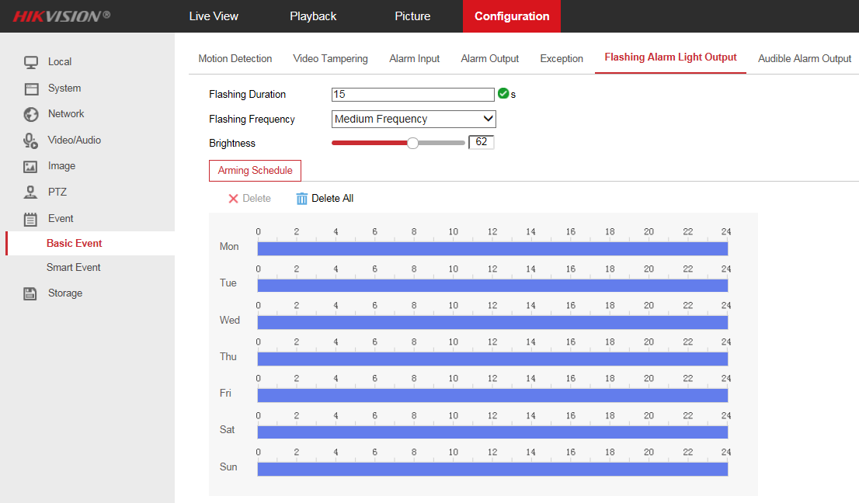

# Audible Alarm Output Configuration.

This page offers options to configure audible warning when the Audible Warning is enabled as an linkage method.

1. Enter 【Configuration】-【Event】-【Basic Event】-【Audible Alarm Output】 page, set Sound Type according to your needs.
2. Set the sound type to **Warning**, there are 11 kinds of warning are selectable.

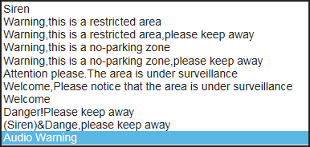

1. Set the sound type to **Prompt,** only one prompt is supported so far.

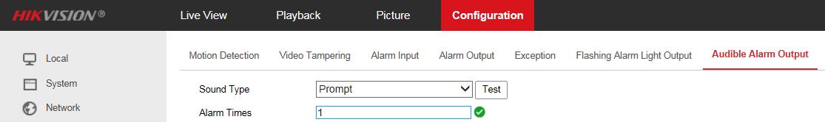

1. Set the sound type to **Custom Audio**, click Add to upload a .wav mono sound audio file with the size smaller than 512 KB and sampling rate as 8 KHz.

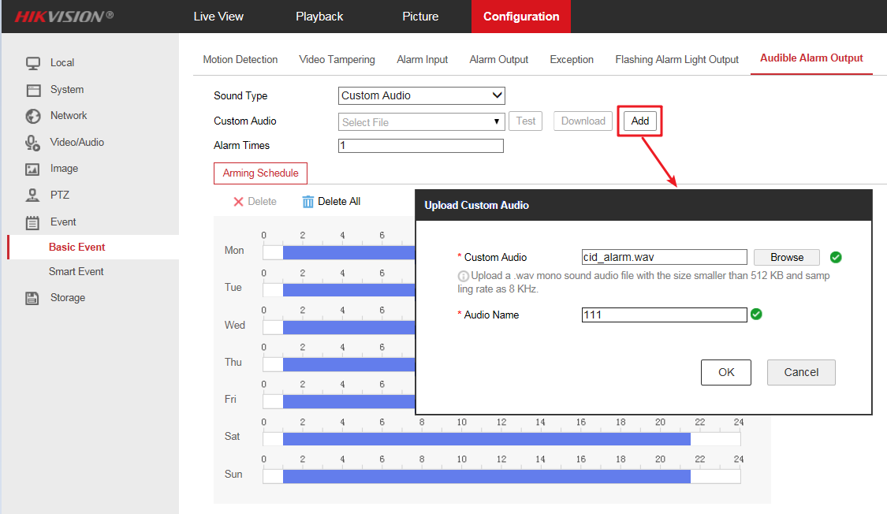

***Note:***

*If audio do not meet above requirements, it will prompt Uploading failed.*

1. Set Alarm Times according to the needs. It means the repeating times of the warning.
2. Set arming schedule for audible alarm.
3. Save the settings.

# Alarm Linkage Configuration.

Choose an event, check the Audible Alarm and Flash Alarm in the linkage mode.

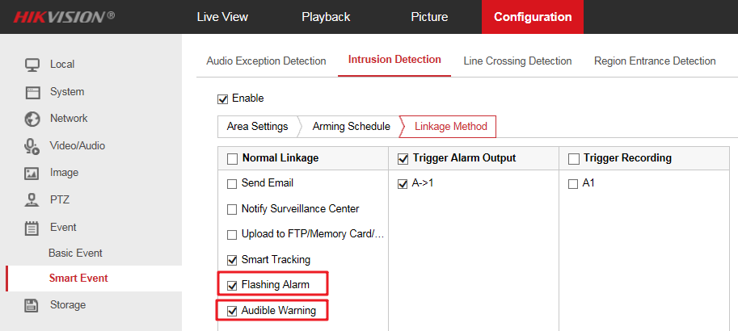

***Note:***

*For PTZ Dome Cameras, only four perimeter events (Intrusion Detection, Line Crossing Detection, Region Entrance Detection, Region Exiting Detection) and Alarm Input events support linked audible alarm and flash alarm.*

**First Choice for Security Professionals**

***HIKVISION* Technical Support**