Configuration Guide of ColorVu Camera Supplement Light(NEW)

E3 platform V5.5.95 and above,G0 platform V5.5.85 and above, E7 platform, G3 platform ColorVu camera supplement light configuration path：【Configuration】-【Image】-【Display Settings】-【Day/Night Switch】

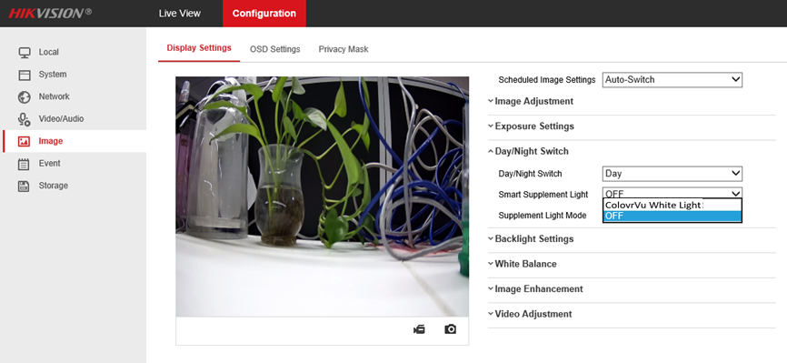

# Logic of supplement light

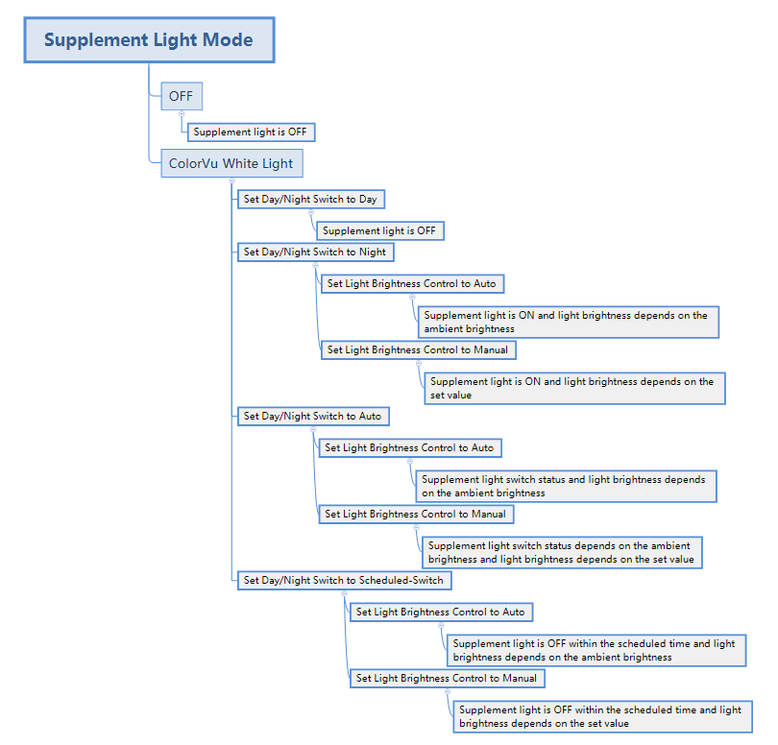

# Supplement light mode

1. If set the Supplement Light Mode to OFF, then the supplement light is always in OFF status

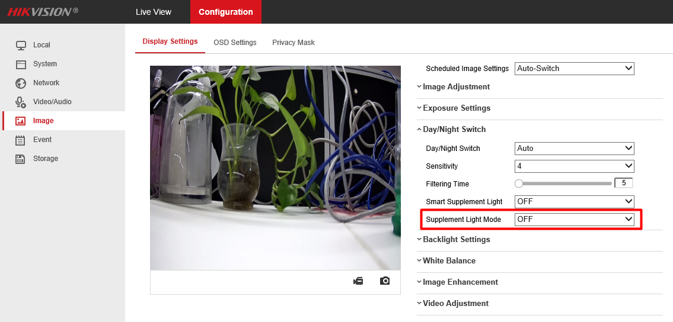

1. If set the Supplement Light Mode to ColorVu White Light, then the status of the supplement light is determined by Day / Night Switch, and the brightness of the supplement light is determined by Light Brightness Control

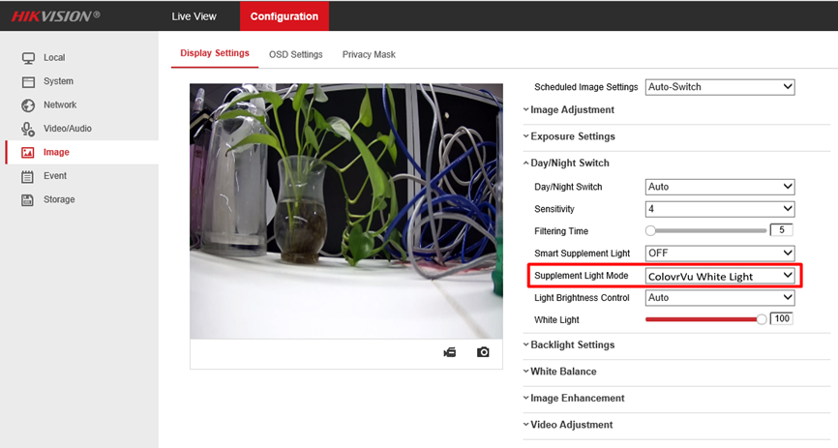

1. Mode configuration of supplement light
   1. **Day Mode**

If set Day/Night Switch to Day, the camera image is in color, the supplement light is always in OFF status, Supplement Light Mode and Light Brightness Control are unavailable.

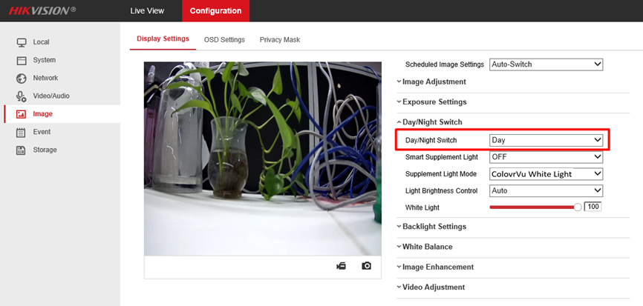

* 1. **Night Mode**

If set Day/Night Switch to Night, the camera image is in color, the supplement light is always in ON status, set Supplement Light Mode to OFF will turn off the supplement light, light brightness can be controlled with Light Brightness Control.

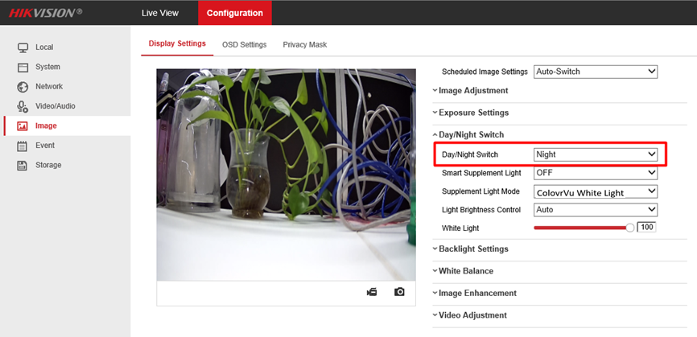

* 1. **Auto Mode**

If set Day/Night Switch to Auto, the camera image is in color,

1. Camera will detect ambient brightness automatically with Auto mode, and turn on supplement light automatically. The mechanism is similar to the automatic adjustment of infrared supplement lamplight;
2. Setting filtering time in the range of 5-120s;

When the ambient brightness exceeds the light limit and lasts for a period of time (as shown in the picture below: 5 seconds), the camera begins to turn the light on and off. This setting prevents the camera from continuing to turn on and off lights when the brightness changes rapidly;

1. Setting sensitivity in the range of 0-7;

The lower the sensitivity, the greater changing in ambient brightness is required before the camera can turn on and off the light; the higher the sensitivity, the lower the requirement of ambient brightness change.

1. Set Supplement Light Mode to OFF will turn off the supplement light.

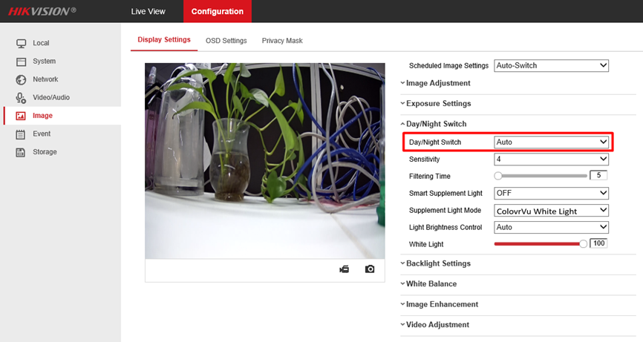

* 1. **Scheduled-Switch Mode**

If set Day/Night Switch to Scheduled-Switch, camera image is in color, within the Start and End Time periods, the camera turns off the supplement light, and outside the Start and End Time periods, the camera turns on the supplement light. Set Supplement Light Mode to OFF will turn off the supplement light.

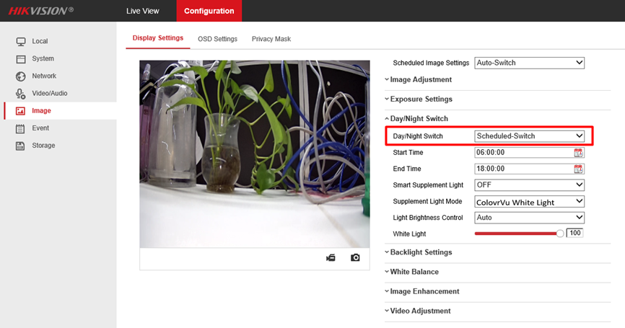

# Supplement light brightness mode

## Auto Mode

If set Light Brightness Control to Auto, camera will detect ambient brightness and adjust the brightness of supplement light automatically.

White Light can be set within level 1-100, 0 means no brightness, the level of White Light can limit the maximum brightness of supplement light, and default level is 50.

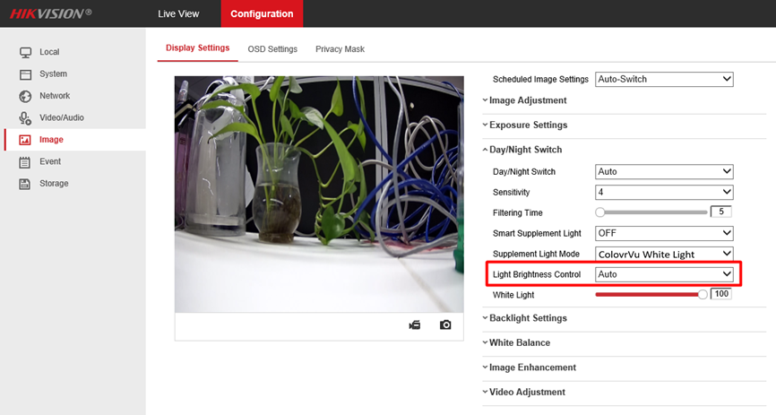

## Manual Mode

If set Light Brightness Control to Manual, the brightness of supplement light can be control with White Light, the set Level value is the actual brightness.

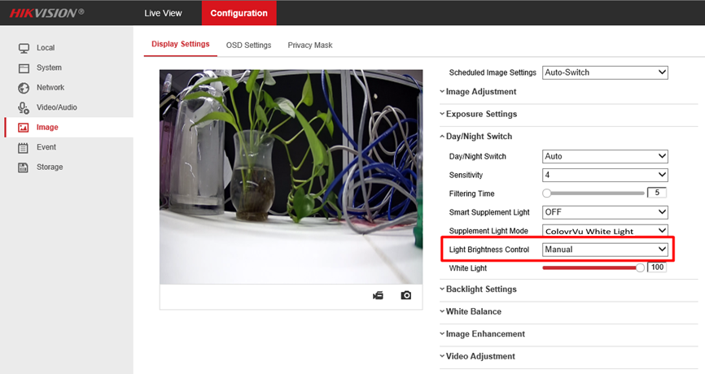

Configuration Guide of ColorVu Camera LED Supplement Light(Old)

# 1 Brightness configuration of LED supplement light

Note:

1, When the camera is electrified, it is self-check at full power, and the supplement light is bright, so avoid to stare at supplement light of camera;

2, LED supplement light will be locked in the light-on state for an hour after continuous switching for 5 times in a short time due to manual test or ambient brightness change.

Path：【Configuration】-【System】-【System Settings】-【External Device】

## 1.1 Enable supplement light

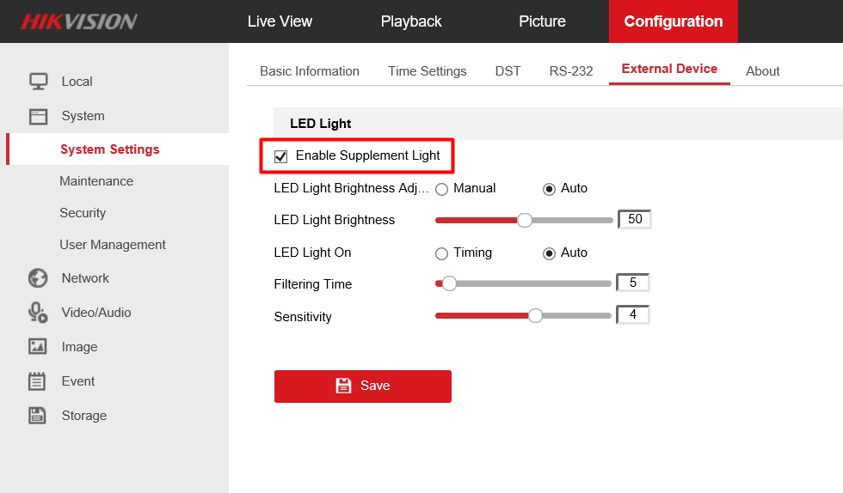

## 1.2 LED light brightness adjustment

LED light brightness can be set to Manual mode or Auto mode.

### 1.2.1 Manual mode

1. Select Manual mode in LED Light Brightness Adjustment;

2. Adjust LED light Brightness during level 1-100, 0 means no brightness;

3. Startup default is level 15 (sample model is 50, order model is 15)

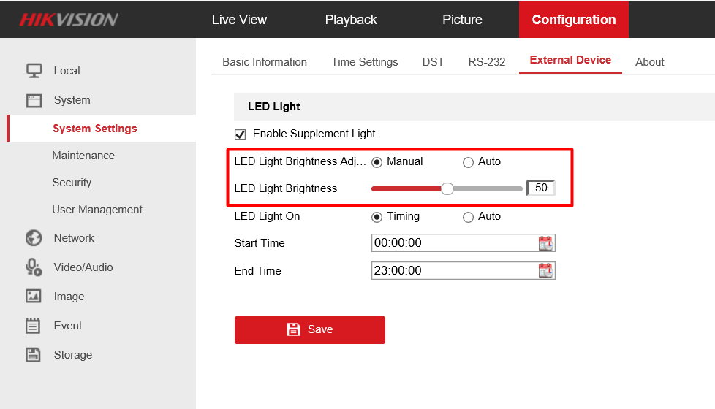

### 1.2.2 Auto mode

1. Select LED Light Brightness Adjustment mode with Auto, camera will detect ambient brightness automatically, adjusting the brightness of supplement light.

2. The level of LED light brightness can limit the maximum brightness of supplement light.

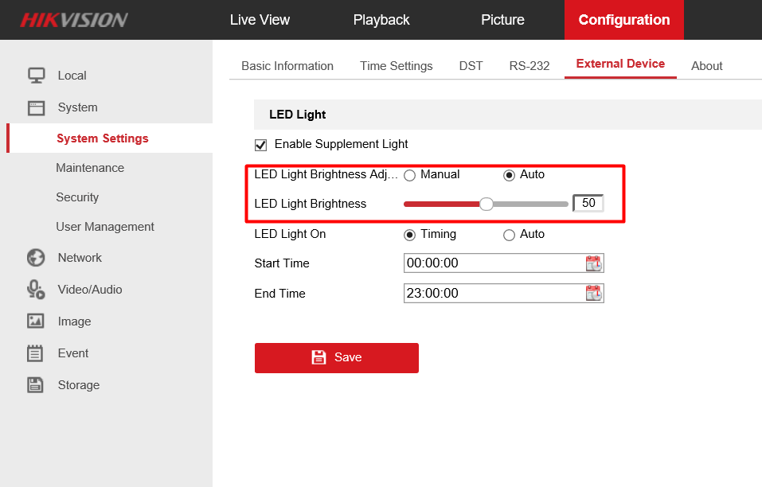

# 2 Mode configuration of LED Light On

Mode of LED Light On can be set to Timing or Auto.

## 2.1 Timing mode

1. Selecting Timing in LED Light On, camera will turn on/off the LED supplement light according to Start/End Time;

2. Setting schedule time according to application requirements. Start time should be earlier than End Time. Start Time can be on the previous day of End Time.

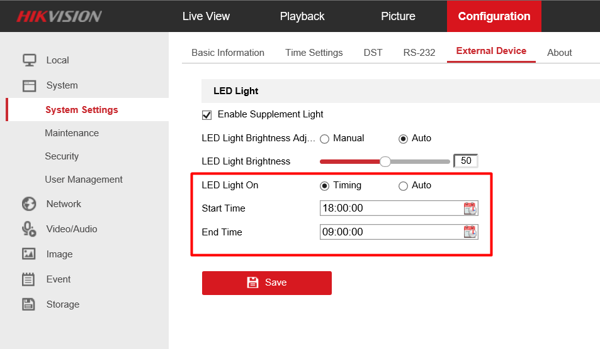

## 2.2 Auto mode

1. Camera will detect ambient brightness automatically with Auto mode, and turn on LED light automatically. The mechanism is similar to the automatic adjustment of infrared supplement lamplight;

2. Setting filtering time in the range of 0-120s;

When the ambient brightness exceeds the light limit and lasts for a period of time (as shown in the picture below: 5 seconds), the camera begins to turn the light on and off. This setting prevents the camera from continuing to turn on and off lights when the brightness changes rapidly;

3. Setting sensitivity in the range of 0-7;

The lower the sensitivity, the greater changing in ambient brightness is required before the camera can turn on and off the light;

The higher the sensitivity, the lower the requirement of ambient brightness change;

4. Currently, the default mode is Auto. Adjusting the parameters or customizing the firmware if need to turn off the light by default.

