**KD9203 Firmware**

**V2.2.37_220316 Release Note**

**(2022-03-20)**

|  |  |
| --- | --- |
| Device Model | DS-KD9203-E6、 DS-KD9203-FE6、 DS-KD9203-TE6、 DS-KD9203-FTE6 |
| Firmware Version | V2.2.37_220316 |
| iVMS-4200 Version | Late version |
| Hik-Connect APP | Late version |

**Fix:**

1. Fix the issue that the fails to log in when the language other than English is selected .

**KD9203 Firmware**

**V2.2.37_211125 Release Note**

**(2021-11-29)**

|  |  |
| --- | --- |
| Device Model | DS-KD9203-E6、 DS-KD9203-FE6、 DS-KD9203-TE6、 DS-KD9203-FTE6 |
| Firmware Version | V2.2.37_211125 |
| iVMS-4200 Version | Late version |
| Hik-Connect APP | Late version |

**Fix:**

Modified bugs:

1. When Door Station call Indoor Station by “Outer Door Station” mode (with protocol 2.0), there is no massage record in Indoor Station.
2. The device will be rebooted caused by switching Portuguese.

**KD9203 Firmware**

**V2.2.37_210812 Release Note**

**(2021-08-12)**

|  |  |
| --- | --- |
| Device Model | DS-KD9203-E6、 DS-KD9203-FE6、 DS-KD9203-TE6、 DS-KD9203-FTE6 |
| Firmware Version | V2.2.37_210812 |
| iVMS-4200 Version | Late version |
| Hik-Connect APP | 4.13.1 or above |

**Modify**

1、 HiK-Connect is disabled and Verification code is empty by default.

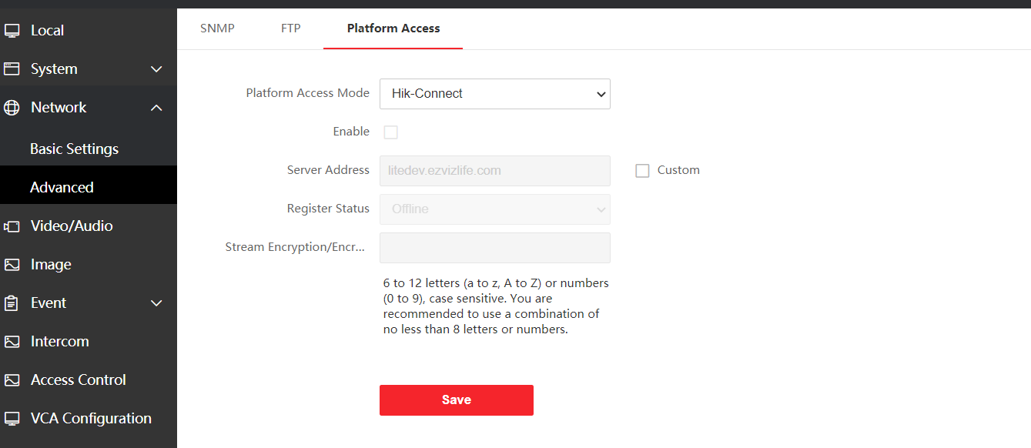

**Face Recognize Door Station Firmware V2.0.0_210120 Release Note**

**(2021-02-01)**

|  |  |
| --- | --- |
| Device Model | DS-KD9203-E6、DS-KD9203-FE6  DS-KD9203-TE6、DS-KD9203-FTE6 |
| Firmware Version | Value Indoor Station : V2.0.0_210120 |
| iVMS-4200 Version | 3..4.0.10 Build201214 |

**New Function**

1. Support address book function

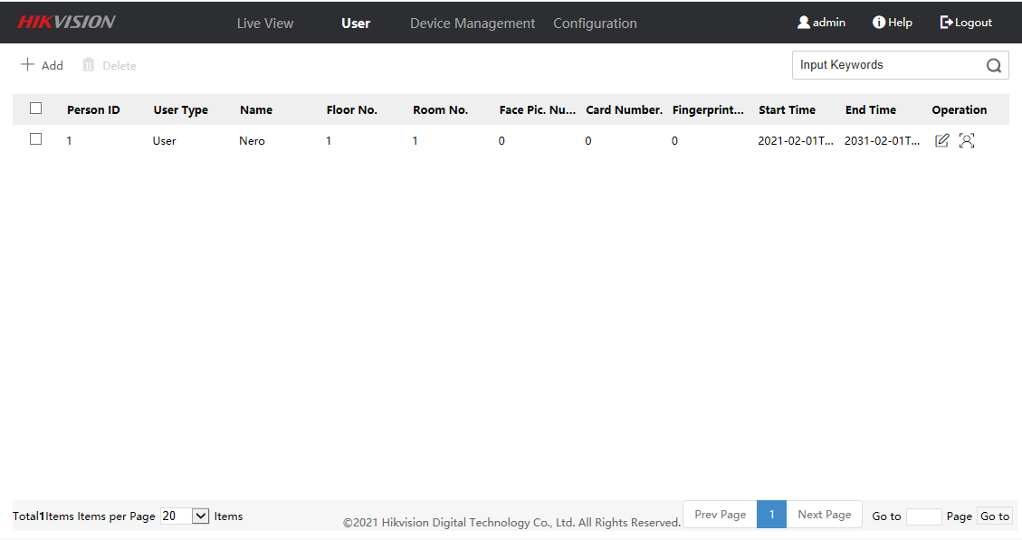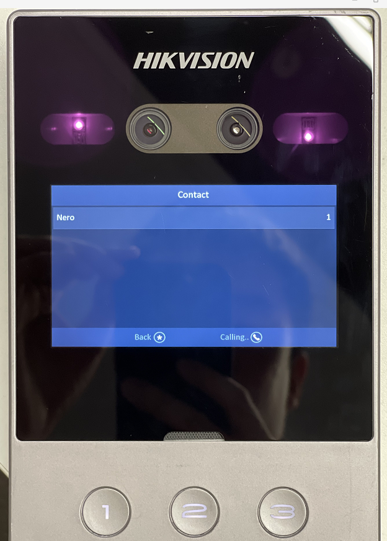

2. Support DST function

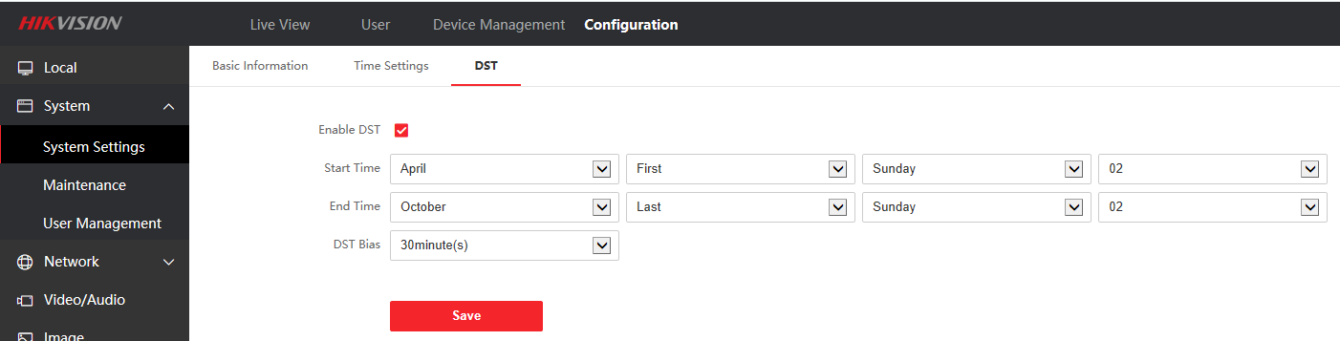

3. Multi-language support increased to 8 countries: English, Traditional Chinese, Portuguese (Brazil), Russian, Spanish, Turkish, Arabic and Vietnamese

**Fix Bugs**

1. Fix the problem that iVMS-4200 cannot get the card number

