**Network Camera Firmware Version:** **V5.5.111**

**Release Note(Internal)**

**(2021-01-15)**

|  |  |  |
| --- | --- | --- |
| **Firmware**  **Basic Information** | Firmware Version: | V5.5.111 build201223 |

**Camera V5.5.111 Features**

1. **New Features**

* Newly release the 2x46G2, 2x47G2 and 3x47G2 models:

DS-2CD2046G2-I(U)(C), DS-2CD2046G2-IU/SL(C), DS-2CD2146G2-I(S)(U)(C), DS-2CD2346G2-I(U)(C), DS-2CD2346G2-ISU/SL(C), DS-2CD2646G2(T)-IZS(C), DS-2CD2646G2-IZSU/SL(C), DS-2CD2746G2(T)-IZS(C), DS-2CD2H46G2(T)-IZS(C), DS-2CD2T46G2-2I/4I(C), DS-2CD2T46G2-ISU/SL(C);

DS-2CD2047G2-L(U)(C), DS-2CD2347G2-L(U)(C), DS-2CD2T47G2-L(C);

DS-2CD3047G2-LS(C), DS-2CD3347G2-LS(C);

* Newly support for Monitoring mode, which supports Third Stream and Rotate function.

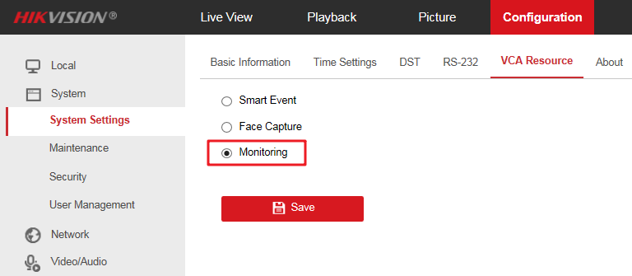

1. **Improved Features**

* The Intrusion Detection and Line Crossing Detection of 2xx3G2 models support the classification of Human and Vehicle.
* The difference function between 2xx6G2, 2xx7G2 and 2xx6G2(C), 2xx7G2(C) are shown in the table below:

|  |  |  |
| --- | --- | --- |
| **Type** | **2xx6G2/2xx7G2(V5.5.150)** | **2xx6G2(C)/2xx7(C)(V5.5.111)** |
| OSD | Support custom colors | Does not support custom colors |
| Monitoring Mode | Only 8MP models support monitoring mode, which supports rotate function | All models of the 2 series support monitoring mode, which supports rotate and third stream function(including 2xx3/2xx6/2xx7) |
| Coding | Compliant with configuration, low bitrate at night | The night bitrate is 2 times larger than 2xx6G2/2xx7G2, and the overall configuration is in line with the configuration |
| Resolution | The third stream supports up to 720P@30fps | Remove the resolution 2592*1944(2xx6G2) and 2304*1296;  The third stream supports up to 1080P@10pfs |

* The difference function between 3x47G2 and 3x47G2(C) are shown in the table below:

|  |  |  |
| --- | --- | --- |
| **Type** | **3x47G2(V5.5.150)** | **3x47G2(C)(V5.5.111)** |
| OSD | Support custom colors | Does not support custom colors |
| Monitoring Mode | Only 8MP models support monitoring mode, which supports rotate function | All models of the 3 series support monitoring mode, which supports rotate and third stream function |
| Coding | Compliant with configuration, low bitrate at night | The night bitrate is 2 times larger than 2xx6G2/2xx7G2, and the overall configuration is in line with the configuration |
| Resolution | The third stream supports up to 720P@30fps | Remove the resolution 2592*1944 and 2304*1296;  The third stream supports up to 1080P@10pfs |
| SRTP/EIS/EPTZ | Support | Does not support |

1. **Leftover Issues**

* The watermark function of the 1x83 model is invalid.
* The BNC function of models 26x3G2, 27x3G2 and 2Hx3G2 is invalid.
* OSD switching between 16*16 and 48*48 prompts that the save is successful, but it does not actually take effect.
* When the WDR level is setted greater than 50, there will be noise.
* The built-in microphone can’t hear clearly at a distance of 3 meters.
* It takes 1-3 seconds to switch between PAL(50HZ)/NTSC(60HZ) and WDR enable/disable, during which there are problems of freeze and image abnormality.

**Customer Impact and Recommended Action**

This update refers to function/compatibility improvement and will take effect automatically after the Date of Change. We are very sorry for any inconvenience of use-habit changes caused by this action.

For any questions and request for this firmware, please contact our local technical support team.

***Remarks:***

* Hikvision reserves the right to change, alter or withdraw the above notification without prior notice.
* Product design and specifications are subject to change without prior notice.
* The Hikvision firmware may contain errors known as errata which may cause the product to deviate from published specifications. Current characterized errata are available on request.
* Hikvision is not liable for any typing or printing errors.

Hikvision Digital Technology CO., Ltd.

No. 555 Qianmo Road, Binjiang District, Hangzhou 310051, China

Tel: +86-571-8807-5998

FAX: +86-571-8993-5635

Email: overseabusiness@hikvision.com

|  |  |
| --- | --- |
| **Supported Product List (2xx3G2, 2xx6G2(C), 2xx7G2(C), 3xx7G2(C)Series)** | |
| **Product Category** | **Model Number** |
| 1 Series | DS-2CD1083G0-I(U)(F) |
| 1 Series | DS-2CD1183G0-I(U)(F) |
| 1 Series | DS-2CD1383G0-I(U)(F) |
| Pro Series | DS-2CD2023G2-I(U) |
| Pro Series | DS-2CD2043G2-I(U) |
| Pro Series | DS-2CD2123G2-I(S) |
| Pro Series | DS-2CD2123G2-IU |
| Pro Series | DS-2CD2143G2-I(S) |
| Pro Series | DS-2CD2143G2-IU |
| Pro Series | DS-2CD2323G2-I(U) |
| Pro Series | DS-2CD2343G2-I(U) |
| Pro Series | DS-2CD2T23G2-2I/4I |
| Pro Series | DS-2CD2T43G2-2I/4I |
| AcuSense Series | DS-2CD2046G2-I(U)(C) |
| AcuSense Series | DS-2CD2046G2-IU/SL(C) |
| AcuSense Series | DS-2CD2146G2-I(S)(U)(C) |
| AcuSense Series | DS-2CD2346G2-I(U)(C) |
| AcuSense Series | DS-2CD2346G2-ISU/SL(C) |
| AcuSense Series | DS-2CD2646G2(T)-IZS(C) |
| AcuSense Series | DS-2CD2646G2-IZSU/SL(C) |
| AcuSense Series | DS-2CD2746G2(T)-IZS(C) |
| AcuSense Series | DS-2CD2H46G2(T)-IZS(C) |
| AcuSense Series | DS-2CD2T46G2-2I/4I(C) |
| AcuSense Series | DS-2CD2T46G2-ISU/SL(C) |
| ColorVu Series | DS-2CD2047G2-L(U)(C) |
| ColorVu Series | DS-2CD2347G2-L(U)(C) |
| ColorVu Series | DS-2CD2T47G2-L(C) |
| ColorVu Series | DS-2CD3047G2-LS(C) |
| ColorVu Series | DS-2CD3347G2-LS(C) |

*Note: Models in red font are newly released models.*