

Brief Introduction and Notice

About Overseas Keyboards

V1.0

(For Internal Reference Only)



Hangzhou Hikvision Digital Technology Co., Ltd.

1. There are 5 models of keyboard sold abroad now, two of them are analog keyboard DS-1003KI& DS-1004KI, another one is USB keyboard DS-1005KI, and the last two models are network keyboard DS-1100KI& DS-1600KI.The fellow table tells the main functions and differences between them.(Not all of functions are listed in the table, please refer to the user manual for details).

|  |  |  |  |  |  |
| --- | --- | --- | --- | --- | --- |
| Model | Control Interface | Working Mode | Connection | Main Functions | Device Support List |
| DS-1003KI | RS485 Bus(Support 15 auxiliary keyboards) | PTZ | PTZ-CON(Ta,Tb)connected to the RS485 of PTZ or decoder | Preview screen switch, PTZ control, set and call of preset &patrol & pattern  Note：  1) .Support connecting up to 128 PTZ  2) .Control PTZ via the transparent channel of decoder | DS-1004KI is a ungraded device of DS-1003KI.A keyboard can support DVR/NVR, if only they **have the KB interface and support the panel control**(The function of an analog keyboard is to send control command, if an end device does not support keyboard control, then in most case, it need the end device to adjust) |
| DVR/NVR | DVR-Con(Ta,Tb) connected to the KB interface of DVR/NVR | Record & replay, PTZ control, Call preset(set preset , patrol &pattern not supported )  Note： Support connecting up to 31 DVR/NVR |
| DS-1004KI | RS485 Bus( Support 16 auxiliary keyboards ) | DVR/NVR | DVR/MATRIX-CON1）connected to the KB interface of DVR/NV | Record & replay, PTZ control, Call preset(set preset , patrol &pattern not supported )  Note： Support connecting up to 128 DVR/NVR |
| PTZ | PTZ-CON main interface connected to the RS485 of PTZ | Preview screen switch, PTZ control, set and call of preset &patrol & pattern  Note： Support connecting up to 128 PTZ |
| MVC | DVR/MATRIX-CON1）connected to the RS485 of MVC | 1). Display control : Input a certain camera (or camera group) to a selected screen (screen group);  2). PTZ control: set and call of preset &patrol & pattern |
| Analog matrix | RS232 serial port connected to the RS232 0f analog matrix | 1). Analog matrix control switching;  2). Input a certain camera (or camera group) to a selected screen (screen group);  Note: Support connecting up to 128 analog matrix; |
| DS-1005KI | USB 2.0 | Keyboard | Plugging the USB interface into the PC | Control iVMS-4200 & iVMS-5200:  Preview interface:  Preview screen switch, picture capture, record, PTZ control etc.  Video wall interface: Display video channel on video wall, PTZ control;  Note：Device driver should be installed on PC | **NVR:**  -E/Netra series, (V3.2.0 and later versions), -I series;  **TVI DVR :**  V3.3.1 and later versions; |
| Joystick | Plugging the USB interface into the PC or DVR/NVR | Control iVMS-4200 & iVMS-5200(USB plugged into PC ):  Preview interface:  Preview screen switch, picture capture, record, PTZ control, preset & patrol &pattern etc. (video wall interface not supported).  USB plugged into DVR/NVR:  Preview screen switch, live view, record, PTZ control, etc.  Note：Only under Joystick mode, could DVR/NVR be controlled by keyboard |
| 1100KI | RJ45(7’ TFT touch screen, 1-ch 1080P decoding ability) | Joystick | RJ45 | 1). Local live view, replay, picture capture;  2). PTZ control, set and call of preset &patrol & pattern;  3). The DS-1100KI can automatically obtain the video output(multi-screen and roaming window) parameters of DS-6400HDI-T which is configured by video client, and display video channel on those video output interfaces;  4). The DS-1100KI can automatically obtain the video output parameters(video all and roaming window) of DS-6400HDI-S or B20(not sold overseas ) which is configured by video client, and display video channel on video output interfaces; | DVR/NVR/IPC/PTZ/Decoder/MVC … |
| MVC | RJ45 | 1). Local live view, preview screen switch, multi-screen configuration, background picture configuration, etc.  2).Display video on normal output interface ; Display video on multi-screen (support configuration locally ); Display video on video wall and roaming window (the configuration should be operated on video wall client); | C10S, B10, B20… |
| Analog matrix | RS232 serial port connected to the RS232 0f analog matrix | 1). Input a certain camera (or camera group) to a selected screen (screen group);  2). Support PTZ control and setting and calling of preset & patrol & pattern of PTZ connected on the analog matrix | Analog matrix |
| iVMS Software | RJ45 | Support video wall interface control of iVMS-5200(overseas market) | iVMS-5200, iVMS-8700 |
| 1600KI | RJ45(  10.1’ capacitive touchscreen, 2-ch 1080P decoding ability, Android system, detachable design, HDMI&DVI external output interface ) | NA | RJ45 | 1). Local live view, record & replay, intercom, PTZ control, set and call of preset & pattern, call of patrol, etc.  2). TheDS-1600KI keyboard can automatically obtain the video output parameters of the DS-6400HDI-S or DS-B20which is configured by the video wall,  3). The video wall settings of theDS-6400HDI-T can be configured via DS-1600KI keyboard, while the multi-screen display needs to be configured on video wall client;  4). The video wall configuration of DS-6400HDI-S and DS-B20 is not supported by DS-1600KI keyboard.( DS6400HDI-S and DS-B20 are not sold at overseas now); The keyboard support opening roaming window, moving roaming windows, stretching and narrowing roaming window;  5). The keyboard supports external preview of the live video of the added devices, e.g., external display via HDMI or DVI interface. | DVR/NVR/IPC/PTZ/Decoder/MVC… |
|  |  |  |  |  |  |

1. **Notice**

a). The latest firmware V2.4.0 of DS-1100KI is not compatible with the latest firmware V3.5 of DS-6400HDI-T series decoder. If the keyboard is needed to be compatible with the latest firmware of Ds-6400HDI-T decoder, the firmware of Ds-1100KI should be customized.

b).There is a corresponding relationship between firmware version and panel version of DS-1100KI. Due to the different joystick type, DS-1100KI comes into three generations and the panel version varies with the joystick. The joystick of first generation keyboard is quite different with the second and the third generation, so the panel version of first generation are not compatible with the second and the third, while the second and the third enjoys the same panel version. HIKVISION does not provide upgrade service for first generationkeyboard anymore, and the final firmware version is V2.3.1 and the panel version is V1.0. If a second or third generation keyboard needed to upgrade to firmware version V2.4.0, the panel version should be upgraded to V1.1 at the same time. The joystick difference between first generation keyboard and second &third generation keyboard is displayed as fellow two pictures:

**The first generation DS-1100KI：**

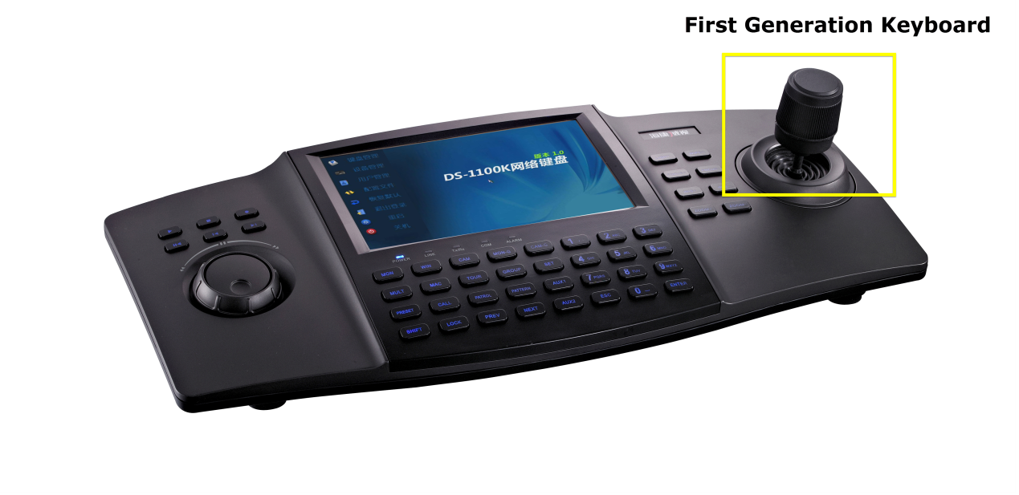

**The second & third generation DS-1100KI:**

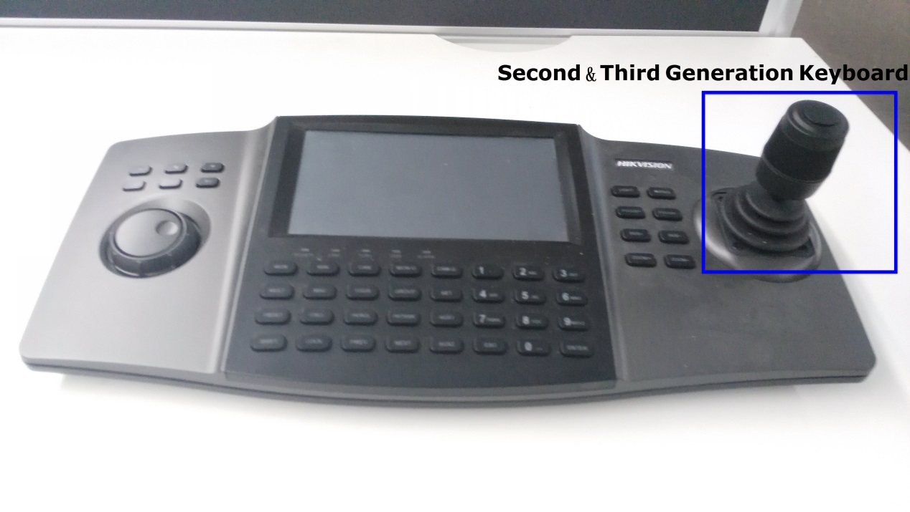

c). For earlier version before V2.31, the only way to restore password is serial command via telnet service or direct connection through serial port. As to V2.3.1 version, the telnet service and serial command have been prohibited, so it needs the help of special software. If customer demands the password restoration service, job done by our engineer is strongly suggested. Please try not to tell customer the authentication password and serial command, which **matters our** products safety. You can refer to the operation documents provided on our 400FTP service. The file path as bellow:

**/Product File(Overseas)/05 Transmission&Display/【Firmware】固件/【3】Control/【3】Keyboard/**

For V.2.4.0 or updated version, the keyboard supports the latest password restoration strategy.

d).The instrument files for keyboard update are uploaded on the 400 FTP service, the file path is the same with above.

**Note: This document is only for internal reference, should there any mistakes, please contact us. Many thanks!**