**how to call main station from door station**

1. Go to the remote configuration of the master station KM8301, set the community Number and Index as below:

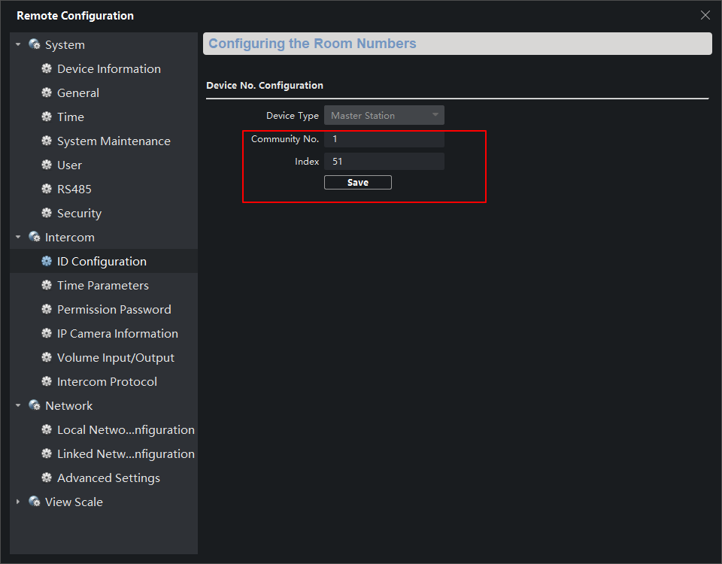

1. Set the Center IP as the IP address of the master station.

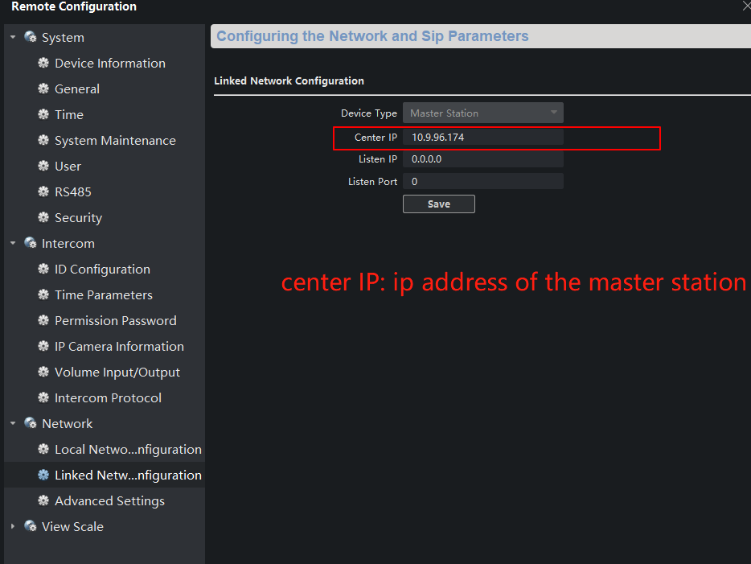

After these 2 steps, you can check whether the interface of the master station is as shown in the picture below. (if it is not ‘Connected’, please check step 1 and step2)

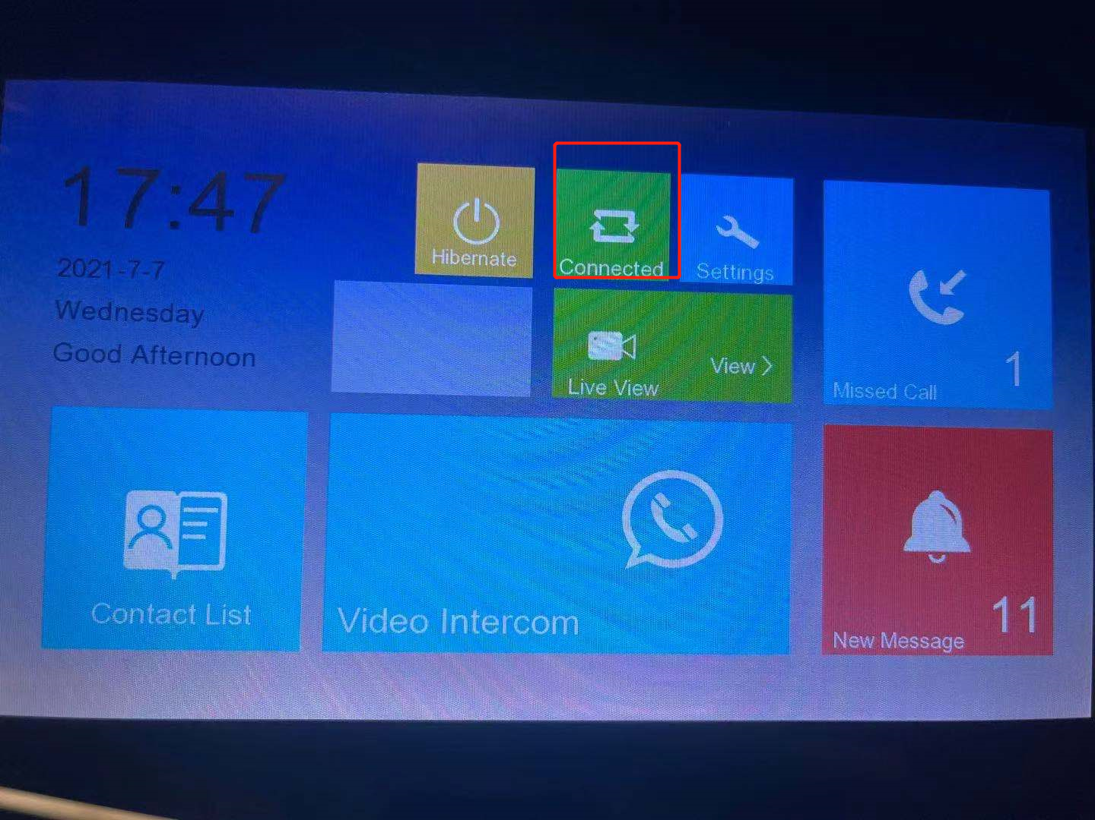

1. Go to ‘IP camera information’, choose the device type as door station and input the parameters of the door station.

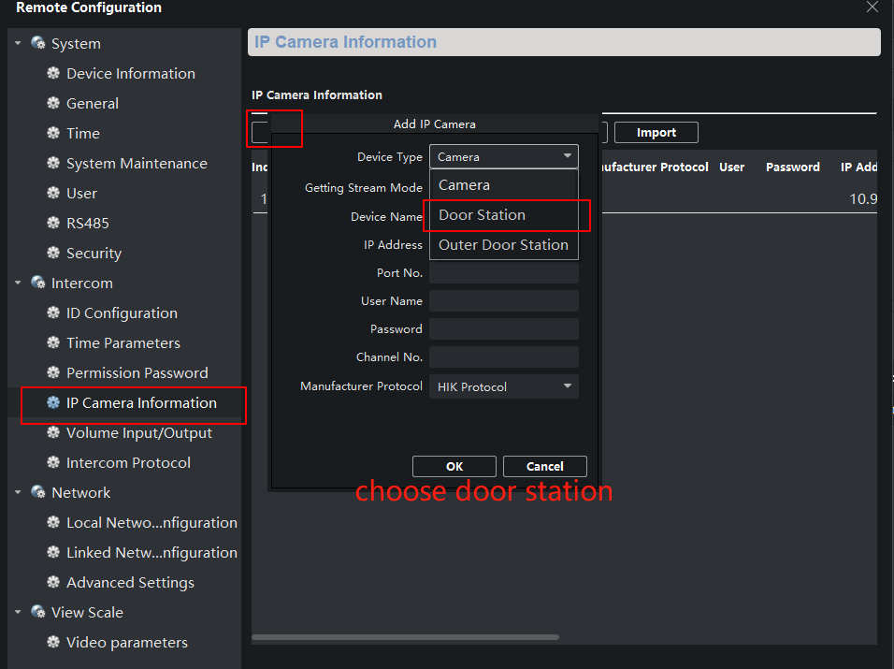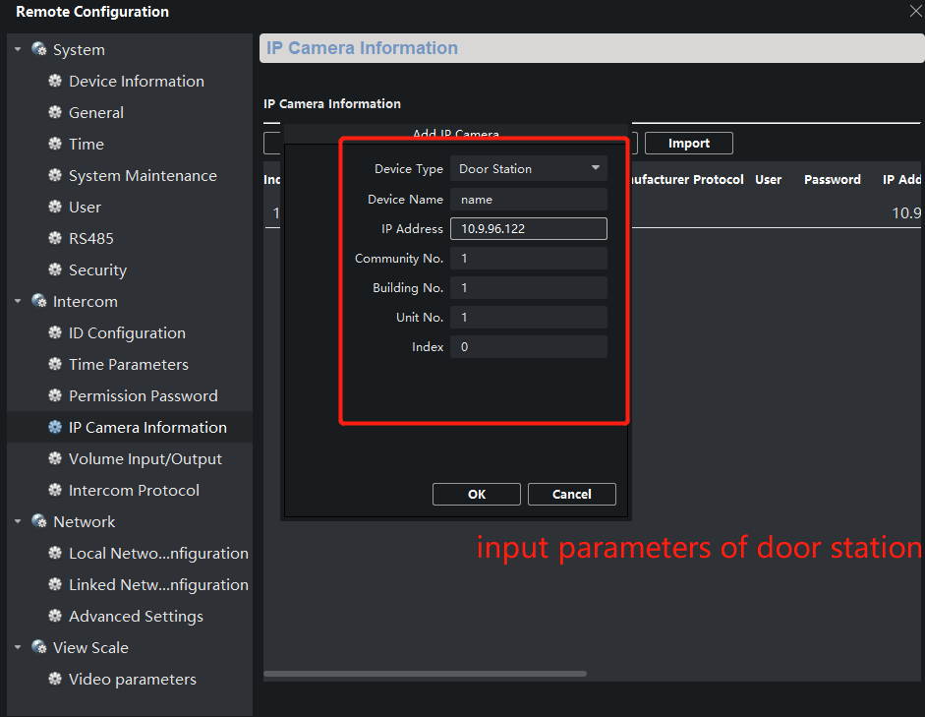

1. Go the ‘remote configuration’ of the door station KV8113. Link the door station with the master station like below and configuration the time schedule when you can call the master station from the door station.

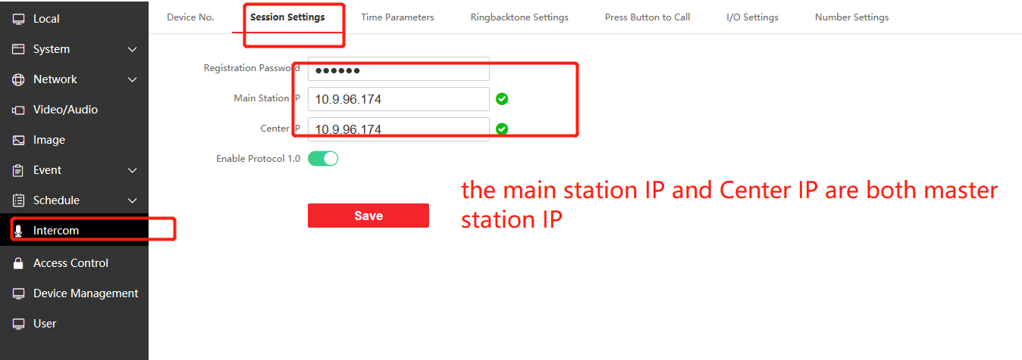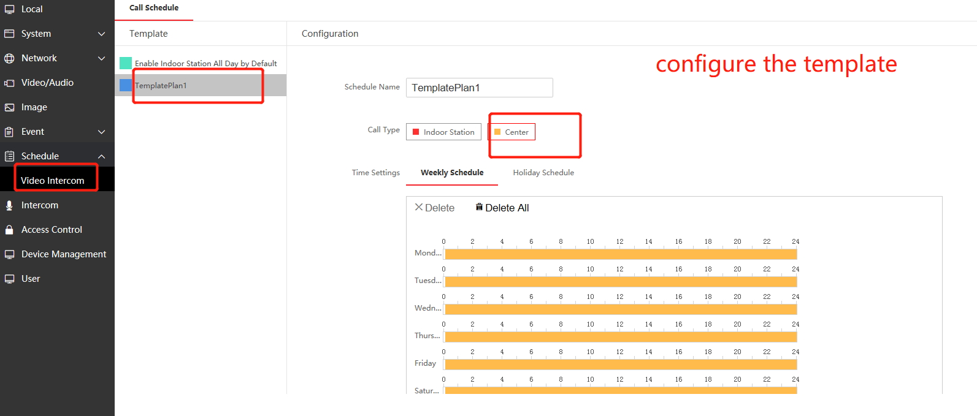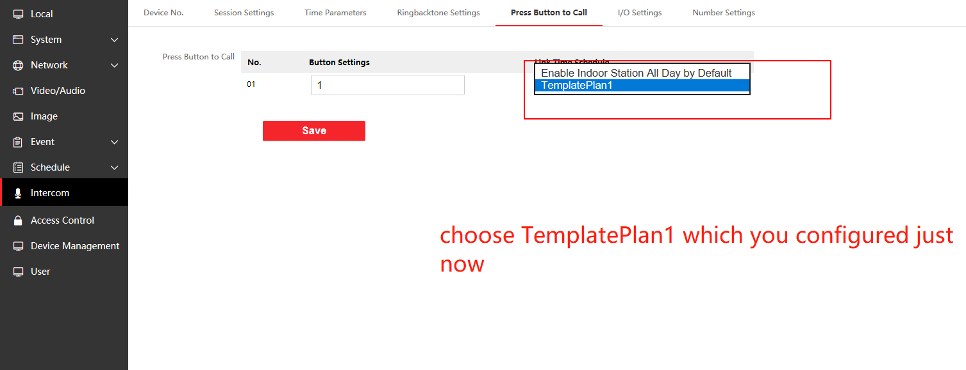

1. If you have more than one main door station (not door station extension), replicate the step3 to step4 for other door stations.