**How to use the private password of the Indoor Station**

**to open the door**

**Preparation**

1. This guide takes

|  |  |  |
| --- | --- | --- |
| Type | Model | Version |
| Door station | DS-KD8003-IME1 | V2.2.45_210430 |
| Indoor Station | DS-KH8520-IME1 | V2.1.24_210617 |

As examples to introduce How to open door with private password.

2. Software: iVMS-4200 Version 3.6.1.3

**How to use the private password of the Indoor Station to open the door**

1. **Add the Indoor Station to the Door Station** 
   1. Please refer to the attached document about how to add the Indoor Station to the Door Station



1. **Set a public password for the Indoor Station**
   1. Go to Remote Configuration 🡪Permission Password 🡪 Unlocking password to set a private password

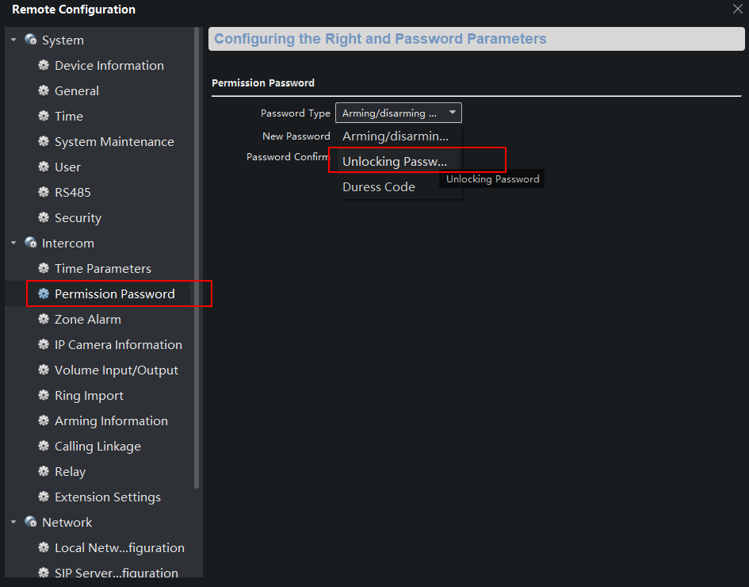

Notice: the length of password must be 6

1. **Open door with the public password**

Enter the private password in the format of **#room NO. + private password#** on the keypad and you will hear the voice prompt “the door is open”.

For example, if the room NO. of the Indoor station is 101 and the private password is 123456, then you should enter #101123456# on the keypad to open the door